Research Article
Genome-wide association study identifies candidate genes and favorable haplotypes for seed yield in Brassica napus
Haijiang Liu^{1,2#}, Maoyan Zou^{1,2#}, Bingbing Zhang^{1,2}, Xinyu Yang^{1,2}, Pan Yuan^{1,2}, Guangda Ding ^{1,2}, Fangsen Xu^{1,2}, Lei Shi^{1,2}*
1 National Key Lab of Crop Genetic Improvement, Huazhong Agricultural University, Wuhan, 430070, Hubei Province, China
2 Key Lab of Cultivated Land Conservation, Ministry of Agriculture and Rural Affairs/ Microelement Research Centre, Huazhong Agricultural University, Wuhan, Hubei Province, 430070, China

*Corresponding Author：E-mail Address: leish@mail.hzau.edu.cn
# These authors contributed equally to this work

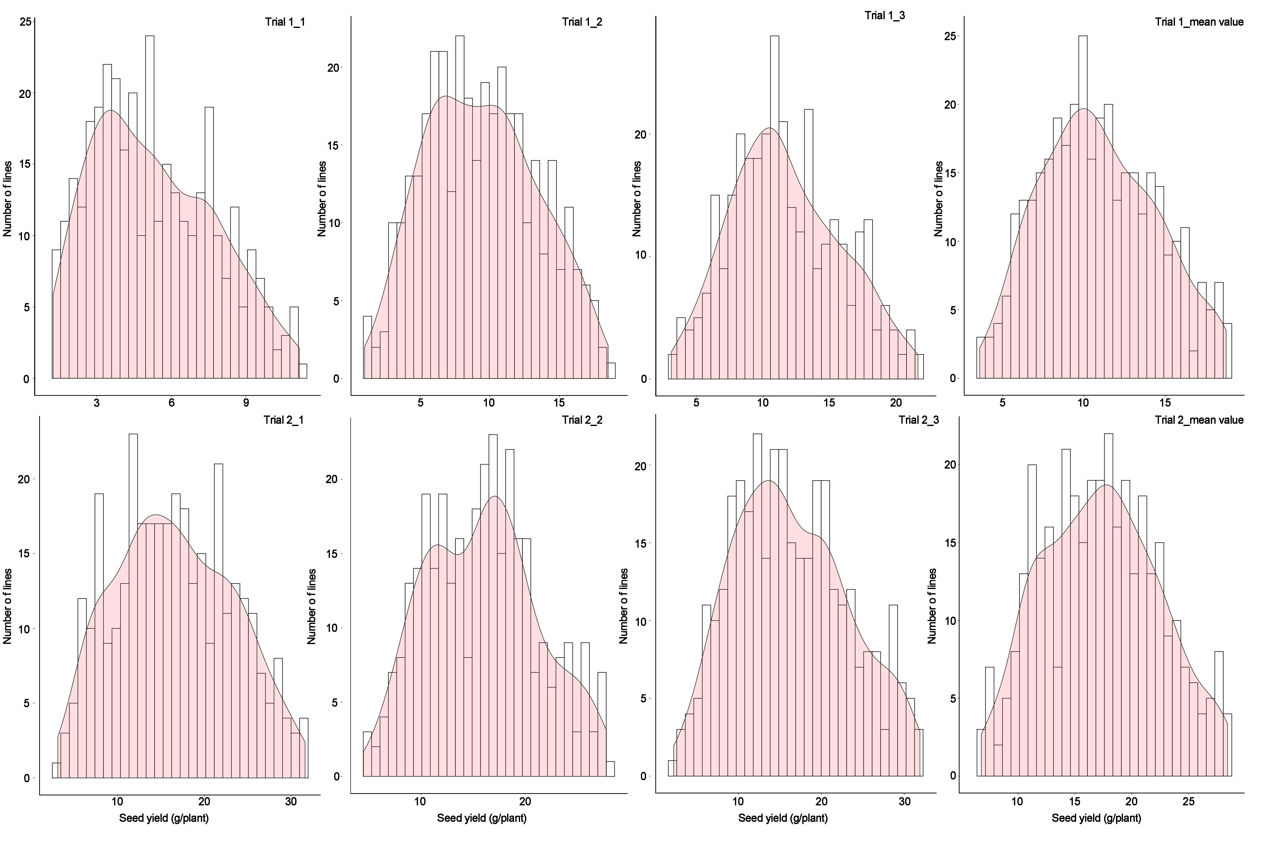
Fig. S1. Frequency distribution of seed yield of an association panel of B. napus in Trial 1 and Trial 2.

