Supplementary Figures
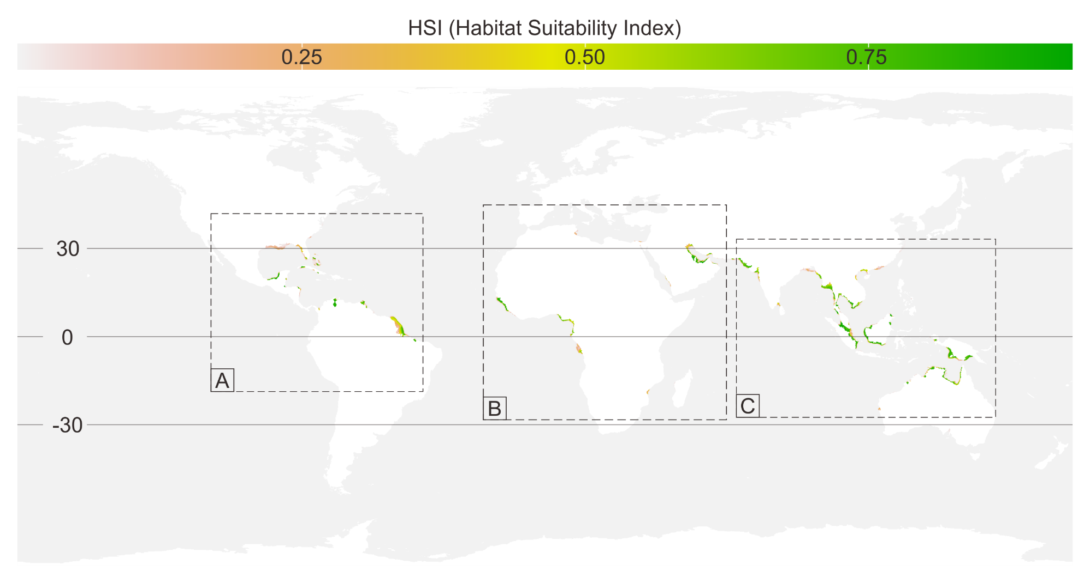
Figure 1. Spatial extrapolation of over a global extent. Inset images (A, B, and C) are shown in detail in figure 8, 9, and 10 respectively.
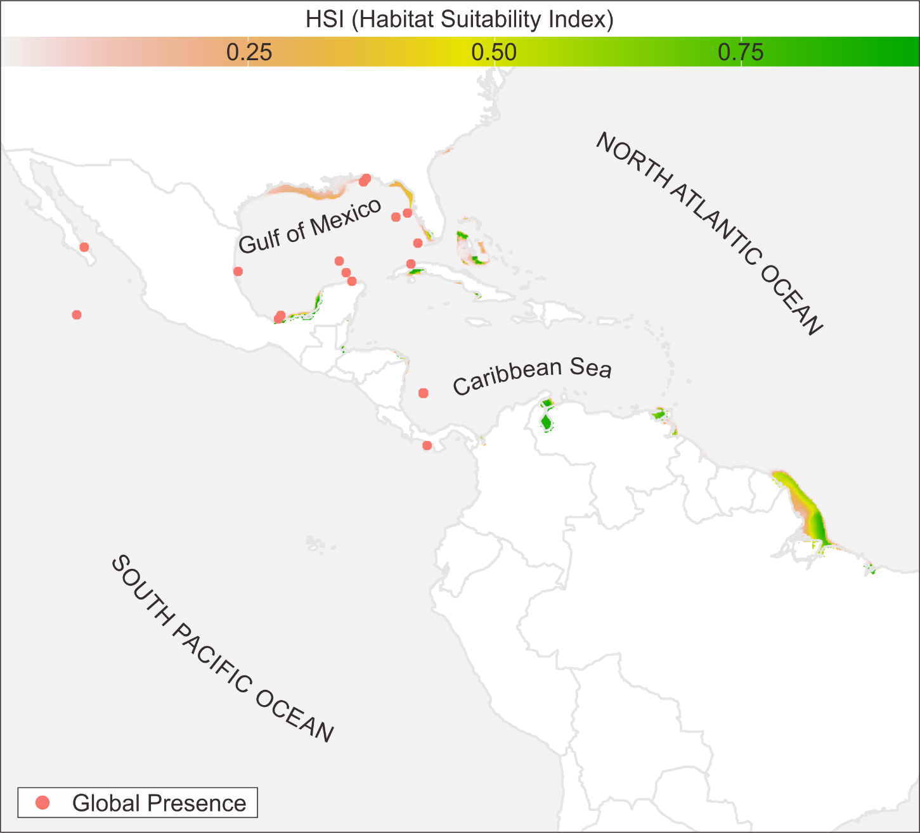
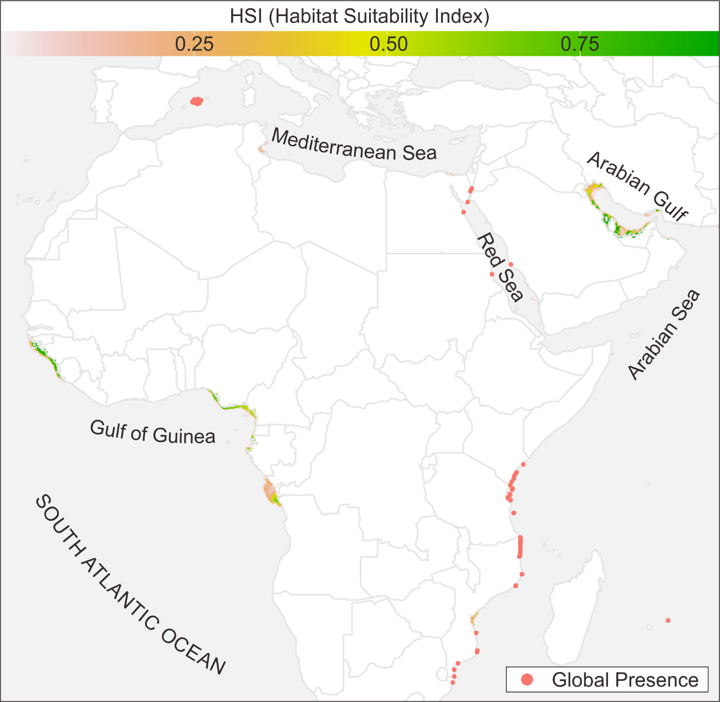
Figure 2. Temperate North Atlantic and South Pacific realm
Figure 3. Temperate South Atlantic, Mediterranean, and Arabian Peninsula
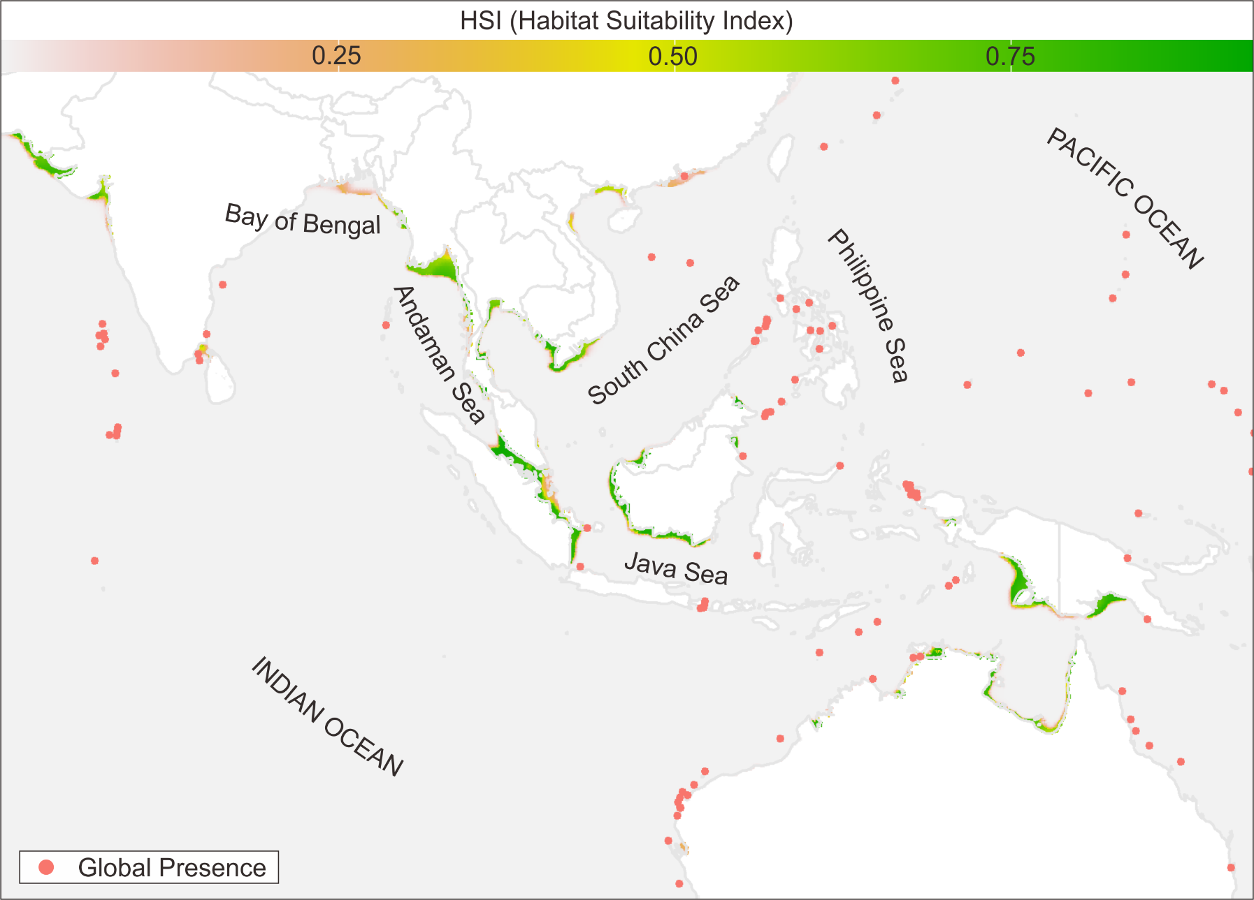
Figure 4. Temperate Indo-pacific realm with several hot spots for the four species.
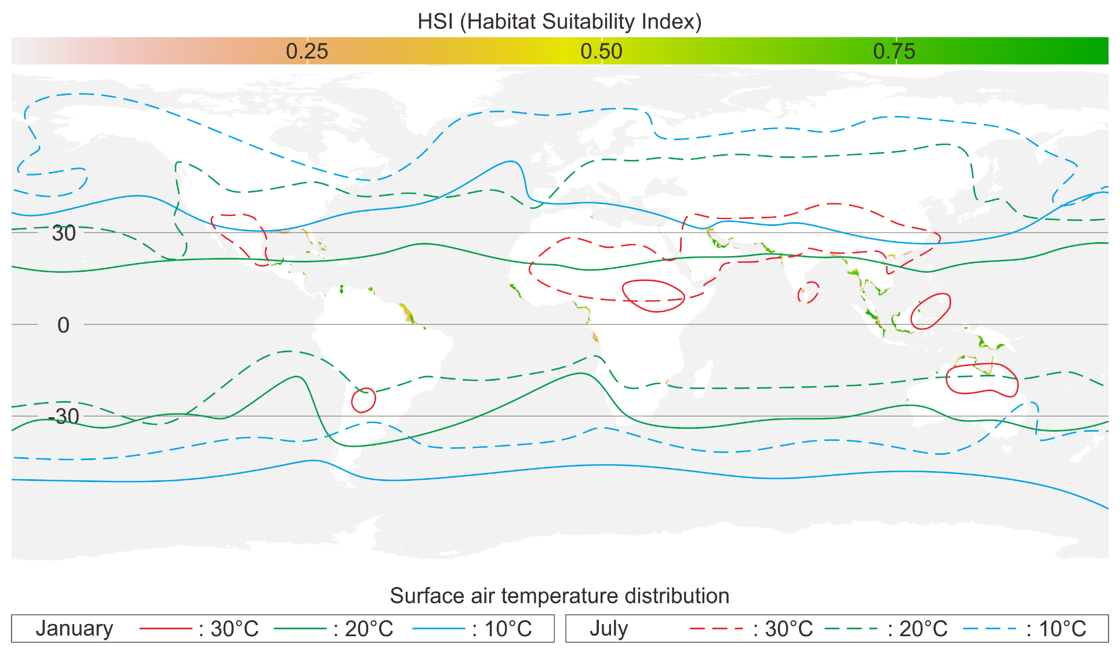
Figure 5. Spatial extrapolation of over a global extent overlain with surface air temperature distribution during the month of January and July.

