Electronic Supplementary Material 2

Impact on technological properties, sensory acceptance, bioactive compounds, and nutritional quality of blend pinto beans and red rice for novel cookies

Camila Soares de Magalhães ¹, Gleicyane de Almeida Marques ¹, Ronel Joel Bazán-Colque ², Erica Aguiar Moraes ¹, Erika Madeira Moreira da Silva ^{1,}*, José Luis Ramirez Ascheri ³

¹ Postgraduate Program in Nutrition and Health, Center of Health Sciences, Universidade Federal do Espírito Santo, Avenida Marechal Campos 1468, CEP 29040-090, Vitória, ES, Brazil.
² Postgraduate Program in Food Science and Technology, Universidade Federal Rural do Rio de Janeiro, Rodovia BR 465, Km 07, CEP 23890-000, Seropédica, RJ, Brazil.
³ Food Extrusion and Physical Properties Laboratory, Embrapa Food Technology, Avenida das Américas 29501, CEP 23020-470, Guaratiba, RJ, Brazil.

* Corresponding author: E-mail address: erika.m.silva@ufes.br
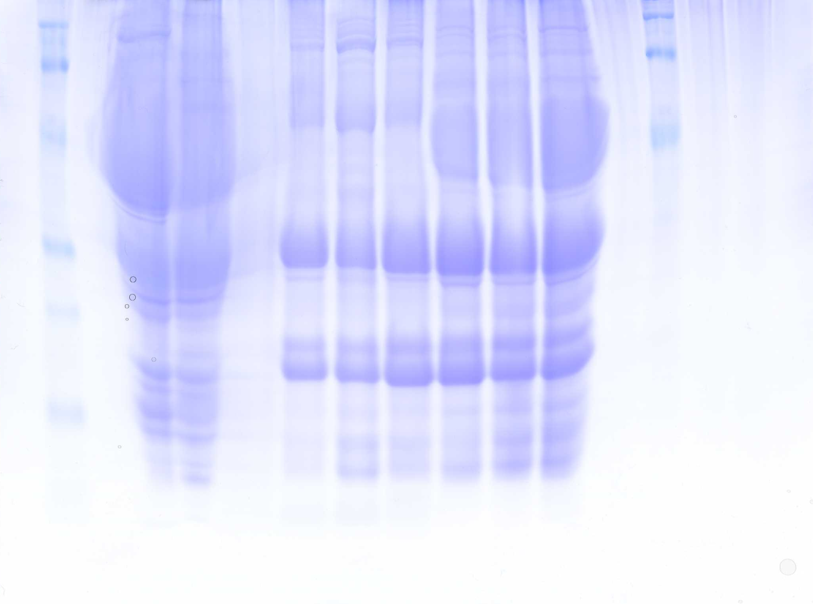
76,80
91,06
(kDa)
PB
1
*
2
*
3
4
*
*
*
101,36
(kDa)
72,89
47,82
33,99
26,84
17,62
93,69
62,95
46,57
18,21
21,03
39,29
35,41
24,11
26,31
30,77
50,71
14,48
16,00
Full image of gel electrophoresis (SDS/PAGE) of pinto bean flour ($PBF$) and red rice flour ($RRF$). PB (Marker); $PBF$ raw (Line 1); $PBF$ processed (Line 2); $RRF$ raw (Line 3); $RRF$ processed (Line 4). * Other samples of another study

