Supplementary Information
A Digital Twin of Synchronized Circular Laser Array for Powder Bed Fusion Additive Manufacturing
Hamed Attariani¶,*,Shayna Renay Petitjean¶, Majid Dousti¶
*, ¶Department of Mechanical and Materials Engineering, Wright State University, Dayton, OH 45431, USA
Corresponding Author: hamed.attariani@wright.edu, Tell: (937) 775-8320, Fax: (419) 586-0320

Table S1. Density, thermal conductivity, and specific heat of the Ti-6Al-4V [1].

Temperature  (K) | Density  (kg/m³) | Thermal Conductivity  (W/mꞏK) | Specific Heat  (J/Kꞏkg)
298 | 4420 | 7 | 546
373 | 4406 | 7.45 | 562
473 | 4395 | 8.75 | 584
573 | 4381 | 10.15 | 606
673 | 4366 | 11.35 | 629
773 | 4350 | 12.6 | 651
873 | 4336 | 14.2 | 673
973 | 4324 | 15.5 | 694
1073 | 4309 | 17.8 | 714
1173 | 4294 | 20.2 | 734
1273 | 4282 | 19.3 | 641
1373 | 4267 | 21 | 660
1473 | 4252 | 22.9 | 678
1573 | 4240 | 23.7 | 696
1673 | 4225 | 24.6 | 714
1773 | 4205 | 25.8 | 732
1873 | 4198 | 27 | -

Table S2. Equations and Boundary Conditions

Governing Equations

Anisotropic heat conduct model | $$c_{p}ρ\frac{∂T}{∂t}= \frac{∂}{∂x}\left(λ_{x}k_{x}\frac{∂T}{∂x}\right)+\frac{∂}{∂y}\left(λ_{y}k_{y}\frac{∂T}{∂y}\right)+\frac{∂}{∂z}\left(λ_{z}k_{z}\frac{∂T}{∂z}\right)-{ρH}_{f}\frac{∂α}{∂t}.$$
Melt volume fraction, 0<α<1 | $$α=\left\{\begin{aligned}0, &T<T_{S} \\ ({T-T_{S})}/{(T_{L}-T_{S})}, &T_{S}<T<T_{L} \\ 1, &T>T_{L}\end{aligned}\right.$$
Boundary Conditions

Gaussian Heat Flux | $$q\left(x,y\right)=\frac{2PA}{πr_{o}^{2}}exp\left(⁡-\frac{2({\left(x-vt\right)}^{2}-y^{2}}{r_{o}^{2}}\right).$$
Radiation boundary conditions | $${\dot{q}}_{}=h_{c}\left(T-T_{0}\right)+h_{r}\left({T^{4}-T}_{0}^{4}\right)$$
 | $${\dot{q}}_{}=q\left(x,y\right)+h_{c}\left(T-T_{0}\right)+h_{r}\left(T^{4}-T_{0}^{4}\right)$$
Solidification Map Equations

Thermal Gradient ($\vec{G}$) | $$\left|\vec{G}\right|=\sqrt{{\left(\frac{∂T}{∂x}\right)}^{2}+{\left(\frac{∂T}{∂y}\right)}^{2}+{\left(\frac{∂T}{∂z}\right)}^{2}}$$
Solidification Rate (R) | $$R=v\frac{G_{x}}{\left|G\right|}.$$
Equiaxed Criterion | $${G^{1.91}}/{R<1.04×{10}^{6} {K^{1.91}}/{{cm}^{2.91}.s}}$$
Columnar Criterion | $${G^{1.91}}/{R>1.92×{10}^{6} {K^{1.91}}/{{cm}^{2.91}.s}}$$

Table S3. Variables List
Variable | Symbol
Specific heat capacity | $$c_{p}$$
Density | $$ρ$$
Thermal conductivity enhancement factors | $$λ_{x}, λ_{y}, λ_{z}$$
Thermal conductivity | $$k_{x}, k_{y}, k_{z}$$
Absorption coefficient | A
Laser beam velocity | v
Laser power | P
Melting enthalpy | $$H_{f}$$
Solidus temperature | T_{S}
Liquidus temperature | T_{L}
Melting Temperature | T_{m}
Room temperature | T₀
Heat transfer convection coefficient | h_{c}
Heat transfer radiation coefficient | h_{r}
Laser spot radius | r_{o}

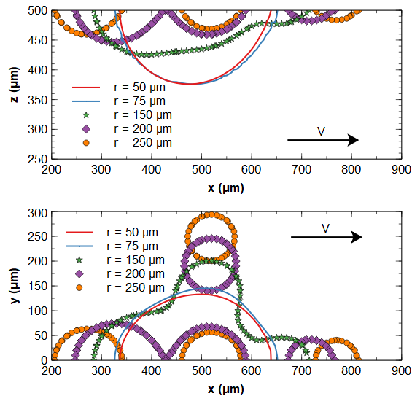  b  a | 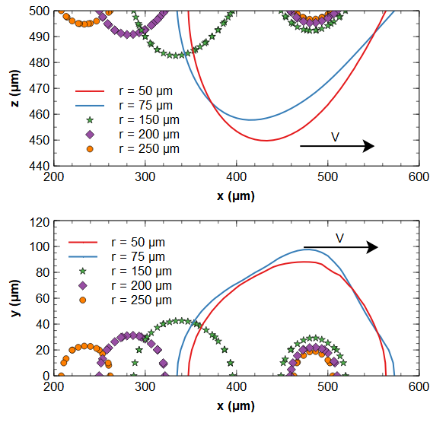  d  c
Figure S1. The melt pool shape on the x-z and y-z planes for P=50W and v=100-1000 mm/s. a-b) v=100 mm/s, c-d) v=500 mm/s, e-f) v=1000 mm/s | 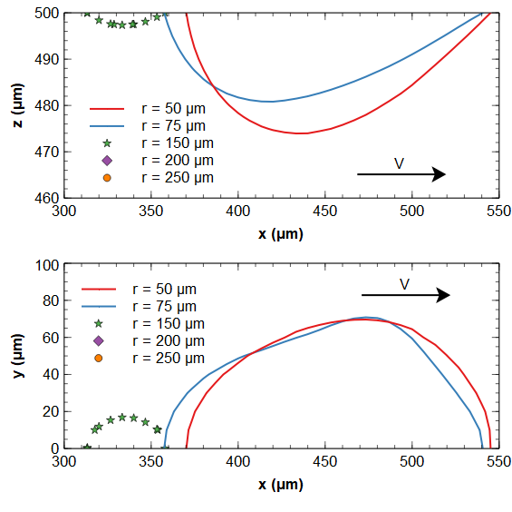  e  f

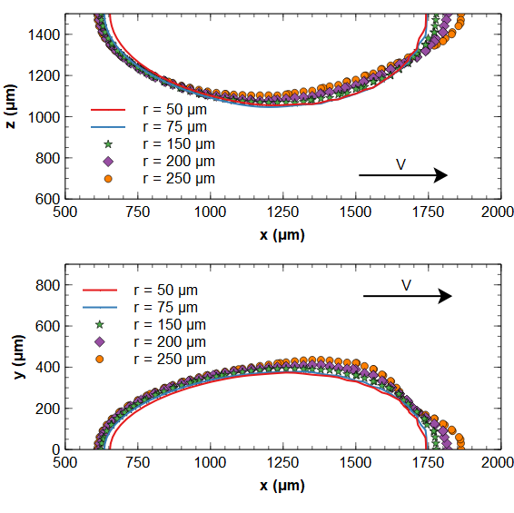  b  a | 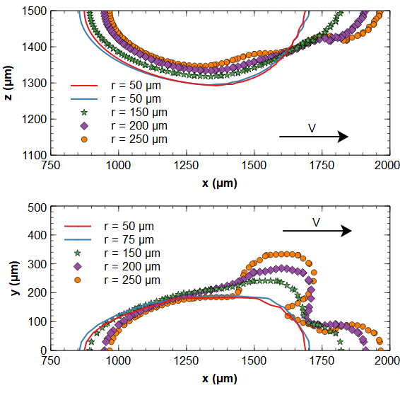  d  c
Figure S2. The melt pool shape on the x-z and y-z planes for P=300W and v=100-1000 mm/s. a-b) v=100 mm/s, c-d) v=500 mm/s, e-f) v=1000 mm/s | 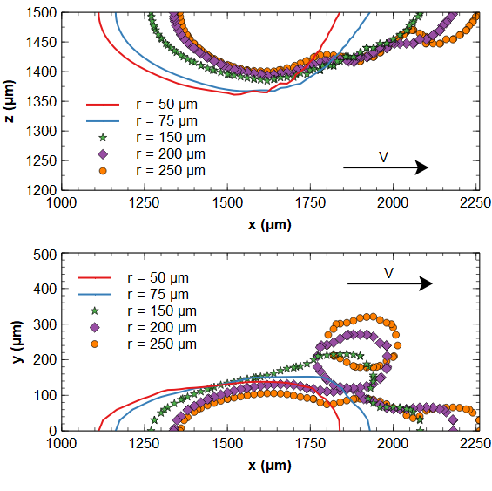  f  e

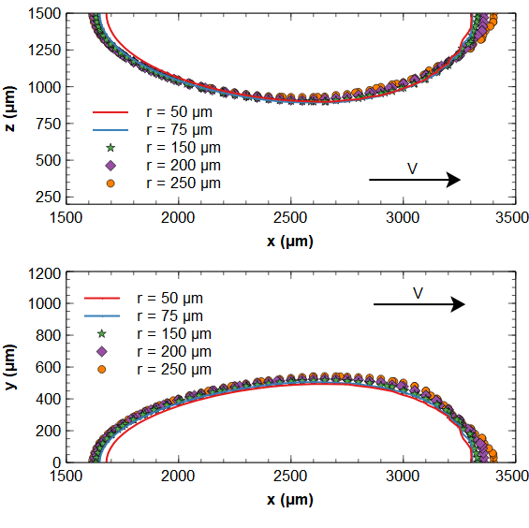  b  a | 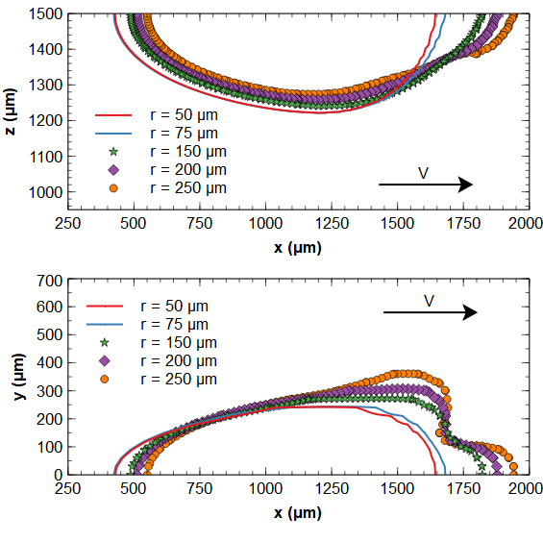  d  c
Figure S3. The melt pool shape on the x-z and y-z planes for P=500W and v=100-1000 mm/s. a-b) v=100 mm/s, c-d) v=500 mm/s, e-f) v=1000 mm/s | 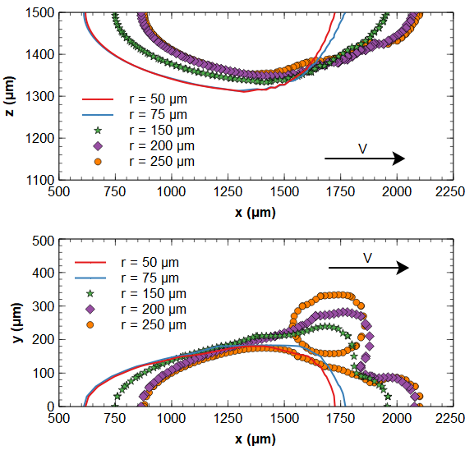  f  e

[1] K.C. Mills, Recommended values of thermophysical properties for selected commercial alloys , Woodhead Publishing, 2002.

