Supplementary file

Table S1. Primers used in the study
Gene name | Primer F (5′ → 3′) | Primer R (5′ → 3′)
AtOAT | ATGGCAGCCACCACGAGACG | TCAAGCATAGAGGTTTCTTCCACAGC
qRT-AtOAT | TCTGCAGTTAATCAGGGACATT | TTATCGTTGTAAAACGCTCGTG
qRT-TaOAT | AATGAACACTGGAGCCGAAGG | GACCAGGAACCAAAGGACCAA
qRT-TaP5CS1 | GATGGTGCTCGTTTTGGACTCGG | ACATCCTTGTCACCATTCACCACT
qRT-TaP5CR | TAAATGCCGTTGTTGCTGCC | AGCAAAACTAACAATGGCTACCAG
qRT-TaP5CDH | CGGTGTCCCCCGAGGAGATCTC | GGTTGTGAAGTCCATGCTTTGGGC
TaADP | GCTCTCCAACAACATTGCCAAC | GCTTCTGCCTGTCACATACGC

Table S2. Induction of hapolid embryos from the transgenic wheat plants by mailze pollens
Background of transgenic plants | Florets pollinated | Caryopsis obtained | Embryos cultured | Caryopsis induction rate (%) | Embryo production rate (%)
Fielder | 500 | 230 | 55 | 46.0 | 11.0
Ningchun 4 | 300 | 97 | 25 | 32.3 | 8.0

Fig. S1 Proline biosynthesis and catabolism pathway in plants. Green lines indicate the glutamate pathway for proline biosynthesis. Red lines indicate the ornithine pathway for proline biosynthesis. Black lines indicate the proline catabolic pathway.

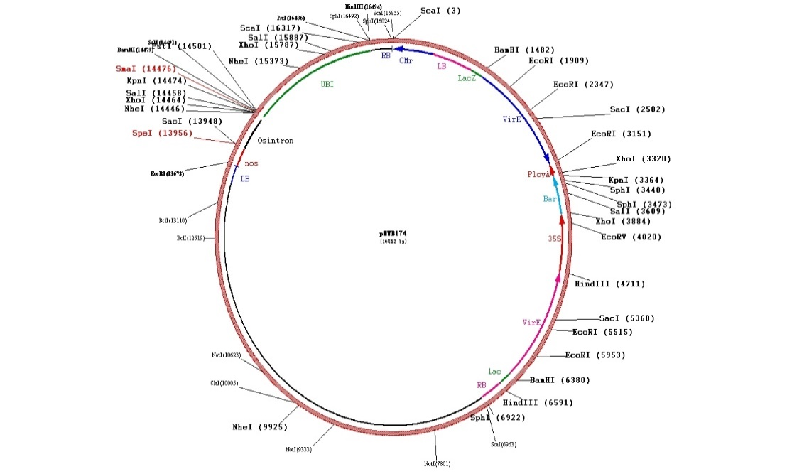

Fig. S2 The map of the backbone vector pWMB174 used in this study to construct the expression vector containing AtOAT for wheat transformation.

Fig. S3 Detection of the homozygous positive wheat plants by PCR amplification for AtOAT gene. a The homozygous positive plants derived from Fielder as a receptor. b The homozygous positive plants derived from Ningchun 4 as a receptor. WT, the negative control plant without AtOAT; P, the positive control expression vector plasmid used for Agrobacterium mediated wheat transformation.

Fig. S4 Botanic traits of the transgenic wheat plants expressing AtOAT under salt stress. a Germination rate of the WT Ningchun 4 (NC) and its transgenic lines (OE-N1, OE-N2, and OE-N3) under 200 mM NaCI stress condition. b Root length of NC and its transgenic lines under 200 mM NaCI stress condition. c Shoot length of NC and its transgenic lines under 200 mM NaCI stress condition. d Germination rate of the WT Fielder (FC) and its transgenic lines (OE-F1, OE-F2, and OE-F3) under 150 and 200 mM NaCI stress condition. (E) Root length of FC and its transgenic lines under 150 mM NaCI stress condition. (F) Shoot length of FC and its transgenic lines under 150 mM NaCI stress condition.
Fig. S5 Physiological parameters of the transgenic wheat lines expressing AtOAT under salt stress. a Phenotypes of transgenic lines (OE-F1, OE-F2, and OE-F3) and their WT Fielder (FC) after five times irrigation with 250 mM NaCI solution. b Free proline content in the transgenic lines and FC before and after salt stress. c Chlorophyll content in the transgenic lines and FC before and after salt stress. d Peroxidase activity in the transgenic lines and FC plants before and after salt stress. Data represent the average of three replicates and were analyzed with IBM-SPSS statistic 20. Letters in bold represent significant difference between groups at α = 0.05. Bars indicate the standard errors of the means.

Fig. S6 Measurements of catalase activity in the transgenic wheat lines expressing AtOAT in response to salt stress. a Catalase activity in the transgenic lines (OE-N1, OE-N2, and OE-N3) and their WT Fielder (NC) after five times irrigation with 250 mM NaCI solution. b Catalase activity in the transgenic lines (OE-F1, OE-F2, and OE-F3) and their WT Fielder (FC). Data represent the average of three replicates and were analyzed with IBM-SPSS statistic 20. Letters in bold represent significant differences between groups at α = 0.05. Bars indicate the standard errors of the means.

Fig. S7 Measurements of catalase activity in the transgenic wheat lines expressing AtOAT in response to drought stress. a Catalase activity in the transgenic lines (OE-N1, OE-N2, and OE-N3) and their WT Ningchun 4 (NC) under water stress for different time. b Catalase activity in the transgenic lines (OE-F1, OE-F2, and OE-F3) and their WT Fielder. Data represent the average of three replicates and were analyzed with IBM-SPSS statistic 20. Letters in bold represent significant differences between groups at α = 0.05. Bars indicate the standard errors of the means.

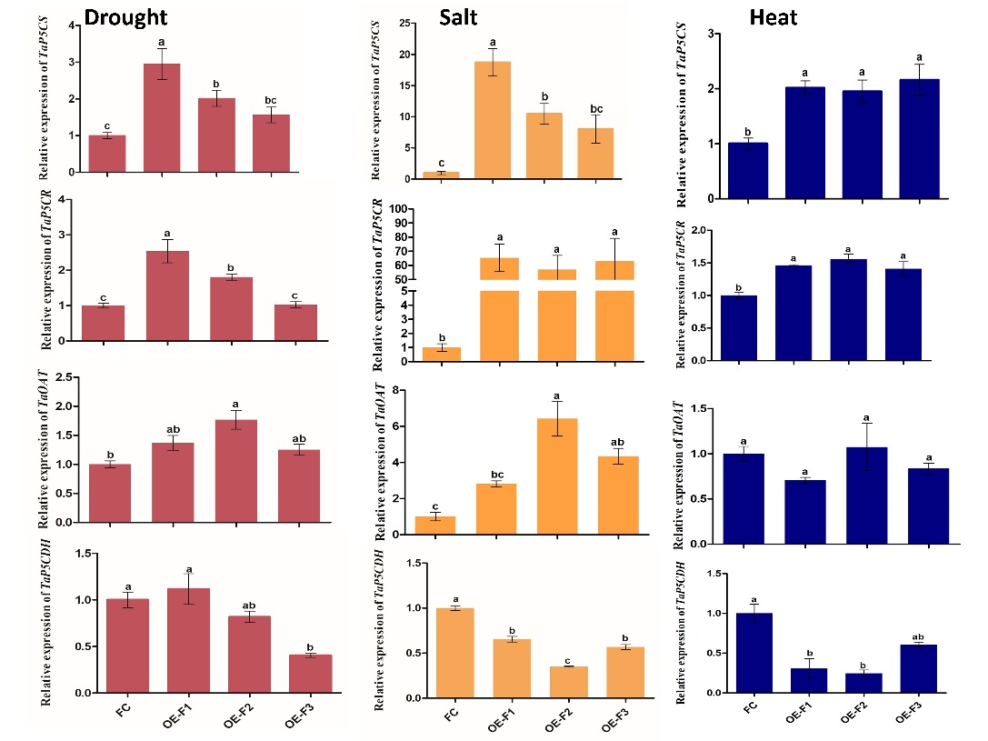
Fig. S8. Relative expression of proline biosynthesis and catabolism associated genes in the transgenic wheat lines expressing AtOAT under abiotic stress conditions. The red column represents the expression of proline biosynthesis related genes (TaP5CS1, TaP5CR, and TaOAT) and proline catabolism related gene TaP5CDH under drought stress condition. The orange column represents the expression profiles of the proline biosynthesis and catabolism related genes under salt stress condition. Blue column represents the expression profiles of the proline biosynthesis and catabolism related genes under heat stress condition. Data represent the average of three biological replicates. Statistical significance was calculated by IBM-SPSS statistic 20. Letters in bold represent significant differences between groups at α = 0.05. Bars indicate the standard errors of the means. FC represents the WT Fielder. OE-F1, OE-F2, and OE-F3 are the transgenic lines derived from FC.

