Supplemental Figure 1. The H3N8-infected patient’house and surrounding environment, Zhumadian prefecture, Henan Province, China
- The location of the patient is within the East Asian-Australian migratory birds’ flyway (marked in yellow)
- Satellite image of the house of the patient (marked in red) and the neighboring pond (marked in orange); C. The neighboring pond
The companion dog (D and cat (E) kept in the patient’s house.
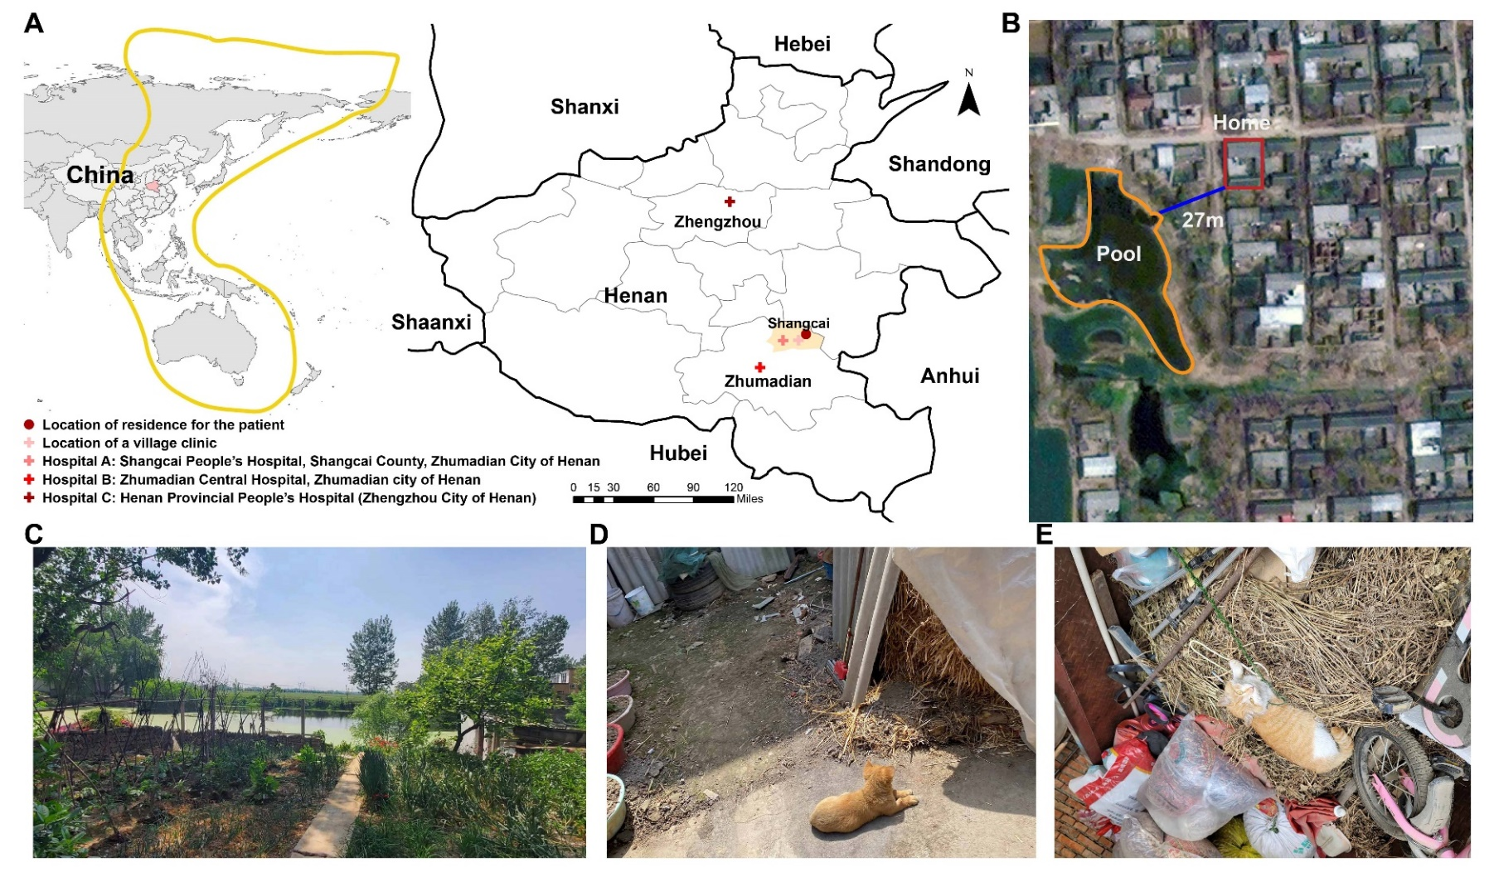

Supplemental Figure 2. Dynamic changes of laboratory indicators during hospitalization. The blue dotted line represents the upper limit of the normal range, and the green dotted line represents the lower limit of the normal range. A-H: Blood routine laboratory indicators; I-O: liver function laboratory indicators; P: blood glucose; Q-V: routine coagulation laboratory indicators; W-X: cardiac function laboratory indicators; Y-Z: electrolyte; AA-AD: inflammation indicators; AE-AF: renal function laboratory indicators.
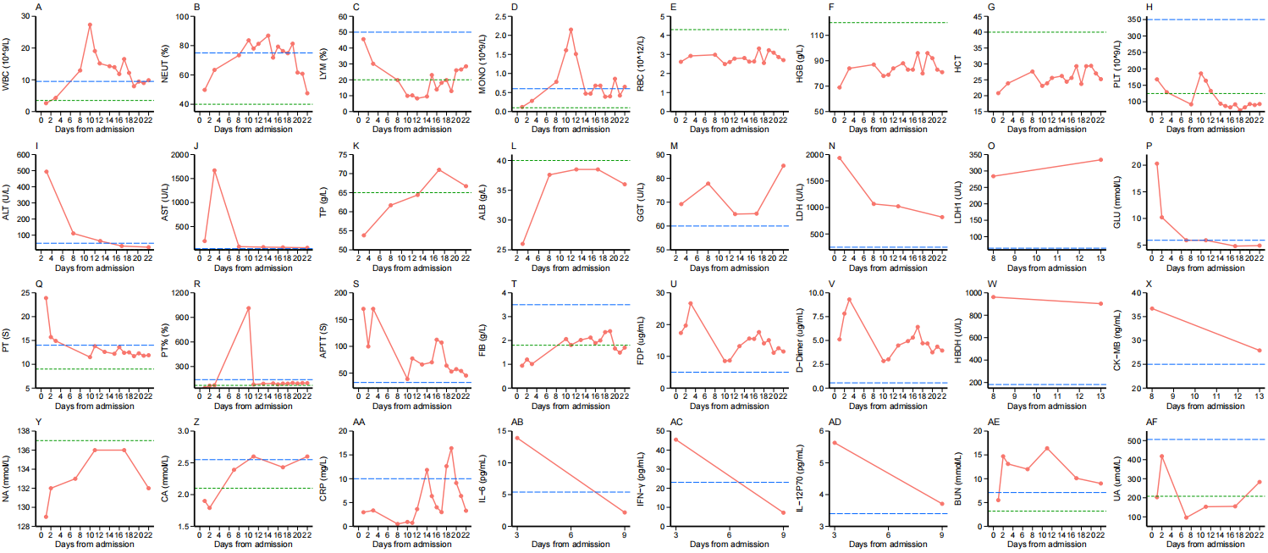

Supplemental Figure 3. Phylogenetic trees of PB2 (A), PB1 (B), PA (C), NP (D), M (E) and NS (F) genes of the novel avian influenza A (H3N8) virus. A/Henan/ZMD-22-2/2022(H3N8) virus was indicated with a red color.
Supplemental Table 1. Complications and treatments of the patient
 | Signs and treatment
Fever
Temperature on admission (°C) | 39.5
Highest temperature (°C) | 41
Oximetry saturation, Lowest (%) | 55%
Complications
Severe pneumonia | Yes
Liver dysfunction | Yes
Myocardial damage | Yes
Renal damage | Yes
Coagulation dysfunction | Yes
Sepsis | Yes
Systemic inflammatory response syndrome | Yes
Bacterial co-infection | Yes
Mechanical ventilation via endotracheal intubation | Hospital day 1-Now
Extracorporeal Membrane Oxygenation | Hospital day 1-Now
Blood transfusion
Red blood cells | Hospital day 7, 9, 11, 16 (1U)
Plasma | Hospital day 9 (200mL)
Glucocorticoids (methylprednisolone) | Hospital day 1-10 (30mg doses given intravenously, twice a day)
 | Hospital day 11-Now (10mg doses given intravenously, twice a day)
Antibiotic treatment
Linezolid | Hospital day 1-2 (75 mL, three times a day)
Meropenem | Hospital day 1- Now (0.3g, three times a day)
Compound sulfamethoxazole | Hospital day 2- Now (one tablet, once a day)
Antiviral treatment
Oseltamivir phosphate | Hospital day 1-10 (30mg, twice a day)
Recombinant human interferon α1b | Hospital day 2- Now (30ug, twice a day)

Supplemental Table 2. Laboratory test result of dog and cat kept in the house of the patient.

 | Dog |  |  | Cat
 | Normal range | Value |  | Normal range | Value
Albumin (g/L) | 23–40 | 29.23 |  | 22–40 | 33.94
Alanine aminotransferase (U/L) | 10–125 | 10.76 |  | 12–130 | 46.76
Aspartate transaminase (U/L) | 0–50 | 28 |  | 0–48 | 33
Urea (mmol/L) | 2.5–9.6 | 2.45 (↓) |  | 5.7–12.9 | 7.25
Cholesterol (mmol/L) | 2.84–8.27 | 3.98 |  | 1.68–5.81 | 3.61
Creatine kinase (U/L) | 10–200 | 323 (↑) |  | 0–314 | 220
Creatinine (µmol/L) | 44–159 | 34.32 (↓) |  | 71–212 | 85.88
C-Reactive protein (mg/L) | 0.0–10.0 | 0.21 |  | 0.0–10.0 | 0.34
Glucose (mmol/L) | 4.11–7.94 | 5.62 |  | 4.11–8.83 | 3.79 (↓)
Lactate (U/L) | 40–400 | 388 |  | 0–798 | 147
Protein total (g/L) | 52–82 | 53.56 |  | 57–89 | 67.65
Alkaline phosphatase (U/L) | 20-156 | 116 |  | 25-93 | 31
Triglycerides (mmol/L) | 0.56-1.7 | 0.19 (↓) |  | 0.2-1.1 | 0.54
Low-density lipoprotein (g/mL) | 1.019-1.087 | 1.29 (↑) |  | 1.030-1.043 | 0.96
High-density lipoprotein (g/mL) | 1.063-1.100 | 3.23 (↑) |  | 1.063-1.100 | 2.63 (↑)

Supplemental Table 3. Characteristics of a confirmed patient with A (H3N8) infection and six close contacts.
Characteristics | Patient |  | Close contacts
Relationship |  |  | Grandfather | Grandmother | Father | Aunt | Brother | Sister
Age (years) | 4 |  | 60 | 60 | 32 | 36 | 8 | 6
Sex | Male |  | Male | Female | Male | Female | Male | Female
Occupation | Children |  | Farmer | Farmer | Worker | Teacher | Student | Student
Comorbidity | None |  | None | None | None | None | None | None
History of animal contact
Recent visit to poultry market | None |  | None | None | None | None | None | None
Contact with dog | Frequent |  | Infrequent | None | None | None | Infrequent | None
Type of contact dog | Daily feeding and playing |  | Infrequent feeding | - | - | - | Playing | None
Contact with cat | Frequent |  | Infrequent | None | None | None | Infrequent | None
Type of contact cat | Daily feeding and playing |  | Infrequent feeding | - | - | - | Playing | None
Contact with chickens | Yes |  | Yes | Yes | Yes | Yes | Yes | Yes
Neutralizing antibody titer | 1:121 |  | 1:339 | 1:179 | ND* | ND* | Negative | Negative
*The sample was not available and the test was not done.
Supplemental Table 4. Key molecular characteristics of the A(H3N8) virus identified in this Study.
Gene | Mutation | A/H3N8/ZMD-22-2/2022 | Mutation comments
HA | Cleavage site | PEKQTR/GL | Pathogenic to poultry
HA | Q226L | Q | RBS position, altered receptor specificity
HA | G228S | G | RBS position, altered receptor specificity
PB1 | H99Y | H | H5 virus transmissible among ferrets
PB2 | Q591K | Q | Enhance replication efficiency and Increase virulence in mice
PB2 | E627K | K | Increase virulence in mice
PB2 | D701N | D | Increase virulence in mice and transmission in mammals
NP | N319K | N | Enhance replication efficiency
M | N30D | D | Increase virulence in mice
M | T215A | A | Increase virulence in mice
NS | P42S | S | Increase virulence in mice

