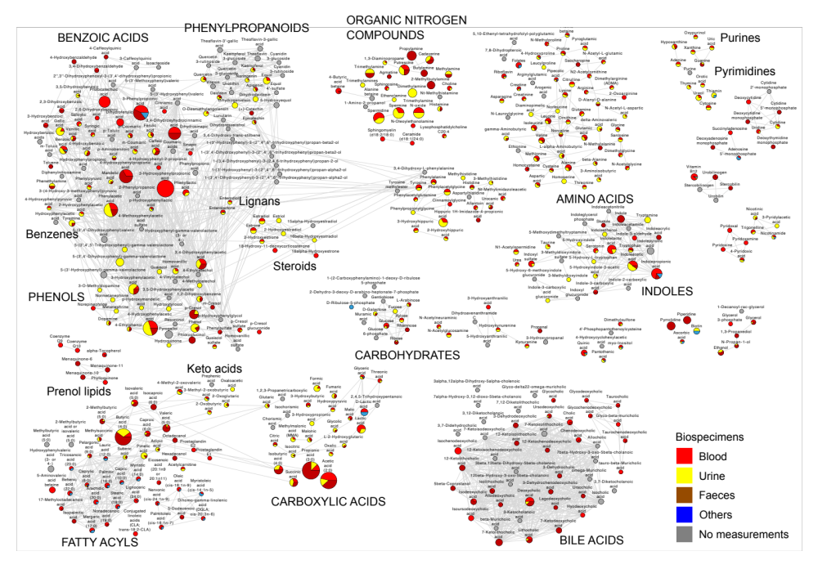

Fig. S1 Chemical similarity network of 462 microbial metabolites in the Exposome-Explorer database. Node size is proportional to the number of records supporting their microbial origin. Types of human biospecimens where metabolites have been measured are represented in red for blood, in yellow for urine, in brown for faeces, in blue for others types, and in grey when they were no measurements found in human.

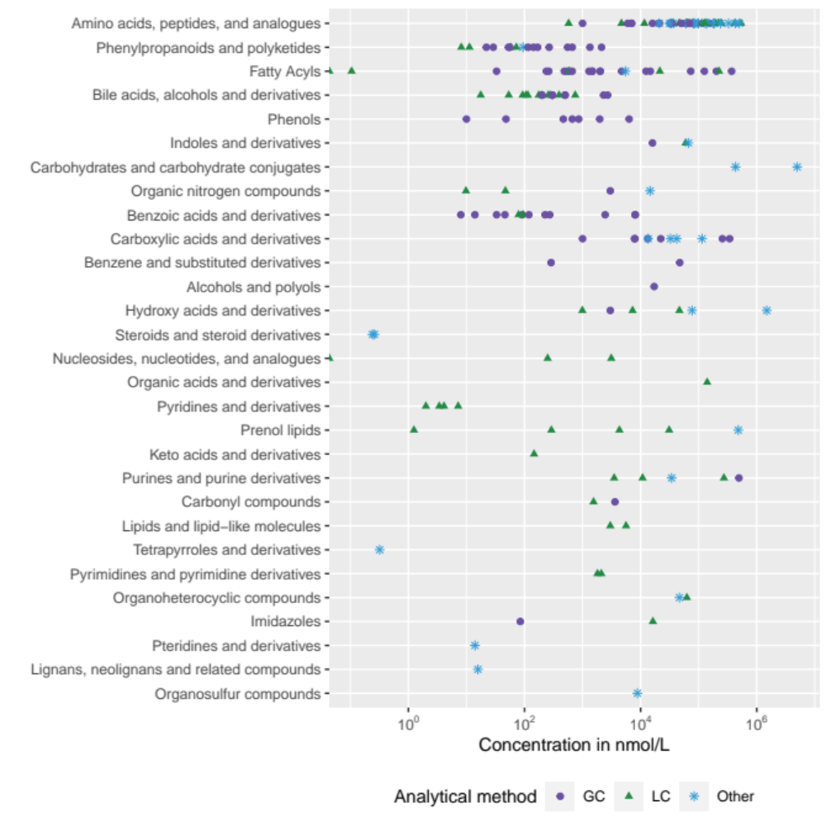

Fig. S2 Concentrations of 152 microbial metabolites in the Exposome-Explorer database measured in human blood with different types of analytical methods. GC, gas chromatography; LC, liquid chromatography.

