Solar-driven ultrafast lithium extraction from low-grade brine using microfluidics-mediated vortex in scalable electrochemical reactors
Xianyun Zhang,^{a†} Zhen Li,^{b†} Jiang Liu,^{c} Fuzong Xu,^{c} Leiliang Zheng,ª Stefaan De Wolf,^{c} Zhiping Lai,^{b *} Xu Lu^{a,c *}
ª Clean Combustion Research Center (CCRC), Division of Physical Science and Engineering, King Abdullah University of Science and Technology (KAUST), Thuwal, 23955-6900, Kingdom of Saudi Arabia.
^{b} Chemical Engineering Program, Division of Physical Science and Engineering, King Abdullah University of Science and Technology (KAUST), Thuwal, 23955-6900, Kingdom of Saudi Arabia.
^{c} KAUST Solar Center (KSC), Division of Physical Sciences and Engineering, King Abdullah University of Science and Technology (KAUST), Thuwal, 23955-6900, Kingdom of Saudi Arabia.
† These authors contributed equally.
* Corresponding authors: Xu Lu (xu.lu@kaust.edu.sa) and Zhiping Lai (zhiping.lai@kaust.edu.sa)

 |  | Supplementary Table 1: Comparison of Li extraction performance in this study and the literature
Active material |  |  | Reactor type | c_{Lithium}  (ppm) | Mg/Li mass ratio in feed | Na/Li mass ratio in feed | Voltage  (V) | Li/Mg selectivity | Li/Na selectivity | Current density  (mA/cm²) | Extraction rate  (mg/g/h) | Reference
LiFePO₄/FePO₄ |  |  | SMER | 308 | 66.00 | 182.89 | 0.70 | 391.06 | 191.47 | 2.50 | 21.96 | This study
LiTiO₂ |  |  | Beaker | 400 | No Mg²⁺ | 19.96 | - | No Mg²⁺ in feed | 19.96 | - | 0.71 | 1
Li_{1.36}Mn_{1.63}O₄ |  |  | Beaker | 118 | 3.42 | 3.28 | - | 58556 | 5464 | - | 0.52 | 2
Hydrogenated manganese oxide |  |  | H-shape reactor | 1460 | 6.53 | 5,163.26 | 1.0 – 3.5 | 10 | 26 | - | 0.093 | 3
LiFePO₄/FePO₄ |  |  | H-shape reactor | 220 | 60 | 375.45 | 1.00 | 133.33 | - | - | 3.89 | 4
Ag/FePO₄ |  |  | Beaker | 347 | No Mg²⁺ | 100 | 0 – 0.50 | No Mg²⁺ in feed | 547.61 | 0.50 | - | 5
Li_{(1−x)}Ni_{0.33}Co_{0.33}Mn_{0.33}O₂/ Ag |  |  | Beaker | 234.8 | 5.15 | 10.93 | 0.3 – 0.75 | 130.80 | 156.10 | 0.25 | - | 6
LiMn₂O₄/Li_{(1−x)}Mn₂O₄ |  |  | H-shape reactor | 2050 | 58.8 | 0.40 | 0.65 | 399.46 | - | - | 3.14 | 7
c_{Lithium} denotes the Li concentration of the target brine.

Supplementary Table 2: Financial assumptions and cost analysis in the TEA model.
Assumptions |  | Value | Units
Plant specifications | Plant scale | 100,000 | Reactor quantity
Plant specifications | Plant capacity | 310.08ª | Kilogram/year
Plant specifications | Plant life | 10 | Year
Plant specifications | Utilization rate | 90 | %
Plant specifications | Working hour | 3,648^{b} | Hour
Plant specifications | Annual output | 279.07^{c} | Kilogram/year
Plant specifications | Starting year | 2022 | -
Plant specifications | Development and construction period | 1 | Year
Financial specifications | Nominal hurdle IRR^{d} | 9.24 | %
Financial specifications | Cost of debt (after tax) | 2.40 | %
Financial specifications | Gearing ratio | 3:7 | -
Financial specifications | Debt tenor | 10 | Year
Financial specifications | Inflation rate | 1.18 | %
Financial specifications | Income tax rate | 20 | %
Financial specifications | Depreciation method | Straight line | -
Financial specifications | Depreciation life | 10 | Year
Financial specifications | Salvage value | 0 | USD
- Plant capacity = Unit reactor yield × Working hour × Reactor quantity; Unit reactor yield = 0.16 mg (Li⁺) per hour = 0.85 mg (Li₂CO₃) per hour;
- Working hour complies with the labor laws and public holidays in the Kingdom of Saudi Arabia;
- Annual output = Plant capacity × Utilization rate.
- IRR: Internal rate of return.

Supplementary Table 3: Initial and boundary assumptions and conditions for the COMSOL model.
Position | Condition
Inlet | Constant inlet velocity
Outlet | Constant outlet pressure of 0  Zero-diffusive flux of species
Electrode | Chemical reaction
Wall | Non-flux boundaries  Non-slip condition
Solution phase | Newtonian incompressible
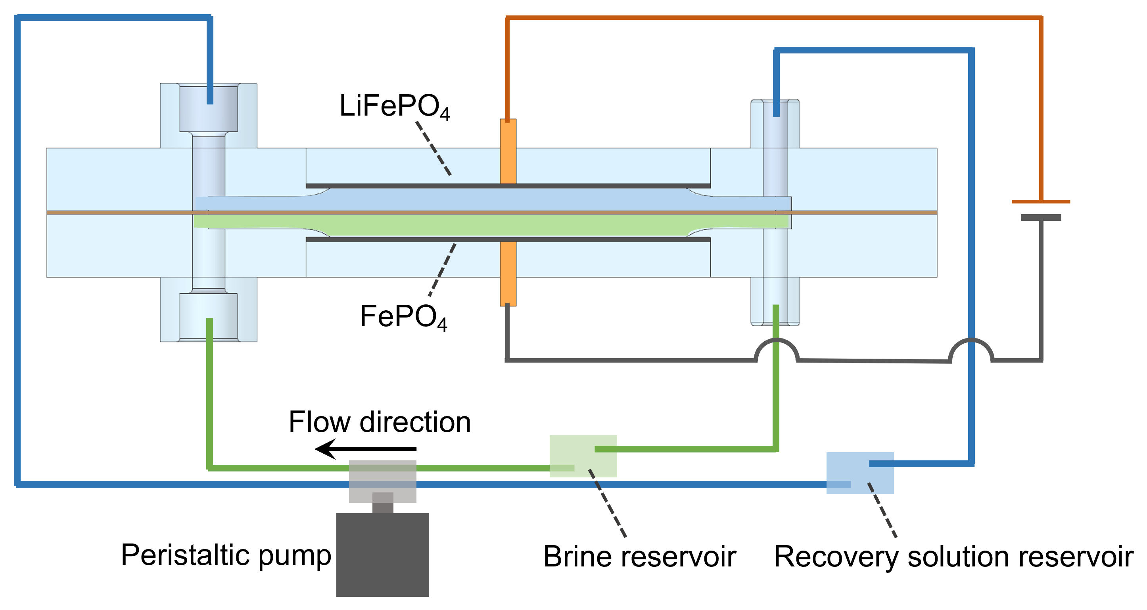
Supplementary Figure 1: Schematic of SMER during Li extraction.

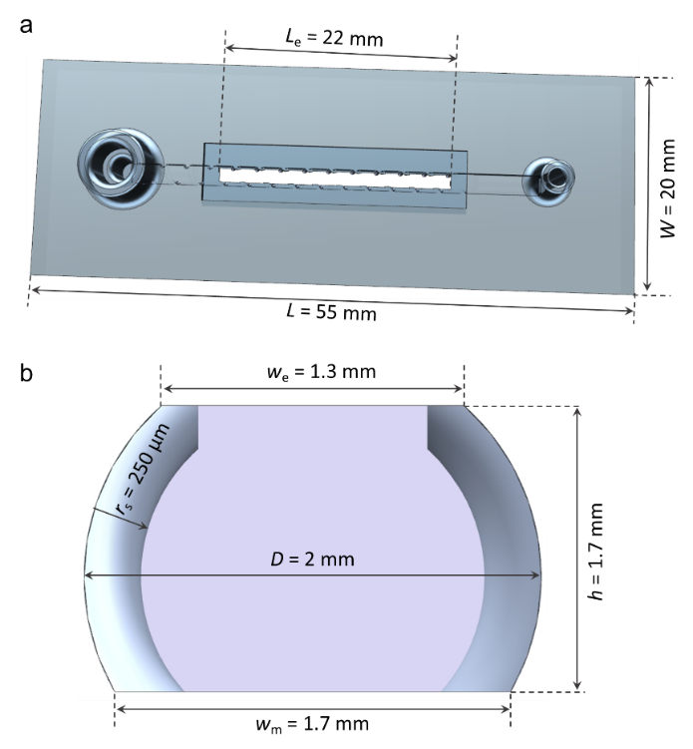
Supplementary Figure 2: (a) Geometry of the SMER design and (b) cross-sectional view of the flow channel with dimensions, where L and W denote the length and width of the reactor, respectively; D is the channel diameter; r_{s} is the spiral radius; L_{e} and w_{e} represent the length and width of the electrode, respectively; w_{m} is the membrane width; h is the channel height; and the pitch of the spiral is set to 2 mm.
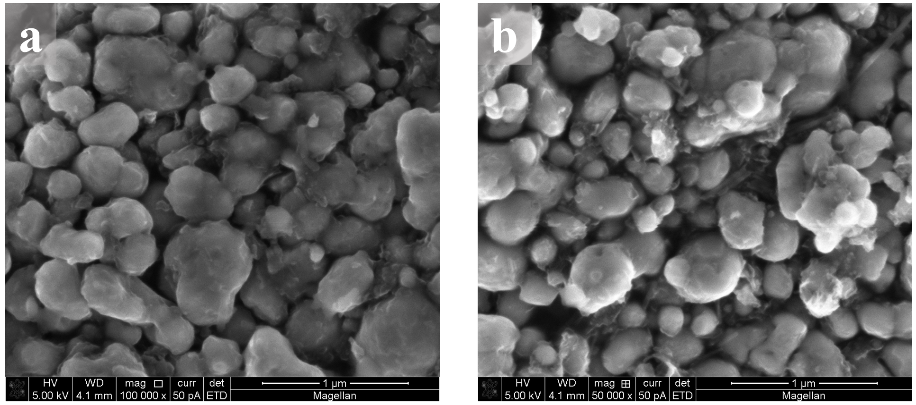
Supplementary Figure 3: SEM images of (a) LiFePO₄ and (b) FePO₄ electrodes. The as-prepared LiFePO₄ nanoparticles were irregularly shaped at diameters of 100 to 500 nm.

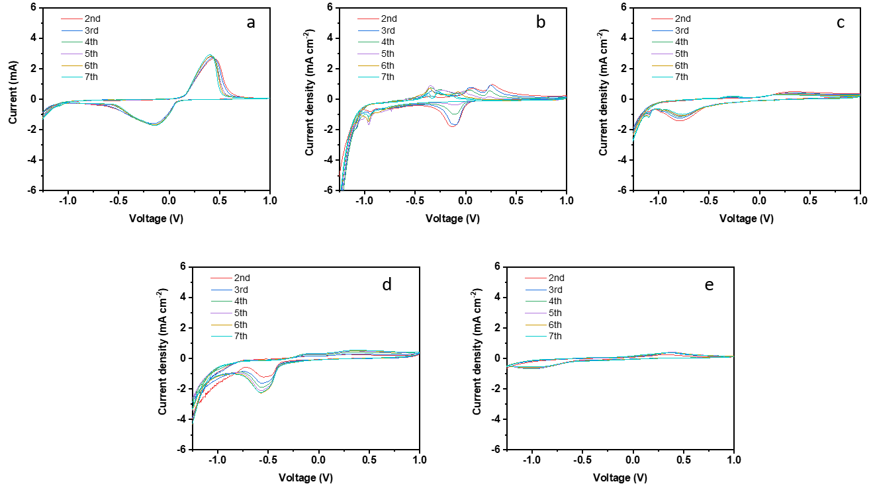
Supplementary Figure 4: CVs of FePO₄ electrodes in different solutions containing (a) 308 ppm of LiCl; (b) 56,329 ppm of NaCl; (c) 474 ppm of KCl; (d) 20,324 ppm of MgCl₂; and (e) 214 ppm of CaCl₂. The first cycle was excluded because the impurity peaks of temporary side reactions disturb CV profiles.⁸ The scan rate was 1 mV/s. A Pt plate was used as the counter electrode. The Ag/AgCl electrode (saturated KCl, Pine Research) was employed as the reference electrode.

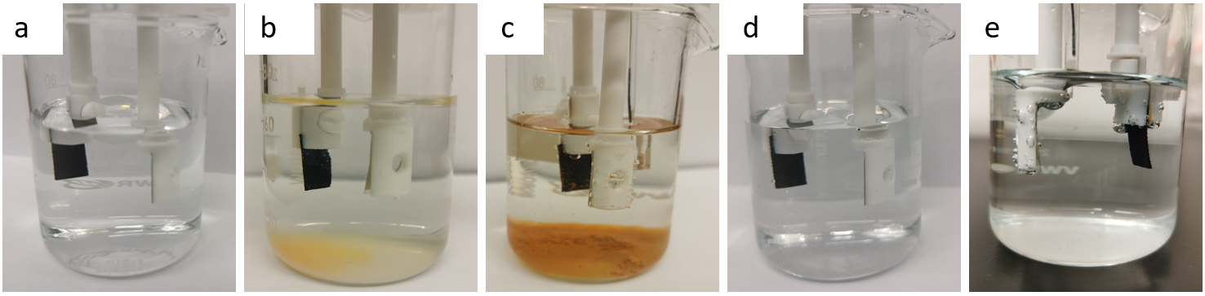
Supplementary Figure 5: Photographs of (a) LiCl, (b) NaCl, (c) KCl, (d) MgCl₂ and (e) CaCl₂ solutions after the CV tests on FePO₄ electrodes in Supplementary Figure 4.

Supplementary Figure 4a presents the redox peaks at 0.423 and -0.136 V vs. Ag/AgCl, corresponding to the intercalation/release of Li⁺ to/from the electrode. The intensity and position of the redox peaks remained the same after four cycles, indicating good stability and cyclic performance of FePO₄ in the LiCl solution. As a result, no precipitation was observed in the solution (Supplementary Figure 5a).

Supplementary Figure 4b demonstrates multiple redox peaks corresponding to the intercalation of Na⁺ as agreed by previous studies.⁸ The ionic radius of Na⁺ is 0.102 nm, larger than that of Li⁺ (0.076 nm).⁸ Intercalation of larger ions leads to the collapse of the FePO₄ lattice structure, resulting in the yellow precipitate of Fe³⁺ salt in Supplementary Figure 5b.

K⁺ (ionic radius = 0.138 nm) is larger than Na⁺;⁹ thus, the intercalation of K⁺ into FePO₄ is more difficult than that of Na⁺ and poses more serious damage to FePO₄. This finding is validated by the reduced intensity of the redox peaks (Supplementary Figure 4c) and the orange precipitate of Fe³⁺ salt (Supplementary Figure 5c).

In contrast, the radius of Mg²⁺ is 0.072 nm,¹⁰ slightly smaller than that of Li⁺. The intercalation of Mg²⁺ would not deteriorate the lattice structure of FePO₄ (Supplementary Figure 5d). However, due to its incompatible ionic charge, the intercalation of Mg²⁺ is harder than Li⁺, as reflected by the lower intensity of redox peaks in Supplementary Figure 4d.

Although the ionic radius of Ca²⁺ (0.100 nm)⁹ is similar than Na⁺, the ionic charge of Ca²⁺ is also incompatible with FePO₄. Based on Supplementary Figure 4e, the intercalation of Ca²⁺ seems to be impossible over the scanned voltage range, and FePO₄ was fully preserved after the CV test (Supplementary Figure 5e). Bubbles in Supplementary Figure 5e were gaseous hydrogen and oxygen from water electrolysis.

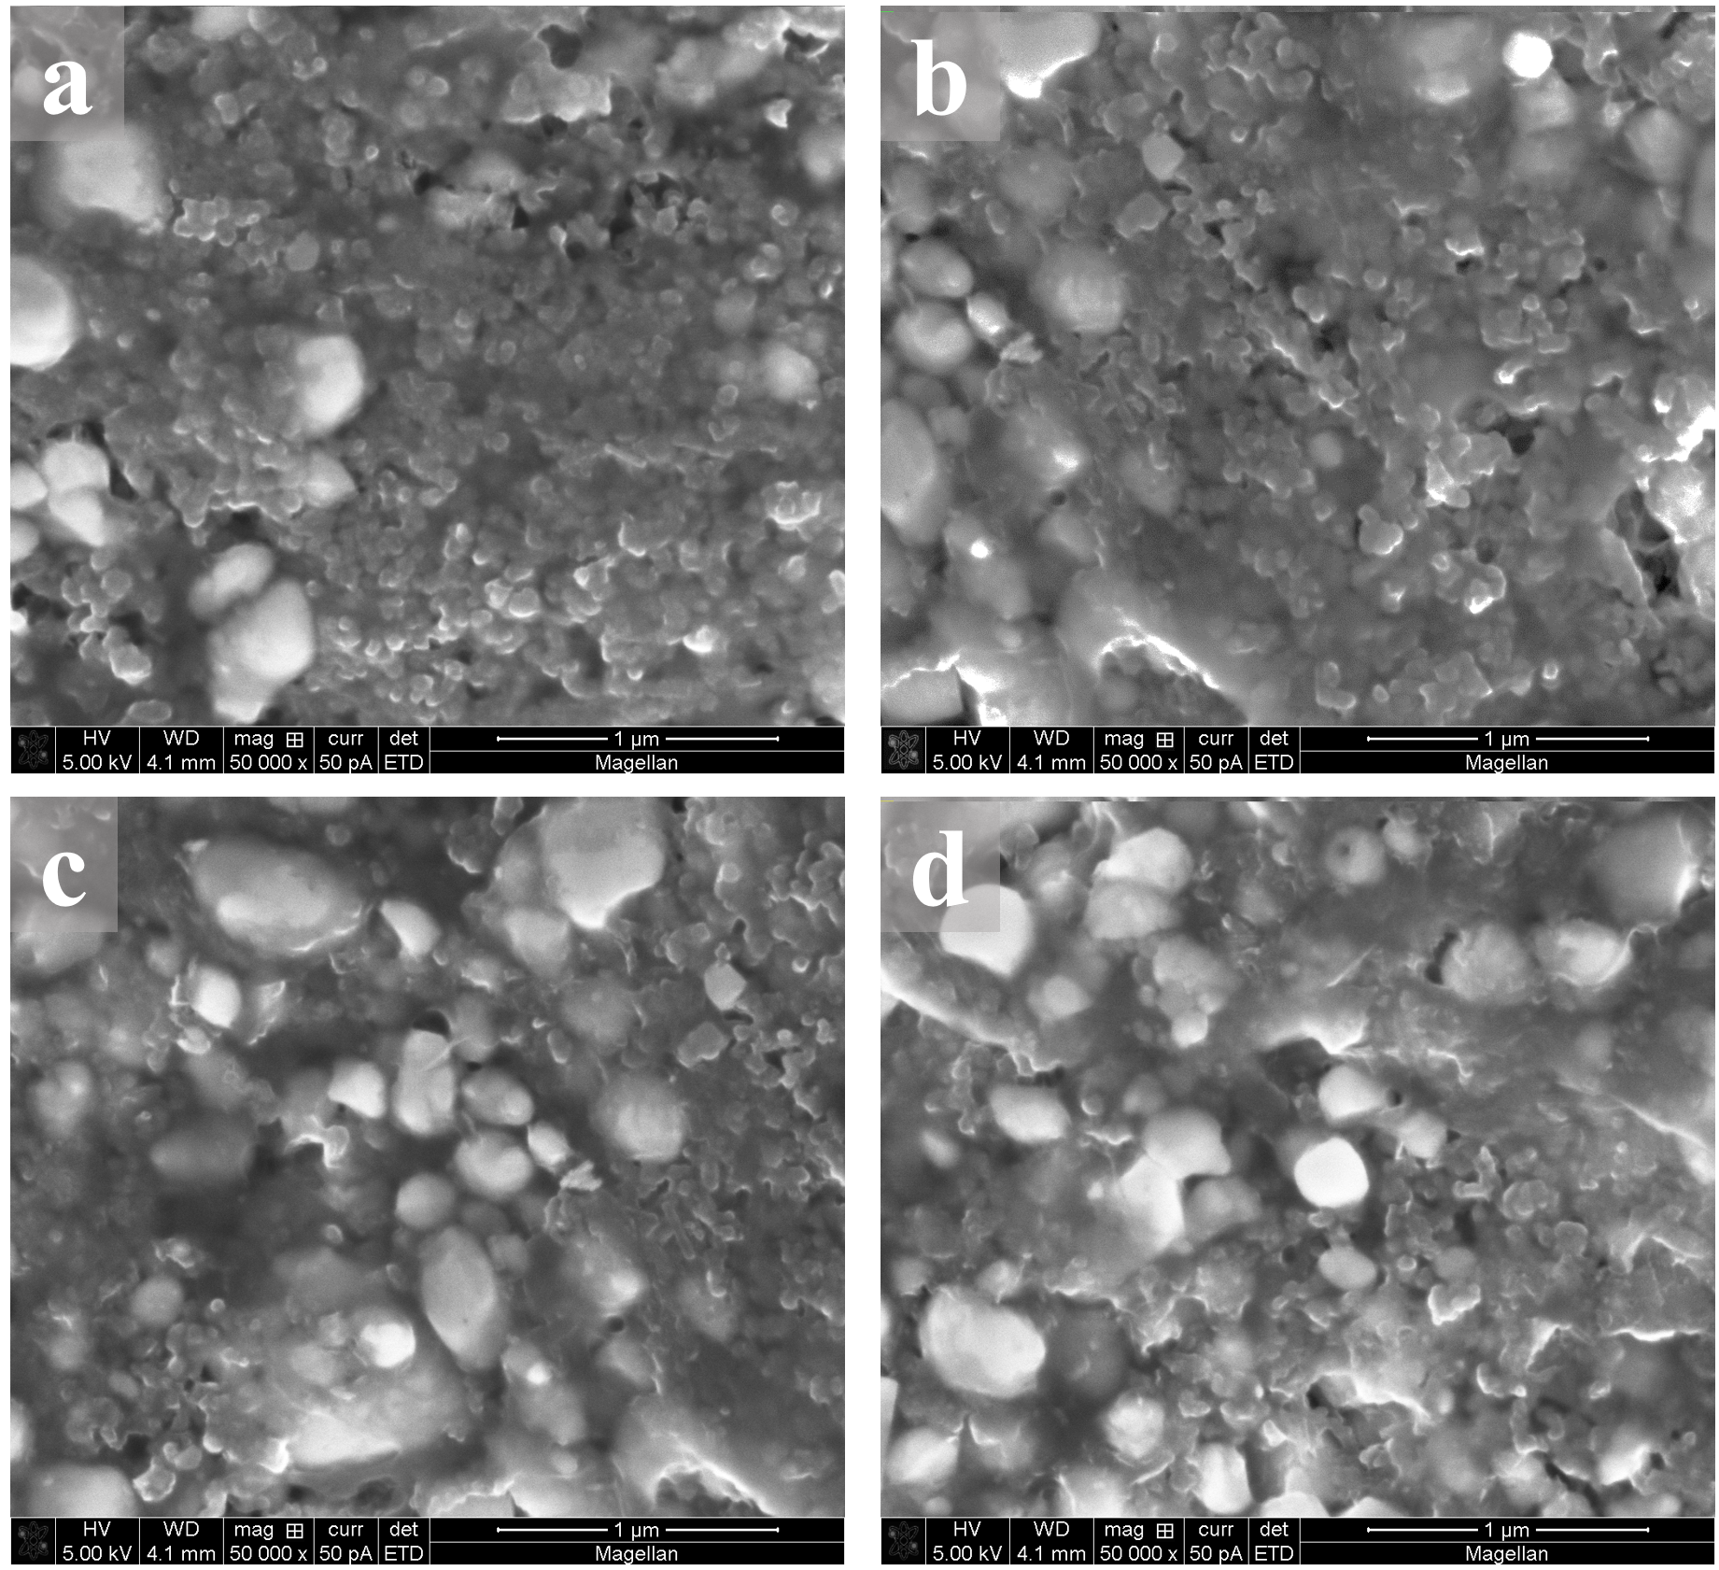
Supplementary Figure 6: SEM images of the LiFePO₄ electrode (a) before and (b) after eight cycles of operation and the FePO₄ electrode (c) before and (d) after eight cycles of operation. The LiFePO₄/FePO₄ electrodes had porous structures consisting of LiFePO₄/FePO₄ nanoparticles, carbon black particles and polymer binder (Supplementary Figures 3a, 3b, 6a, and 6c). These components adhered to each other, and the morphologies were well maintained after eight cycles of operation (Supplementary Figures 6b and 6d).

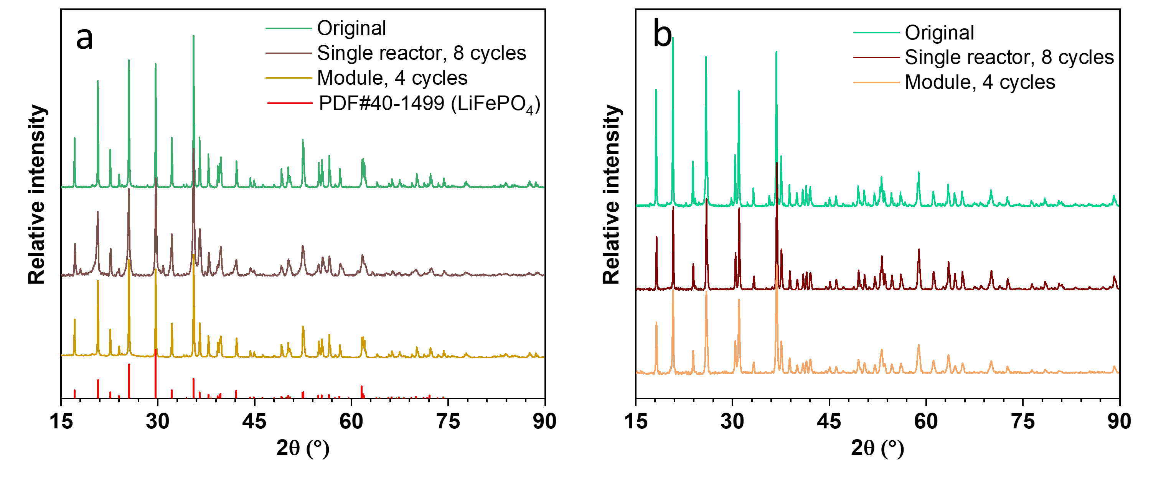
Supplementary Figure 7: XRD patterns of (a) LiFePO₄ and (b) FePO₄ electrodes before and after experiments in a single reactor and module. XRD patterns of the as-prepared LiFePO₄ electrode fitted well with the standard pattern of olivine LiFePO₄ (Crystalline PDF #40-1499), and these patterns were maintained after a series of experiments (Supplementary Figure 7a). The FePO₄ electrode was prepared from the de-lithiation of olivine LiFePO₄. The standard pattern of olivine FePO₄ is unavailable; however, the pattern of olivine FePO₄ in this study (Supplementary Figure 7b) fits well with that in the literature,¹¹ indicating the full de-lithiation of LiFePO₄. XRD patterns of FePO₄ were also maintained after a series of experiments.

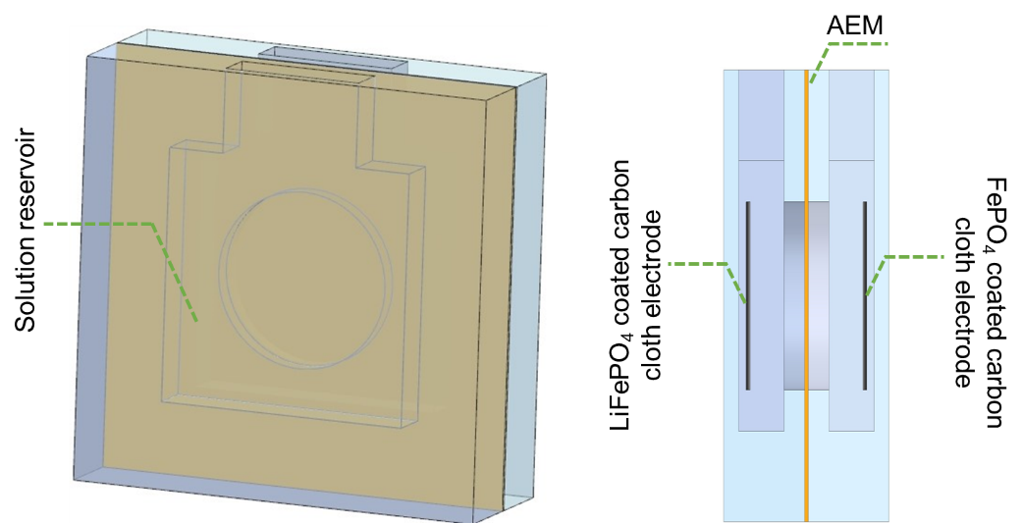
Supplementary Figure 8: Schematic of a traditional H-shape two-compartment reactor.

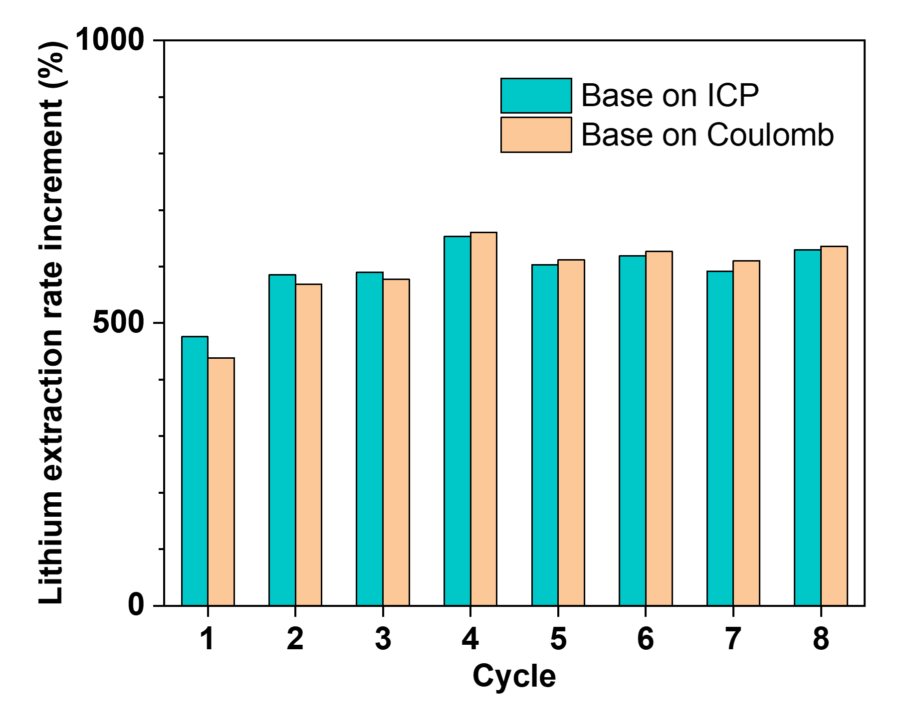
Supplementary Figure 9: Ratios of Li⁺ extraction rates in SMER to those in a traditional H-shape reactor based on ICP analyses and columbic calculations.

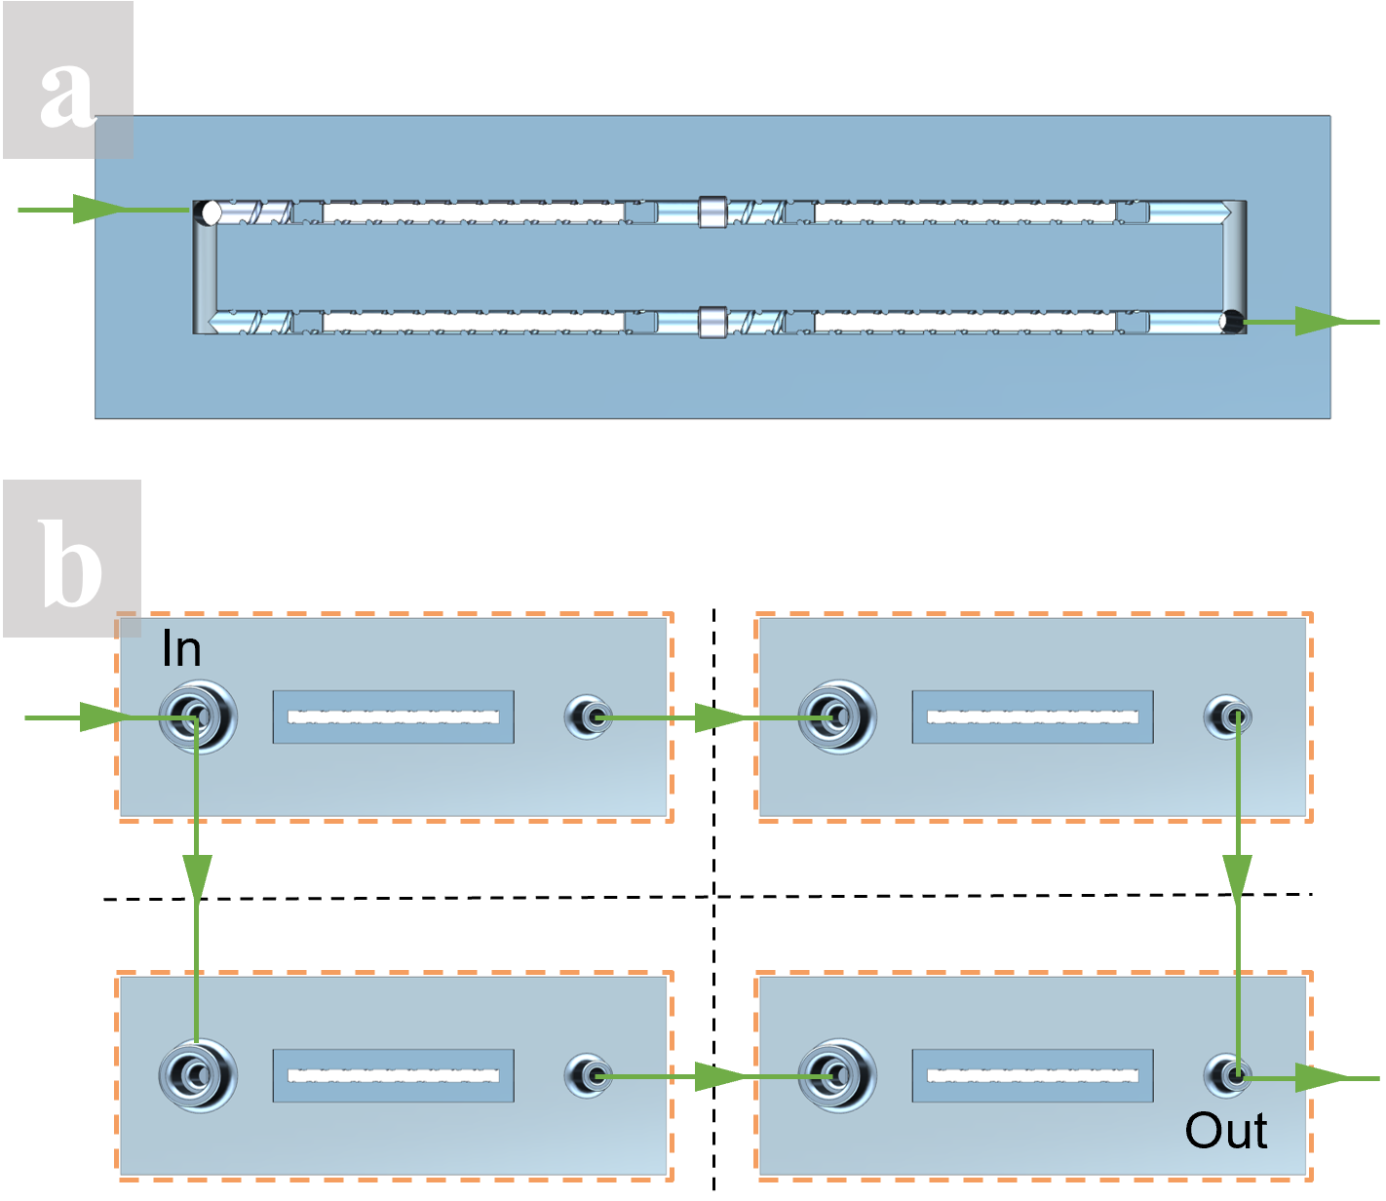
Supplementary Figure 10: (a) Integrated and (b) disassembled schematics for the SMER module consisting of four reactors in series and parallel.

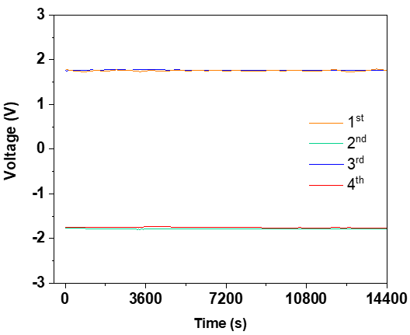
Supplementary Figure 11: Output voltage profiles of the perovskite/silicon tandem solar cell when operating the SMER module.

Financial Assumptions and Cost Analysis
The LCOP of the plant that operates the up-scaled SMER assembly was calculated using the carrying charge and the capital recovery factor by considering capital, operational, and financial costs. The LCOP reflects the net present cost of production for the plant over the project lifetime, which also equals the price at which the produced Li₂CO₃ should be sold to break even at the end of its lifetime.

The financial assumptions made in the calculation are listed in Supplementary Table 2. The plant was assumed to run at an annual capacity of 309 kg with a utilization rate of 90%. The plant lifetime was 10 years, which was the same for the depreciation and debt payback period. The project was financed with 30% debt at an after-tax cost of 2.4% and 70% equity at a real IRR of 8%. The straight-line depreciation method was used. The development and construction of the plant were completed in one year, and there would be no salvage value of the plant in the end. The inflation rate was set to 1.18%, and the tax rate was 20%, both based on the average value in the Kingdom of Saudi Arabia. The total capital cost includes 15% contingency, and the annual plant maintenance cost was assumed to be 10% of the capital expenditure. However, the sales and labor costs were not included in this analysis.

Figure 3h indicates that the CapEx of the plant only accounted for a small amount of the total cost, whereas the OPEX dominated. In particular, the electrode took 58.4% of the total cost, whereas the membrane ranked second at 13.7%. Reducing these costs can further lower the LCOP and enhance the cost-effectiveness of the project.
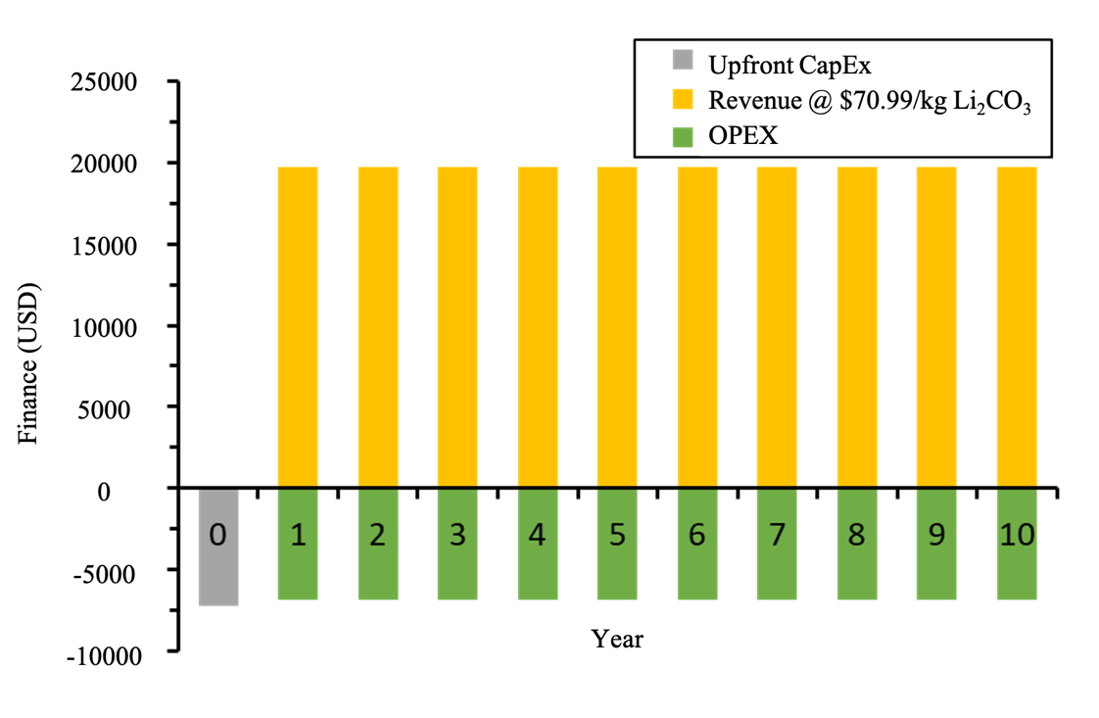
Supplementary Figure 12: Revenue and cost over the years of operation.

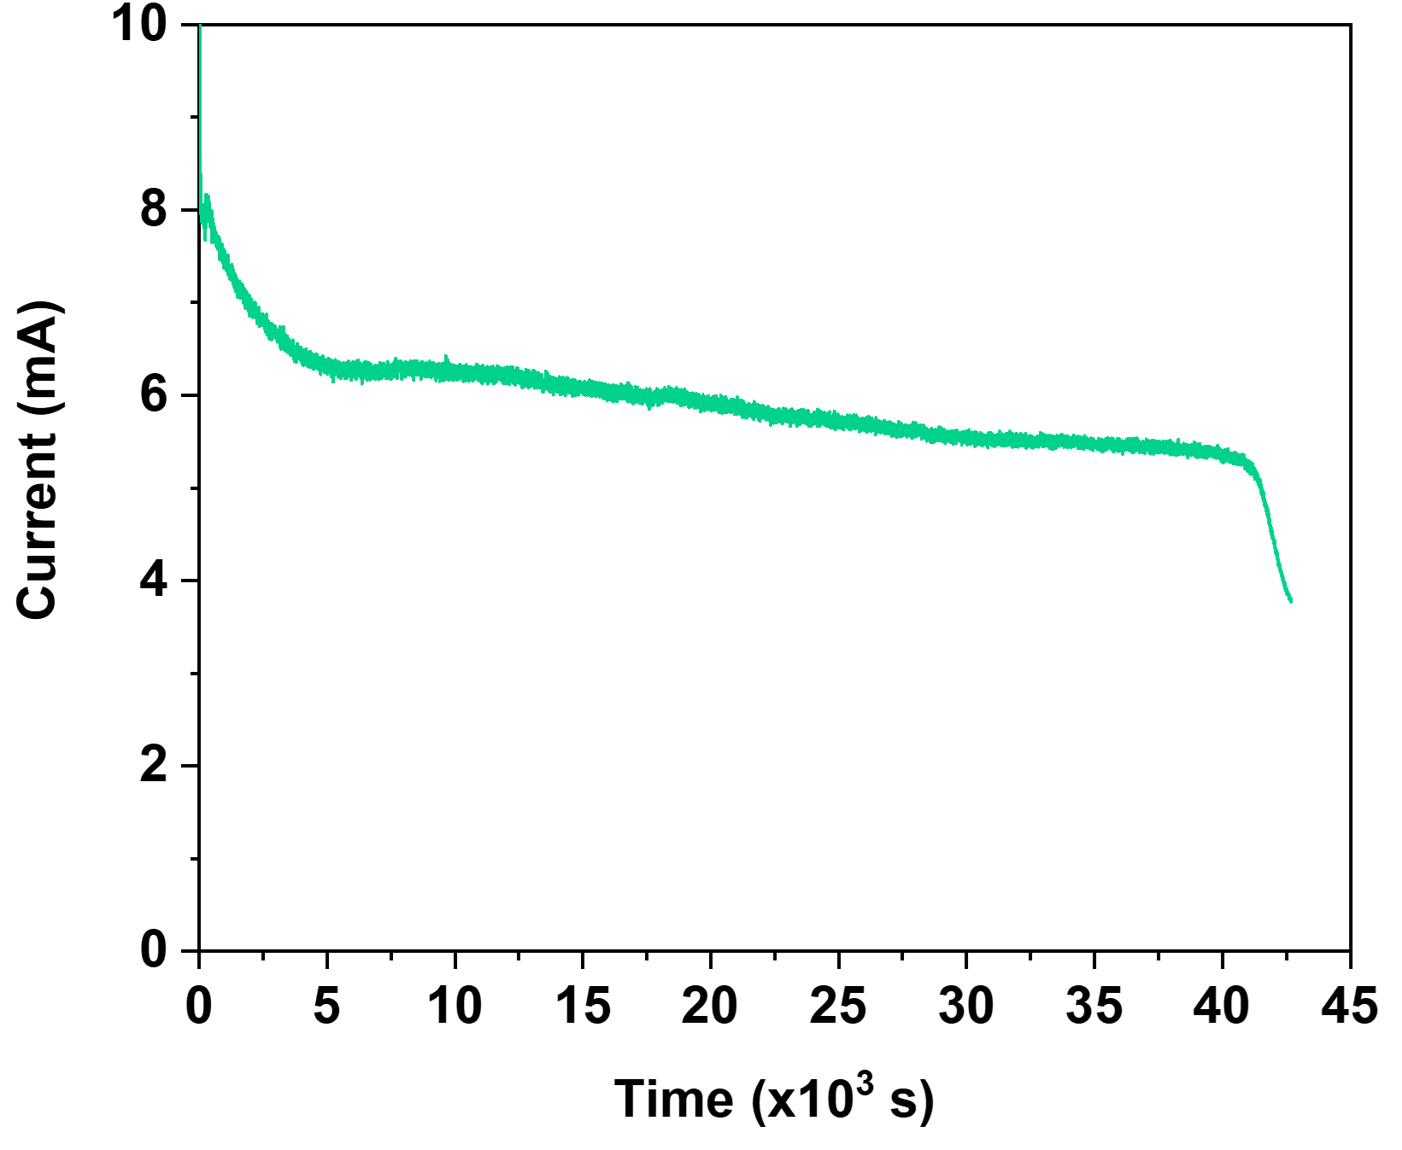
Supplementary Figure 13: Chronoamperograms for the electrochemical de-lithiation of LiFePO₄.

References
1 Li, X. et al. Taming wettability of lithium ion sieve via different TiO₂ precursors for effective Li recovery from aqueous lithium resources. Chem. Eng. J. 392, 123731 (2020).
2 Zandevakili, S., Ranjbar, M. & Ehteshamzadeh, M. Improvement of lithium adsorption capacity by optimising the parameters affecting synthesised ion sieves. Micro Nano Lett. 10, 58-63 (2015).
3 Lee, D.-H. et al. Selective lithium recovery from aqueous solution using a modified membrane capacitive deionization system. Hydrometallurgy 173, 283-288 (2017).
4 Zhao, Z., Si, X., Liu, X., He, L. & Liang, X. Li extraction from high Mg/Li ratio brine with LiFePO₄/FePO₄ as electrode materials. Hydrometallurgy 133, 75-83 (2013).
5 Pasta, M., Battistel, A. & La Mantia, F. Batteries for lithium recovery from brines. Energy Environ. Sci. 5, 9487-9491 (2012).
6 Lawagon, C. P. et al. Li_{1−x}Ni_{0.33}Co_{1/3}Mn_{1/3}O₂/Ag for electrochemical lithium recovery from brine. Chem. Eng. J. 348, 1000-1011 (2018).
7 Xu, W., He, L. & Zhao, Z. Lithium extraction from high Mg/Li brine via electrochemical intercalation/de-intercalation system using LiMn₂O₄ materials. Desalination 503, 114935 (2021).
8 Liu, X., Chen, X., Zhao, Z. & Liang, X. Effect of Na⁺ on Li extraction from brine using LiFePO₄/FePO₄ electrodes. Hydrometallurgy 146, 24-28 (2014).
9 Li, X. et al. Synthesis and luminescent properties of CaMoO₄: Tb³⁺, R⁺ (Li⁺, Na⁺, K⁺). Journal of alloys and compounds 478, 684-686 (2009).
10 Ying, J., Luo, M., Jin, Y. & Yu, J. Selective separation of lithium from high Mg/Li ratio brine using single-stage and multi-stage selective electrodialysis processes. Desalination 492, 114621 (2020).
11 Xiong, J., He, L., Liu, D., Xu, W. & Zhao, Z. Olivine-FePO₄ preparation for lithium extraction from brines via electrochemical de-intercalation/intercalation method. Desalination 520, 115326 (2021).

