Supplemental Material
Total discharge volume to shark river slough (SRS) and Taylor Slough and Coastal Basins (TSCB) is estimated as the total discharge volume from several water control structures discharging to each respective drainage within the freshwater Everglades. The terms in the equations below are daily discharge from water control structures specific to each drainage (Fig. 6). Discharge to SRS is estimated using equation S1 accounts for water from Water Conservation Area 3 (to the north) minus water returning from seepage and water moving east.
$$Q_{SRS}=S12s+\left[S333s+S355s+minimum \left(S356,S335\right)-S334\right]$$ | Eq S1

Discharge to TSCB is estimated using equation S2 where discharges are estimates entering Taylor Slough and the Coastal Basins accounting for infrastructure changes as part of restoration and water management operations.
Pre Oct 1999 | $$Q_{TSCB}=S332+S175+S18C$$ | Eq S2
Post Oct 1999 | $$Q_{TSCB}=\left[S332D-S332DX1-S328\right]+S328+G737+S18C$$ | Eq S2

Table S1. Monitoring location with latitude, longitude, and region. Latitude and longitude are in meters spatial coordinate system is North American Datum 1983 Universal Transverse Mercator Zone 17 (NAD83 UTM Zone 17).
Provided as csv file – Sites_TableS1.csv

Table S2. Kendall trend and Thiel Sen results for each monitoring location and parameter
Provide as csv file - TrendRslt_TableS2.csv
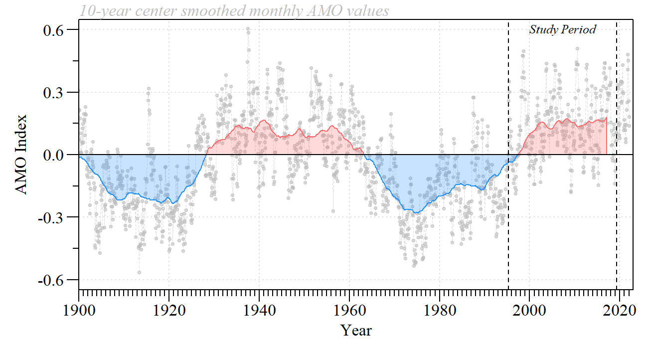
Figure S1. Monthly and smoothed Atlantic Multidecadal Oscillation (AMO) index with current study period identified. Data source: https://psl.noaa.gov/data/timeseries/AMO/; see Enfield et al. (2001) for more detail.
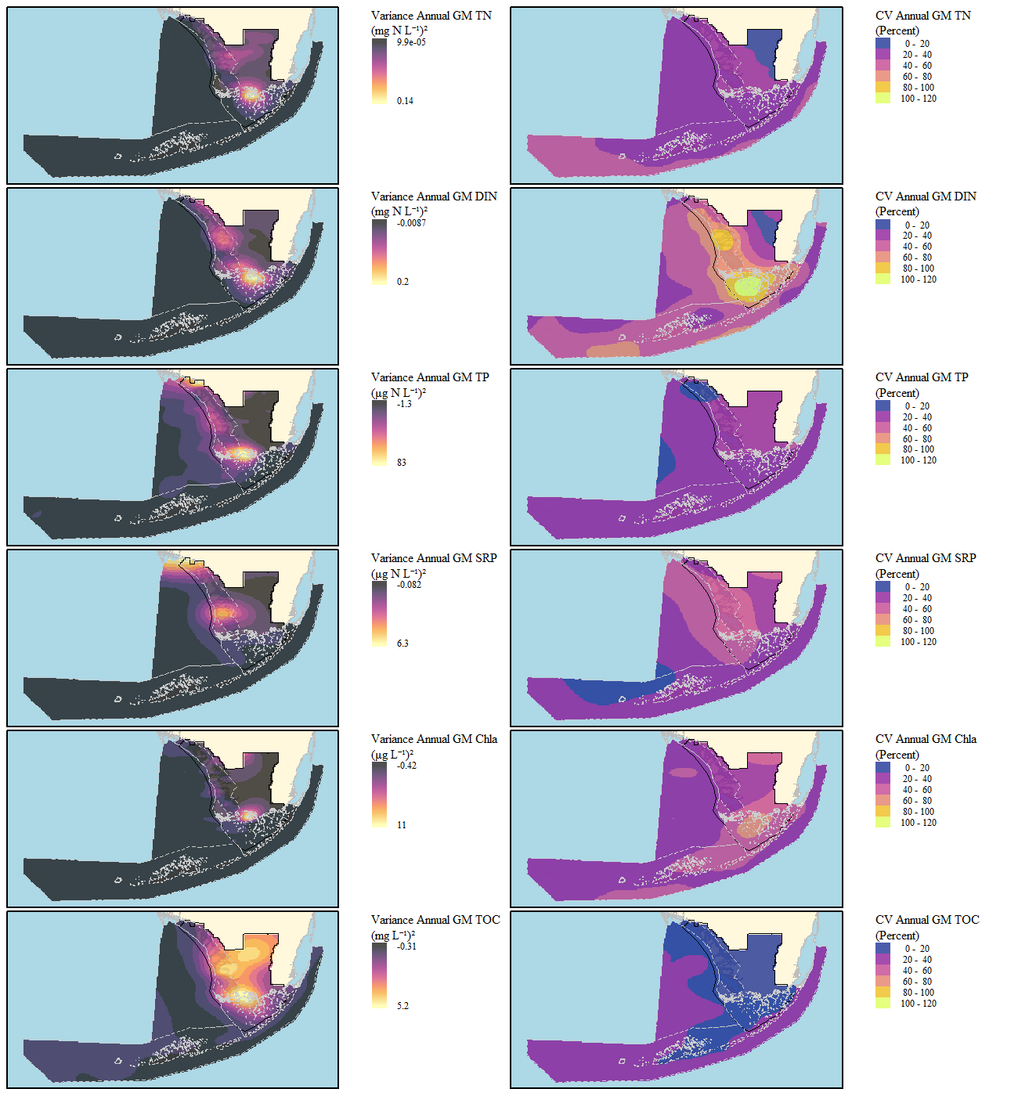
Fig S2. Variance (left) and coefficient of variation (right) of annual geometric mean concentrations for geometric mean total nitrogen (TN), dissolved inorganic nutrient (DIN), total phosphorus (TP), soluble reactive phosphorus (SRP),chlorophyll-a (Chl-a), and total organic carbon (TOC) concentrations at individual stations across the Everglades-Florida Bay-West Florida Shelf-Keys ecosystem during the period of record

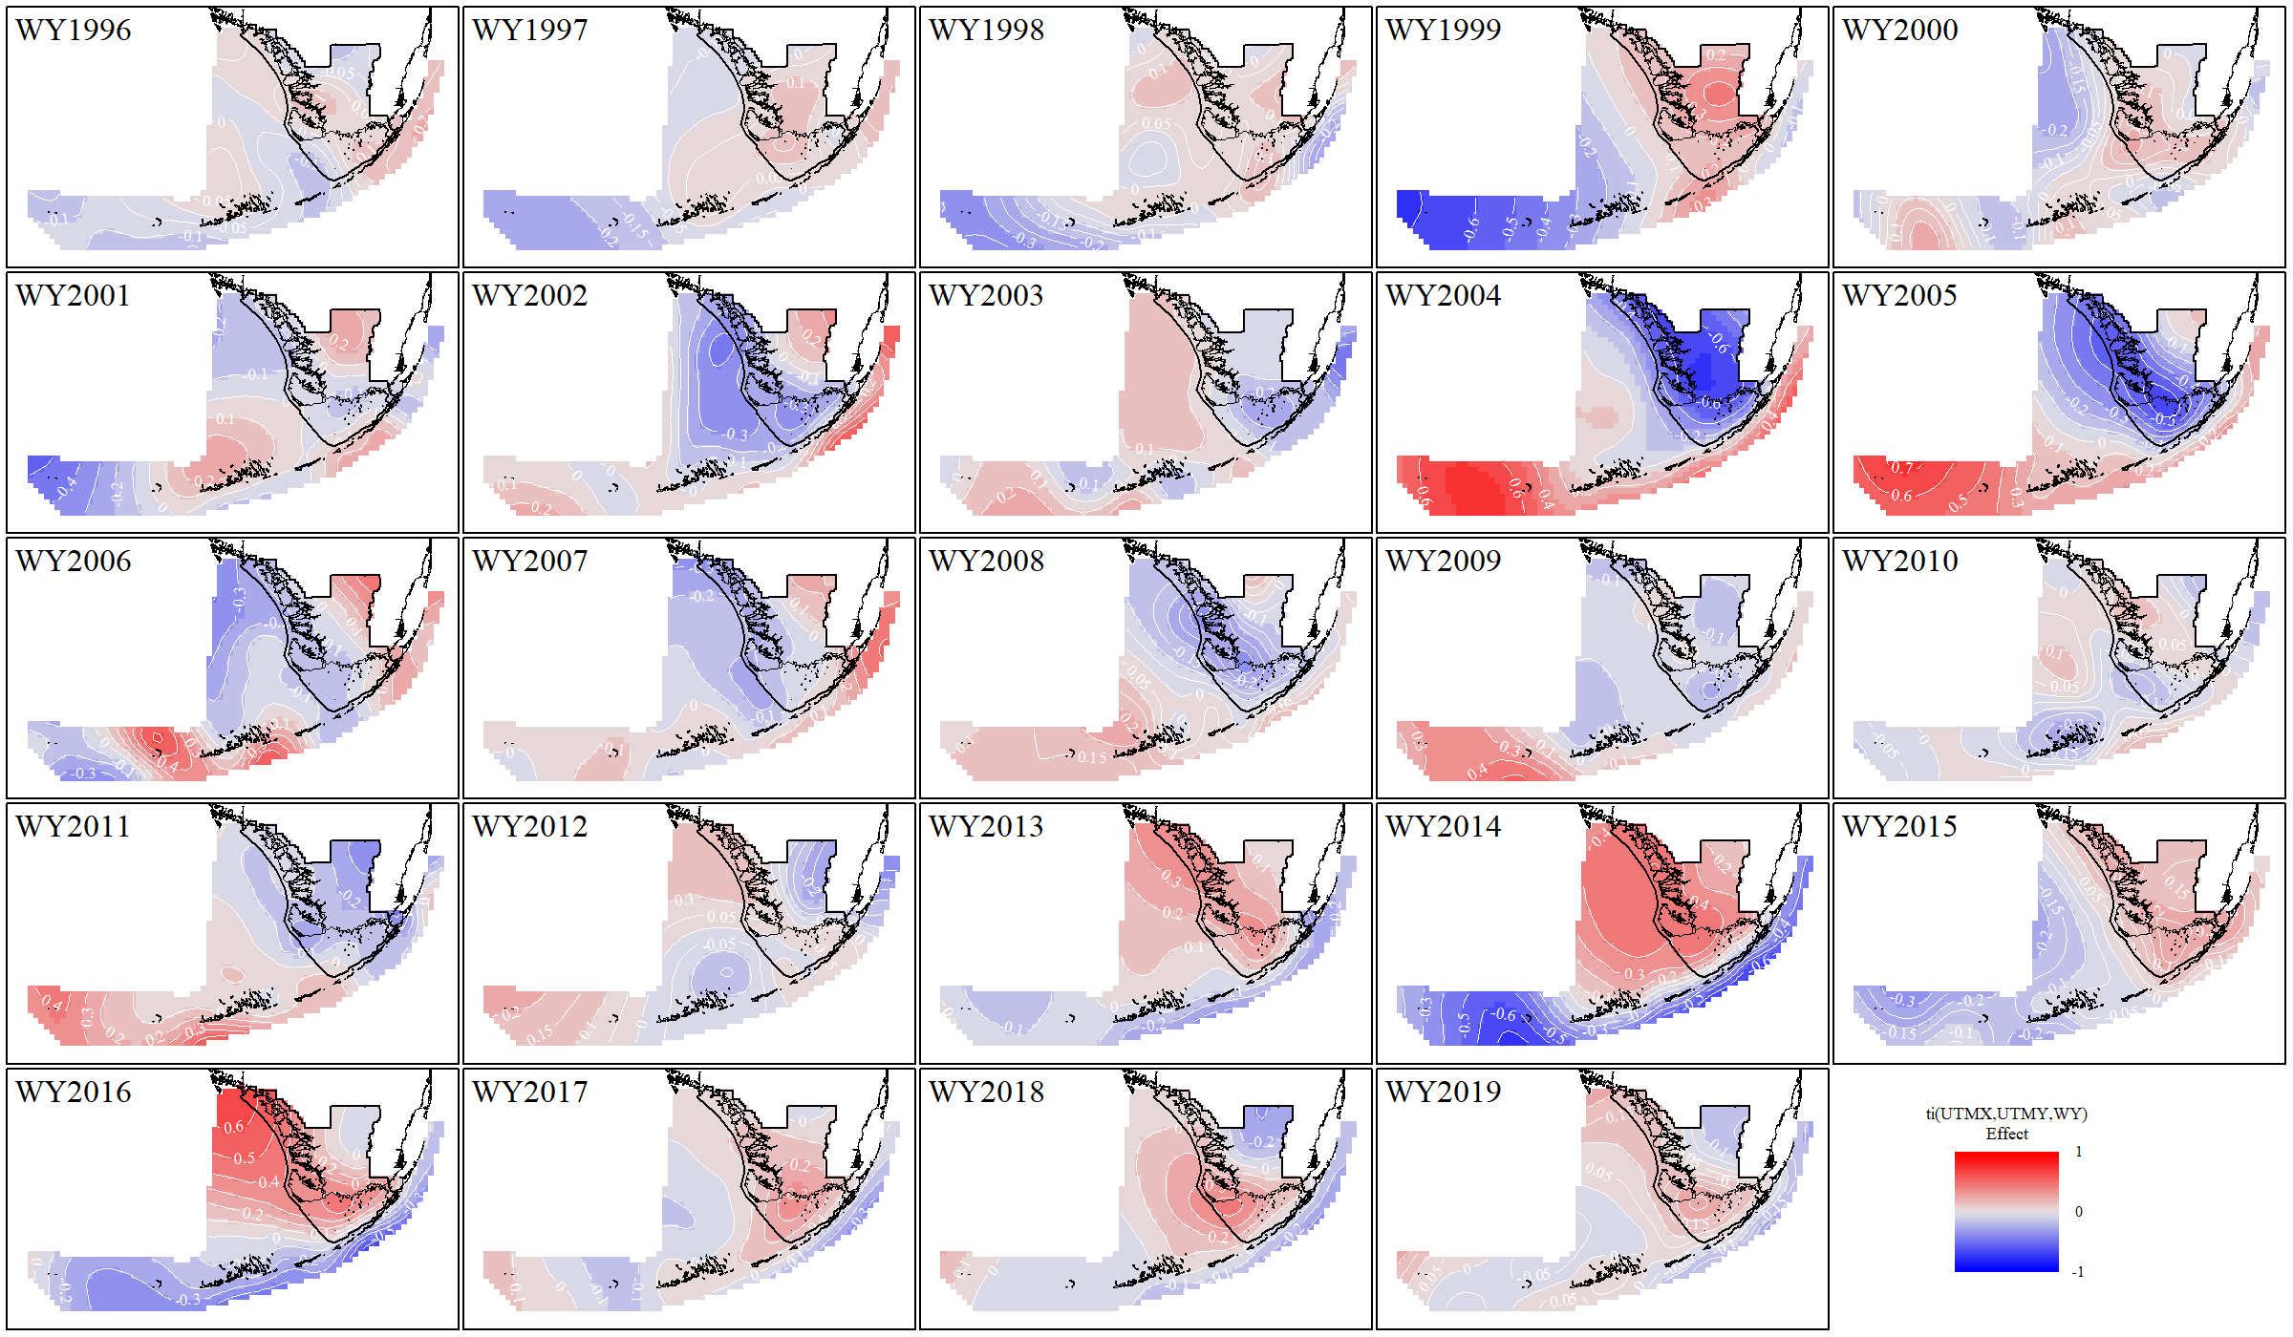
Fig S3. Total nitrogen spatial and temporal generalized additive model location and time interaction effect for all water years.

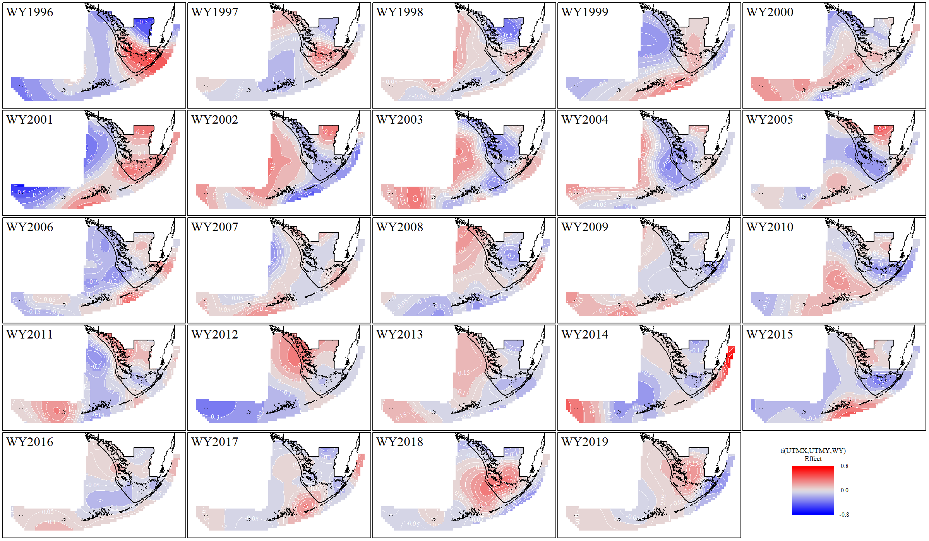
Fig S4. Total phosphorus spatial and temporal generalized additive model location and time interaction effect for all water years.

