Supplementary Information: Anterior Cingulate Glutamatergic Metabolites as a Predictor of Antipsychotic Response in First Episode Psychosis.

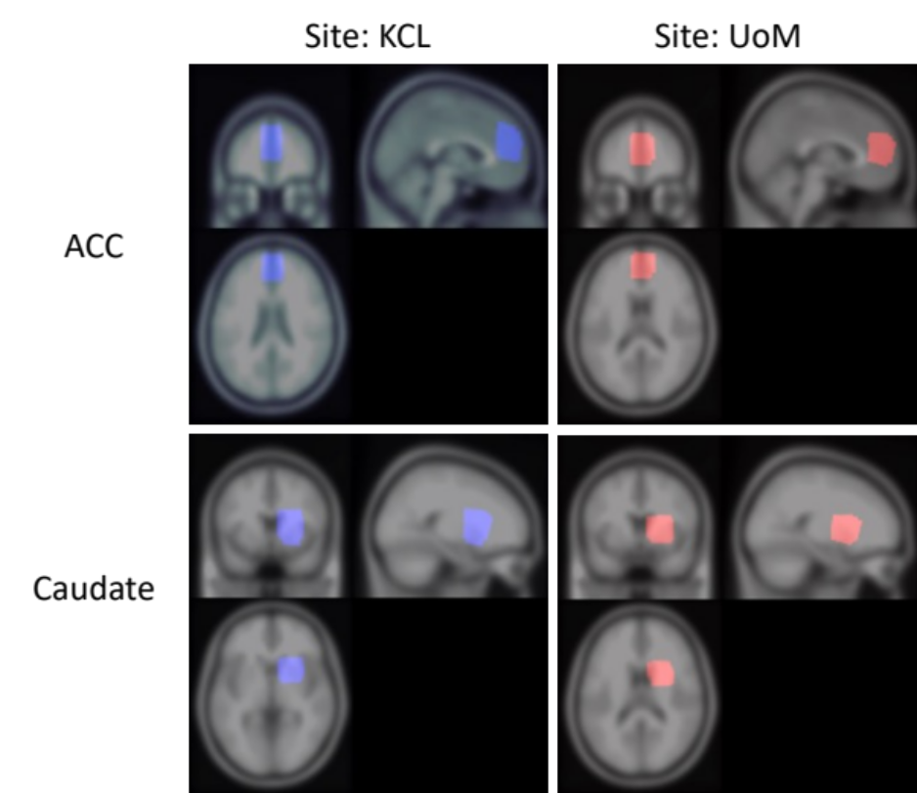

Supplement Figure 1. Images showing ¹H-MRS voxel placement in the anterior cingulate cortex (ACC, top row) and right caudate (bottom row), at the King’s College London (KCL, left) and University of Manchester (UoM, right) sites. The images show overlaid voxels (each 20 x 20 x 20 mm³) from study participants at baseline.

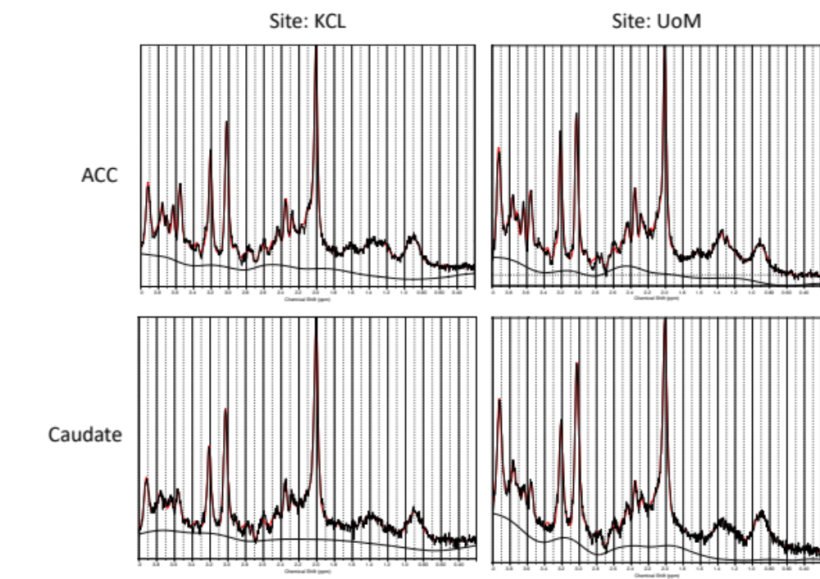
Supplement Figure 2. Example ¹H-MRS spectra in the anterior cingulate cortex (ACC, top row) and right caudate (bottom row), at the King’s College London (KCL, left) and University of Manchester (UoM, right) sites. The figures show LCModel output of the fit in red, overlaid on the acquired spectrum (black). The estimated baseline is shown underneath in black.

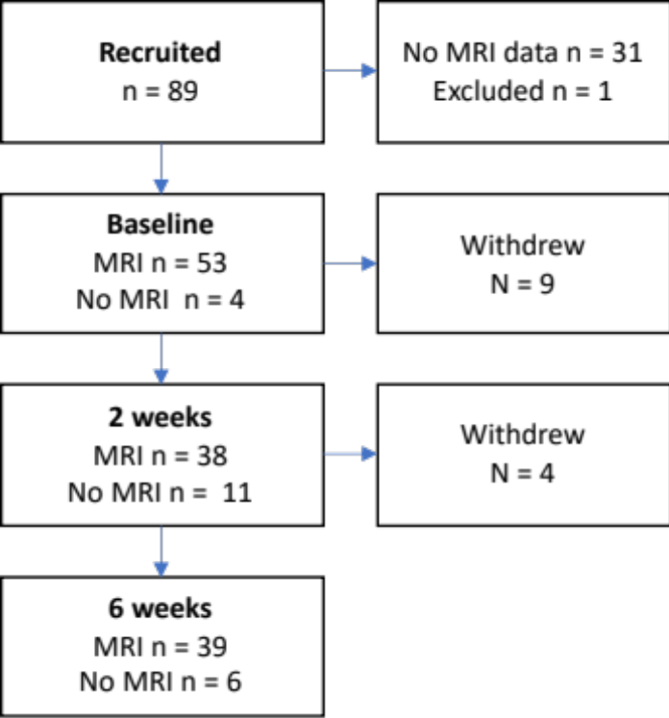

Supplement Figure 3. Participant flow though the study.

Site (Name or Number) | King’s College London | University of Manchester
1. Hardware
a. Field strength [T] | 3 T | 3 T
b. Manufacturer | General Electric | Philips Achieva TX
c. Model (software version if available) | MR750
d. RF coils: nuclei (transmit/ receive), number of channels, type, body part | C-GE HNS | Sense 32 Channel Headcoil
e. Additional hardware | None | None
2. Acquisition
a. Pulse sequence | PRESS | PRESS
b. Volume of Interest (VOI) locations | Anterior cingulate cortex  Right Caudate  (Supplement Fig 1) | Anterior cingulate cortex  Right Caudate  (Supplement Fig 1)
c. Nominal VOI size [cm³, mm³] | 20 x 20 x 20mm | 20 x 20 x 20mm
d. Repetition Time (TR), Echo Time (TE) [ms, s] | TR = 2000ms;  TE = 35ms | TR = 2000ms;  TE = 35ms
e. Total number of Excitations or acquisitions per spectrum  In time series for kinetic studies  - Number of Averaged spectra (NA) per time-point  - Averaging method (e.g. block-wise or moving average)  - Total number of spectra (acquired / in time-series) | 128 averages | 128 averages
f. Additional sequence parameters  (spectral width in Hz, number of spectral points, frequency offsets)  If STEAM:, Mixing Time (TM)  If MRSI: 2D or 3D, FOV in all directions, matrix size, acceleration factors, sampling method | 5000 Hz; 4096 complex points. | 5000 Hz; 4096 complex points.
g. Water Suppression Method | CHESS | Excitation, window = 140 Hz
h. Shimming Method, reference peak, and thresholds for “acceptance of shim” chosen | Automated B0 field mapping | Automated B0 field mapping
i. Triggering or motion correction method  (respiratory, peripheral, cardiac triggering, incl. device used and delays) | None | None
3. Data analysis methods and outputs
a. Analysis software | LCModel version 6.3-1M | LCModel version 6.3-1M
b. Processing steps deviating from quoted reference or product | None | None
c. Output measure  (e.g. absolute concentration, institutional units, ratio) Processing steps deviating from quoted reference or product | Metabolite concentration in institutional units, corrected for voxel tissue fractions | Metabolite concentration in institutional units, corrected for voxel tissue fractions
d. Quantification references and assumptions, fitting model assumptions | LCModel basis set  3t_press_te35_01a | LCModel basis set  3t_press_te35_01a
4. Data Quality
a. Reported variables  (SNR, Linewidth (with reference peaks)) | SNR and Linewidth, Supplement Table 3 | SNR and Linewidth, Supplement Table 3
b. Data exclusion criteria | Linewidth > 2 standard deviations above mean; SNR < 2 standard deviations below mean; metabolite CRLB > 20% | Absence of corresponding unsuppressed water acquisition; Linewidth > 2 standard deviations above mean; SNR < 2 standard deviations below mean; metabolite CRLB > 20%
c. Quality measures of postprocessing Model fitting (e.g. CRLB, goodness of fit, SD of residual) | CRLB, Supplement Table 3 | CRLB, Supplement Table 3
d. Sample Spectrum | Supplement Figure 2 | Supplement Figure 2

 | Baseline | 2 weeks | 6 weeks
Anterior cingulate cortex
Sample size total  KCL  UoM | 53  37  16 | 38  25  13 | 39  23  16
Glu_{corr}  KCL  UoM | 22.28 ± 2.82  13.61 ± 1.08 | 21.37 ± 2.48  13.75 ± 1.02 | 22.06 ± 2.95  13.70 ± 1.33
Glx_{corr}  KCL  UoM | 29.59 ± 3.22  18.73 ± 2.04 | 28.74 ± 3.86  18.55 ± 1.88 | 28.78 ± 4.22  18.85 ± 1.52
NAA_{corr}  KCL  UoM | 18.50 ± 1.81  11.52 ± 0.66 | 18.16 ± 3.56  11.15 ± 0.75 | 18.94 ± 3.56  10.88 ± 0.62
Cho_{corr}  KCL  UoM | 3.84 ± 0.62  2.22 ± 0.36 | 3.71 ± 0.66  2.36 ± 0.32 | 4.90 ± 5.86  2.34 ± 0.28
MI_{corr}  KCL  UoM | 11.11 ± 2.01  7.06 ± 0.86 | 10.54 ± 1.65  7.02 ± 0.73 | 11.08 ± 2.26  6.98 ± 0.73
Cr_{corr}  KCL  UoM | 13.64 ± 1.79  9.51 ± 0.66 | 13.31 ± 1.61  9.56 ± 0.86 | 13.54 ± 1.73  9.50 ± 0.94
Right Caudate
Sample size total  KCL  UoM | 45  29  16 | 36  23  13 | 36  21  15
Glu_{corr}  KCL  UoM | 11.31 ± 1.48  8.58 ± 0.87 | 11.10 ± 1.47  8.71 ± 1.23 | 11.38 ± 1.86  8.53 ± 0.99
Glx_{corr}  KCL  UoM | 15.60 ± 2.66  12.70 ± 1.32 | 15.04 ± 2.05  13.10 ± 2.36 | 15.11 ± 2.81  12.81 ± 1.69
NAA_{corr}  KCL  UoM | 11.35 ± 1.24  7.78 ± 0.57 | 11.55 ± 0.98  7.74 ± 0.40 | 11.34 ± 0.80  7.89 ± 0.36
Cho_{corr}  KCL  UoM | 2.50 ± 1.48  1.77 ± 0.28 | 2.31 ± 0.28  1.80 ± 0.23 | 2.58 ± 1.48  1.81 ± 0.19
MI_{corr}  KCL  UoM | 4.40 ± 0.84  3.32 ± 0.85 | 4.25 ± 0.73  3.50 ± 0.66 | 4.07 ± 0.68  3.54 ± 0.36
Cr_{corr}  KCL  UoM | 8.75 ± 1.01  7.60 ± 0.75 | 8.78 ± 0.68  7.23 ± 1.24 | 8.70 ± 0.93  7.71 ± 0.66
Supplementary Table 2: ¹H-MRS data at each timepoint by study site. All values are corrected for voxel tissue content (Mcorr). Data are expressed as mean ± standard deviation. Glu: glutamate; Glx: glutamate plus glutamine; NAA: N-acetylaspartate plus N-acetylaspartylglutamate; MI: myo-inositol; Cho: choline; Cr: creatine.

 | Baseline | 2 weeks | 6 weeks
Anterior cingulate cortex
Linewidth  KCL  UoM | 0.04 ± 0.01  0.03 ± 0.01 | 0.04 ± 0.01  0.04 ± 0.01 | 0.04 ± 0.01  0.03 ± 0.01
SNR  KCL  UoM | 28 ± 3  29 ± 2 | 27 ± 3  28 ± 2 | 28 ± 3  29 ± 3
Grey matter  KCL  UoM | 0.61 ± 0.07  0.69 ± 0.04 | 0.61 ± 0.05  0.68 ± 0.04 | 0.61 ± 0.06  0.68 ± 0.05
White matter  KCL  UoM | 0.07 ± 0.02  0.08 ± 0.04 | 0.70 ± 0.02  0.09 ± 0.04 | 0.07 ± 0.02  0.10 ± 0.03
CSF  KCL  UoM | 0.32 ± 0.60  0.23 ± 0.03 | 0.33 ± 0.05  0.23 ± 0.03 | 0.32 ± 0.06  0.22 ± 0.05
Glu CRLB  KCL  UoM | 5 ± 1  5 ± 1 | 6 ± 1  5 ± 1 | 5 ± 1  5 ± 1
Glx CRLB  KCL  UoM | 6 ± 1  5 ± 1 | 6 ± 1  5 ± 1 | 6 ± 1  5 ± 1
NAA CRLB  KCL  UoM | 2 ± 1  2 ± 0 | 3 ± 1  3 ± 1 | 3 ± 1  2 ± 0
Cho CRLB  KCL  UoM | 3 ± 0  3 ± 1 | 3 ± 1  3 ± 1 | 3 ± 1  3 ± 0
MI CRLB  KCL  UoM | 5 ± 1  4 ± 1 | 5 ± 1  4 ± 1 | 5 ± 1  4 ± 1
Cr CRLB  KCL  UoM | 2 ± 0  2 ± 0 | 2 ± 0  2 ± 1 | 2 ± 0  2 ± 0
Right Caudate
Linewidth  KCL  UoM | 0.06 ± 0.01  0.06 ± 0.03 | 0.06 ± 0.01  0.05 ± 0.01 | 0.06 ± 0.01  0.05 ± 0.01
SNR  KCL  UoM | 21 ± 4  21 ± 4 | 21 ± 3  21 ± 4 | 21 ± 3  21 ± 3
Grey matter  KCL  UoM | 0.51 ± 0.06  0.55 ± 0.05 | 0.50 ± 0.05  0.45 ± 0.07 | 0.52 ± 0.05  0.53 ± 0.06
White matter  KCL  UoM | 0.47 ± 0.05  0.41 ± 0.07 | 0.48 ± 0.05  0.45 ± 0.07 | 0.47 ± 0.05  0.44 ± 0.06
CSF  KCL  UoM | 0.02 ± 0.02  0.03 ± 0.05 | 0.02 ± 0.02  0.03 ± 0.05 | 0.02 ± 0.02  0.03 ± 0.04
Glu CRLB  KCL  UoM | 7 ± 1  7 ± 1 | 7 ± 1  6 ± 1 | 7 ± 2  6 ± 2
Glx CRLB  KCL  UoM | 8 ± 2  8 ± 2 | 9 ± 2  7 ± 2 | 9 ± 2  7 ± 1
NAA CRLB  KCL  UoM | 3 ± 1  3 ± 1 | 3 ± 1  3 ± 1 | 3 ± 1  3 ± 1
Cho CRLB  KCL  UoM | 4 ± 1  3 ± 1 | 3 ± 1  3 ± 0 | 3 ± 1  3 ± 0
MI CRLB  KCL  UoM | 8 ± 2  8 ± 3 | 8 ± 2  7 ± 2 | 9 ± 2  6 ± 2
Cr CRLB  KCL  UoM | 3 ± 1  2 ± 0 | 3 ± 1  2 ± 0 | 3 ± 1  2± 0
Supplementary Table 3: ¹H-MRS data quality measures at each timepoint by study site.
Data are expressed as mean ± standard deviation. FWHM: full width at half maximum linewidth (ppm); SNR: signal to noise ratio; Grey matter: voxel grey matter fraction; White matter: voxel white matter fraction; CSF: voxel cerebrospinal fluid fraction; CRLB: Cramer Rao Lower Bounds (%); Glu: glutamate; Glx: glutamate plus glutamine; NAA: N-acetylaspartate plus N-acetylaspartylglutamate; MI: myo-inositol; Cho: choline; Cr: creatine.

 |  | Baseline | 2 weeks | 6 weeks | Time | Response | Response x Time
ACC Glu_{corr} | KCL; Responder | 21.26 ± 2.53 (19) | 21.43 ± 1.97 (17) | 21.77 ± 2.32 (16) | F_{2,45.34} = 1.34; P = 0.27 | F_{1,44.81} = 1.66; P = 0.20 | F_{2,45.20} = 2.27; P = 0.12
 | KCL: Non-Responder | 23.66 ± 2.64 (10) | 21.08 ± 2.21 (6) | 22.73 ± 4.20 (7) | F_{2,45.34} = 1.34; P = 0.27 | F_{1,44.81} = 1.66; P = 0.20 | F_{2,45.20} = 2.27; P = 0.12
 | UoM: Responder | 13.21 ± 1.21 (6) | 13.81 ± 1.27 (5) | 14.12 ± 1.21 (8) | F_{2,45.34} = 1.34; P = 0.27 | F_{1,44.81} = 1.66; P = 0.20 | F_{2,45.20} = 2.27; P = 0.12
 | UoM: Non-Responder | 13.89 ± 1.03 (7) | 13.52 ± 0.79 (7) | 13.14 ± 1.37 (8) | F_{2,45.34} = 1.34; P = 0.27 | F_{1,44.81} = 1.66; P = 0.20 | F_{2,45.20} = 2.27; P = 0.12
ACC Glx_{corr} | KCL; Responder | 27.96 ± 2.50 (19) | 29.14 ± 3.34 (17) | 28.54 ± 4.57 (16) | F_{2,41.44} = 0.45; P = 0.64 | F_{1,45.40} = 2.79; P = 0.10 | F_{2,41.39} = 3.29; P = 0.05
 | KCL: Non-Responder | 31.37 + 3.54 (10) | 27.95 ± 2.74 (6) | 29.34 ± 3.55 (7) | F_{2,41.44} = 0.45; P = 0.64 | F_{1,45.40} = 2.79; P = 0.10 | F_{2,41.39} = 3.29; P = 0.05
 | UoM: Responder | 17.84 ± 1.53 (6) | 18.07 ± 2.23 (5) | 18.75 ± 1.25 (8) | F_{2,41.44} = 0.45; P = 0.64 | F_{1,45.40} = 2.79; P = 0.10 | F_{2,41.39} = 3.29; P = 0.05
 | UoM: Non-Responder | 19.39 ± 2.52 (7) | 18.69 ± 1.80 (7) | 18.94 ± 1.84 (8) | F_{2,41.44} = 0.45; P = 0.64 | F_{1,45.40} = 2.79; P = 0.10 | F_{2,41.39} = 3.29; P = 0.05
Caudate Glu_{corr} | KCL; Responder | 11.30 ± 1.06 (15) | 11.38 ± 1.41 (16) | 11.70 ± 1.30 (15) | F_{2;39.96} = 0.31; P = 0.73 | F_{1,37.13} = 3.75; P = 0.06 | F_{2,39.95} = 0.63; P = 0.54
 | KCL: Non-Responder | 11.09 ± 2.33 (9) | 10.21 ± 1.50 (6) | 10.58 ± 2.84 (6) | F_{2;39.96} = 0.31; P = 0.73 | F_{1,37.13} = 3.75; P = 0.06 | F_{2,39.95} = 0.63; P = 0.54
 | UoM: Responder | 8.75 ± 0.59 (6) | 8.76 ± 1.78 (6) | 8.80 ± 1.06 (7) | F_{2;39.96} = 0.31; P = 0.73 | F_{1,37.13} = 3.75; P = 0.06 | F_{2,39.95} = 0.63; P = 0.54
 | UoM: Non-Responder | 8.57 ± 1.15 (7) | 8.75 ± 0.66 (6) | 8.30 ± 0.92 (8) | F_{2;39.96} = 0.31; P = 0.73 | F_{1,37.13} = 3.75; P = 0.06 | F_{2,39.95} = 0.63; P = 0.54
Caudate Glx_{corr} | KCL; Responder | 15.18 ± 2.53 (15) | 15.40 ± 1.90 (16) | 15.76 ± 1.78 (15) | F_{2;37.13} = 0.34; P = 0.72 | F_{1,51.93} = 2.76; P = 0.10 | F_{2,37.12} = 1.31; P = 0.28
 | KCL: Non-Responder | 15.85 ± 3.45 (9) | 13.63 ± 2.25 (5) | 13.46 ± 4.27 (6) | F_{2;37.13} = 0.34; P = 0.72 | F_{1,51.93} = 2.76; P = 0.10 | F_{2,37.12} = 1.31; P = 0.28
 | UoM: Responder | 13.14 ± 1.23 (6) | 13.05 ± 3.25 (6) | 13.37 ± 1.86 (7) | F_{2;37.13} = 0.34; P = 0.72 | F_{1,51.93} = 2.76; P = 0.10 | F_{2,37.12} = 1.31; P = 0.28
 | UoM: Non-Responder | 12.66 ± 1.37 (7) | 13.16 ± 1.67 (6) | 12.32 ± 1.48 (8) | F_{2;37.13} = 0.34; P = 0.72 | F_{1,51.93} = 2.76; P = 0.10 | F_{2,37.12} = 1.31; P = 0.28
Supplement Table 4. Glutamate metabolites in the caudate and ACC at each assessment visit, by 6-week response status and by recruitment site. KCL: King’s College London; UoM: University of Manchester. Glutamate metabolites are presented as mean ± standard deviation (sample size). The table presents the results of the linear mixed model analyses.

