Table 2: Substrate scopes for the synthesis of 2-amino-3-cyano-4H-chromenes derivatives 4a-tª
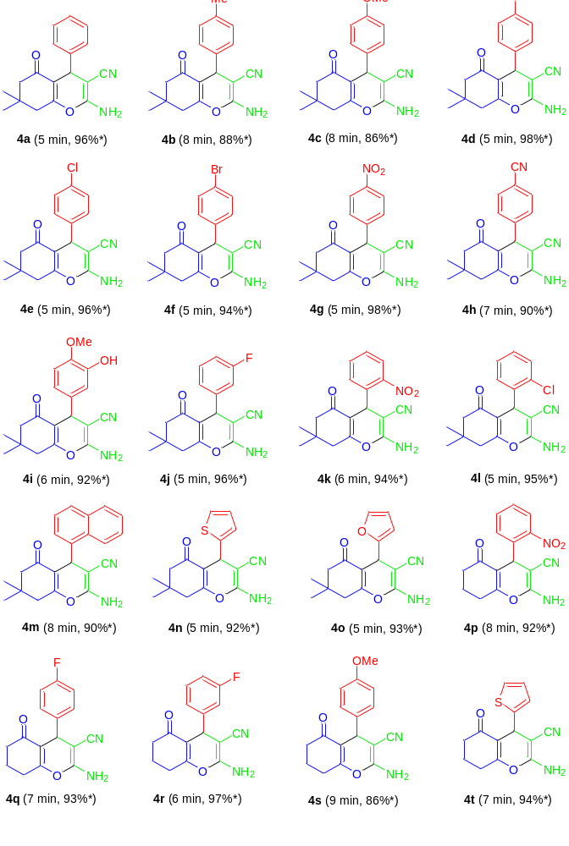
ª Reaction condition: Aldehyde 1a-o (1.0 mmol), malononitrile 2a (1.0 mmol), and 5,5-dimethylcyclohexane-1,3-dione 3a/cyclohexane-1,3-dione 3b (1.0 mmol) in the presence of 10 mol% of TsOH.H₂O in H₂O (ⴄ = 0.35 μL/mg) as LAGs [η = V (liquid; μL)/m (reagents; mg)] at ambient temperature. * Isolated yield.

Table 3: Substrate scopes for the synthesis of 2-amino-tetrahydrospiro[chromenes-3,4´-indoline]-3-carbonitriles 6a-lª
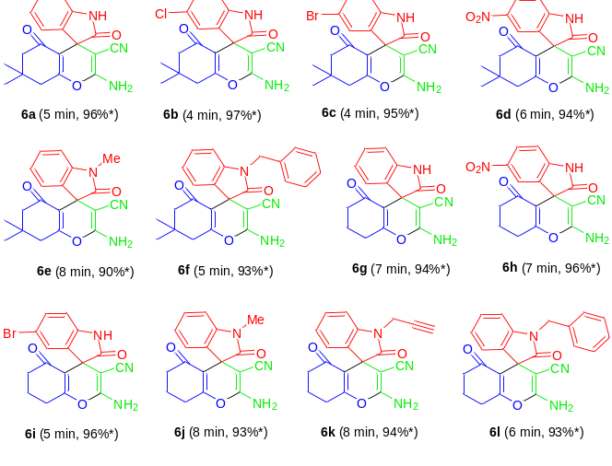
ª Reaction condition: Isatins 5a-g (1.0 mmol), malononitrile 2 (1.0 mmol), and 5,5-dimethylcyclohexane-1,3-dione 3a/cyclohexane-1,3-dione 3b (1.0 mmol) in the presence of 10 mol% of TsOH.H₂O in H₂O (ⴄ = 0.35 μL/mg) as LAGs [η = V (liquid; μL)/m (reagents; mg)] at ambient temperature. * Isolated yield.

Table 5: Substrate scopes for the synthesis of 2,2'-aryl/heteroaryl-methylene-bis(3-hydroxy-cyclohex-2-enone) derivatives 7a-pª
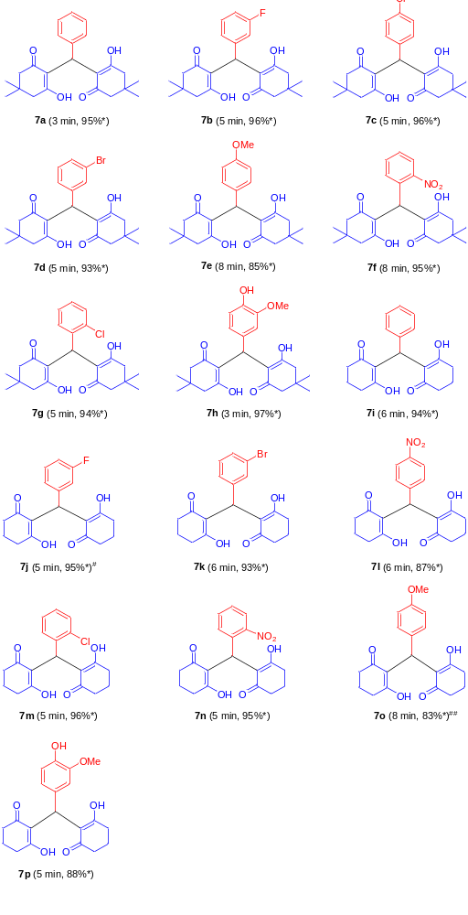
ª Reaction condition: Aldehydes 1a-h (1.0 mmol), and 5,5-dimethylcyclohexane-1,3-dione 3a/cyclohexane-1,3-dione 3b (2.0 mmol) in the presence of 5 mol% of TsOH.H₂O in H₂O (ⴄ = 0.25 μL/mg) as LAGs [η = V (liquid; μL)/m (reagents; mg)] at ambient temperature. * Isolated yield. # 7 mol% of TsOH.H₂O was used. ## 4 mol% of TsOH.H₂O was used.

Table 6: Substrate scopes for the synthesis of tetrahydro-1H-xanthen-1-one 9a-iª
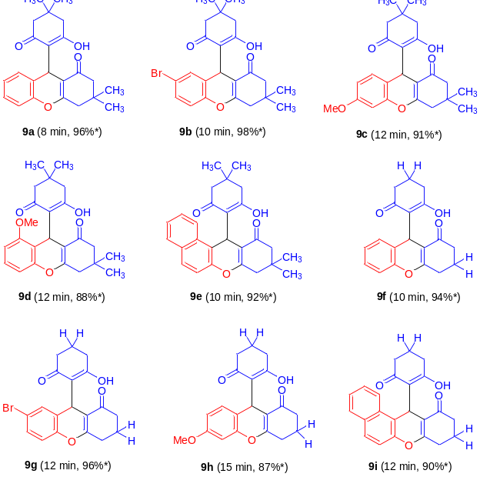
ª Reaction condition: Salicylaldehydes 8a-e (1.0 mmol), and 5,5-dimethylcyclohexane-1,3-dione 3a/cyclohexane-1,3-dione 3b (2.0 mmol) in the presence of 5 mol% of TsOH.H₂O in H₂O (ⴄ = 0.25 μL/mg) as LAGs [η = V (liquid; μL)/m (reagents; mg)] at ambient temperature. * Isolated yield.

