Focusing on the metabolic changes caused by the COVID-19 disease. A Metabolomic approach using urine.
Marhuenda-Egea, F. C., Narro-Serrano, J., Shalabi-Benavent, M.J., Álamo-Marzo, J.M., Amador, C., Algado Rabasa, J. T., Garijo Saiz, A. M.

Suplementary Material
Figure S1. ¹H NMR spectra of urine from COVID-19 patients (gray) and healthy people (black).
Figure 2S. ROBPCA score plots for bucket urine spectrum data for COVID-19 patients (blue circles) and healthy controls (red diamonds).
Figure 3S. (A) Plot A show the prediction error distribution of an informative variable (citric acid). The peak denoted ‘‘1’’ stands for the distribution when the variable is permuted, while the peak denoted ‘‘0’’ refers to the distribution when the variable is not permuted. (B) COSS (COnditional Synergistic Score) is the key output of SPA model and used to rank variables.

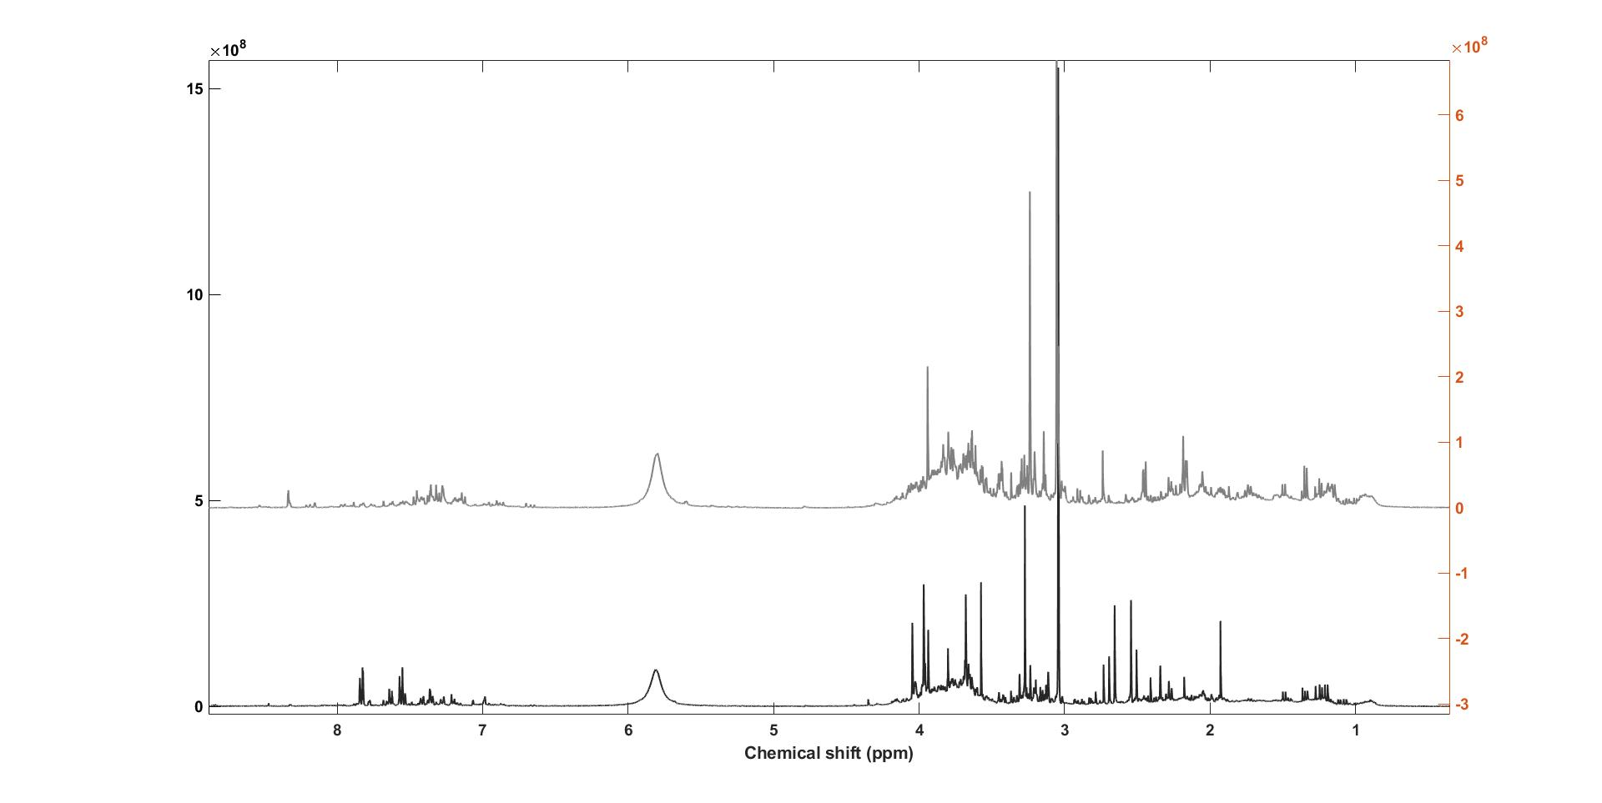
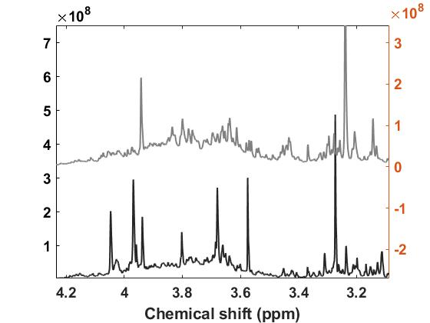
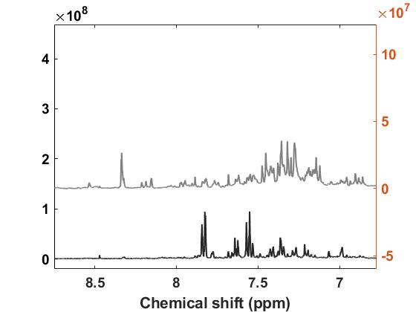
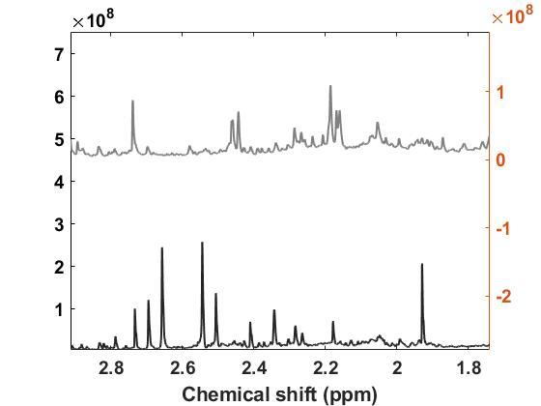

Figure S1. ¹H NMR spectra of urine from COVID-19 patients (gray) and healthy people (black).

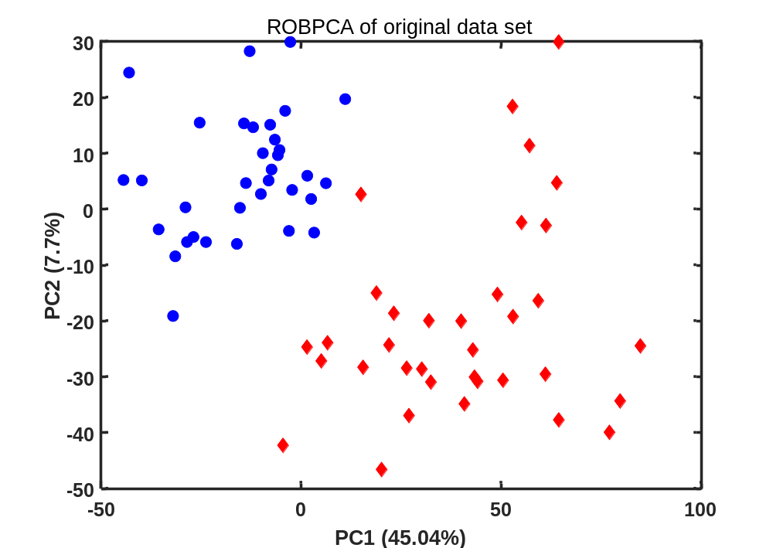
Figure 2S. ROBPCA score plots for bucket urine spectrum data for COVID-19 patients (blue circles) and healthy controls (red diamonds).

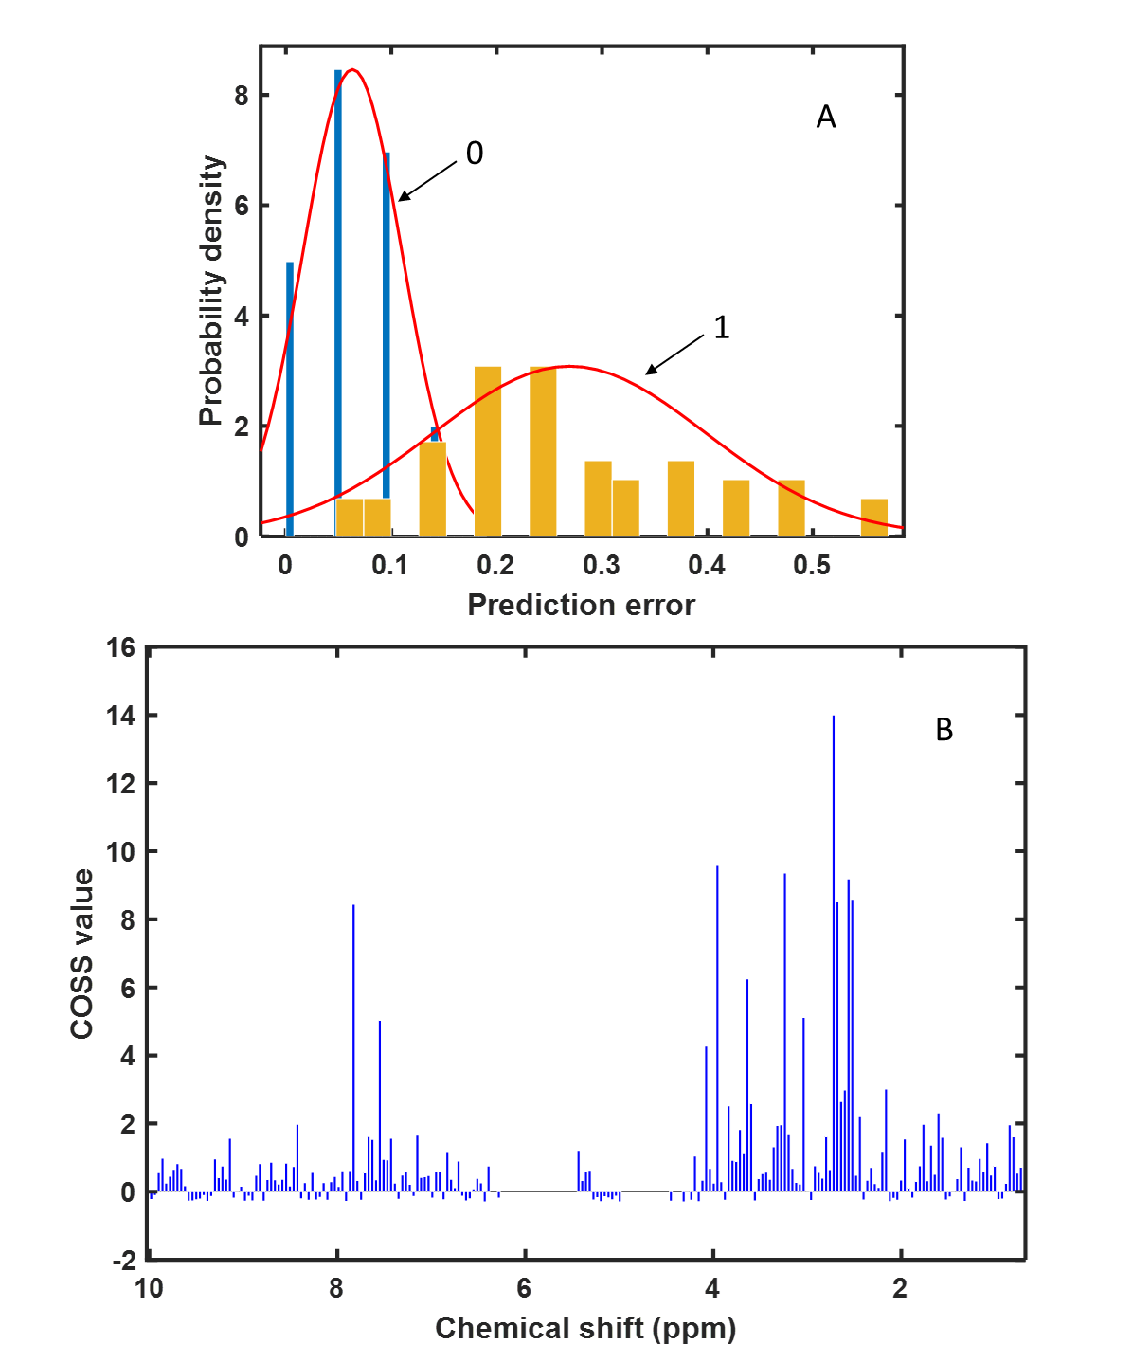
Figure 3S. (A) Plot A show the prediction error distribution of an informative variable (citric acid). The peak denoted ‘‘1’’ stands for the distribution when the variable is permuted, while the peak denoted ‘‘0’’ refers to the distribution when the variable is not permuted. (B) COSS (COnditional Synergistic Score) is the key output of SPA model and used to rank variables.

