Table S1 supplementary data GC-MS results of total volatile organic compounds in barley (Hordeum vulgare L. var. Ardhaoui) seedlings germinated in the presence of distilled water (N°3.1), Cu NP (N°3.2), CuO NP (N°3.3) and CuSO₄ (N°3.4).
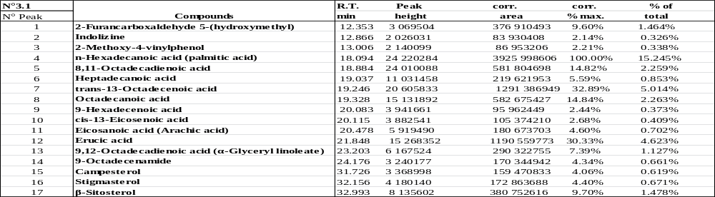

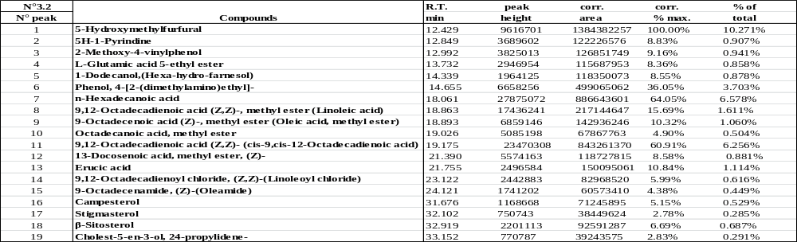

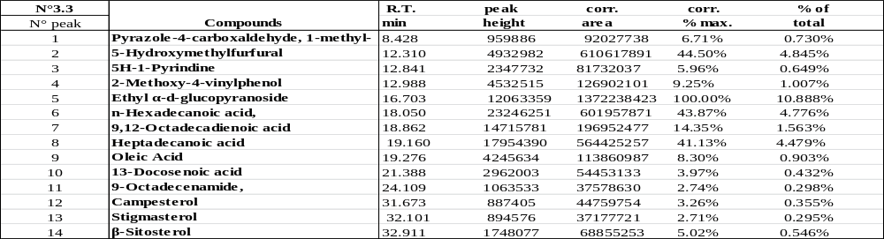

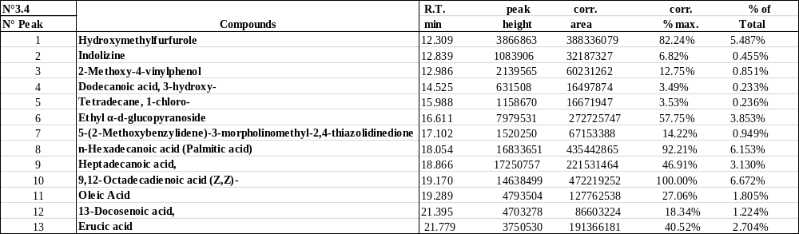

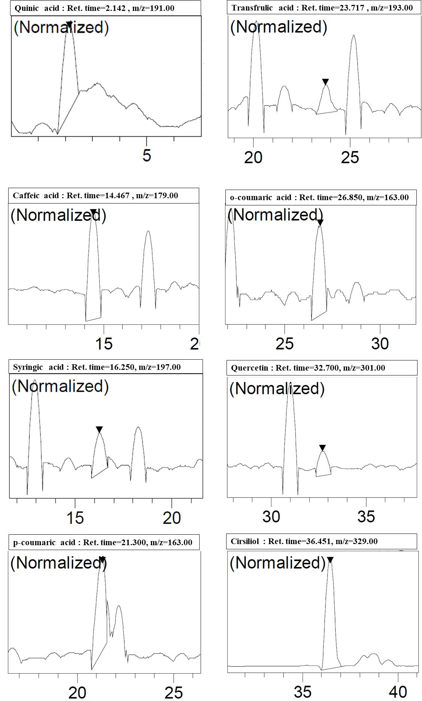
Figure S1. Results of liquid chromatography-mass spectrometry HPLC-MS (chromatograms and mass-spectra) of total polyphenolic compounds in control (H₂O) seedlings.

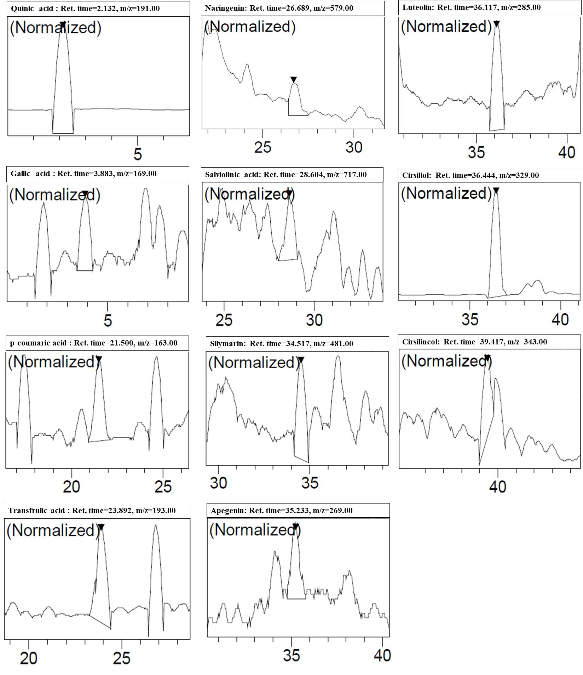
Figure S2. Results of liquid chromatography-mass spectrometry HPLC-MS (chromatograms and mass-spectra) of total polyphenolic compounds in Cu NP treated barley seedlings.

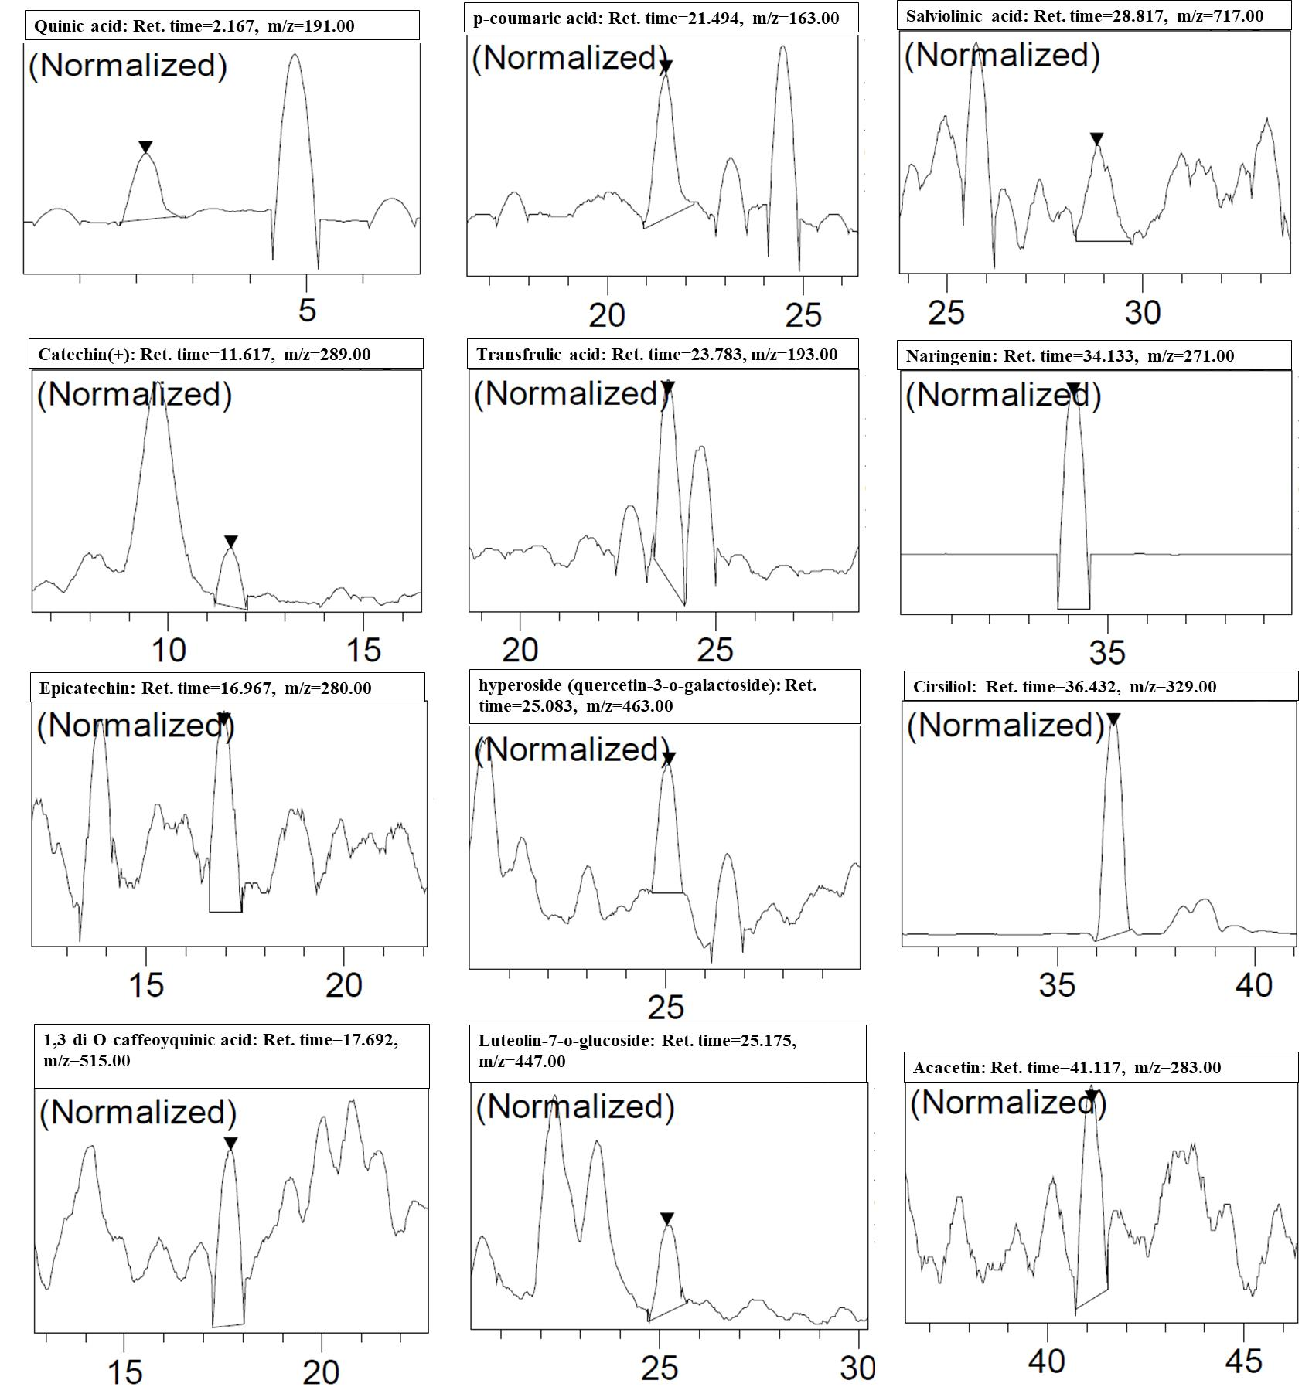
Figure S3. Results of liquid chromatography-mass spectrometry HPLC-MS (chromatograms and mass-spectra) of total polyphenolic compounds in CuO NP treated barley seedlings.

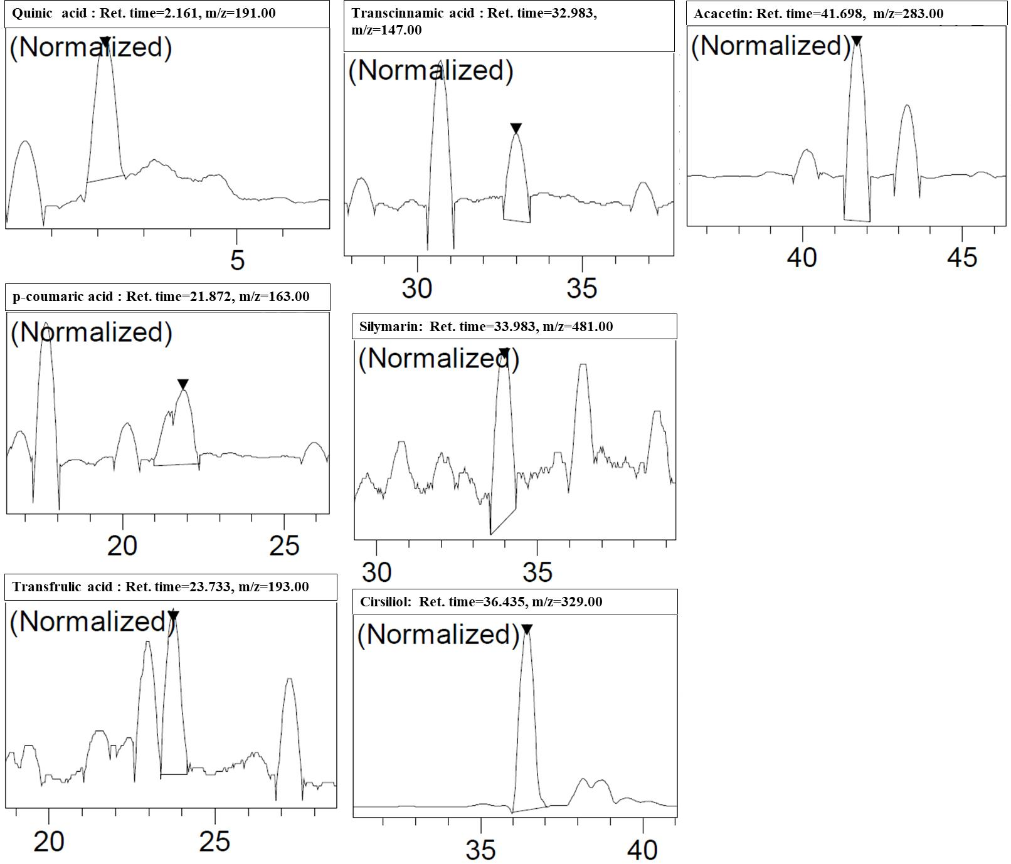
Figure S4. Results of liquid chromatography-mass spectrometry HPLC-MS (chromatograms and mass-spectra) of total polyphenolic compounds in CuSO₄ treated barley seedlings.

