Appendix

Table 1 Adhesion grade as described by Nair et Al.

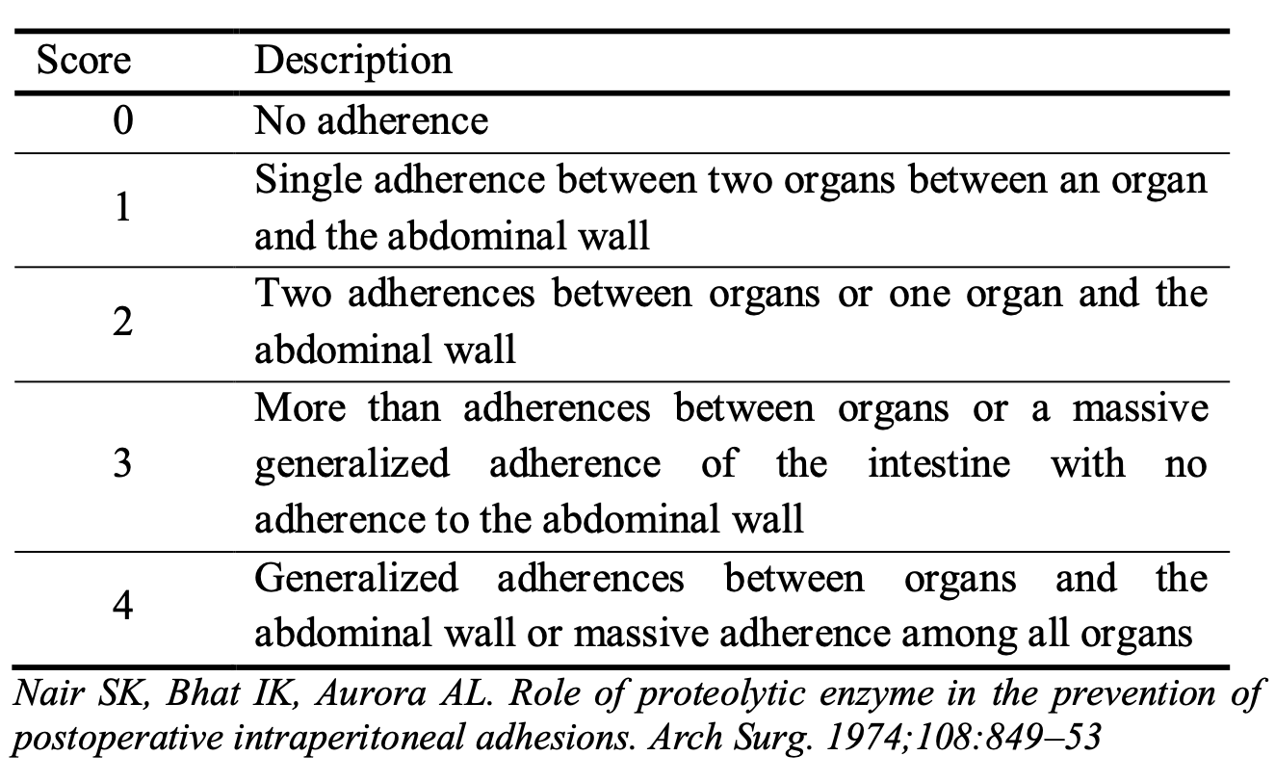

Figure. 1 Four quadrant schema
