Experimental and computational investigations on structural, spectroscopic, electronic and thermodynamic, druggability and pharmacokinetics of a hybrid organic-inorganic synthetic arsenate.

Noureddine Mhadhbi^{a*}, Souad Dgachiª, Noureddine Issaoui^{b}, Samia Nasr^{c,d}, Riadh Badraoui^{e,f} , Bechir Badraoui^{g} and Houcine Naïliª

ª Laboratory of Solid State (LR11ES51), Faculty of Sciences, University of Sfax, BP 1171, 3000 Sfax, Tunisia.
^{b} University of Monastir, Faculty of Sciences, Laboratory of Quantum and Statistical Physics (LR18ES18), Monastir 5079, Tunisia.
^{c} Advanced Functional Materials & Optoelectronic Laboratory (AFMOL), Department of Physics, Faculty of Science, King Khalid University, P.O. Box 9004, Abha, Saudi Arabia.
^{d} Electrochemistry, Materials and Environment (UREME [16ES02]), Preparatory Institute for Engineering Studies Kairouan, Tunisia.
^{e} Laboratory of General Biology, Department of Biology, University of Ha’il, 81451 Ha’il, Saudi Arabia.
^{f} Section of Histology-Cytology, Medicine Faculty of Tunis, University of Tunis El Manar, 1007 La Rabta-Tunis- Tunisia.
^{g} U.R. Matériaux et synthèse organique UR17ES31, Institut Préparatoire aux Etudes d’Ingénieur de Monastir, Université de Monastir, 5019 Monastir, Tunisia.

Table S1: Comparison of calculated geometrical parameters of ((4-APH)(4-APH₂)[AsO₄]·H₂O) with the corresponding experimental ones.
 | Experimental | Theoretical
Bond lengh (Å) | X-ray | Gas | Water
N1—C1 | 1.352(3) | 1.351 | 1.353
N1—C5 | 1.354(4) | 1.344 | 1.353
C1—C2 | 1.363(4) | 1.387 | 1.373
C2—C3 | 1.422(3) | 1.407 | 1.420
C3—C4 | 1.425(3) | 1.410 | 1.420
C4—C5 | 1.363(4) | 1.385 | 1.373
C8A—C9A | 1.390(1) | 1.393 | 1.387
C8A—C7A | 1.390(1) | 1.393 | 1.388
C8A—N4A | 1.310(6) | 1.458 | 1.472
C8B—N4B | 1.420(2) | 1.411 | 1.418
C6A—C7A | 1.390(1) | 1.397 | 1.394
C9A—C10A | 1.390(1) | 1.340 | 1.341
C10A—N3A | 1.390(1) | 1.337 | 1.341
N3A—C6A | 1.390(1) | 1.396 | 1.393
C8B—C9B | 1.390(1) | 1.394 | 1.385
C8B—C7B | 1.390(1) | 1.392 | 1.387
C9B—C10B | 1.390(1) | 1.396 | 1.384
C10B—N3B | 1.390(1) | 1.389 | 1.391
N3B—C6B | 1.390(1) | 1.391 | 1.387
C6B—C7B | 1.390(1) | 1.388 | 1.367
As−O1 | 1.651(1) | 1.857 | 1.735
As−O2 | 1.633(2) | 1.688 | 1.724
As−O3 | 1.647(2) | 1.853 | 1.828
As−O4 | 1.631(2) | 1.685 | 1.719
RMSD |  | 0.026 | 0.026

Table S1 (continued)
 | Experimental | Theoretical
Angles (°) | X-ray | Gas | Water
C5—C4—C3 | 119.9(2) | 118.910 | 119.596
N1—C5—C4 | 121.0(2) | 123.935 | 121.643
C9B—C8B—N4B | 127.8(2) | 124.422 | 124.229
C10B—C9B—C8B | 120.0(2) | 119.474 | 120.111
N3B—C10B—C9B | 120.0(2) | 119.864 | 119.495
C9B—C8B—C7B | 120.0(1) | 120.663 | 120.394
C10B—N3B—C6B | 120.0(2) | 121.521 | 121.332
C7B—C6B—N3B | 120.0(2) | 121.358 | 121.226
C6A—C7A—C8A | 120.0(1) | 120.838 | 120.335
C6B—C7B—C8B | 120.0(2) | 120.251 | 120.069
N4A—C8A—C9A | 117.2(4) | 119.128 | 119.380
N4A—C8A—C7A | 122.8(1) | 120.674 | 119.303
C9A—C8A—C7A | 120.0(2) | 121.294 | 121.902
C8A—C9A—C10A | 120.0(2) | 116.008 | 116.424
C9A—C10A—N3A | 120.0(2) | 35.421 | 116.795
C6A—N3A—C10A | 120.0(2) | 117.080 | 118.672
C7B—C8B—N4B | 112.2(1) | 115.834 | 121.406
O1−As−O2 | 109,19(10) | 103.636 | 113.352
O1−As−O3 | 108,25(10) | 93.702 | 100.085
O1−As−O4 | 109,06(9) | 109.215 | 112.475
O2−As−O3 | 109,91(11) | 104.089 | 106.383
O2−As−O4 | 111,24(11) | 130.384 | 115.848
O3−As−O4 | 109,14(11) | 109.646 | 107.020
RMSD |  | 6.630 | 2.946

Table S2: Second order perturbation theory analysis of Fock matrix on NBO basis for ((4-APH)(4-APH₂)[AsO₄]·H₂O).
Donor NBO (i) | Acceptor NBO (j) | E(2)ª kcal/mol | E(j)-E(i)^{b} a.u. | F(i,j)^{c}a.u.
π(C4 - C6) | LP (1) N1 | 118.91 | 0.03 | 0.079
π(C4 - C6) | LP*(1) C8 | 56.73 | 0.14 | 0.096
π(C9 - C11) | LP (1) N1 | 119.09 | 0.03 | 0.08
π(C9 - C11) | LP*(1) C8 | 54.9 | 0.14 | 0.095
LP (1) N1 | π*(C4 - C6) | 48.1 | 0.27 | 0.111
LP (1) N1 | π*(C9 - C11) | 47.51 | 0.27 | 0.11
LP (1) N3 | LP*(1) C8 | 104.1 | 0.16 | 0.14
LP*(1) C8 | π*(C4 - C6) | 38.67 | 0.16 | 0.092
LP*(1) C8 | π*(C9 - C11) | 38.37 | 0.16 | 0.092
σ(C15 - C16) | σ*(C15 - C24) | 5.55 | 1.29 | 0.076
σ(C15 - C24) | σ*(C15 - C16) | 5.73 | 1.3 | 0.077
π(C16 - C18) | LP*(1) C15 | 54.21 | 0.1 | 0.095
σ(C22 - C24) | σ*(C15 - N 26) | 5.07 | 1.15 | 0.068
π(C22 - C24) | LP*(1) C15 | 45.45 | 0.11 | 0.09
LP*(1) C15 | π*(C16 - C18) | 47.35 | 0.19 | 0.097
LP*(1) C15 | π*(C22 - C24) | 59.88 | 0.18 | 0.105
LP*(1) C15 | σ*(N 26 - H29) | 7.47 | 0.76 | 0.083
LP (1) N 20 | π*(C16 - C18) | 42.93 | 0.26 | 0.1
LP (1) N 20 | π*(C22 - C24) | 41.07 | 0.25 | 0.095
LP (1) O31 | σ*(N1 - H 2) | 8.56 | 1.26 | 0.093
LP (3) O31 | σ*(N1 - H 2) | 12 | 0.78 | 0.092
LP (2) O31 | σ*(As30 - O32) | 6.3 | 0.61 | 0.057
LP (2) O31 | σ*(As30 - O33) | 11.75 | 0.62 | 0.078
LP (3) O31 | σ*(As30 - O34) | 14.88 | 0.59 | 0.086
LP (2) O32 | σ *(As30 - O34) | 15.42 | 0.59 | 0.086
LP (3) O32 | σ*(As30 - O31) | 13.8 | 0.58 | 0.082
LP (3) O32 | σ*(As30 - O33) | 7.76 | 0.6 | 0.062
LP (2) O33 | σ*(As30 - O31) | 9.82 | 0.61 | 0.07
LP (2) O33 | σ*(As30 - O32) | 8.22 | 0.61 | 0.065
LP (3) O33 | σ*(As30 - O34) | 13.11 | 0.6 | 0.081
LP (2) O34 | σ*(As30 - O32) | 14.38 | 0.59 | 0.084
LP (3) O34 | σ*(As30 - O31) | 9.55 | 0.57 | 0.071
LP (3) O34 | σ*(As30 - O33) | 10.57 | 0.58 | 0.076
σ*(As30 - O31) | σ*(As30 - O33) | 165.72 | 0.02 | 0.111
σ*(As30 - O34) | σ*(As30 - O33) | 167.76 | 0.01 | 0.105
LP (1) O33 | σ*(O35 - H36) | 5.9 | 1.19 | 0.075
LP (2) O33 | σ*(O35 - H36) | 7.56 | 0.73 | 0.067
ªE(2) means energy of hyper conjugate interactions (stabilization energy); ^{b}Energy difference between donor and acceptor i and j NBO orbitals; ^{c}F(i,j) is the Fock matrix element between i and j NBO orbitals.

Table S3: Thermodynamic properties at different temperatures at the DFT level for ((4-APH)(4-APH₂)[AsO₄]·H₂O) molecule.
T (K) | S (J/mol.K) | Cp (J/mol.K) | H (kJ/mol)
100 | 425.327 | 164.560 | 10.361
150 | 501.835 | 215.702 | 19.882
200 | 570.584 | 264.268 | 11.888
250 | 634.626 | 311.208 | 16.282
298.15 | 693.181 | 354.605 | 12.32
300 | 695.38 | 356.228 | 12.977
350 | 753.512 | 398.576 | 11.86
400 | 809.324 | 437.661 | 12.78
450 | 862.961 | 473.230 | 125.568
500 | 914.512 | 505.329 | 150.046
550 | 964.053 | 534.196 | 176.047
600 | 1011.668 | 560.161 | 203.417
650 | 1057.445 | 583.574 | 232.02
700 | 1101.48 | 604.763 | 261.737
750 | 1143.872 | 624.022 | 292.464
800 | 1184.715 | 641.599 | 324.111
850 | 1224.102 | 657.701 | 356.6
900 | 1262.12 | 672.5 | 389.86
950 | 1298.85 | 686.141 | 423.83
1000 | 1334.369 | 698.745 | 458.457

Table S4: Observed and calculated wavenumbers using DFT with percentage of potential energy distribution (PED) of ((4-APH)(4-APH₂)[AsO₄]·H₂O) compound.
Experimental wavenumbers |  | Computed wavenumbers |  | I_{i} | Rª | Vibrational assignments (% PED)
FT-IR | FT-Ram | Harmonic | Scaled | I_{i} | Rª | Vibrational assignments (% PED)
 |  | 3772 | 3614 | 57.97 | 103.36 | STRE OH (99)
 |  | 3705 | 3550 | 119.2 | 145.69 | STRE NH (100)
 |  | 3589 | 3438 | 258.93 | 405.49 | STRE NH (100)
 |  | 3473 | 3327 | 209.02 | 82.75 | STRE NH (100)
3432 |  | 3452 | 3307 | 222.47 | 91.48 | STRE NH (97)
 |  | 3382 | 3240 | 156.46 | 229.72 | STRE NH (97)
 |  | 3262 | 3125 | 1.19 | 326.71 | STRE CH (94)
 |  | 3251 | 3114 | 9.8 | 359.1 | STRE CH (99)
 |  | 3246 | 3110 | 2.27 | 656.86 | STRE CH (95)
 |  | 3243 | 3107 | 0.02 | 149.35 | STRE CH(87)
 |  | 3235 | 3099 | 0.94 | 224.9 | STRE CH (87)
 |  | 3235 | 3099 | 1.58 | 182.91 | STRE CH (92)
 |  | 3233 | 3097 | 5.96 | 91.57 | STRE CH (91)
3095 | 3059 | 3230 | 3094 | 7.8 | 199.33 | STRE CH (86)
3042 | 3036 | 3083 | 2954 | 1189.67 | 229.74 | STRE OH (91)
2964 |  | 2933 | 2810 | 3882.53 | 970.67 | STRE OH(95)
2214 |  | 2189 | 2097 | 6089.45 | 551.33 | STRE NH (94)
1648 |  | 1697 | 1668 | 449.87 | 95.97 | STRE CC (53) BEND HCC (19)
 |  | 1685 | 1656 | 153.59 | 6.84 | BEND HNC (68) STRE CC(10)
 |  | 1676 | 1647 | 8.65 | 43.55 | STRE CC (52) BEND HNH(16) BEND HNC(10)
 |  | 1665 | 1636 | 256.38 | 18.06 | BEND HOH(92)
 |  | 1658 | 1630 | 369.1 | 7.86 | BEND HNH (86) STRE NC(10)
 |  | 1658 | 1630 | 151.31 | 31.3 | STRE CC(61) BEND HCC(22)
1592 | 1602 | 1627 | 1599 | 86.48 | 13.99 | BEND HNH(89)
 |  | 1612 | 1584 | 139.3 | 3.81 | STRE CC (16) BEND HNH(68)
 |  | 1589 | 1562 | 26.6 | 0.36 | STRE CC(48) BEND HCC (14)
 |  | 1565 | 1538 | 484.56 | 23.25 | BEND HCC(39) STRE NC (20) BEND CNC (11)
 |  | 1552 | 1525 | 13 | 11.18 | BEND HCC (50) BEND HNH (21) STRE NC (17)
1541 |  | 1538 | 1512 | 189.7 | 8.65 | BEND HCC (14) BEND HNH (74)
 |  | 1486 | 1461 | 1.53 | 27.71 | BEND HNC(13) STRE CC(55) BEND HCC(19)
1436 | 1435 | 1467 | 1442 | 54.18 | 3.07 | STRE CC(45) BEND HCC(34)
1413 |  | 1408 | 1384 | 81.34 | 6.78 | BEND HCC(36) STRE NC(41)
1380 |  | 1383 | 1359 | 7.6 | 5.85 | BEND HCC(78)
 |  | 1377 | 1354 | 2.55 | 0.28 | BEND HCC(55) STRE NC(11) BEND HNC (12)
1336 | 1332 | 1333 | 1310 | 11.65 | 9.03 | BEND HCC(17) STRE NC (56)
 |  | 1331 | 1309 | 18.8 | 3.42 | TORS CNHO(18) STRE NC (41) BEND HOAs (19)
 |  | 1308 | 1286 | 97.1 | 4 | TORS CNHO (18) STRE NC (43) BEND HOAs (22)
1269 | 1275 | 1274 | 1253 | 104.1 | 9.08 | TORS HNCC(94)
 |  | 1249 | 1227 | 5.97 | 20.89 | STRE CC (21) BEND HCC (54) STRE NC (13)
1201 | 1212 | 1230 | 1209 | 116.63 | 10.05 | STRE CC (12) BEND HCC (72)
 |  | 1225 | 1204 | 16.88 | 47.72 | BEND HCC (11) BEND HCC (12) STRE NC (55) BEND CNC (11)
 |  | 1149 | 1129 | 8.69 | 1.9 | STRE CC (10) BEND HCC (63)
 |  | 1131 | 1112 | 2.51 | 0.67 | STRE CC (30) BEND HCC (50)
 |  | 1121 | 1102 | 60.7 | 2.18 | BEND HNC (84)
 |  | 1093 | 1075 | 30.4 | 19.48 | BEND HCC (23) STRE NC (47)
 |  | 1077 | 1059 | 9.75 | 53.41 | BEND HCC (13) STRE NC (70)
1040 | 1057 | 1074 | 1056 | 27.95 | 0.98 | STRE CC (10) STRE HNC (67)
 |  | 1054 | 1036 | 1.47 | 0.14 | BEND HNC (69)
 |  | 1034 | 1017 | 26.12 | 48.22 | BEND CNC (57) STRE NC (22)
 |  | 1015 | 998 | 3.26 | 3.2 | TORS HCCH (87)
 | 993 | 1013 | 995 | 0.45 | 2.21 | TORS HCHO (80) TORS CCCN (13)
 |  | 998 | 981 | 28.74 | 110.84 | BEND CNC (49) STRE CC (34)
995 |  | 994 | 977 | 1.26 | 1.05 | TORS HCCN (79)
 |  | 979 | 962 | 2.21 | 0.67 | TORS HCCH (91)
 |  | 895 | 880 | 234.36 | 0.34 | BEND NHO (61) BEND HNC (13)
 |  | 880 | 865 | 2.2 | 4.12 | TORS HCCN (94)
865 | 850 | 860 | 845 | 30.61 | 16.41 | STRE AsO (93)
 |  | 857 | 843 | 14.11 | 38.79 | STRE NC (12) BEND CNC (13) TORS HCCN (27) STRE CC (28)
 |  | 848 | 833 | 63.66 | 4.09 | TORS HCCC (89)
 |  | 832 | 818 | 81.65 | 8.16 | TORS HCHO (71)
 |  | 822 | 808 | 24.13 | 32.53 | BEND CNC (15) TORS HCHO (10) STRE NC (46 ) BEND CCC (11)
 |  | 812 | 798 | 378.88 | 1.99 | TORS OHOAs (97)
817 |  | 798 | 784 | 240.22 | 25.17 | STRE AsO (97)
 |  | 739 | 726 | 151.13 | 138.01 | STRE AsO(89)
 |  | 736 | 724 | 5.72 | 8.66 | TORS CCCN (77)
 |  | 735 | 723 | 1.36 | 2.12 | TORS CNCC(86)
677 | 667 | 677 | 665 | 0.87 | 16.06 | BEND OAsO (88)
 |  | 670 | 658 | 0.89 | 15.68 | STRE CC (10) BEND CCN (81)
 |  | 630 | 619 | 153.54 | 38.05 | STRE AsO (81)
 |  | 570 | 561 | 1.39 | 2.48 | TORS HNCC (96)
 | 541 | 536 | 527 | 65.12 | 9.6 | STRE NC (11) BEND CCC (56)
 |  | 533 | 524 | 145.18 | 18.54 | BEND CCC (59)
 |  | 524 | 515 | 18.3 | 0.13 | OUT NCCC (75)
 |  | 501 | 493 | 60.01 | 3.23 | OUT NCCC (83)
 |  | 494 | 486 | 224.32 | 9.44 | BEND OHO (74)
 |  | 425 | 418 | 1.58 | 0.98 | TORS CCNO (90)
 |  | 406 | 399 | 0.46 | 0.14 | TORS HCHO (13) TORS CCCN (74)
 |  | 399 | 392 | 8.06 | 3.47 | BEND CCN (79)
 | 410 | 381 | 374 | 42.99 | 9.41 | STRE OH (32) BEND CCN (12) OUT OOOAs (21)
 |  | 373 | 367 | 7.89 | 0.8 | BEND CCN (70)
 |  | 347 | 341 | 263.37 | 15.85 | OUT OOOAs (29) BEND OAsO (10) BEND OAsO (14) STRE ON (25)
 |  | 285 | 281 | 186.61 | 19.88 | OUT OOOAs(66)
 |  | 275 | 270 | 208.27 | 6.17 | BEND HOH (83)
 |  | 253 | 249 | 22.03 | 10.96 | OUT OOOAs (15) BEND OAsO (60) BEND OAsO (10)
 |  | 240 | 236 | 11.1 | 4.76 | TORS CCCC (76
 |  | 234 | 230 | 96.36 | 1.22 | OUT CCON (46) TORS HNCC (19) TORS CCNO (19)
 |  | 200 | 197 | 46.91 | 5.15 | STRE OH (32) BEND OAsO (38)
 |  | 194 | 191 | 267.5 | 0.87 | OUT CCON (16) TORS HNCC (71)
 |  | 156 | 154 | 99.3 | 4.28 | OUT OOOAs (10) OUT OOOAs 16) STRE ON 50)
 |  | 134 | 132 | 0.15 | 0.55 | TORS HNCC (93)
 |  | 129 | 127 | 11.34 | 0.25 | STRE NH (46) BEND CNO (13)
 | 89 | 91 | 90 | 12.97 | 4 | BEND HOAs (27) TORS CNOAs (22)
 |  | 86 | 85 | 1.07 | 3.3 | STRE NH (15) BEND CNO (55)
 |  | 84 | 82 | 14.14 | 5.22 | OUT CCON (12) TORS CCNO (37) BEND NOAs (18)
 |  | 80 | 79 | 21.23 | 4.39 | STRE OH (61)
 |  | 63 | 62 | 2.6 | 11.15 | TORS CNOAs (59) TORS HOAsO (10)
 | 56 | 58 | 57 | 5.36 | 8.64 | TORS CNOAs (42)
 |  | 46 | 45 | 18.24 | 6.72 | TORS CNHO (21) BEND HNC (21) TORS CHOAs (17)
 |  | 41 | 40 | 18.63 | 5.84 | BEND NOAs (49 ) TORS CHOAs (17)
 |  | 38 | 37 | 14.82 | 1.25 | BEND NOAs (34) TORS HOAsO (14)
 |  | 30 | 30 | 1.3 | 20.33 | TORS HOHC (79)
 |  | 28 | 27 | 13.21 | 2.06 | BEND HNC (29) TORS CHOAs (52)
 |  | 19 | 18 | 28.01 | 4.56 | BEND NOAs (11) BEND NOAs (17) TORS HOAsO (50)

Wavenumbers in the ranges from 4000 to 1700 cm⁻¹ and lower than 1700 cm⁻¹ are scaled with 0.958 and 0.983 respectively.
STRE=stretching; BEND= in-plane bending; OUT= out-of-plane bending; TORS= torsion; PED: potential energy distribution.

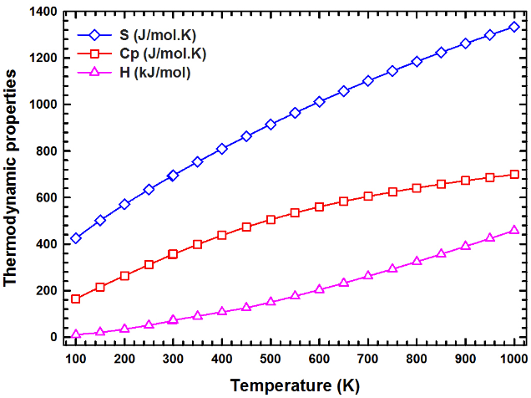

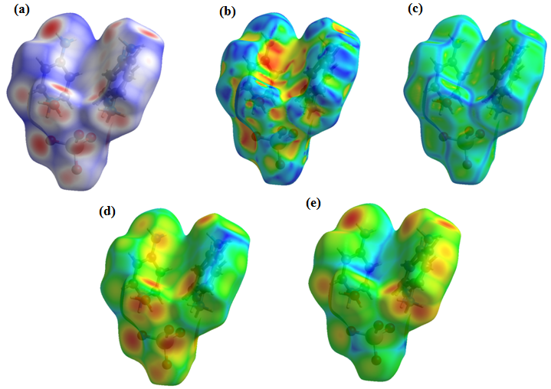
Fig. S1: Correlations graphs of entropy (S), heat capacity (Cp) and enthalpy (H) changes of the title compound with various temperatures.

Fig. S2: Hirshfeld surfaces mapped with ^{(a)} d_{norm}, ^{(b)} shape index, ^{(c)} Curvedness, ^{(d)} d_{e} and ^{(e)} d_{i}.

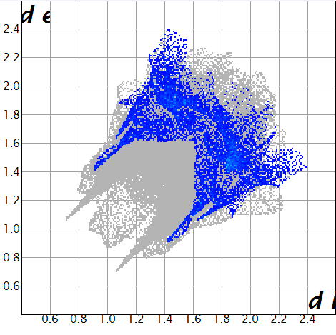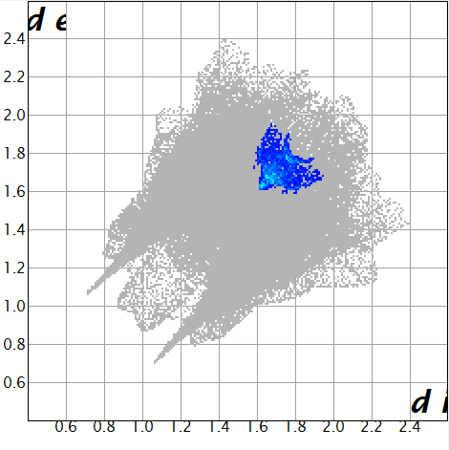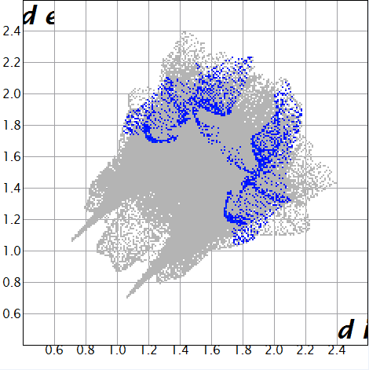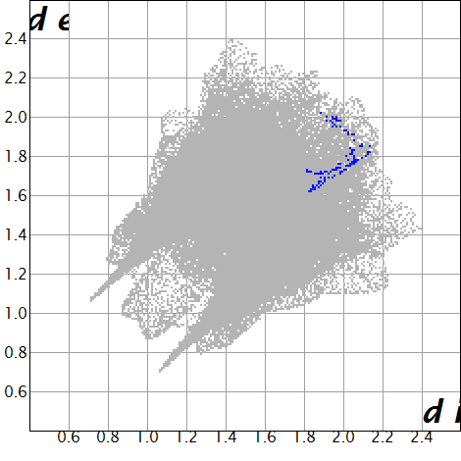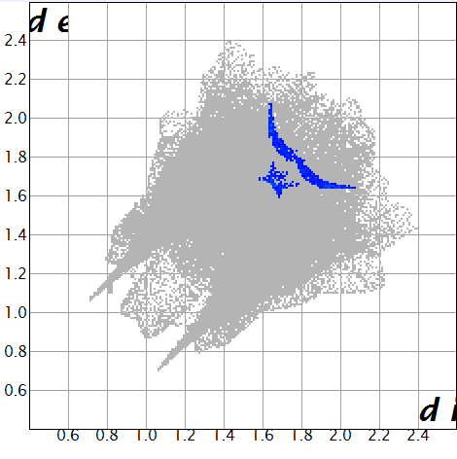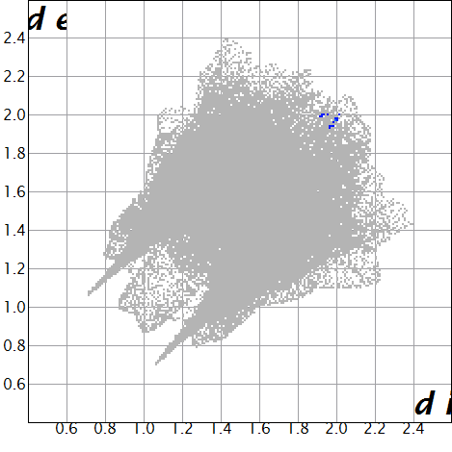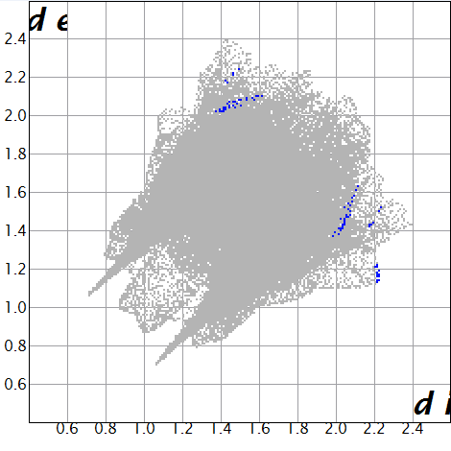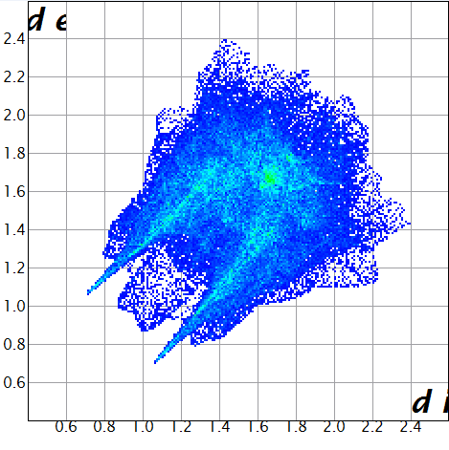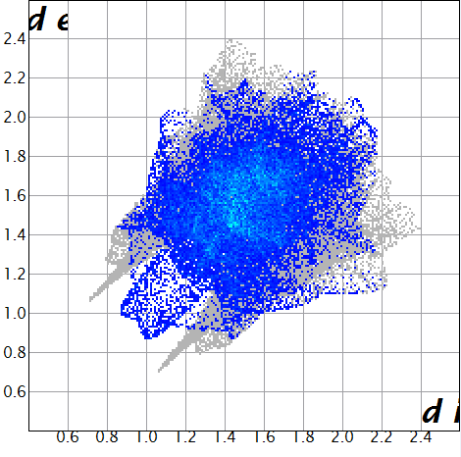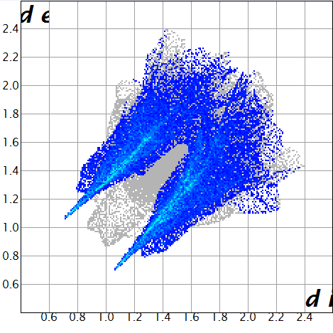
C···H/ H···C = 12.4%
C···C = 3.7%
N···H/ H···N = 2.5%
C···O/ O···C = 0.2%
N···C/ C···N = 1%
N···O/ O···N = 0.1%
H···As/ As···H = 0.1%
All interactions (100%)
H···H = 37.6%
O···H/ H···O = 42.4%
(a)
(b)
(c)
(d)
(e)
(f)
(g)
(h)
(i)
(j)

H···H = 37.6%
O···H/ H···O = 42.4%
All interactions (100%)

(e)

Fig. S3: 2D fingerprint plots of (4-APH)(4-APH₂)[AsO₄]·H₂O compound.
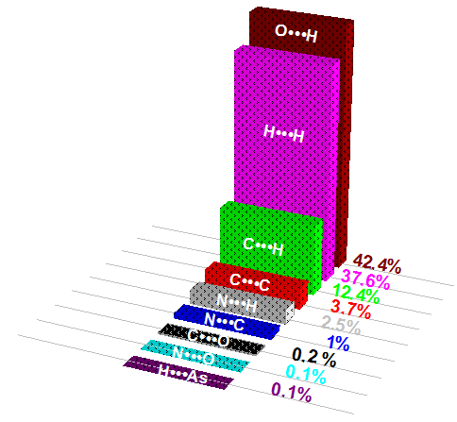

Fig. S4: Percentage of various intermolecular contacts contributed to the Hirshfeld surface in the (4-APH)(4-APH₂)[AsO₄]·H₂O compound.

