Methods and results for the model sensitivity analysis

We used the specific sensitivity coefficients (SSC) to test the sensitivity and uncertainty of the input parameters. The same test, for the simulated oxygen concentration, has been successfully applied in our previous research (see Mi et al. (2020a)) and here we do the job for the maximum concentration of P. rubescens (P.rubs_{max}), in which SSC was calculated as:
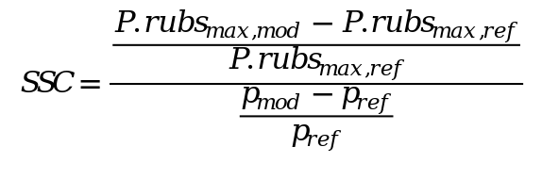
In the equation the indices P_{ref} and P_{mod} stand for reference (i.e. used for the scenario analysis) and modified parameter settings, respectively. For the test all the input parameters were changed four times (±5% and ±10%) based on their reference settings, and we averaged the specific SSC values in order to achieve an average sensitivity result at the local vicinity of each parameter value.
The results shows that the uncertainty of simulated P. rubescens concentration is not only from the parameters directly related to the growth of P. rubescens (e.g. algae growth rate, temperature span for its maximum growth rate), but also those related to diatoms growth (e.g. respiration and mortality rate for diatoms) and nutrients dynamics (e.g. sediment release rate of phosphorus), which illustrates the complicate interaction among such water quality variables (see Table S1).
Despite uncertainties of P. rubescens concentration due to the changes of some parameters, based on all the simulation results the maximum concentration always occurs at 10 m or 11 m depth around day 214 (Fig.S1). Consequently, the model performance in capturing the P. rubescens bloom in the metalimnion is robust against parameter changes.

Table S1: Specific sensitivity coefficients (SSC) for the the maximum concentration of P. Rubescens (absolute values higher than 1 were highlighted by red color)
Parameter | Description | Calibrated Value | SSC
AG #1 | Algal growth rate for P-rub (day⁻¹) | 0.55 | 2.72
AG #2 | Algal growth rate for diatoms (day⁻¹) | 1.5 | -1.57
AR#1 | Algal dark respiration rate for P-rub (day⁻¹) | 0.02 | -0.67
AR#2 | Algal dark respiration rate for diatoms (day⁻¹) | 0.05 | 1.38
AE#1 | Algal excretion rate for P-rub (day⁻¹) | 0.01 | 0.33
AE#2 | Algal excretion rate for diatoms (day⁻¹) | 0.05 | -0.54
AM#1 | Algal mortality rate for P-rub (day⁻¹) | 0.005 | -0.94
AM#2 | Algal mortality rate for diatoms (day⁻¹) | 0.05 | 1.62
AS#1 | Algal settling rate for P-rub (day⁻¹) | 0.001 | 0.22
AS#2 | Algal settling rate for diatoms (day⁻¹) | 0.05 | 1.71
AHSP#1 | Algal half-saturation for phosphorus limited growth for P-rub (g m⁻³) | 0.002 | -2.2
AHSP#2 | Algal half-saturation for phosphorus limited growth for diatoms (g m⁻³) | 0.002 | 0.2
AHSN#1 | Algal half-saturation for nitrogen limited growth for P-rub (g m⁻³) | 0.005 | 0.0
AHSN#2 | Algal half-saturation for nitrogen limited growth for diatoms (g m⁻³) | 0.1 | 0.0
AHSSI#1 | Algal half-saturation for silica limited growth for P-rub (g m⁻³) | 0 | ---
AHSSI#2 | Algal half-saturation for silica limited growth for diatom (g m⁻³) | 0.1 | 0.0
Parameters | Description | Calibrated Value | SSC
ASAT#1 | Light saturation intensity at maximum photosynthetic rate for P-rub (W m⁻²) | 8 | -0.41
ASAT#2 | Light saturation intensity at maximum photosynthetic rate for diatoms (W m⁻²) | 35 | 1.35
AT1#1 | Lower temperature for P-rub growth (ºC) | 5 | ---
AT1#2 | Lower temperature for diatoms growth (ºC) | 0 | ---
AT2#1 | Lower temperature for maximum P-rub growth (ºC) | 10 | -1.05
AT2#2 | Lower temperature for maximum diatoms growth (ºC) | 11 | 1.07
AT3#1 | Upper temperature for maximum P-rub growth (ºC) | 14 | 0.38
AT3#2 | Upper temperature for maximum diatoms growth (ºC) | 15 | 0.27
AT4#1 | Upper temperature for P-rub growth (ºC) | 18 | -0.77
AT4#2 | Upper temperature for diatoms growth (ºC) | 30 | -0.2
ACHLA#1 | Ratio between P-rub biomass and chlorophyll a in terms of mg algae/µg chl a | 0.18 | 0.0
ACHLA#2 | Ratio between diatoms biomass and chlorophyll a in terms of mg algae/µg chl a | 0.12 | 0.0
O2AG#1 | Oxygen stoichiometry for P-rub primary production  (mg O₂/mg algae organic matter) | 1.1 | 0.13
O2AG#2 | Oxygen stoichiometry for diatoms primary production  (mg O₂/mg algae organic matter) | 1.4 | -0.19
O2AR#1 | Oxygen stoichiometry for P-rub primary respiration  (mg O₂/mg algae organic matter) | 1.1 | -0.08
O2AR#2 | Oxygen stoichiometry for diatoms primary respiration  (mg O₂/mg algae organic matter) | 1.4 | -1.93
ORGP | Stoichiometric equivalent between organic matter  and phosphorus | 0.005 | 0.0
ORGN | Stoichiometric equivalent between organic matter  and nitrogen | 0.08 | 0.0
Parameters | Description | Calibrated Value | SSC
ORGC | Stoichiometric equivalent between organic matter  and carbon | 0.45 | 0.0
ORGSI | Stoichiometric equivalent between organic matter  and silica | 0.18 | 0.0
POMS | Particulate organic matter settling rate (m day⁻¹) | 0.5 | 0.11
PO4R | Sediment release rate of phosphorus, fraction of  SOD | 0.015 | 1.02
NH4R | Sediment release rate of ammonium, fraction of  SOD | 0.15 | -0.82
NH4DK | Ammonium decay rate (day⁻¹) | 0.15 | 0.87
NO3DK | Nitrate decay rate (day⁻¹) | 0.05 | 0.81
DSIR | Dissolved silica sediment release rate, fraction of SOD | 0.1 | 0.0
SOD | Maximum sediment oxygen demand (gO₂ m⁻² day⁻¹) | 3 | -2.42
SODT1 | Lower temperature for SOD (ºC) | 4 | -0.65
SODT2 | Upper temperature for SOD (ºC) | 30 | 0.11
SODK1 | Fraction of SOD at lower temperature | 0.1 | 1.44
SODK2 | Fraction of SOD at upper temperature | 0.99 | ---

Fig S1. Cumulative frequency for the occurrence time of the maximum P. rubescens concentration, based on the simulation results from the sensitivity test scenarios. The vertical dashed line shows the time under the reference simulation (i.e. day of 214).

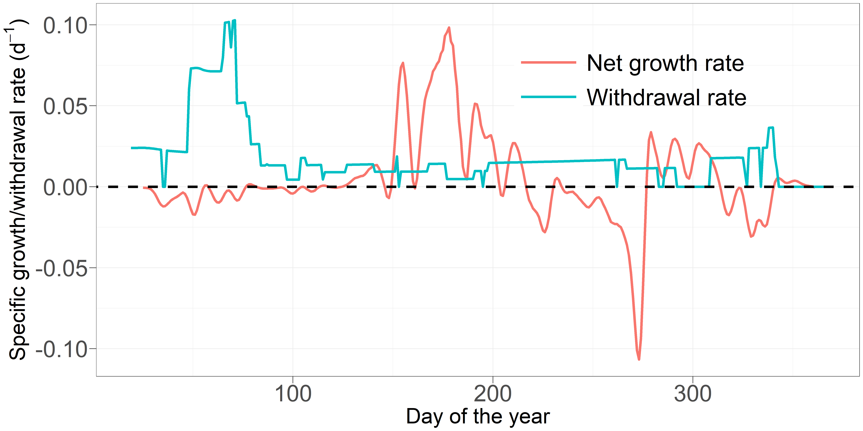

Fig S2. Comparison of net specific growth rates of P. rubescens in the reference scenario (scenario R), averaged over the depth layer from 10 to 12 m, with the specific water withdrawal rates from the same water layer. The dashed line indicates the rate of 0.

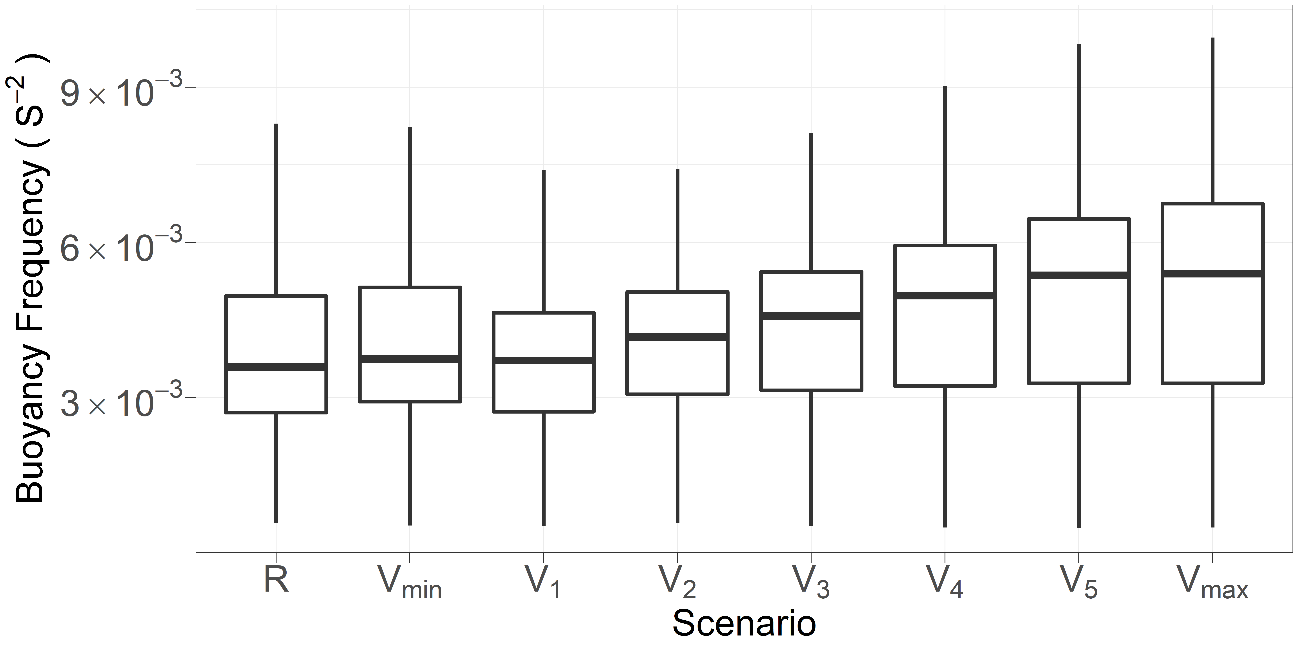
Fig S3. Average buoyancy frequency in the metalimnion (10 to 12 m, from day 180 to 240) under scenario R and V.

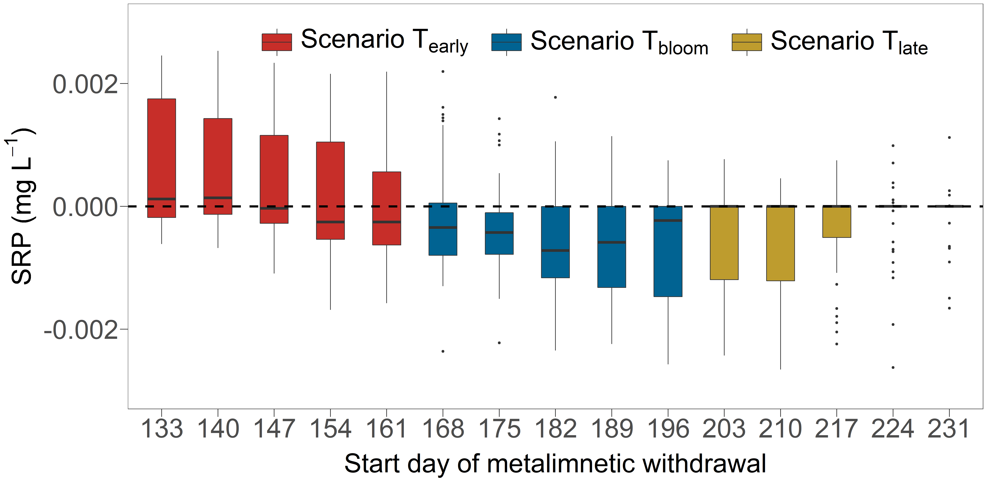
Fig S4. Difference in SRP concentration between the reference scenario and scenario T, in the metalimnion during summer (i.e., 10 to 12 m, from day 180 to 240). The horizontal axis shows the start day of the metalimnetic withdrawal, and vertical axis shows the difference of SRP between the reference scenario and the respective T-scenario (e.g., the first boxplot shows the results of scenario R-scenario T₁₃₃). The dashed line indicates the value of 0.

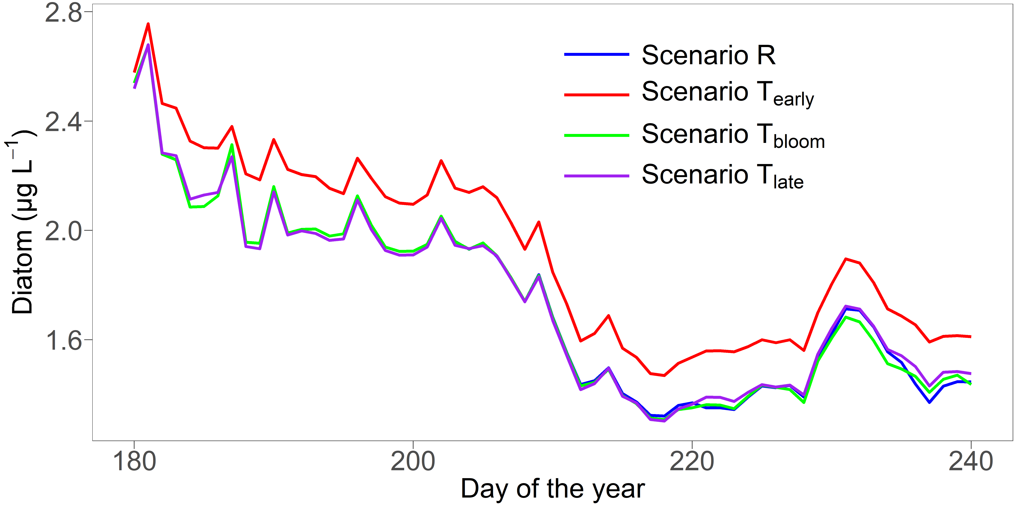
Fig S5. Vertically averaged concentration of diatoms (as chlorophyll a) during summer (day 180 to 240) for 2016 under scenario T. Each line indicates the mean result from 5 sub-scenarios included.

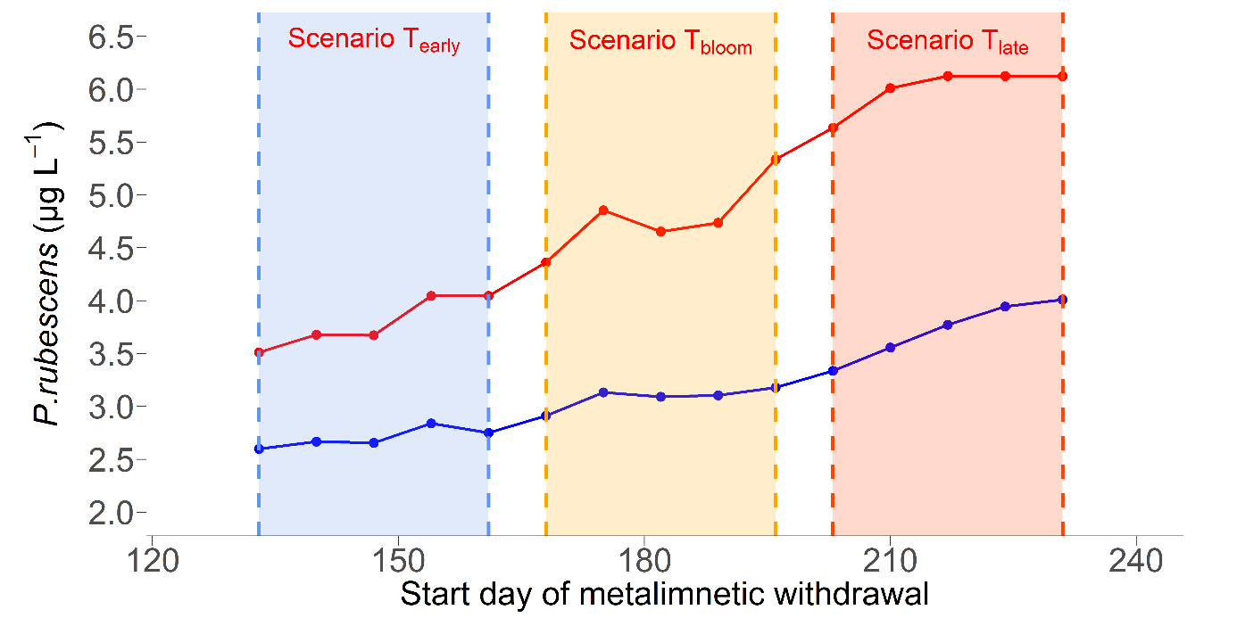
Fig S6. The same as Fig.5, but under scenario VT.

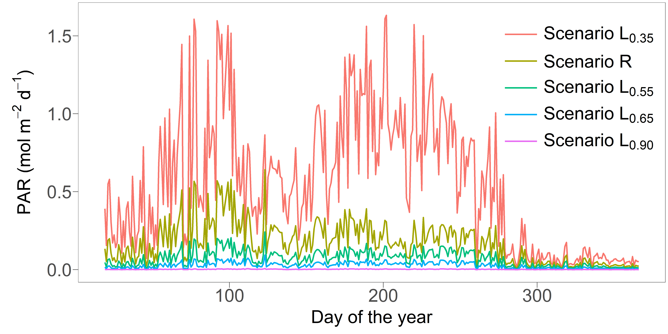
Fig S7. Average photosynthetically active radiation (PAR) in the metalimnion (10 to 12 m) under scenario R and L as outlined in Table 1.

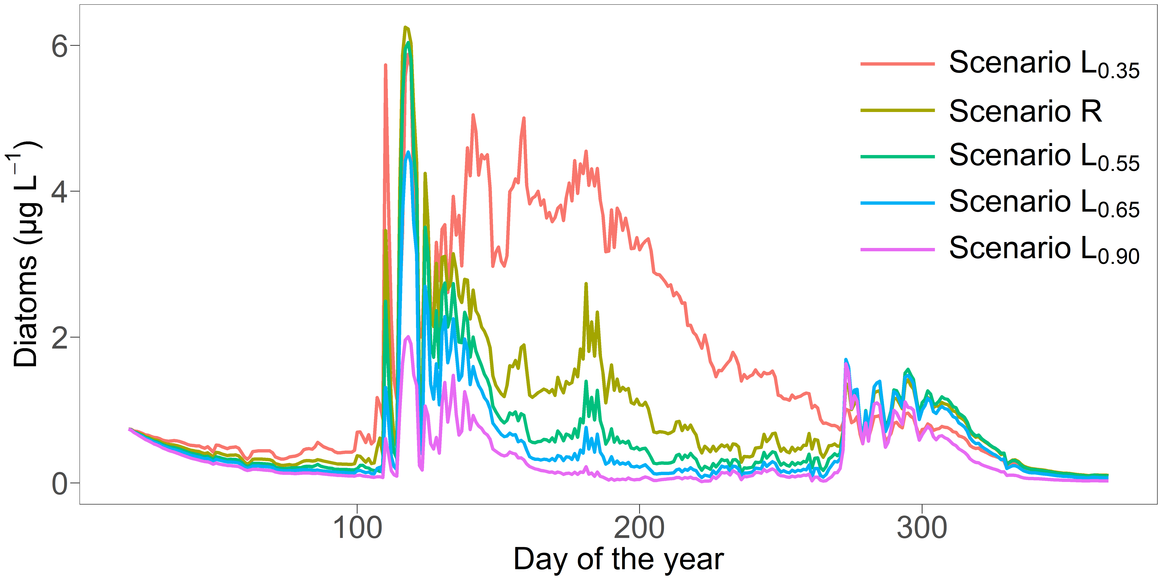

Fig S8. Average concentration of diatoms in the metalimnion (i.e., 10 to 12 m) under scenario R and L as outlined in Table 1.

