Fluorescence “Turn-Off” Sensing of Iron (III) Ions Utilizing Pyrazoline Based Sensor: Experimental and Computational Study
Promila Sharmaª, Shikha Bhogalª, Irshad Mohiuddin^{b}, Mohamad Yusufª, Ashok Kumar Malik^{a*}
ªDepartment of Chemistry, Punjabi University, Patiala -147002,Punjab,India
^{b}Department of Chemistry, Punjab University, Chandigarh-160014,Punjab, India
*Corresponding author: malik_chem2002@yahoo.co.uk (A.K.M)

Figure S1: Experimental FT-IR of CFM.
Figure S2: Experimental FT-IR of PFM.
Figure S3: Experimental ¹H-NMR of CFM.
Figure S4: Experimental ¹H-NMR of PFM.
Figure S5: Experimental ¹³C-NMR of CFM.
Figure S6: Experimental ¹³C-NMR of CFM.
Figure S7: Experimental GC-MS of CFM.
Figure S8: Experimental ESI-MS of PFM.
Figure S9: Fluorescent spectrum of PFM excited at different wavelengths.

Figure S10: FT-IR of PFM-Fe
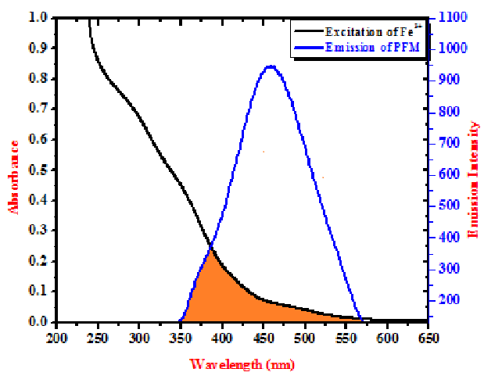
Figure S11: Excitation of Iron ions and Fluorescence Emission of PFM.
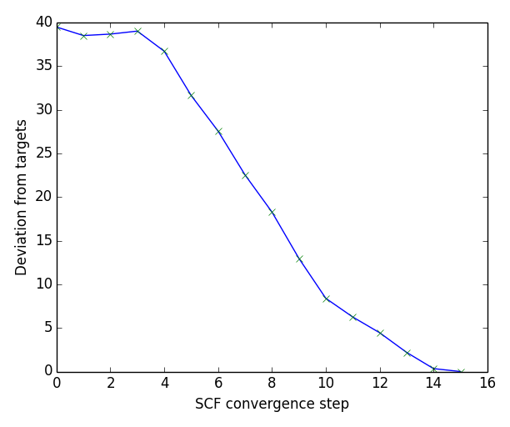
Figure 12a: Optimization process of PFM showing deviation from targets v/s convergence

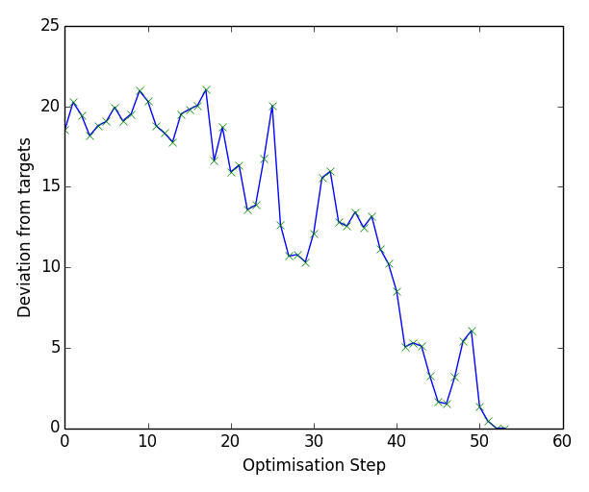
Figure 12b: Deviation from targets v/s Optimization steps of PFM
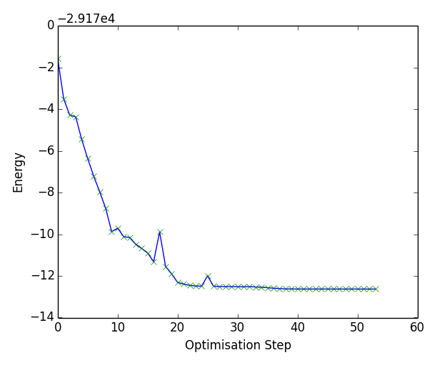
Figure 12c: Energy v/s Optimization steps of PFM.

Table S1: Binding energy with different metals.
Order No. | Metal ion | Energy of metal complex (a.u.) | Binding Energy (Kcal/mol)
1 | Zn²⁺ | -1136.1 | 878.5
2 | Hg²⁺ | -1113.6 | 941.3
3 | Cd²⁺ | -1118.9 | 1004
4 | Fe²⁺ | -1193.6 | 564.8
5 | Fe³⁺ | -1194.4 | -564.8
6 | Mn²⁺ | -1174.6 | 1004
7 | Co²⁺ | -1215.8 | 1004
8 | Cu²⁺ | -1267.1 | 878.5
9 | Ni²⁺ | -1239.7 | 1192
12 | Pb²⁺ | -1072.9 | 1820
11 | Al³⁺ | -1072.4 | 941.3

Section 1
S1. NMR analysis
Nuclear Magnetic Resonance (NMR) analysis for CFM and PFM was carried out at B3LYP/6-311G(d,p) level using the GIAO method in order to comparison between experimental and theoretical NMR data. The impact of the solvent was taken into account using Model IEFPCM/CDCl₃. The theoretical ¹H and ¹³C NMR chemical shifts of synthesized compounds have been compared with the experimental data. To clarify the relation between theoretical and experimental values of NMR chemical shift values, the experimental data are plotted versus computed values. As shown in Fig. S1.1 to S1.4, there is a good linear relationship (R²= 0.99) between experimental and theoretical B3LYP/6-311G(d,p) chemical shifts. The N and O atoms are more electronegative polarizes the electron distribution in its bond to adjacent carbon atom and decreases the chemical shifts value. On the basis of ¹³C NMR spectra in CFM, chemical shift for C18 is calculated 187.69 ppm, because it attaches to electronegative oxygen atoms which withdraw electronic density from the carbon atom and make it most deshielded. In the proton NMR of CFM, the olefinic protons theoretically appear at 7.75 ppm (H31) and 7.80 ppm (H32). In the ¹³C-NMR of PFM, carbon of C=N of pyrazoline ring resonated theoretically at 157.37 ppm and experimentally at 159.04 ppm. The doublet of doublet for H30, H33, and H45 has chemical shift values at 2.44 ppm, 2.52 ppm, and 5.74 ppm in the pyrazoline derivative. Thus, the calculated chemical shifts are in compliance with the experimental findings. There is a good agreement between experimental and theoretical chemical shift results for the title compound.
Figure S1.1: Correlation diagram for experimental and theoretical values of ¹H-NMR of CFM.
Figure S1.2: Correlation diagram for experimental and theoretical values of ¹H-NMR of PFM.
Figure S1.3: Correlation diagram for experimental and theoretical values of ¹³C-NMR of CFM.
Figure S1.4: Correlation diagram for experimental and theoretical values of ¹³C-NMR of PFM.
S2. Vibrational Analysis
The compounds CFM and PFM has 90 (32 atoms) and 129 (45 atoms) normal modes of fundamental vibration. Computational FTIR spectra of the title compounds are shown in figure S2.1 and S2.2. All the normal modes of the vibrations are assigned based on animated view of normal mode description and also in comparison with the literature. From our calculated data and experimental FTIR spectra, we observe similarities and differences between the experimental and the calculated frequencies by DFT/B3LYP method. Here we are discussing modes of vibration which are observed theoretically and experimentally. The aromatic C-H stretching vibration appears weakly between 3200-3100 cm⁻¹. Also, it was observed that the in-plane C-H bending vibrations normally appear in the range 1100-1400 cm⁻¹ in the substituted benzenes and the out-of-plane bending vibrations occur in the region 900-750 cm⁻¹ region. Usually, C=N stretching bands appears in the region 1650-1500 cm⁻¹ and the C-N stretching vibration usually appears in the region 1100-1300 cm⁻¹. In the present work, the absorption band located at 1152 cm⁻¹ and 1503 cm⁻¹ is attributed to C-N and C=N stretching vibration. Normally, the C-O and C=O stretching vibrations occur in the region 1260-1000 cm⁻¹ and 1750-1600 cm⁻¹. In the present study, the C-O and C=O stretching vibration is assigned at 1257 cm⁻¹ and 1723 cm⁻¹. The band observed between 1100-1000 cm⁻¹ and 960-750 cm⁻¹ was assigned to C-C-C stretching and C-C-H vibrations in DFT method. A good agreement is found between the theoretical and experimental data with R² value 0.99 (Figure S2.3 and S2.4).
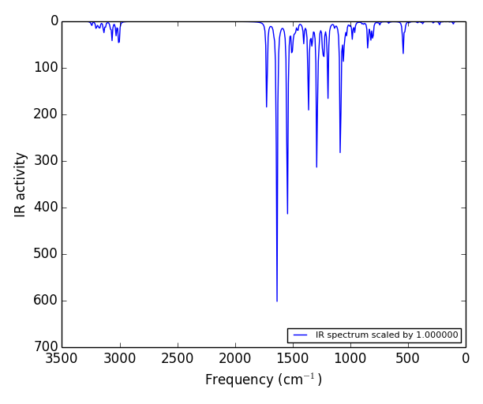
Figure S2.1: Theoretical FT-IR of CFM.
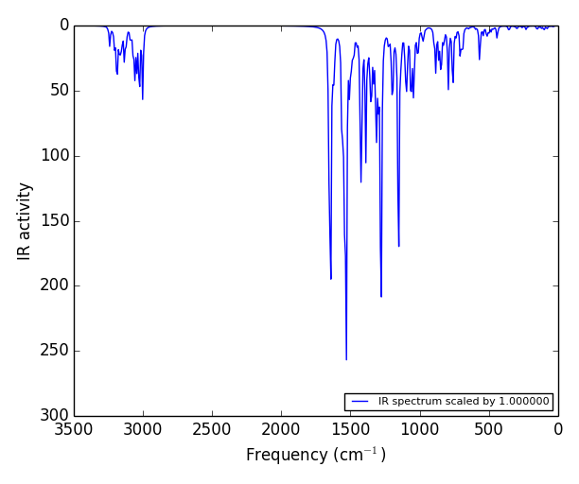
Figure S2.2: Theoretical FT-IR of PFM.
Figure S2.3: Correlation diagram for experimental and theoretical values of FT-IR of CFM.
Figure S2.4: Correlation diagram for experimental and theoretical values of FT-IR of PFM.
S3. NBO Analysis
The knowledge of Natural bond orbital and natural atomic orbital occupancies is used to explain the distribution or delocalization of electron density in atoms and in bonds between atoms. NBO method gives detailed information about interactions in both occupied and virtual orbital spaces for the study of intra- and intermolecular interactions. The second-order Fock matrix is the basis for evaluation of the the donor–acceptor interactions in the NBO analysis. The larger the stabilization energy expresses more donating tendency of electrons from donors to acceptors and the greater the extent of conjugation of the whole system. For PFM under study, the 570 NAO functions presenting occupancy and energy of the corresponding orbitals. The core, NMB and valance electrons contribute more than 99% for bonding by the natural population analysis. Moreover, Rydberg orbitals of the (NRB) set accounted for only 0.26% of the electron density. The natural charge distribution shows that highest negatively charged carbon was C-21= -0.614. For H, the slightly more positive charge is H-38= 0.226. For O5, O21, N31 and N32, the values were -0.455, -0.524, -0.239 and -0.254, respectively.
The stabilization energy (E(2)) was estimated with the help of donor (NBO (i)) and acceptor (NBO (j)) when the interaction energy exceeds a default threshold of 0.5 kcal mol⁻¹. Moreover remarkable interactions with E(2)>15 kcal mol⁻¹) are shown Table S3.1. Here, the highest stabilization energies are attributed to the π→π* and LP→π* intramolecular transitions. These calculated hyper conjugative interactions lead to create an intermolecular charge transfer which maintains the stability of the studied molecule.
Table S3.1: NBO Analysis of PFM at B3LYP/6-311G (d,p) in gas phase.
Order No. | Donor | Acceptor | E₍₂₎(kcalmol⁻¹)
1 | LP(N32) | π*(C34-N36) | 37.82
2 | LP(N32) | π*(C18-C31) | 30.33
3 | LP(O25) | π*(C10-C11) | 30.59
4 | LP(O5) | π*(C4-C3) | 29.70
5 | LP(O5) | π*(C1-C2) | 27.36
6 | π(C1-C2) | π*(C18-N31) | 19.52
7 | π(C8-C9) | π*(C10-C11) | 17.72
8 | π(C8-C9) | π*(C12-C13) | 22.05
9 | π(C11-C10) | π*(C8-C9) | 22.26
10 | π(C11-C10) | π*(C12-C13) | 17.24
11 | π(C12-C13) | π*(C10-C11) | 21.37
12 | π(C12-C13) | π*(C8-C9) | 18.18
13 | π(C34-C36) | π*(C35-C37) | 16.69
14 | π(C34-C36) | π*(C39-C41) | 23.18
15 | π(C35-C37) | π*(C34-C36) | 21.60
16 | π(C35-C37) | π*(C39-C41) | 17.40
17 | π(C39-C41) | π*( C34-C36) | 17.70
18 | π(C39-C41) | π*(C35-C37) | 22.23

S4. Thermodynamic properties
The values of some thermodynamic parameters (such as zero-point vibrational energy, thermal energy, specific heat capacity, rotational constants, and entropy) of CFM, PFM and PFM-Fe at 298.15K in ground state are listed in Table S4.1. All the thermodynamic data supply helpful information for the further study on the compounds. They can be used to compute the other thermodynamic energies and estimate directions of chemical reactions.

Table 4.1 Calculated Thermodynamics Parameters of Compounds.
Order | Property | B3LYP/321G | B3LYP/631G | B3LYP/6311G | B3LYP/6311G(d,p) | B3LYP/321G | B3LYP/631G | B3LYP/6311G | B3LYP/6311G(d,p) | B3LYP/ LANL2DZ
1 | Energy(a.u.) | -801.23 | -805.43 | -805.62 | -805.86 | -1066.29 | -1071.88 | -1072.12 | -1072.44 | -1194.4232
2 | Dipole moment(Debye) | 5.37 | 5.95 | 6.04 | 5.29 | 3.20 | 2.88 | 2.89 | 3.047 | 5.51
3 | Thermal Energy(Kcal/moles) | 171.362 | 171.51 | 170.19 | 169.531 | 244.622 | 245.0967 | 243.342 | 242.141 | 244.32
4 | Entropy(Cal mol-1 k-1) | 61.181 | 61.39 | 61.755 | 62.155 | 83.146 | 83.167 | 83.605 | 83.350 | 88.558
5 | Heat Capacity(Cv)(Cal mol-1 k-1) | 134.290 | 134.915 | 135.388 | 135.582 | 160.493 | 160.185 | 160.525 | 161.401 | 167.877
6 | Rotational Constant
 | A | 1.5483 | 1.5509 | 1.5592 | 1.5861 | 0.232302 | 0.23474 | 0.233344 | 0.24808 | 0.27813
 | B | 0.1240 | 0.12329 | 0.1236 | 0.1243 | 0.14134 | 0.13999 | 0.14104 | 0.13663 | 0.10460
 | C | 0.1149 | 0.11438 | 0.1143 | 0.1154 | 0.09661 | 0.09697 | 0.09736 | 0.9939 | 0.08132
7 | Zero point vibrational energy | 161.014 | 161.11 | 159.73 | 159.03 | 231.0706 | 231.544 | 299.735 | 228.455 | 229.718
8 | Degree of Freedom | 90 |  |  |  | 129 |  |  |  | 132

