Supplementary Table 1. Cross-sectional association of plasma GFAP with Aβ pathology, neurodegeneration, cerebral glucose metabolism and cognitive and functional performance. Relationships of plasma GFAP with Aβ pathology (represented by PiB-PET), neurodegeneration (represented by hippocampal volume and precuneus thickness), cerebral glucose metabolism (represented by FDG-PET) and cognition (represented by cognitive composite score, MMSE and CDR-SOB) utilising LMEMs adjusting for (A) sex (and education for cognition) with family as a random effect and (B) age and sex (and education for cognition) with family as a random effect. β: standardised coefficient; B: unstandardised coefficient; SE: B standard error. P<.05 was considered significant.
A. | All participants |  |  | Non-carriers |  |  | Mutation carriers
 | β (SE) | B (SEM) | P | β (SE) | B (SEM) | P | β (SE) | B (SEM) | P
PiB-PET | 0.59 (0.07) | 0.49 (0.05) | 1.00e-15 | -0.02 (0.11) | -0.15 (0.65) | .822 | 0.66 (0.09) | 0.5 (0.07) | 1.04e-10
Hippocampal volume | -0.47 (0.07) | -0.27 (0.04) | 2.30e-10 | -0.12 (0.11) | -0.08 (0.07) | .25 | -0.56 (0.09) | -0.3 (0.05) | 3.75e-08
Precuneus thickness | -0.47 (0.07) | -1.5 (0.22) | 9.69e-11 | -0.03 (0.11) | -0.1 (0.32) | .766 | -0.63 (0.08) | -2.04 (0.27) | 6.19e-11
FDG-PET | -0.22 (0.08) | -0.65 (0.22) | .004 | 0 (0.11) | 0.01 (0.3) | .982 | -0.27 (0.11) | -0.78 (0.3) | .011
Cognitive composite | -0.53 (0.07) | -0.4 (0.05) | 1.09e-12 | 0.03 (0.11) | 0.02 (0.09) | .791 | -0.64 (0.08) | -0.47 (0.06) | 1.72e-11
MMSE | -0.46 (0.07) | -0.07 (0.01) | 1.28e-10 | 0.11 (0.11) | 0.04 (0.04) | .288 | -0.51 (0.09) | -0.06 (0.01) | 9.42e-08
CDR-SOB | 0.55 (0.06) | 0.12 (0.01) | 1.00e-15 | 0.03 (0.11) | 0.04 (0.15) | .797 | 0.59 (0.08) | 0.11 (0.02) | 2.66e-10
 | Asymptomatic mutation carriers |  |  | Symptomatic mutation carriers
 | β (SE) | B (SEM) | P | β (SE) | B (SEM) | P
PiB-PET | 0.57 (0.11) | 0.43 (0.08) | 4.86e-06 | 0.47 (0.23) | 0.33 (0.16) | .056
Hippocampal volume | -0.22 (0.13) | -0.16 (0.09) | .081 | -0.33 (0.2) | -0.16 (0.1) | .122
Precuneus thickness | -0.34 (0.12) | -1.08 (0.38) | .007 | -0.67 (0.17) | -2.02 (0.51) | 9.76e-04
FDG-PET | 0.16 (0.13) | 0.41 (0.32) | .211 | -0.47 (0.19) | -1.22 (0.5) | .023
Cognitive composite | -0.17 (0.13) | -0.15 (0.11) | .179 | -0.63 (0.16) | -0.48 (0.12) | 7.26e-04
MMSE | 0.1 (0.13) | 0.04 (0.05) | .433 | -0.4 (0.18) | -0.03 (0.01) | .033
CDR-SOB | 0.05 (0.12) | 0.17 (0.38) | .669 | 0.47 (0.16) | 0.05 (0.02) | .008

B. | All participants |  |  | Non-carriers |  |  | Mutation carriers
 | β (SE) | B (SEM) | P | β (SE) | B (SEM) | P | β (SE) | B (SEM) | P
PiB-PET | 0.54 (0.07) | 0.45 (0.06) | 2.59e-13 | -0.05 (0.11) | -0.29 (0.66) | .660 | 0.55 (0.1) | 0.42 (0.08) | 5.23e-07
Hippocampal volume | -0.37 (0.08) | -0.22 (0.05) | 3.06e-06 | -0.08 (0.11) | -0.05 (0.07) | .510 | -0.35 (0.11) | -0.19 (0.06) | .001
Precuneus thickness | -0.37 (0.08) | -1.19 (0.25) | 5.53e-06 | 0.04 (0.11) | 0.11 (0.34) | .753 | -0.46 (0.11) | -1.49 (0.37) | 1.17e-04
FDG-PET | -0.1 (0.08) | -0.3 (0.23) | .187 | 0.05 (0.12) | 0.13 (0.31) | .686 | -0.1 (0.1) | -0.29 (0.28) | .301
Cognitive composite | -0.44 (0.08) | -0.33 (0.06) | 7.17e-08 | 0.08 (0.11) | 0.06 (0.09) | .497 | -0.47 (0.1) | -0.34 (0.08) | 2.65e-05
MMSE | -0.34 (0.07) | -0.05 (0.01) | 2.62e-06 | 0.11 (0.11) | 0.04 (0.04) | .301 | -0.23 (0.1) | -0.03 (0.01) | .024
CDR-SOB | 0.45 (0.07) | 0.1 (0.01) | 1.63e-10 | 0.04 (0.11) | 0.06 (0.15) | .686 | 0.33 (0.1) | 0.06 (0.02) | 7.15e-04
 | Asymptomatic mutation carriers |  |  | Symptomatic mutation carriers
 | β (SE) | B (SEM) | P | β (SE) | B (SEM) | P
PiB-PET | 0.54 (0.12) | 0.41 (0.09) | 3.21e-05 | 0.32 (0.25) | 0.23 (0.18) | .217
Hippocampal volume | -0.17 (0.13) | -0.12 (0.09) | .194 | -0.17 (0.21) | -0.08 (0.1) | .417
Precuneus thickness | -0.29 (0.14) | -0.91 (0.45) | .047 | -0.53 (0.22) | -1.6 (0.65) | .022
FDG-PET | 0.2 (0.13) | 0.5 (0.31) | .120 | -0.38 (0.19) | -1 (0.48) | .053
Cognitive composite | -0.1 (0.13) | -0.09 (0.12) | .440 | -0.54 (0.2) | -0.42 (0.15) | .013
MMSE | 0.11 (0.12) | 0.04 (0.05) | .396 | -0.12 (0.22) | -0.01 (0.02) | .586
CDR-SOB | 0.04 (0.12) | 0.11 (0.37) | .767 | 0.26 (0.19) | 0.03 (0.02) | .172

Supplementary Table 2. Optimal cut-off point, area under the curve (AUC), sensitivity, specificity, accuracy, negative predictive value (NPV) and positive predictive value (PPV) of GFAP in differentiating between Aβ- and Aβ+, calculated at the cut point which gives rise to Youden’s index in (A) all mutation carriers and (B) asymptomatic mutation carriers.

 | Optimal cut-off | AUC | Sensitivity | Specificity | Accuracy | NPV | PPV
A. All MC | 87.5 pg/mL | 0.839 | 0.795 | 0.886 | 0.838 | 0.795 | 0.886
B. Asymptomatic MC | 87.5 pg/mL | 0.769 | 0.696 | 0.909 | 0.821 | 0.811 | 0.842

Supplementary Table 3. Association of plasma GFAP with prospective neurodegeneration, cerebral glucose hypometabolism and cognitive and functional decline in mutation carriers. Relationships between plasma GFAP and change in neurodegeneration (represented by hippocampal volume and precuneus thickness), change in glucose metabolism (represented by FDG-PET) and change in cognition (represented by Clinical Dementia Rating – Sum of Boxes (CDR-SOB), Mini-Mental State Examination (MMSE) and a cognitive composite score) were assessed using LMEMs adjusting for age and sex (and education for cognition) with family as a random effect. Natural log GFAP values were used in the analyses. P<.05 was considered as statistically significant.
 | N | B | SEM | P
All participants
Hippocampal volume | 36 | -0.202 | 0.077 | .013
Precuneus thickness | 36 | -0.039 | 0.011 | .001
FDG-PET | 36 | -0.031 | 0.021 | .150
Cognitive composite | 36 | -0.035 | 0.052 | .500
MMSE | 38 | -0.722 | 0.341 | .041
CDR-SOB | 38 | 0.570 | 0.219 | .013

Supplementary Table 4. Cross-sectional association of serum GFAP with Aβ pathology, neurodegeneration, cerebral glucose metabolism and cognitive and functional performance. Relationships of serum GFAP with Aβ pathology (represented by PiB-PET), neurodegeneration (represented by hippocampal volume and precuneus thickness), cerebral glucose metabolism (represented by FDG-PET) and cognition (represented by cognitive composite score, MMSE and CDR-SOB) utilising LMEMs adjusting for (A) sex (and education for cognition) with family as a random effect and (B) age and sex (and education for cognition) with family as a random effect. β: standardised coefficient; B: unstandardised coefficient; SE: B standard error. P<.05 was considered significant.
A. | All participants |  |  | Non-carriers |  |  | Mutation carriers
 | β (SE) | B (SEM) | P | β (SE) | B (SEM) | P | β (SE) | B (SEM) | P
PiB-PET | 0.38 (0.12) | 0.32 (0.1) | .002 | 0.09 (0.19) | 0.59 (1.21) | .629 | 0.32 (0.18) | 0.25 (0.14) | .079
Hippocampal volume | -0.46 (0.12) | -0.26 (0.07) | <.001 | -0.53 (0.18) | -0.39 (0.14) | .009 | -0.64 (0.14) | -0.33 (0.07) | <.001
Precuneus thickness | -0.36 (0.13) | -1.28 (0.45) | .009 | -0.21 (0.19) | -0.64 (0.58) | .277 | -0.44 (0.16) | -1.66 (0.61) | .012
FDG-PET | -0.35 (0.13) | -1.1 (0.4) | .008 | -0.11 (0.18) | -0.34 (0.55) | .541 | -0.4 (0.18) | -1.4 (0.64) | .040
Cognitive composite | -0.59 (0.09) | -0.45 (0.07) | <.001 | -0.25 (0.17) | -0.27 (0.18) | .148 | -0.6 (0.12) | -0.42 (0.09) | <.001
MMSE | -0.45 (0.1) | -0.07 (0.02) | <.001 | -0.3 (0.2) | -0.17 (0.11) | .198 | -0.45 (0.14) | -0.05 (0.02) | .004
CDR-SOB | 0.46 (0.1) | 0.14 (0.03) | <.001 | -0.28 (0.17) | -1.56 (0.92) | .103 | 0.49 (0.14) | 0.12 (0.03) | .001

B. | All participants |  |  | Non-carriers |  |  | Mutation carriers
 | β (SE) | B (SEM) | P | β (SE) | B (SEM) | P | β (SE) | B (SEM) | P
PiB-PET | 0.37 (0.11) | 0.31 (0.09) | .002 | 0.1 (0.14) | 0.67 (0.88) | .457 | 0.09 (0.21) | 0.07 (0.17) | .663
Hippocampal volume | -0.39 (0.13) | -0.23 (0.07) | .004 | -0.18 (0.17) | -0.13 (0.13) | .313 | -0.5 (0.16) | -0.26 (0.08) | .006
Precuneus thickness | -0.27 (0.14) | -0.96 (0.48) | .055 | 0.23 (0.17) | 0.71 (0.53) | .190 | -0.32 (0.18) | -1.19 (0.66) | .088
FDG-PET | -0.34 (0.12) | -1.09 (0.37) | .005 | 0.01 (0.14) | 0.02 (0.41) | .952 | -0.3 (0.18) | -1.06 (0.63) | .103
Cognitive composite | -0.56 (0.09) | -0.43 (0.07) | <.001 | -0.12 (0.14) | -0.13 (0.15) | .394 | -0.51 (0.16) | -0.37 (0.12) | .004
MMSE | -0.38 (0.1) | -0.05 (0.01) | <.001 | -0.25 (0.15) | -0.14 (0.08) | .130 | -0.23 (0.14) | -0.03 (0.02) | .152
CDR-SOB | 0.4 (0.1) | 0.12 (0.03) | <.001 | -0.31 (0.13) | -1.71 (0.69) | .022 | 0.35 (0.15) | 0.09 (0.04) | .029
Supplementary Table 5. Cross-sectional association of CSF GFAP with Aβ pathology, neurodegeneration, cerebral glucose metabolism and cognitive and functional performance. Relationships of CSF GFAP with Aβ pathology (represented by PiB-PET), neurodegeneration (represented by hippocampal volume and precuneus thickness), cerebral glucose metabolism (represented by FDG-PET) and cognition (represented by cognitive composite score, MMSE and CDR-SOB) utilising LMEMs adjusting for (A) sex (and education for cognition) with family as a random effect and (B) age and sex (and education for cognition) with family as a random effect. β: standardised coefficient; B: unstandardised coefficient; SE: B standard error. P<.05 was considered significant.
A. | All participants |  |  | Non-carriers |  |  | Mutation carriers
 | β (SE) | B (SEM) | P | β (SE) | B (SEM) | P | β (SE) | B (SEM) | P
PiB-PET | 0.15 (0.13) | 0.08 (0.07) | .271 | -0.15 (0.14) | -0.81 (0.74) | .288 | 0.4 (0.21) | 0.19 (0.1) | .066
Hippocampal volume | -0.39 (0.12) | -0.15 (0.05) | .002 | -0.23 (0.14) | -0.25 (0.07) | .001 | -0.42 (0.19) | -0.13 (0.06) | .040
Precuneus thickness | -0.28 (0.13) | -0.66 (0.31) | .040 | -0.21 (0.19) | -0.58 (0.35) | .114 | -0.35 (0.21) | -0.82 (0.48) | .101
FDG-PET | -0.21 (0.13) | -0.45 (0.28) | .113 | -0.27 (0.13) | -0.63 (0.31) | .056 | -0.32 (0.23) | -0.69 (0.49) | .172
Cognitive composite | -0.34 (0.12) | -0.18 (0.06) | .006 | -0.24 (0.15) | -0.21 (0.13) | .115 | -0.46 (0.18) | -0.23 (0.09) | .016
MMSE | -0.29 (0.12) | -0.03 (0.01) | .019 | -0.08 (0.18) | -0.04 (0.08) | .646 | -0.41 (0.18) | -0.03 (0.02) | .034
CDR-SOB | 0.28 (0.12) | 0.06 (0.03) | .021 | 0.24 (0.14) | 1.07 (0.63) | .104 | 0.35 (0.18) | 0.06 (0.03) | .066

B. | All participants |  |  | Non-carriers |  |  | Mutation carriers
 | β (SE) | B (SEM) | P | β (SE) | B (SEM) | P | β (SE) | B (SEM) | P
PiB-PET | 0.16 (0.12) | 0.09 (0.07) | .199 | -0.15 (0.13) | -0.8 (0.67) | .245 | 0.2 (0.25) | 0.09 (0.12) | .446
Hippocampal volume | -0.29 (0.12) | -0.11 (0.05) | .022 | -0.34 (0.13) | -0.2 (0.08) | .018 | -0.28 (0.2) | -0.09 (0.06) | .171
Precuneus thickness | -0.17 (0.13) | -0.4 (0.31) | .202 | -0.1 (0.14) | -0.25 (0.35) | .495 | -0.2 (0.22) | -0.46 (0.51) | .380
FDG-PET | -0.22 (0.12) | -0.46 (0.25) | .075 | -0.21 (0.12) | -0.49 (0.29) | .106 | -0.21 (0.22) | -0.44 (0.48) | .366
Cognitive composite | -0.26 (0.12) | -0.14 (0.07) | .036 | -0.2 (0.14) | -0.17 (0.12) | .169 | -0.11 (0.22) | -0.06 (0.11) | .616
MMSE | -0.22 (0.11) | -0.02 (0.01) | .060 | -0.05 (0.18) | -0.02 (0.08) | .760 | -0.14 (0.19) | -0.01 (0.02) | .477
CDR-SOB | 0.21 (0.11) | 0.04 (0.02) | .072 | 0.24 (0.14) | 1.05 (0.61) | .099 | 0.07 (0.19) | 0.01 (0.03) | .703
Supplementary Figure 1. Plasma GFAP in APP, PSEN1 and PSEN2 mutation carriers. Two-tailed pairwise Student’s t-test comparisons of plasma GFAP in carriers of a mutation in PSEN1 (n=70), PSEN2 (n=8) or APP (n=20). No significant difference in plasma GFAP was found between PSEN1, PSEN2 and APP mutation carriers, when age and disease status (asymptomatic or symptomatic) were used as covariates.

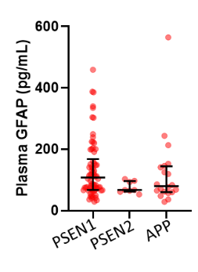

Supplementary Figure 2. Comparison of plasma GFAP levels are presented for non-carriers (NC, n=86), asymptomatic mutation carriers (aMC, n=66) and symptomatic mutation carriers (sMC, n=32). The middle line represents the median and the error bars represent the interquartile range. Natural log GFAP values were used to calculate P values from LMEMs adjusting for age and sex with family as a random effect with Tukey’s post hoc test for pairwise comparisons. P<.05 was considered statistically significant and tests were two-tailed.
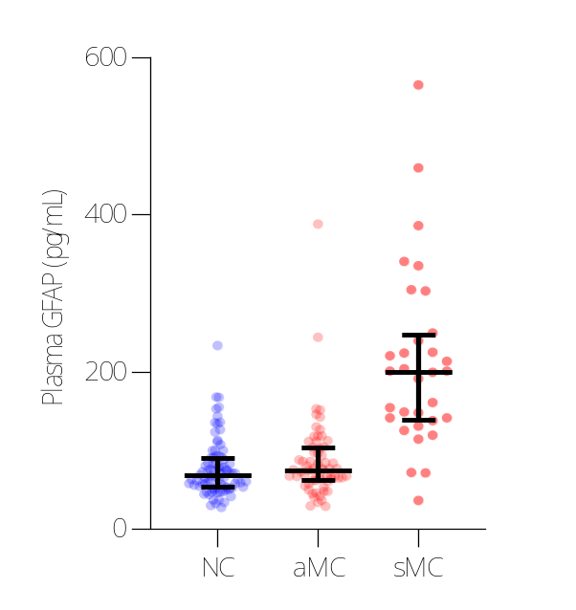
P<.0001
P<.0001
P=.035

Supplementary Figure 3. Overview GFAP EYO curves. Divergence curves for GFAP levels in (a) plasma, (b) serum and (c) CSF are presented. The middle line represents the median and shading is the 99% credible interval. The dotted vertical line is the point of diversion of GFAP levels between mutation carriers and non-carriers; for plasma GFAP at EYO -10.0; for serum GFAP at EYO -10.2, and for CSF GFAP there is no diversion.
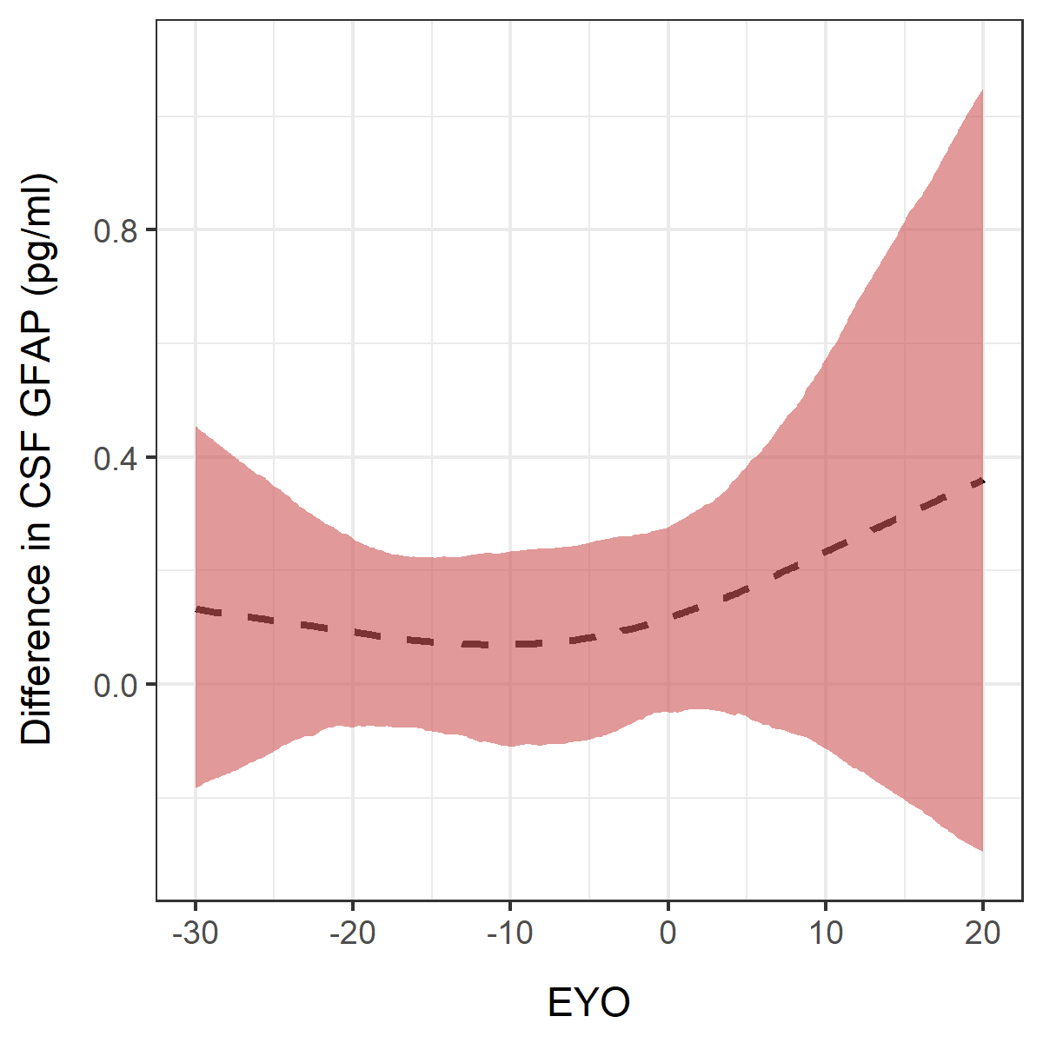a. b. c.

