Additional file 1
Reflecting on the research and revision process
This research project was initially driven by the observation that vaccinations qualify as an instance of Human Enhancement under nearly all used conceptualizations in the literature. In the midst of the COVID-19 pandemic and the passionate debate about vaccinations and an environment that contains a potentially deadly virus, we developed the idea that people not vaccinated against SARS-CoV-2 may reject this technology for reasons linked to the broader Human Enhancement debate. Among others, reasons for reluctance against the latter are concerns about naturalness and invasiveness. In that sense, we originally hypothesized that people not vaccinated against SARS-CoV-2 reject both the wider concept of Human Enhancement and the specific instance vaccinations due to their characteristics of being an invasive and unnatural technological intervention. To further elaborate on their perception of naturalness, we also collected data on their attitude toward a wide range of phenomena.
In an earlier version of this manuscript, we formulated these theses , somewhat polemically, specific on the topic, but low in precision on how the collected data actually may serves as evidence for them. However, after a fruitful discussion with the two anonymous reviewers, who suggested being more precise with our hypotheses, and a review of suggested literature, we reevaluated our data, models, and conclusions. We came to the insight that our research design and collected data do not support some of our conclusions and could not be interpreted as direct evidence to the level of specificity with which we formulated our first theses. Taking the reviewers’ concerns very seriously, we adjusted the drawn conclusions, recapitulated, and further explained our intentions when conducting the study.
We attempted to be more precise on the connection between our hypotheses and their operationalization within our study. This happened by giving additional thoughts on the underlying processes that may fuel the hypothesized link between concerns about naturalness, invasiveness, and vaccination behavior and how they relate to the debate about Human Enhancement. Reflecting on our initial idea and discussions when planning the study, we suggest that: “Reasons for rejecting vaccination against SARS-CoV-2 include a greater emphasis on the role of invasiveness and naturalness. If so, these derivations of general concerns about Human Enhancement might explain vaccination reluctance among the unvaccinated, but also possible rejection of Human Enhancement (H1).” This is different from our first hypotheses that: ” a) People who reject a vaccination against SARS-CoV-2 do so mainly because they see it as an unnatural and invasive technological intervention, b) these reasons are more emphasized derivation of the general concerns against Human Enhancement.” We consider our reformulation more differentiated, less polemic and not changing the alleged direction of effects. Hence, this approach allows for a more nuanced perspective on the hypothetical link between vaccination behavior and reservations against Human Enhancement while also touching on the suspected underlying evaluation processes. In an attempt to test for the reformulated hypotheses, we then redesigned and recalculated our statistical models when necessary and reported them in the manuscript. These findings were then discussed on how they relate to our hypothesis more deeply.
We want to stress that we did not change our assumptions about the direction of effects and did not reformulate with the intention to fit them to our findings better. We evaluated each statistical analysis from the first version of our manuscript on whether they should be recalculated and did so if necessary. In both the original and revised version of the manuscript, statistical analyses were always conducted after formulating the hypotheses they referred to.
While we deem a direct causality between concerns about unnaturalness and invasiveness highly probable, our research design could only reveal the alleged link but provides no further information on causality. We acknowledge this limitation within the manuscript. Nevertheless, re-newed statistical analyses were conducted to provide as much evidence as possible under the given operationalization. Conclusions were also reevaluated based on the new findings and the limitations that emerged due to the necessary choices when operationalizing. These limitations are certainly aggravated due to the dynamic of the pandemic situation and the need to balance robustness and quickness during data collection. Limitations were and are also discussed in the manuscript.
This reflection on the research process is reported for the sake of transparency and to showcase the iterative approach with which we tried to shine light on the alleged connection between vaccination behavior and attitude toward naturalness, invasiveness, and Human Enhancement. Issues that, in this particular combination, have experienced little empirical attention.
We sincerely thank the reviewers for their comments and the opportunity to improve our manuscript in the subsequent creative process. They greatly enhanced the communication quality of our findings, helped us get a better grip on the data, and allowed for more differentiated models and subsequent conclusions.
Changes made: To do justice to the elaboration of our hypotheses, we recalculated our statistical models while introducing new interaction terms that reflect vaccination behavior (e.g., vaccination status). We also added naturalness attitude to the models that predicted willingness to use and displayed them in more detail to make the iterative process more comprehensible. Models to predict attitude on Human Enhancement were newly calculated. Various models, meant to reveal the percentage of mediation between vaccination status and variables like naturalness attitude were exchanged against models that predicted the attitude toward Human Enhancement. This was done in the context of the comments of one of the reviewers and because the new models were deemed a more suitable test for our renewed hypotheses. We also examined invasiveness and naturalness ratings of examples of cognitive enhancement methods.
We added additional figure panels to visualize model prediction of vaccination intention better.
General
All models ran four sample chains, 10,000 iterations each with 5,000 warmup iterations. All models converged. We used rather uninformative priors due to missing knowledge about the adequacy of the items used here and the novel population and situation.
Current and planned doses
Received Doses | Planned Doses | n
0 Doses | 0 Doses | 54
0 Doses | Undecided | 1
0 Doses | 2 Doses | 2
0 Doses | NA | 1
1 Dose | 2 Doses | 1
1 Dose | 3 Doses | 2
1 Dose | As needed | 1
2 Doses | Undecided | 1
2 Doses | 2 Doses | 15
2 Doses | 3 Doses | 42
2 Doses | As needed | 4
2 Doses | NA | 3
3 Doses | Undecided | 1
3 Doses | 3 Doses | 88
3 Doses | 3+ | 20
3 Doses | As needed | 69
3 Doses | NA | 9

Enhancement ratings:
Estimating willingness to use:
We chose a cumulative mixed-model Bayesian ordered logistic regression to account for the highly non-normal distribution of Use ratings (Figure 1). Unlike other surveys, the intervention characteristics were rated by the participants themselves and were not pre-set by the researchers (besides frequency of application). The interaction terms were implemented to reflect the hypothesized different salience of attributes. The density of willingness to use and thresholds suggests that people are generally more adverse to using the enhancement at all. Similar findings are reported by Sattler et al. [2]. Priors for the predictors: normal distributed, μ = 0, σ = 2. Thresholds and SD = Student’s t-distribution, v = 3, μ = 0, σ = 2.5. Values were non-scaled and not centered due to the necessity for the outcome to be a positive value. Priors were chosen to reflect this.
Figure 1. Enhancement ratings. Error bars indicate 95% Confidence Intervals (CIs). Döbler and Carbon (2021) is a study using the same examples [1].
The following pages feature more detailed information about the models presented in the manuscript. First, those that assessed all possible interventions and then those that only used the ones with parallel frequencies.

All Interventions | Model 1 |  |  |  | Model 2 |  |  |  | Model 3 |  |  |  | Model 4 |  |  |  | Model 5
 | Use |  |  |  | Use |  |  |  | Use |  |  |  | Use |  |  |  | Use
Predictors | Odds Ratios |  | CI (95%) |  | Odds Ratios |  | CI (95%) |  | Odds Ratios |  | CI (95%) |  | Odds Ratios |  | CI (95%) |  | Odds Ratios |  | CI (95%)
Intercept[1] | 2.37 |  | 0.47 – 11.94 |  | 11.77 |  | 2.09 – 66.84 |  | 2.9 |  | 0.46 – 17.55 |  | 2.55 |  | 0.31 – 19.21 |  | 2.02 |  | 0.13 – 29.30
Intercept[2] | 6.06 |  | 1.20 – 30.41 |  | 31.52 |  | 5.63 – 179.72 |  | 7.81 |  | 1.25 – 47.79 |  | 6.87 |  | 0.84 – 51.50 |  | 5.47 |  | 0.35 – 79.27
Intercept[3] | 14.24 |  | 2.82 – 71.83 |  | 76.4 |  | 13.63 – 435.82 |  | 19.07 |  | 3.04 – 118.33 |  | 16.76 |  | 2.06 – 125.47 |  | 13.32 |  | 0.84 – 194.46
Intercept[4] | 33.79 |  | 6.68 – 171.61 |  | 185.58 |  | 32.99 – 1060.42 |  | 46.17 |  | 7.37 – 286.00 |  | 40.64 |  | 5.00 – 308.28 |  | 32.37 |  | 2.03 – 470.70
Intercept[5] | 101.08 |  | 19.81 – 511.10 |  | 563.26 |  | 99.33 – 3278.71 |  | 139.77 |  | 22.28 – 871.05 |  | 122.97 |  | 15.25 – 935.54 |  | 98.35 |  | 6.15 – 1417.71
Intercept[6] | 240.71 |  | 47.22 – 1223.75 |  | 1358.28 |  | 241.07 – 7898.11 |  | 336.74 |  | 53.62 – 2114.97 |  | 295.82 |  | 36.56 – 2274.25 |  | 236.49 |  | 14.91 – 3430.31
Inv | 0.76 |  | 0.72 – 0.81 |  | 0.76 |  | 0.72 – 0.80 |  | 0.59 |  | 0.52 – 0.66 |  | 0.59 |  | 0.52 – 0.67 |  | 0.59 |  | 0.52 – 0.67
Nat | 1.61 |  | 1.52 – 1.71 |  | 2.53 |  | 2.29 – 2.80 |  | 2.23 |  | 1.99 – 2.50 |  | 2.23 |  | 1.99 – 2.51 |  | 2.24 |  | 2.00 – 2.52
Att_HE | 1.44 |  | 1.23 – 1.68 |  | 1.48 |  | 1.27 – 1.73 |  | 1.47 |  | 1.25 – 1.72 |  | 1.41 |  | 1.06 – 1.89 |  | 1.41 |  | 1.05 – 1.88
Nat. Att. | 0.97 |  | 0.94 – 0.99 |  | 0.96 |  | 0.94 – 0.99 |  | 0.97 |  | 0.94 – 0.99 |  | 0.96 |  | 0.94 – 0.99 |  | 0.96 |  | 0.90 – 1.01
Application: Frequent | 0.72 |  | 0.08 – 6.86 |  | 0.78 |  | 0.08 – 8.19 |  | 0.83 |  | 0.07 – 9.45 |  | 0.81 |  | 0.07 – 9.18 |  | 0.8 |  | 0.08 – 9.11
Application: Once | 5.31 |  | 4.40 – 6.43 |  | 5.84 |  | 4.82 – 7.10 |  | 6.11 |  | 5.02 – 7.40 |  | 6.1 |  | 5.05 – 7.40 |  | 6.1 |  | 5.04 – 7.38
Vaccinated: Vaccinated | 2.24 |  | 1.25 – 4.06 |  | 16.56 |  | 8.11 – 34.25 |  | 2.8 |  | 1.01 – 7.83 |  | 2.31 |  | 0.45 – 11.09 |  | 1.77 |  | 0.13 – 24.39
VaccinatedVaccinated:Nat |  |  |  |  | 0.57 |  | 0.51 – 0.62 |  | 0.66 |  | 0.59 – 0.75 |  | 0.66 |  | 0.59 – 0.75 |  | 0.66 |  | 0.58 – 0.75
VaccinatedVaccinated:Inv |  |  |  |  |  |  |  |  | 1.37 |  | 1.20 – 1.56 |  | 1.37 |  | 1.20 – 1.56 |  | 1.37 |  | 1.20 – 1.56
VaccinatedVaccinated:Att_HE |  |  |  |  |  |  |  |  |  |  |  |  | 1.06 |  | 0.76 – 1.47 |  | 1.06 |  | 0.76 – 1.48
VaccinatedVaccinated:Nat. Att |  |  |  |  |  |  |  |  |  |  |  |  |  |  |  |  | 1.01 |  | 0.95 – 1.07
Random Effects
σ² | 0.9 |  |  |  | 0.99 |  |  |  | 1 |  |  |  | 0.99 |  |  |  | 1
τ₀₀ | 4.39 |  |  |  | 4.30 |  |  |  | 4.29 |  |  |  | 4.30 |  |  |  | 4.29
ICC | 0.17 |  |  |  | 0.19 |  |  |  | 0.19 |  |  |  | 0.19 |  |  |  | 0.19
N | 8 _{Art} |  |  |  | 8 _{Art} |  |  |  | 8 _{Art} |  |  |  | 8 _{Art} |  |  |  | 8 _{Art}
 | 314 _{id} |  |  |  | 314 _{id} |  |  |  | 314 _{id} |  |  |  | 314 _{id} |  |  |  | 314 _{id}
Observations | 3,454 |  |  |  | 3,454 |  |  |  | 3,454 |  |  |  | 3,454 |  |  |  | 3,454
Marginal R² / Conditional R² | 0.377 / 0.648 |  |  |  | 0.375 / 0.663 |  |  |  | 0.372 / 0.665 |  |  |  | 0.373 / 0.665 |  |  |  | 0.372 / 0.665
Interventions with parallel frequences |  | Model 6 |  |  |  | Model 7 |  |  |  | Model 8 |  |  |  | Model 9 |  |  |  | Model 10
Predictors |  | Odds Ratios |  | CI (95%) |  | Odds Ratios |  | CI (95%) |  | Odds Ratios |  | CI (95%) |  | Odds Ratios |  | CI (95%) |  | Odds Ratios |  | CI (95%)
Intercept[1] |  | 2.15 |  | 0.17 – 28.28 |  | 8.27 |  | 0.59 – 139.08 |  | 2.9 |  | 0.15 – 54.48 |  | 1.34 |  | 0.06 – 29.91 |  | 0.27 |  | 0.01 – 11.64
Intercept[2] |  | 6.96 |  | 0.54 – 92.69 |  | 28.16 |  | 2.05 – 476.55 |  | 9.95 |  | 0.50 – 184.96 |  | 4.66 |  | 0.20 – 102.71 |  | 0.93 |  | 0.02 – 41.23
Intercept[3] |  | 21.71 |  | 1.66 – 292.76 |  | 90.98 |  | 6.58 – 1535.09 |  | 32.31 |  | 1.62 – 600.96 |  | 15.13 |  | 0.66 – 336.52 |  | 3.07 |  | 0.06 – 132.78
Intercept[4] |  | 63.02 |  | 4.76 – 848.00 |  | 270.1 |  | 19.07 – 4617.81 |  | 95.51 |  | 4.74 – 1820.89 |  | 44.98 |  | 2.01 – 1002.85 |  | 9.09 |  | 0.19 – 398.57
Intercept[5] |  | 310.3 |  | 23.13 – 4175.53 |  | 1354.29 |  | 96.62 – 23525.82 |  | 478.59 |  | 24.32 – 9147.26 |  | 225.26 |  | 10.04 – 5077.37 |  | 46.19 |  | 0.97 – 2030.32
Intercept[6] |  | 1049.64 |  | 79.16 – 14562.18 |  | 4698.96 |  | 331.59 – 81443.56 |  | 1652.67 |  | 80.64 – 32283.93 |  | 777.88 |  | 34.64 – 18045.19 |  | 159.32 |  | 3.38 – 7112.51
Inv |  | 0.63 |  | 0.56 – 0.70 |  | 0.63 |  | 0.57 – 0.70 |  | 0.51 |  | 0.41 – 0.64 |  | 0.52 |  | 0.41 – 0.65 |  | 0.55 |  | 0.43 – 0.69
Nat |  | 1.87 |  | 1.68 – 2.09 |  | 3.2 |  | 2.66 – 3.87 |  | 2.99 |  | 2.44 – 3.68 |  | 3.03 |  | 2.48 – 3.73 |  | 3.15 |  | 2.55 – 3.93
Att_HE |  | 1.84 |  | 1.39 – 2.44 |  | 1.9 |  | 1.43 – 2.54 |  | 1.88 |  | 1.41 – 2.53 |  | 1.42 |  | 0.86 – 2.29 |  | 1.44 |  | 0.87 – 2.37
Nat. Att |  | 0.94 |  | 0.90 – 0.99 |  | 0.93 |  | 0.89 – 0.98 |  | 0.93 |  | 0.89 – 0.98 |  | 0.93 |  | 0.89 – 0.98 |  | 0.88 |  | 0.81 – 0.97
Application: Once |  | 10.9 |  | 8.48 – 14.03 |  | 12.18 |  | 9.45 – 15.76 |  | 12.66 |  | 9.82 – 16.44 |  | 12.72 |  | 9.81 – 16.50 |  | 12.64 |  | 9.78 – 16.46
Vaccinated: Vaccinated |  | 7.8 |  | 2.83 – 22.83 |  | 58.65 |  | 17.42 – 208.26 |  | 16.12 |  | 2.89 – 91.25 |  | 4.82 |  | 0.39 – 51.82 |  | 0.85 |  | 0.03 – 23.44
VaccinatedVaccinated:Nat |  |  |  |  |  | 0.5 |  | 0.41 – 0.60 |  | 0.54 |  | 0.43 – 0.67 |  | 0.53 |  | 0.43 – 0.66 |  | 0.51 |  | 0.41 – 0.64
VaccinatedVaccinated:Inv |  |  |  |  |  |  |  |  |  | 1.29 |  | 1.01 – 1.66 |  | 1.26 |  | 0.99 – 1.62 |  | 1.2 |  | 0.92 – 1.56
VaccinatedVaccinated:Att_HE |  |  |  |  |  |  |  |  |  |  |  |  |  | 1.47 |  | 0.86 – 2.51 |  | 1.39 |  | 0.81 – 2.43
VaccinatedVaccinated:Nat. Att |  |  |  |  |  |  |  |  |  |  |  |  |  |  |  |  |  | 1.07 |  | 0.98 – 1.18
Random Effects
σ² |  | 0.88 |  |  |  | 0.98 |  |  |  | 1.00 |  |  |  | 0.97 |  |  |  | 1.00
τ₀₀ |  | 4.69 |  |  |  | 4.59 |  |  |  | 4.57 |  |  |  | 4.6 |  |  |  | 4.57
ICC |  | 0.16 |  |  |  | 0.18 |  |  |  | 0.18 |  |  |  | 0.17 |  |  |  | 0.18
N |  | 3 _{Art} |  |  |  | 3 _{Art} |  |  |  | 3 _{Art} |  |  |  | 3 _{Art} |  |  |  | 3 _{Art}
 |  | 314 _{id} |  |  |  | 314 _{id} |  |  |  | 314 _{id} |  |  |  | 314 _{id} |  |  |  | 314 _{id}
Observations |  | 1,884 |  |  |  | 1,884 |  |  |  | 1,884 |  |  |  | 1,884 |  |  |  | 1,884
Marginal R² / Conditional R² |  | 0.489 / 0.802 |  |  |  | 0.488 / 0.810 |  |  |  | 0.488 / 0.810 |  |  |  | 0.490 / 0.810 |  |  |  | 0.489 / 0.811

Histograms for the willingness to use cognitive enhancement interventions
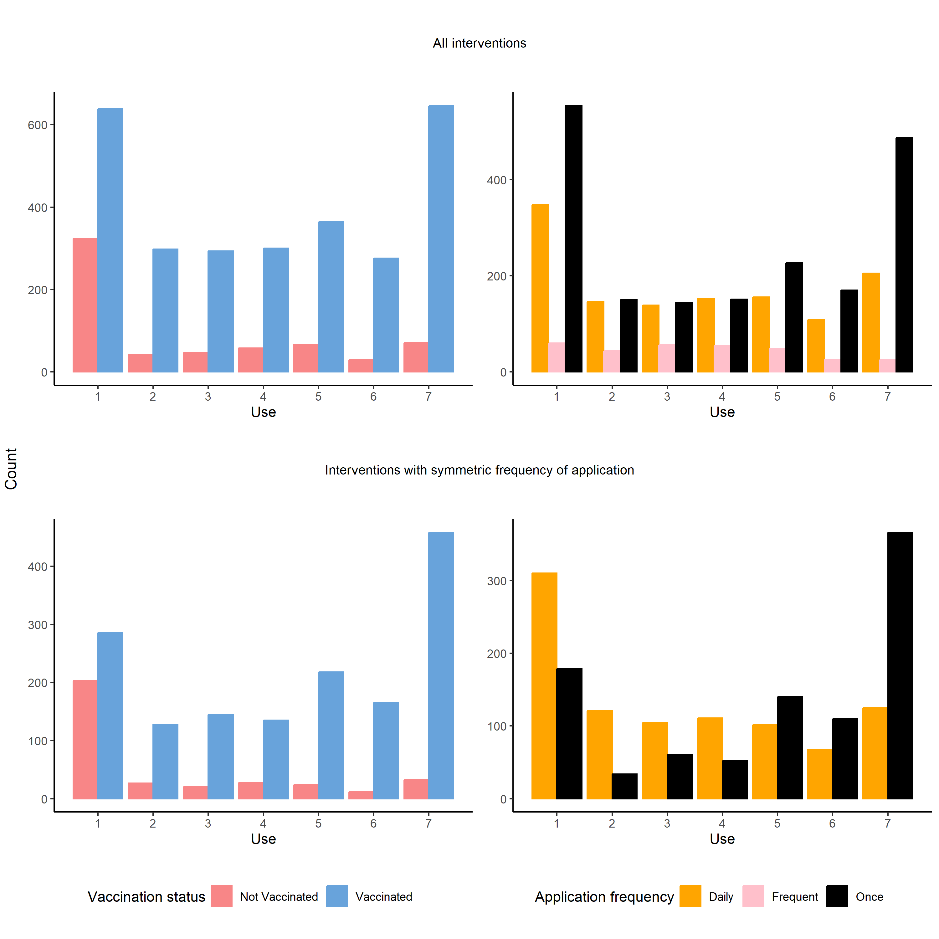

Analysis of the Attitude toward vaccination / Human Enhancement:
We chose vaccination status as binary variable over the exact number of doses due to small size of the “1 Dose group”. Priors for the predictors were set as being informative, normal distributed with μ = 0 and σ = 1. For the intercept, the brms default settings used a Student’s t-distribution (v = 3, μ = 0.7 and σ = 2.5) and for SD a Student’s t-distribution (v = 3, μ = 0 and σ = 2.5). Family = Gaussian.

Differences and distribution of items:
Figure 2 Differences between vaccinated and unvaccinated participants. Bold labels: differences are significant p < .05, and the credible interval of posterior differences does not include 0. Figure D: Minus sign behind questions denotes reverse coding. Values are scattered for visibility.

Wanting more doses of vaccine
As the exact number of received doses is of interest here, it was decided to implement the respective predictor and not the general vaccination status. The number of received doses was implemented as a factor to evaluate differences between the groups. Note that the 1 Dose group only contains four individuals. Priors for the predictors were set as being uninformative, normally distributed with μ = 0 and σ = 1. For the intercept, the brms default settings used a Student’s t-distribution (v = 3, μ = 0 and σ = 2.5). Family = Bernoulli.
A model dropping attitude on vaccination and number of received doses had a poorer fit than the compared first model (Loo difference = -25.1 (5.8)). In this model, credible intervals around the estimated Odds ratio always included 1. The only exception was the Support of Disease control measures OR = 3.25, 95%CI [2.15, 5.06].
Predicting exact numbers of planned vaccine dose
To avoid logical contradiction between current and desired doses (Boostered participants can only plan to get three or more doses, while people with two doses can desire two or more. In an ordered cumulative logistic regression, the predictor of having had three doses cannot be interpreted on its effect of planning two doses), the data was split. Priors for the predictors were considered uninformative, normally distributed with μ = 0 and σ = 1. For the intercept, the brms default settings used a Student’s t-distribution (v = 3, μ = 0 and σ = 2.5).

Items used in the different scales
Question Block |  | Item
Attitude toward … |  | Human interference with nature | Genetic manipulation of animals
Attitude toward … |  | Human Enhancement | Genetic manipulation of humans
Attitude toward … |  | Efforts to colonize space | Anthroposophy
Attitude toward … |  | Vaccinations | Homeopathy
Attitude toward … |  | Genetic manipulation of plants | Healing practitioners
Naturalness attitude |  | Humans and nature have separated too much | The self-healing powers of the body are underestimated
Naturalness attitude |  | Humans are the crown of creation- | There are some things in the world that humans should not research
Naturalness attitude |  | What is natural is also good | Humans should stop trying to control nature
Naturalness attitude |  | The so-called conventional medicine (Schulmedizin) is unnatural
Effects of vaccination status |  | I feel relieved | I feel vulnerable-
Effects of vaccination status |  | I am careful not to get infected | My social environment reacts negatively to my vaccination status-
Effects of vaccination status |  | My vaccination status gives me back possibilities | I feel left out-
Effects of vaccination status |  | The disease appears less dangerous to me | I feel better than before the vaccination
Effects of vaccination status |  | I feel stressed- | I feel technologically enhanced
Effects of vaccination status |  | I am relaxed as I go through the world
Support of disease control measures |  | General vaccine mandate | Access to certain areas only if tested, vaccinated, or recovered
Support of disease control measures |  | Vaccine mandate for certain occupations | Access to certain areas only if vaccinated or recovered
Support of disease control measures |  | Closing of schools | Cancellation of mass and cultural events
Support of disease control measures |  | Mask mandate | Restrictions for gastronomical enterprises
Support of disease control measures |  | Social meeting restrictions | Curfews
Support of disease control measures |  | Mandatory testing | Strict quarantine rules
Improvements after (possible) first dose |  | Feelings of safety
Improvements after (possible) first dose |  | Fear of infection
Improvements after (possible) first dose |  | Mental stress
Improvements after (possible) first dose |  | Distrust of others
Improvements after (possible) first dose |  | Activity level
Note. Anthroposophy is an esoteric philosophy founded by Rudolf Steiner. It consists of a set of theses mainly concerned with the individual’s spiritual development. It is a major part of Waldorf education, which is mainly taught at “Waldorf schools.” Germany hosts the highest number of these schools, followed by the U.S. and the Netherlands (https://www.freunde-waldorf.de/fileadmin/user_upload/images/Waldorf_World_List/Waldorf_World_List.pdf). Alternative healing practitioners are part of the German health care system since 1939. They are recognized by law to conduct specific therapies. However, with regularities differing from state to state, no formal education is needed, but only an exam held by health authorities. Alternative healing practitioners are commonly known for focusing on alternative and naturopathic approaches to medicine. Items with an - were reverse coded after being identified as negatively correlated with the first component of principal component analysis. This was done using the check.keys method of the alpha function in the R psych (2.1.9.) package [3].

References
1. Döbler NA, Carbon C-C. Vaccination against SARS-CoV-2: A human enhancement story. Translational Medicine Communications 2021. doi:10.1186/s41231-021-00104-2.
2. Sattler S, Forlini C, Racine E, Sauer C. Impact of contextual factors and substance characteristics on perspectives toward cognitive enhancement. PloS one. 2013;8:e71452. doi:10.1371/journal.pone.0071452.
3. Revelle W. psych: Procedures for psychological, psychometric, and personality research. 2021.

