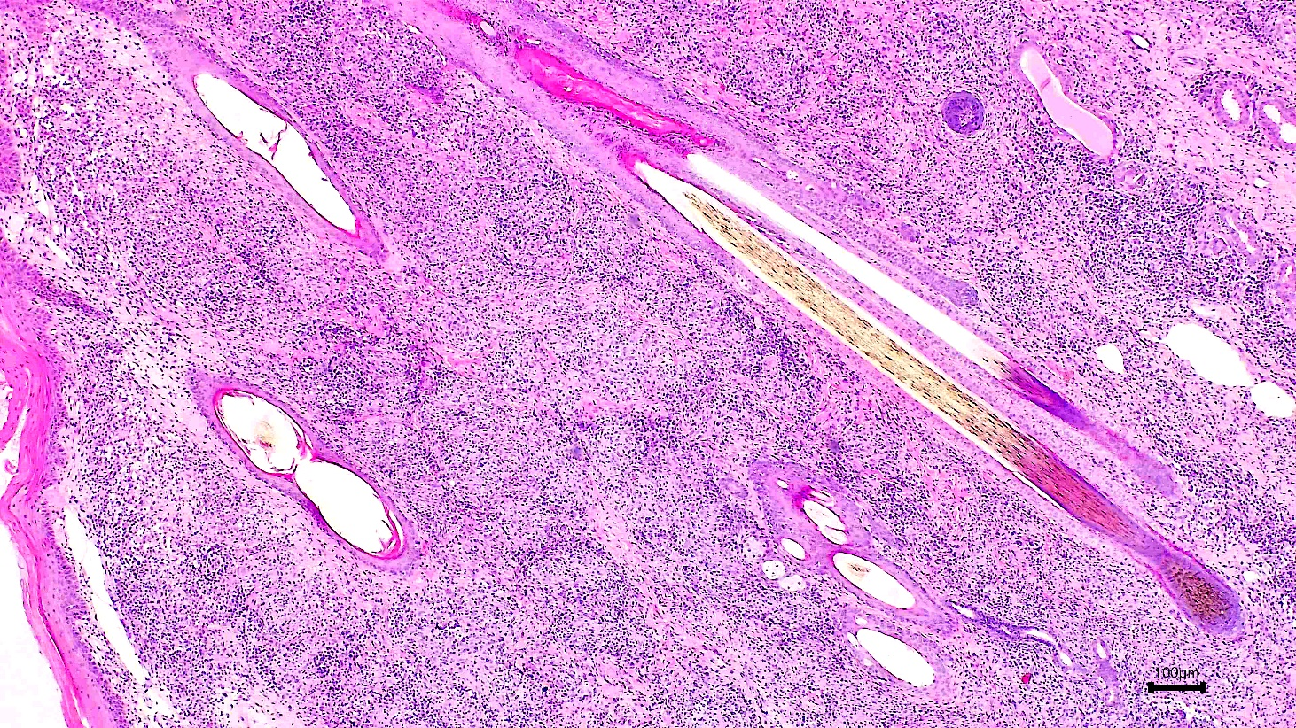
a

Figure 1a. Skin histopathology from dog 1 showing granulomatous dermatitis. Hematoxylin and eosin staining; Bar = 100 um.

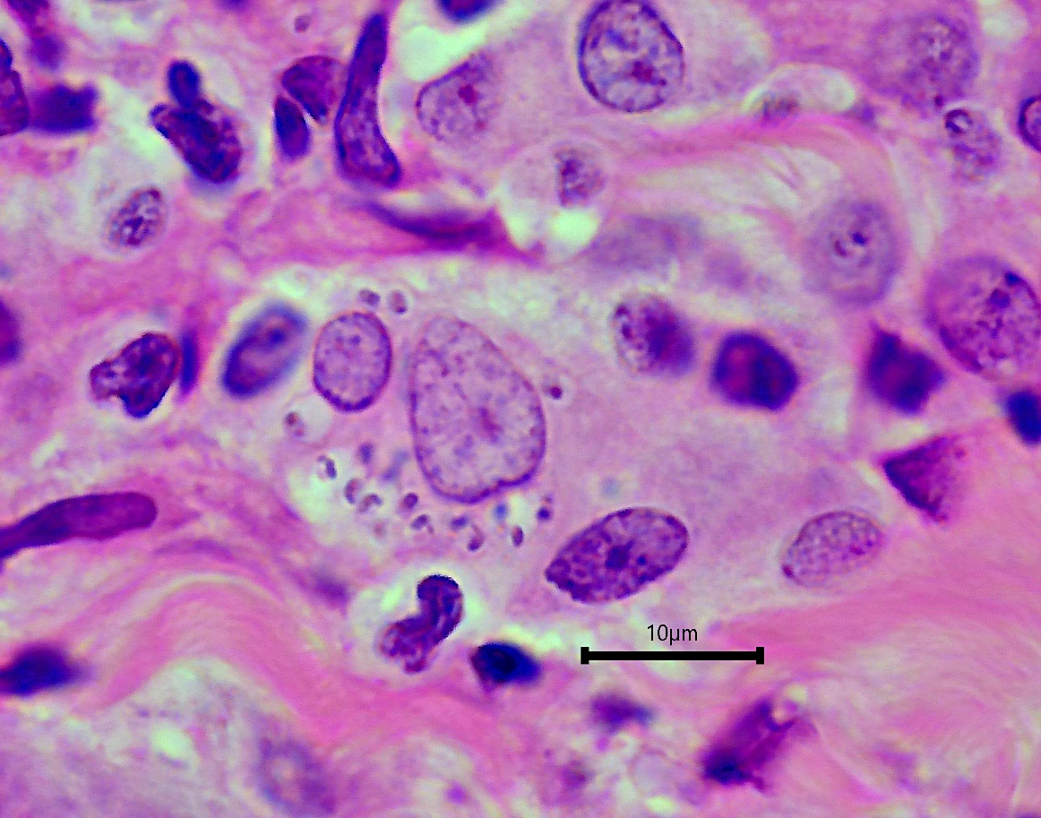
b

Figure 1b: Skin histopathology from dog 1 showing multiple Leishmania amastigotes within the cytoplasm of a macrophage. Arrow points to a kinetoplast at right angles to the amastigote nucleus. Hematoxylin and eosin staining; Bar = 10 um.

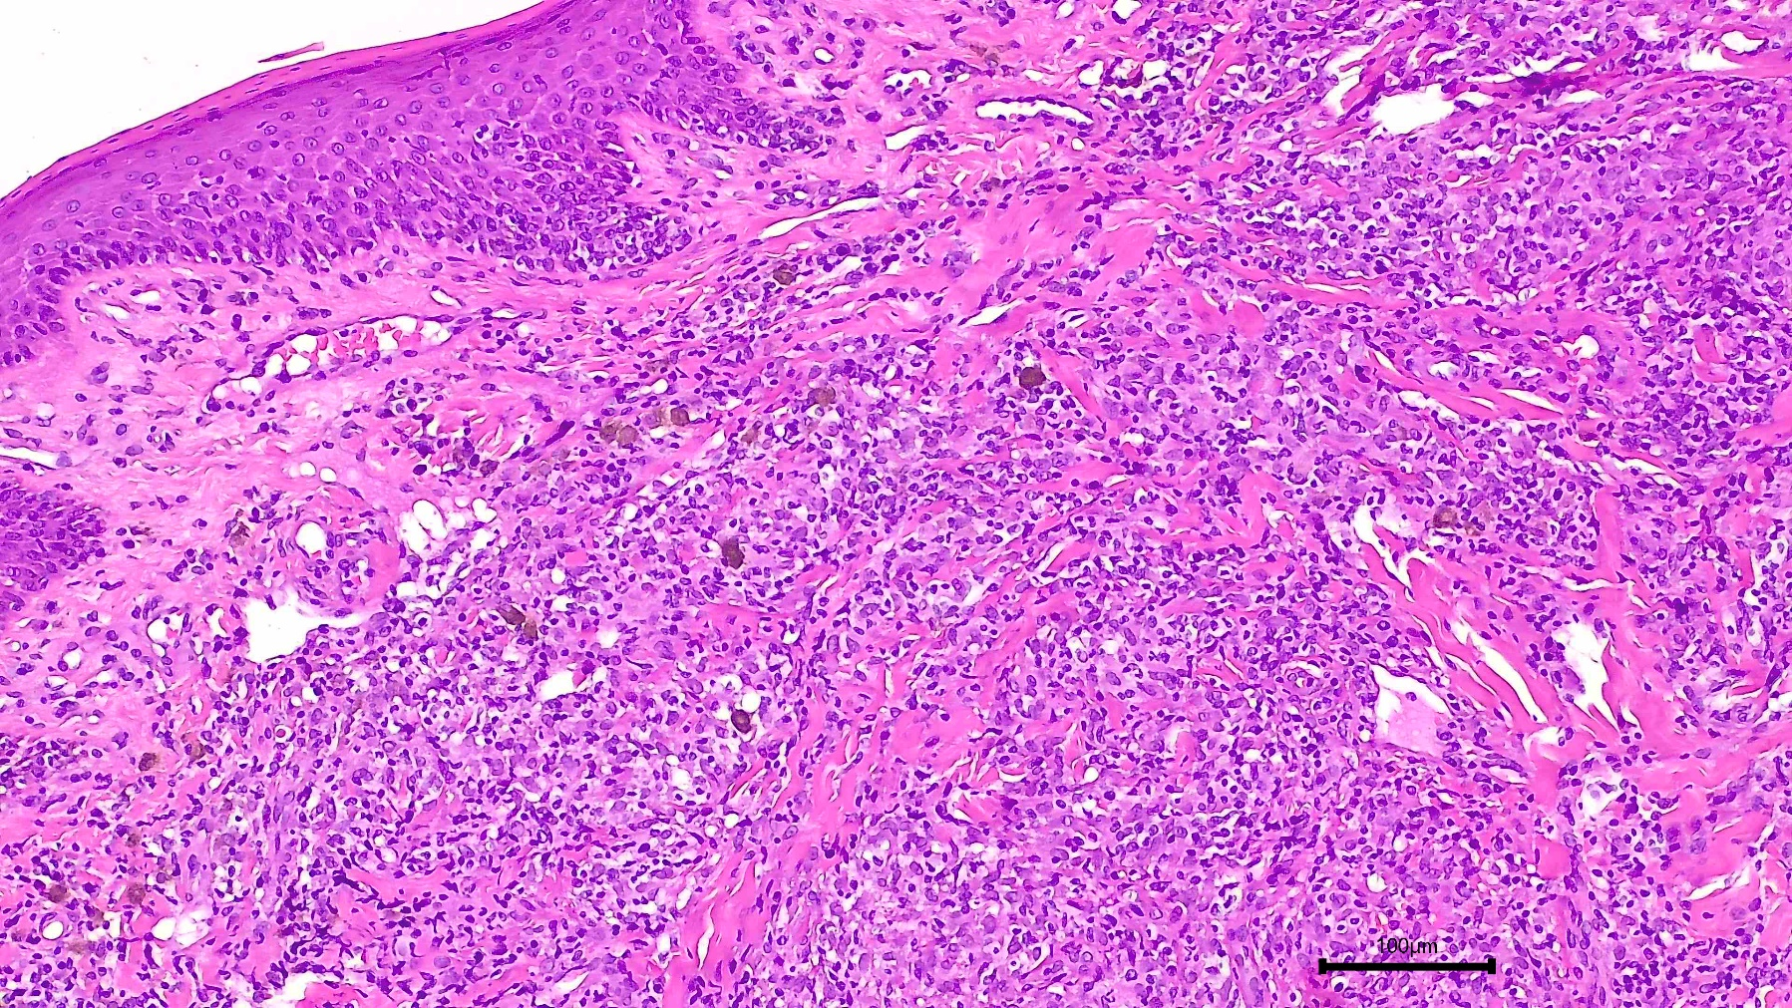
a

Figure 2a Dog 2. Nasal mucosa with granulomatous inflammation. Hematoxylin eosin staining; Bar = 100 um.
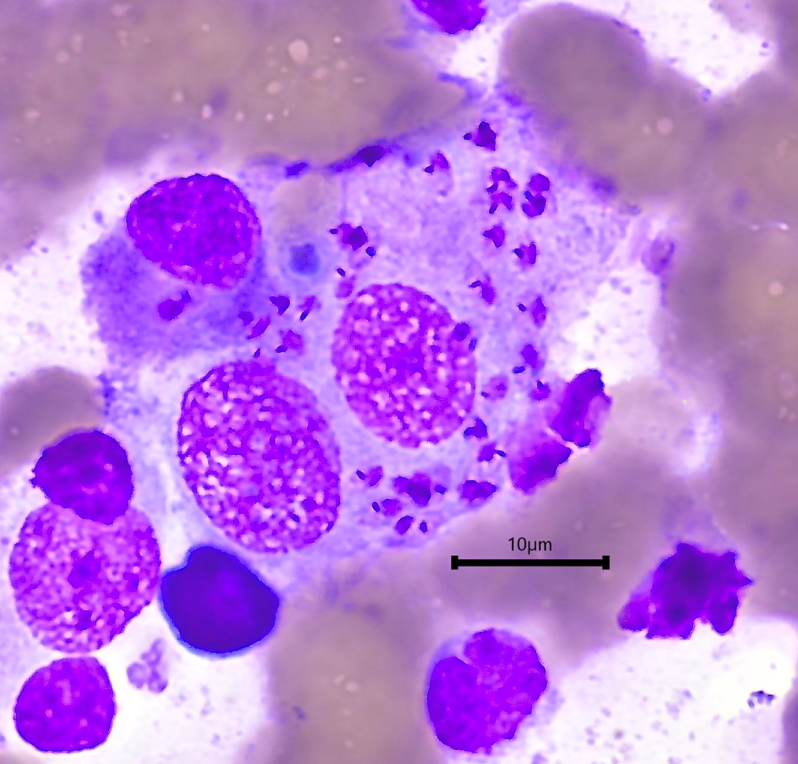
b
Figure 2b. Dog 2. Splenic aspirate. Wright’s Giemsa stain. Leishmania amastigotes within the cytoplasm of macrophages.

