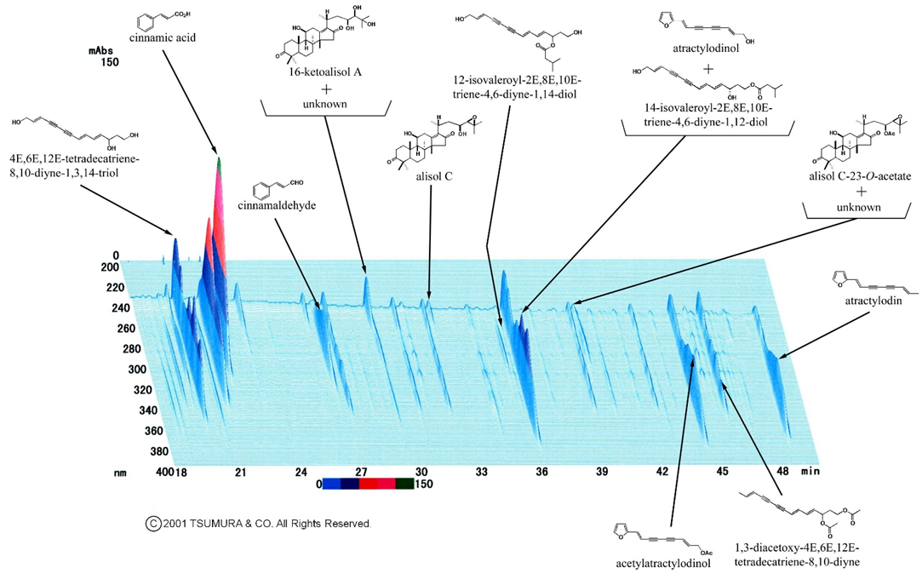
Supplementary Figure 1 Three-dimensional high-performance liquid chromatography profile of GRS. The three-dimensional high-performance liquid chromatography (3D-HPLC) profile of the representative batch of goreisan (GRS) is shown in Supplementary Figure 1. For the components analysis, the dried extract (1.0 g) of GRS was extracted with methanol (20 mL) under ultrasonication for 30 min and centrifuged at 3000 rpm for 5 min. The supernatants were filtered with a membrane (0.45 µm) and then submitted for HPLC analysis (30 µL). The HPLC apparatus consisted of a Shimadzu LC 10A (analysis system software: CLASS-M10A ver. 1.64, Tokyo, Japan) equipped with a multiple wavelength detector (UV 200–400 nm) (Shimadzu SPD-M10Avp, diode array detector) and an auto-injector (Shimadzu CTO-10AC). HPLC conditions were described as follows: column, ODS (TSK-GEL 80TS, 250 × 4.6 mm i.d., TOSOH, Tokyo, Japan); eluent, (A) 0.05 M AcONH₄ (pH 3.6) (B) 100% CH₃CN. A linear gradient of 90% of A and 10% of B changing over 60 min to 0% A and 100% B was used (and 100% B was continued for 20 min.); temperature, 40 °C; and flow rate, 1.0 mL/min. Standard compounds that have been isolated, purified, and identified via mass spectrometry, infrared spectrometry, and nuclear magnetic resonance spectroscopy from botanical raw materials in GRS were analysed under the same conditions, and data from the UV spectrum and column retention time were used to create a chromatogram library. The degree of coincidence and the homogeneity of peaks were evaluated using the library’s peak detector (an auxiliary function of HPLC).

