Appendix 1 (Ethical Approval)
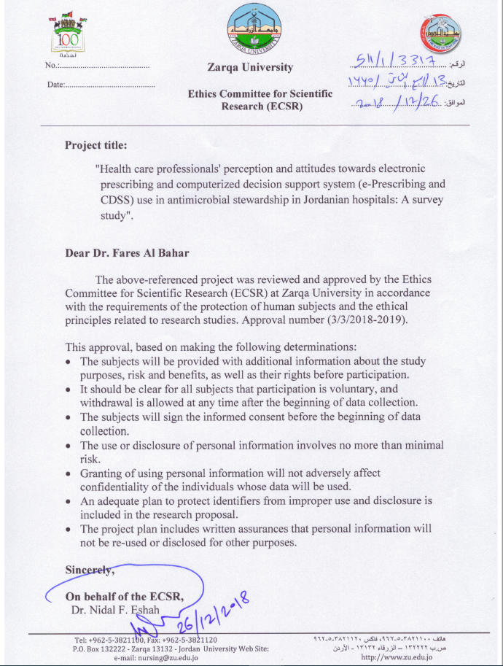
Appendix 2 (Survey tool)

Perceptions of health care professionals towards the use of computerized clinical decision support systems in antimicrobial stewardship in Jordanian hospitals

Welcome,
Antimicrobial stewardship refers to a coordinated intervention designed to enhance and improve the selection of an optimal antimicrobial drug regimen, dose, duration of therapy, and route of administration. It ultimately seeks to achieve an optimal therapeutic outcome concerning antimicrobial use, thus minimising toxicity and other adverse events. This, in turn, reduces the costs of health care for infections, thus limiting the occurrence of antimicrobial-resistant strains. The use of technology has advanced the use of antimicrobial stewardship interventions. In this questionnaire, we aim to explore the perceptions and attitudes of health care professionals towards antimicrobial stewardship using electronic prescribing and electronic health record systems implemented in Jordanian hospitals.
Your participation is highly appreciated. The gathering of information will be kept confidential and used only for research purposes. The estimated completion time for this survey is 10 – 15 minutes.
Anonymity and confidentiality: The data collected in the study will be treated as strictly confidential. The participants’ names would not be revealed, and the researchers maintained the confidentiality of participants’ responses. The information would not be released to your organisation or anyone in a way that could identify you.
Right of withdrawal: Your participation in this research is voluntary. I do not anticipate any risks resulting from participating in this study other than minimal fatigue.
Section A: Demographics
- Please indicate your gender
Male
Female

- Please indicate your age group
20-30
31-40
41-50
51-60
˃60

- Please indicate your speciality that you have attained at this point in time:
Internal medicine doctor
Paediatric doctor
Surgery doctor
Infectious diseases doctor
Haematology/oncology doctor
Critical care doctor
Clinical pharmacist
Nurse
Infection control specialist
Microbiologist
Other, please specify

- Job grade
Senior doctor
Junior doctor
Other allied health care professionals

Section B: Perception of participants towards antimicrobial stewardship (AMS)
Strongly Disagree – Strongly Agree (1-5)

 | Perceptions towards antimicrobial stewardship | ^{Strongly disagree} | ^{Disagree} | ^{Neither Disagree or Agree} |  | ^{Agree} | ^{Strongly Agree}
Check your level of agreement with the following sentences:
 | Antimicrobial prescribing at your hospital is already as good as it can be | 1 | 2 | 3 | 4 |  | 5
 | Antimicrobial stewardship programs may improve patient care. | 1 | 2 | 3 | 4 |  | 5
 | Antimicrobial stewardship should be incorporated at a hospital level | 1 | 2 | 3 | 4 |  | 5
 | Antimicrobial stewardship programs may reduce the problem of antimicrobial resistance. | 1 | 2 | 3 | 4 |  | 5
 | Adequate training should be provided to health care professionals on antimicrobial use | 1 | 2 | 3 | 4 |  | 5

Section C: Perceptions towards electronic prescribing and electronic health record system
Awareness and previous use
Yes, No, Don’t know (1-3)
 | Awareness and previous use | Yes | No | Don’t know
1. | Have you previously used electronic prescribing and electronic health record system? | 1 | 2 | 3
2. | Are you aware that electronic prescribing and electronic health record system can be used to facilitate antibiotic prescribing? | 1 | 2 | 3
3. | Are you aware that electronic prescribing and electronic health record system is capable of providing clinical decision support function in order to support evidence-based practice? | 1 | 2 | 3

Perceived benefits of using electronic prescribing and electronic health record system

 | Perceived benefits of using electronic prescribing and electronic health record system in antimicrobial stewardship | ^{Strongly disagree} | ^{Disagree} | ^{Neither Disagree or Agree} |  | ^{Agree} | ^{Strongly Agree}
In my opinion, I believe my use of the electronic prescribing and electronic health record system may have the following benefits:
 | The system may improve efficacy of antibiotic treatment | 1 | 2 | 3 | 4 |  | 5
 | The system may improve the safety on antibiotic use | 1 | 2 | 3 | 4 |  | 5
 | The system may reduce the problem of antimicrobial resistance | 1 | 2 | 3 | 4 |  | 5
 | The system may reduce expenditure on antibiotics | 1 | 2 | 3 | 4 |  | 5
 | The system may improve work efficiency | 1 | 2 | 3 | 4 |  | 5
 | The system may reduce the risk of clostridium difficile | 1 | 2 | 3 | 4 |  | 5
 | The system may improve the ability to deliver antimicrobial stewardship | 1 | 2 | 3 | 4 |  | 5

Section D: Perceived barriers and facilitators to use electronic prescribing and electronic health record system in antimicrobial stewardship
 | ^{Perceived barriers} | ^{Strongly disagree} | ^{Disagree} | ^{Neither Disagree or Agree} |  | ^{Agree} | ^{Strongly Agree}
In my opinion, I believe my use of electronic prescribing and electronic health record system is limited because of the following reason(s):
 | Low level of awareness to the system | 1 | 2 | 3 | 4 |  | 5
 | Unfamiliarity of using the system | 1 | 2 | 3 | 4 |  | 5
 | Insufficient training to use the system | 1 | 2 | 3 | 4 |  | 5
 | Lack of access to reliable technical support to solve day to day problems related to the system | 1 | 2 | 3 | 4 |  | 5
 | Lack of enough time to use the system | 1 | 2 | 3 | 4 |  | 5
 | Rigidity of the system to be applicable for individual patients | 1 | 2 | 3 | 4 |  | 5
 | Disruption of usual workflow pattern | 1 | 2 | 3 | 4 |  | 5
 | Lack of sufficient computer terminals available to use the system | 1 | 2 | 3 | 4 |  | 5
 | Lack of benefit of using the system | 1 | 2 | 3 | 4 |  | 5
 | Limitation of medical autonomy | 1 | 2 | 3 | 4 |  | 5

 | Perceived facilitators | Strongly Disagree | Disagree | Neither Agree nor Disagree | Agree | Strongly Agree
In my opinion, I believe that my use of electronic prescribing and electronic health record system will be facilitated because of the following reason(s)

 | Endorsement by department heads | 1 | 2 | 3 | 4 | 5
 | Linking laboratory results with the system | 1 | 2 | 3 | 4 | 5
 | Linking radiology results with the system | 1 | 2 | 3 | 4 | 5
 | Organising more frequent training sessions | 1 | 2 | 3 | 4 | 5
 | Regular feedback to its users | 1 | 2 | 3 | 4 | 5
 | Users’ participation in developing future programs related to the system | 1 | 2 | 3 | 4 | 5
 | Making more computers/systems available for use | 1 | 2 | 3 | 4 | 5
 | Making the system available in portable format like mobile or personal digital assistant | 1 | 2 | 3 | 4 | 5
 | Increasing technical support related to day to day problems related to the system | 1 | 2 | 3 | 4 | 5

