Supporting Information
A Biomimetic Laminated Strategy Enabled Durable and Ultra-Sensitive MXene-based Flexible Electronics for Temperature Monitoring with Strain-Tolerant Performance

Sanwei Hao¹, Qingjin Fu¹, Lei Meng¹, Feng Xu¹, and Jun Yang^{1,2}*
¹Beijing Key Laboratory of Lignocellulosic Chemistry, College of Materials Science and Technology, Beijing Forestry University, Beijing 100083, China.
²State Key Laboratory of Pulp and Paper Engineering, South China University of Technology, Guangzhou 510640, China.
*E-mail: yangjun11@bjfu.edu.cn Tel: 86-10-62337223.
Table of Contents
Section S1 Supplementary note 1
Section S2 Experimental section 3
Section S3 Thermosensation performances 8
Section S4 Strain insensitivity mechanism 11
Section S5 Universality and customizability 15
Section S6 High fidelity temperature monitor 16
Section S7 Summary 18
Section S8 Tables 19
Section S9 References 22
Section S10 Movie captions 23

Section S1 Supplementary note
Note 1. Preparation and proposed mechanism of high crystallinity PVA polymer networks.

With respect to the film supporting skeleton, PVA was chosen to ensure structural integrity of the nanocomposite films due to its good water solubility, cost-effective, low-toxicity, and superior mechanical robustness. According to previous reports,^{[1]} the construction of dense polymer networks and achievement of high degree of crystallinity are the major contributing factors to prepare the PVA layers with high mechanical properties and structure stability. Herein, the applying of a strong alkaline hydroxide (6 M) into a dried PVA single layer brings the twofold implications. First, OH⁻ of the alkaline hydroxide attacks the hydroxyl groups of PVA, resulting in disrupted hydrogen bonds and deprotonation of the hydroxyl groups of the PVA chains that described as follows:
$R-OH+{Na}^{+}{OH}^{-}=R-O^{-}{Na}^{+}+H_{2}O$ (1)
Second, the complexation can be formed between O⁻ group and the free Na⁺, facilitating the mobility of PVA chains to be aligned and formation of crystalline domains. After adding water to remove Na⁺ ions, the O⁻ became protonated and crystalline domain was permanently stabilized, leading to the PVA polymer networks with high crystallinity.

Note 2. Finite element simulation.

In the finite element simulation, the PTF/MXene/Fe composites with alternating laminated architecture (thickness = 0.6 mm) were modelled as a linear elastic material with Lagrangian formulation with predetermined parameters including density (ρ) = 1.3 g/cm³, Young's modulus (E) = 0.35 MPa, Poisson ratio (υ) = 0.35. The boundary conditions were set at the bottom of the architecture model, and a gradually increased smooth downward velocity of the model with the final displacement on Z direction of 200 μm within 0.2 s and an average velocity of 1 mm/s.^{[2-6]}

Section S2 Experimental section

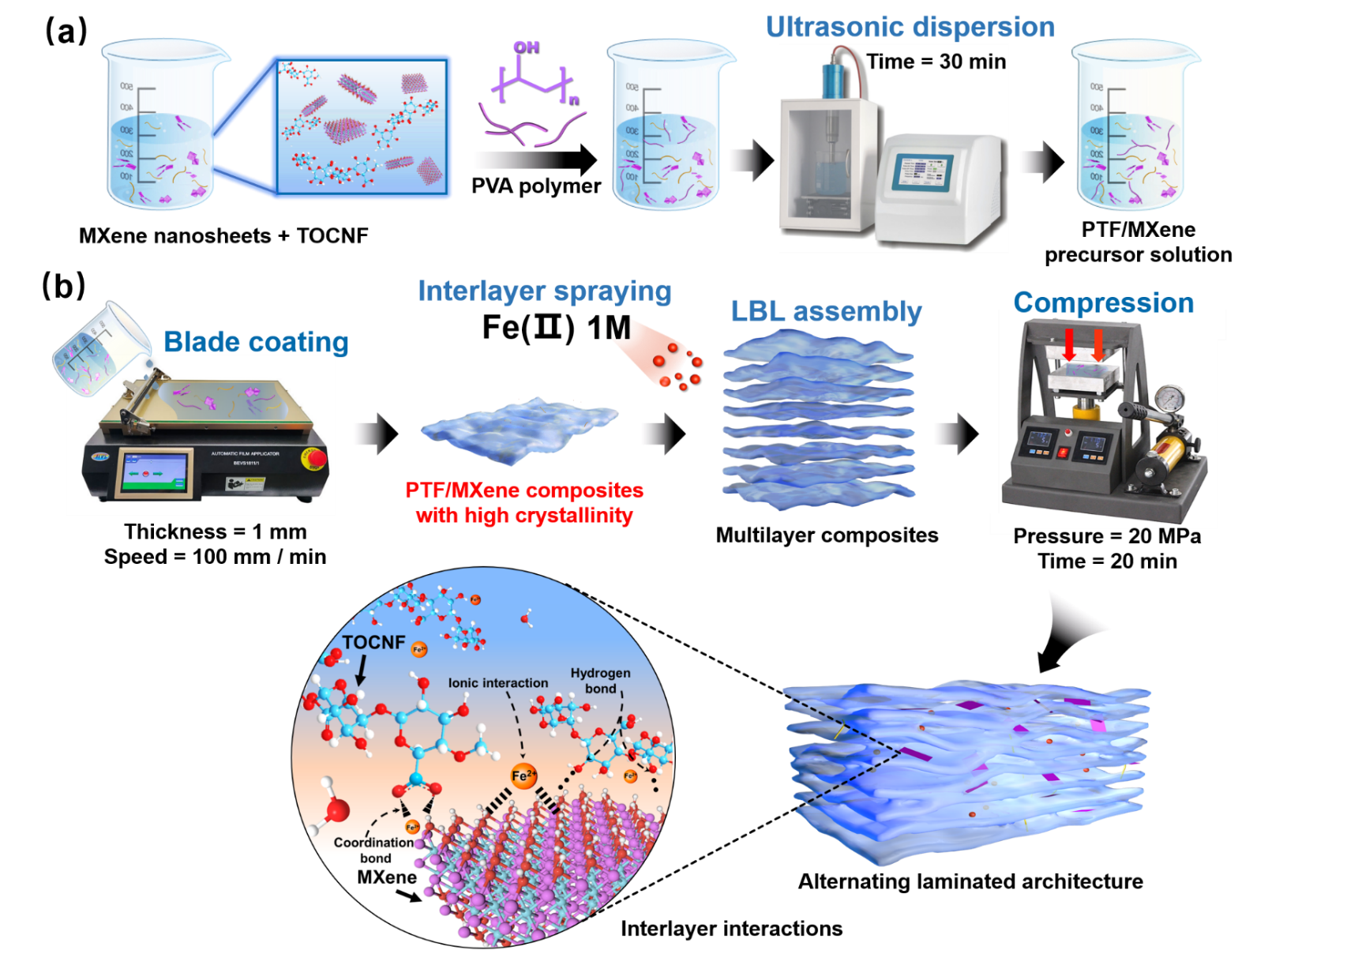
Fig. 1. (a) Preparation diagram of PTF/MXene precursor solution. (b) Schematic illustration of the fabrication process and the interfacial bridging of the PTF/MXene/Fe composites.

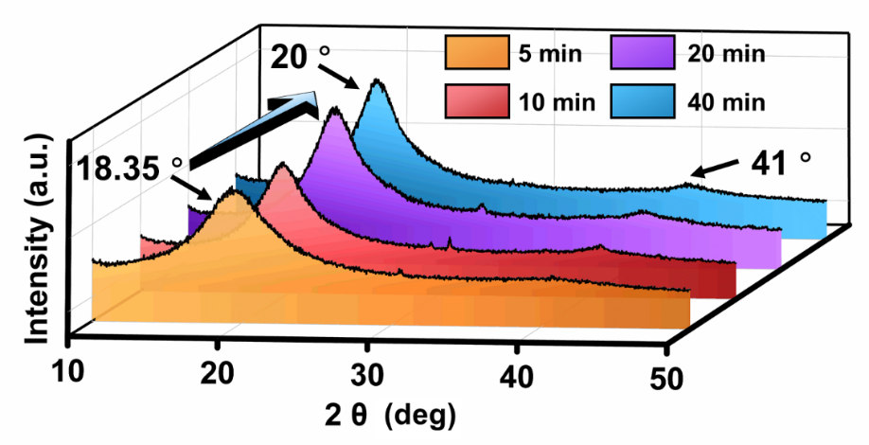
Fig. 2. Representative XRD profiles of PVA after different immersing times (5, 10, 20, and 40 min, respectively) in NaOH solution (6 M).

The PVA showed strong diffraction peaks at about 18.35°, corresponding to the typical reflection crystal plane of (10$\overline{1}$). The red shift phenomenon occurred with the extension of the immersing time, which was mainly ascribed to the self-association of ─ OH (PVA) during the metal complexation by Na⁺ ions. Additionally, the gradually increased peak intensity of the diffraction profiles indicated the enhancement of crystallinity. Considering that the increasement in peak of crystallinity slowed down after soaking for 20 min, we thereby chose 20 min as a typical soaking time.

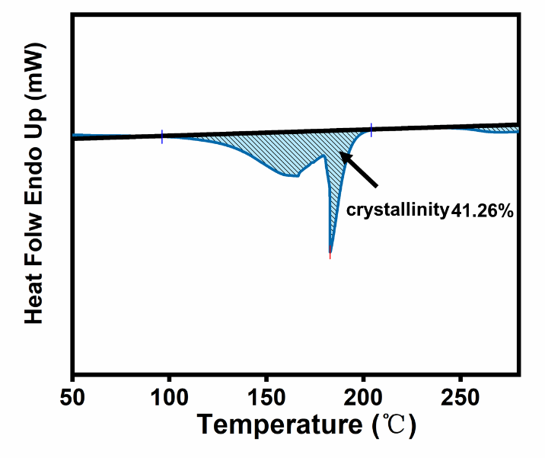
Fig. 3. The differential scanning calorimetry (DSC) curve for calculating the crystalline fraction of PVA after immersed in NaOH solution (6 M) for 20 min.

An increased in crystallinity of PVA after NaOH solution immersion was also examined from differential scanning calorimetry (DSC), confirming the rationality of our procedure. The crystallinity of the PVA after NaOH immersion was about 41.26 %, calculated as follows:
$$\overline{X_{c}}=\frac{ΔH_{f}(T_{m})}{{ΔH}_{f}^{0}(T_{m}^{0})}$$
where $ΔH_{f}(T_{m})$ was the enthalpy fusion at the melting point T_{m} as measured by DSC. ${ΔH}_{f}^{0}(T_{m}^{0})$=138.60 𝐽. 𝑔⁻¹ was the enthalpy fusion of the 100 % crystalline PVA.^{[7]}

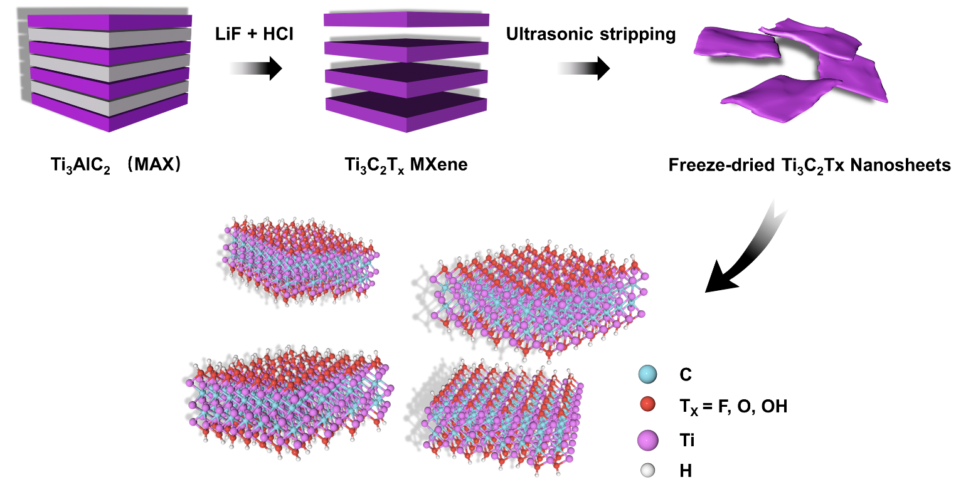
Fig. 4. Schematic illustration of etching Ti₃AlC₂ (MAX) by HCl and LiF to obtain the multilayered Ti₃C₂T_{x} (MXene) nanosheets.

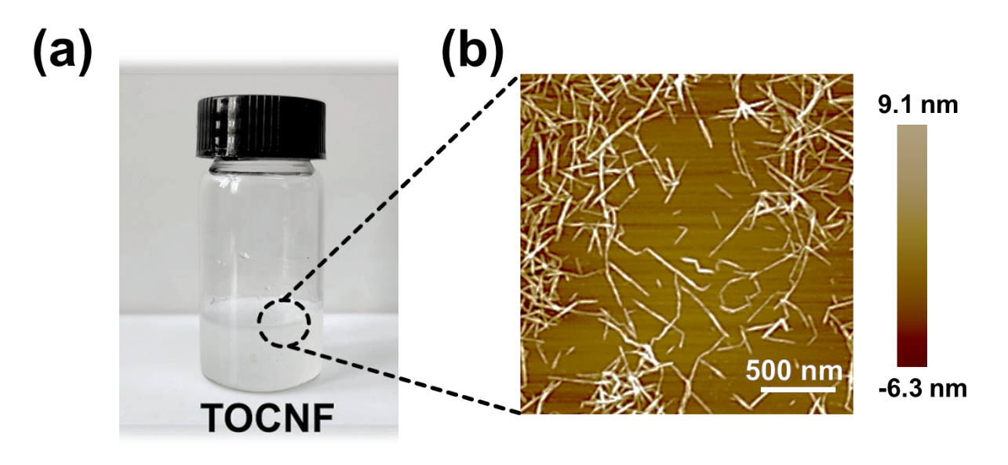
Fig. 5. (a) The optical image of TEMPO oxidated cellulose nanofibrils (TOCNF) and (b) the corresponding AFM image showed the size of the obtained TOCNF about 0.8−2.0 um and several nanometers in length and diameter, respectively.

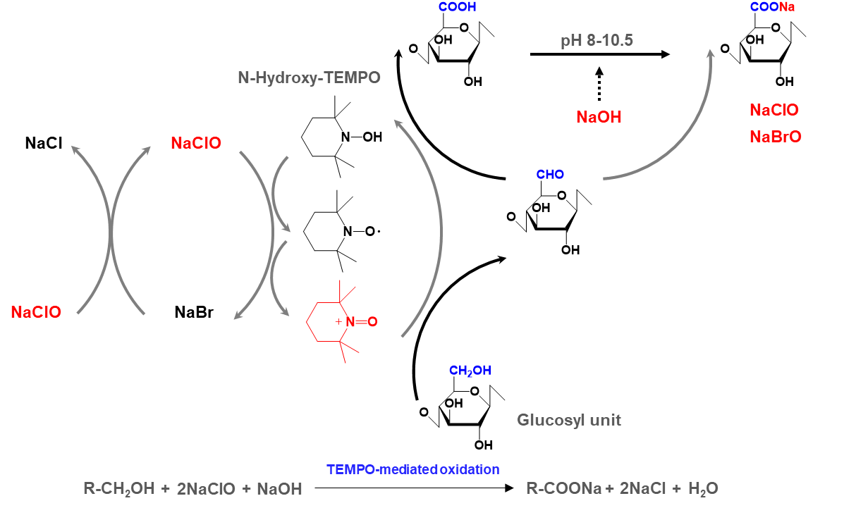

Fig. 6. The typical synthetic route of TEMPO oxidated cellulose nanofibrils (TOCNF).
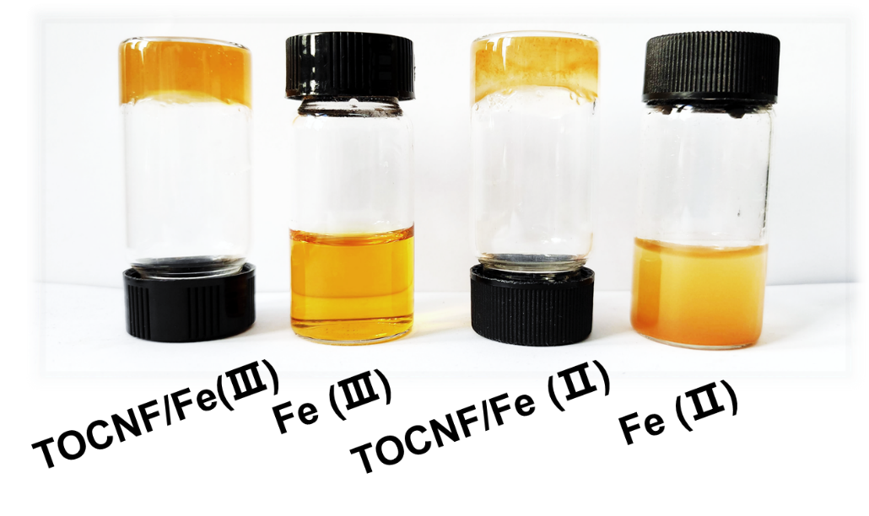
Fig. 7. The photos of TOCNF cross-linked by Fe (Ⅱ) and Fe (Ⅲ).

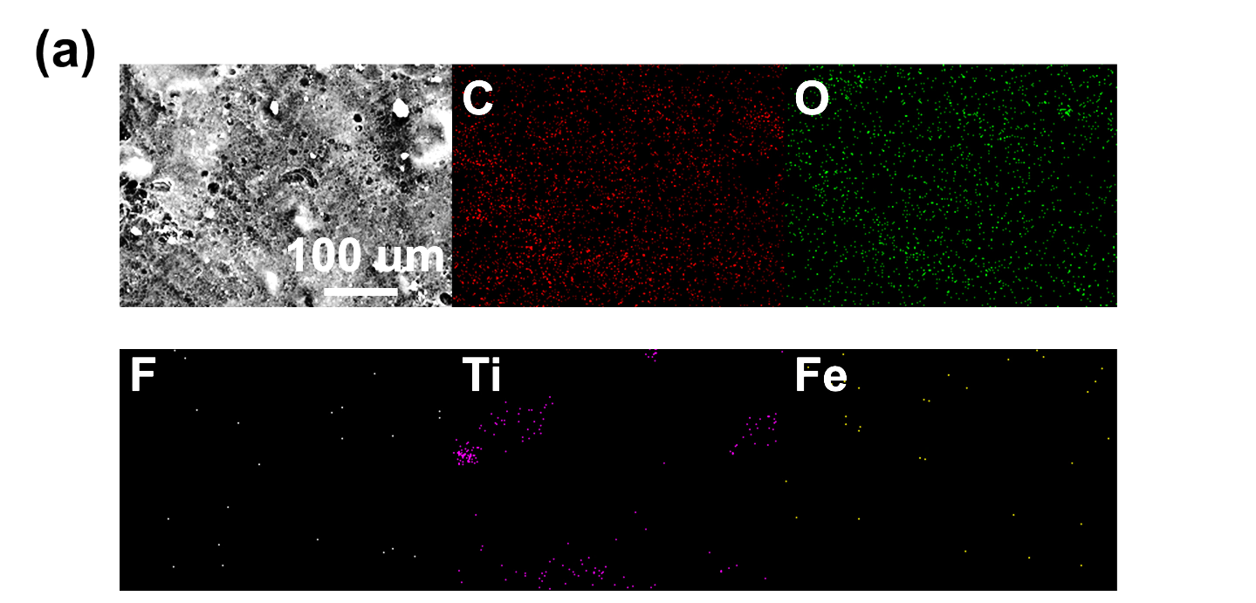
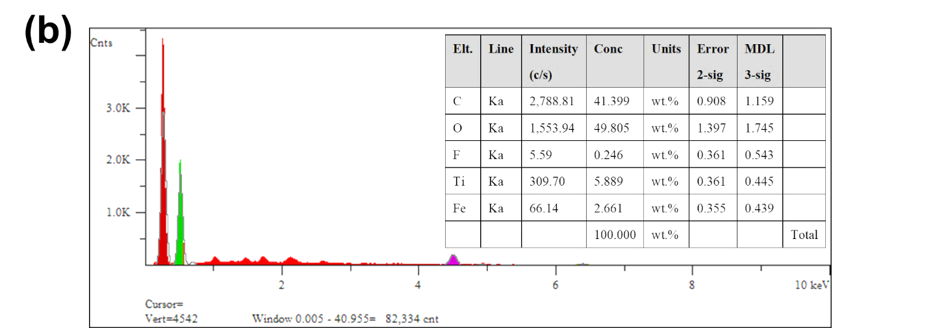
Fig. 8. (a) SEM images of PTF/MXene/Fe membrane and (b) the corresponding EDX spectra of the selected area.

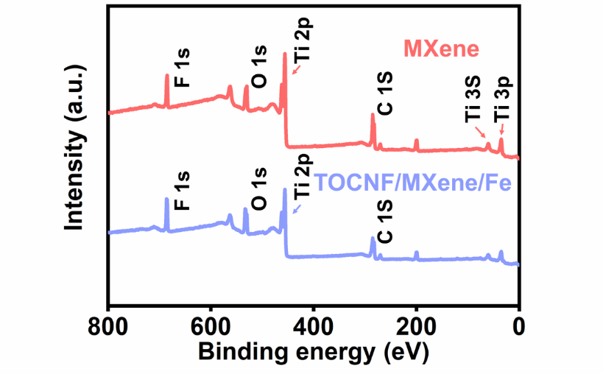
Fig. 9. XPS survey spectrum of the MXene and TOCNF/MXene/Fe.

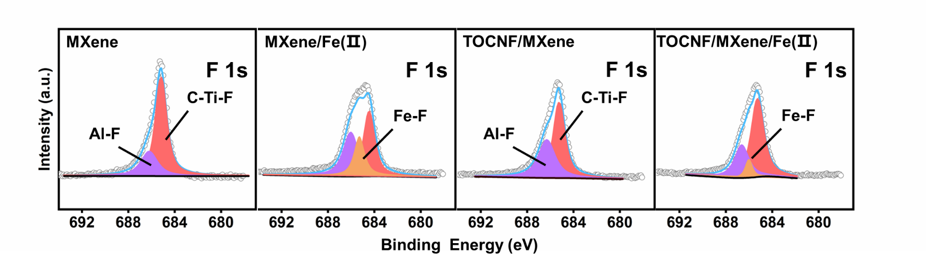
Fig. 10. F 1s XPS spectra of MXene, MXene/Fe, TOCNF/MXene, and TOCNF/MXene/Fe, respectively.

Section S3 Thermosensation performances
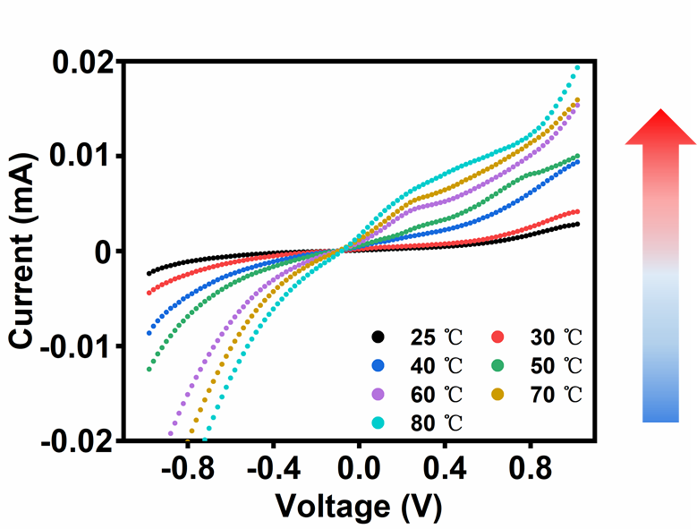
Fig. 11. I−V curves of the TES under different temperatures ranging from 25 to 70 °C.

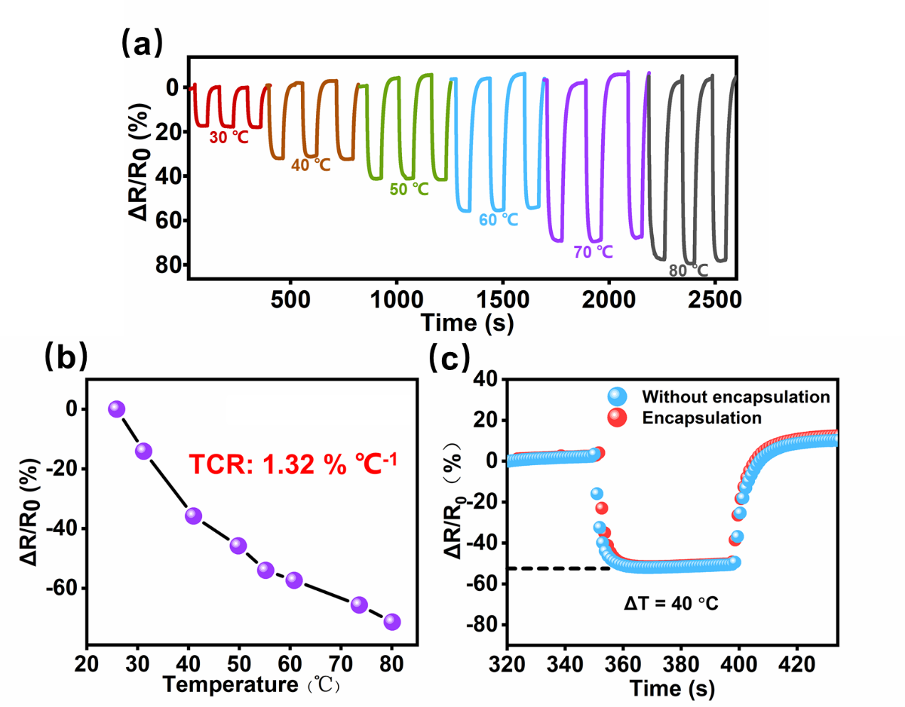
Fig. 12. (a) Temperature-dependent relative resistance curves of TES sensors by different batches and (b) the corresponding temperature coefficient of resistance (TCR). (c) The neglectable heat transfer obstruction of the ultrathin FEP encapsulation layer (80 um) for stable thermal performances of TES.

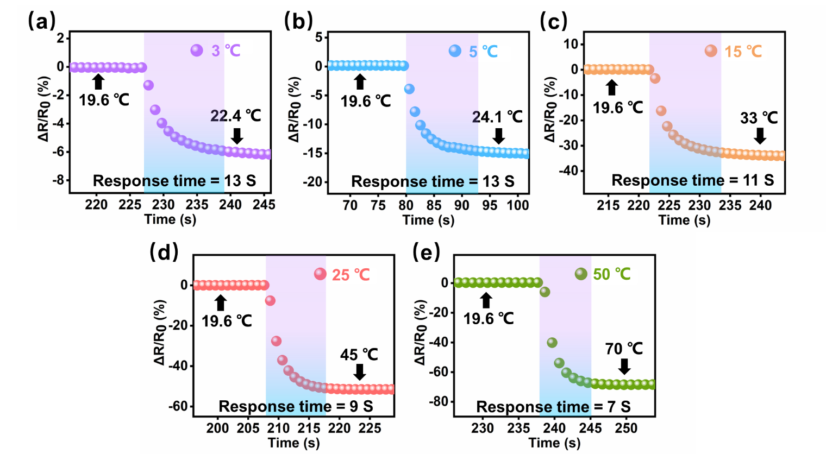
Fig. 13. Thermal responses of TES sensors to different temperature gradients (from constant initial 19.6 ℃ to 22.4, 24.1, 33, 45, and 70 ℃, respectively).

Notably, the thermal resistance variations at 22.4 °C (13 s) required a much longer time than that of at 70 °C (7 s). We attributed this result to the fact that a larger temperature gradient between the heat source (70 °C) and ambient surrounding (19.6 °C) may cause a stronger thermal convection, resulting in more dramatic resistance changes and achieved the heat equilibrium in a shorter time.

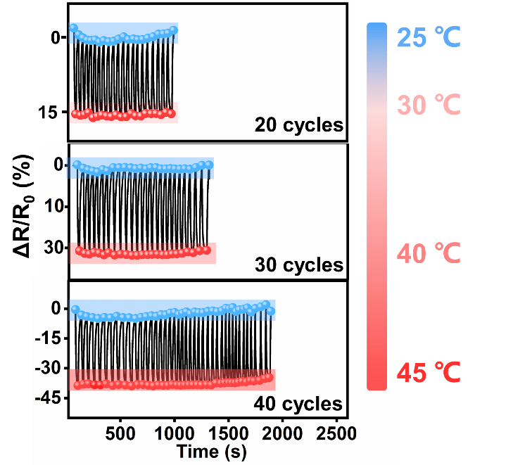
Fig. 14. Reproducible temperature discrimination during various repetitive heating-cooling cycles (25-30 ℃, 25-40 ℃, and 25-45 ℃).

The relative resistance variation displayed distinct divergence between cold-hot temperature interval, and the output signals under each temperature gradient showed negligible deviation, implying high durability and stability of the TES sensors.

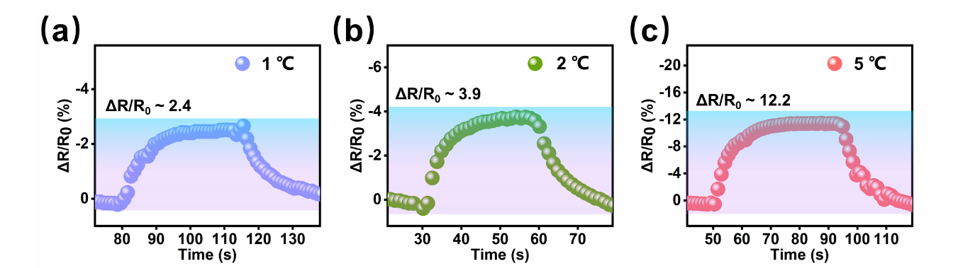
Fig. 15. Highly discernible temperature resolution with different relative resistance variations.

Section S4 Strain insensitivity mechanism
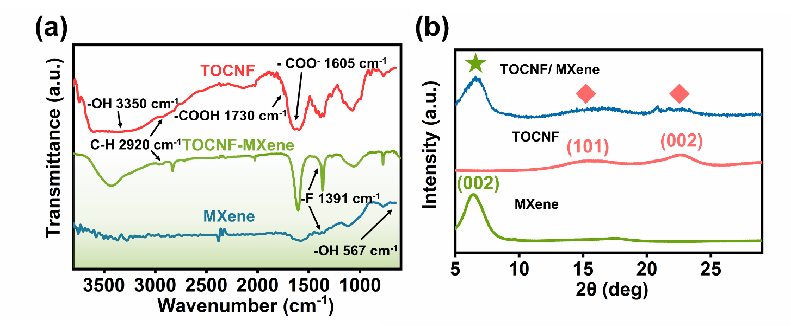
Fig. 16. (a) FTIR spectra and (b) XRD patterns of the Ti₃C₂T_{x} (MXene), TOCNF, and TOCNF/Ti₃C₂T_{x} (MXene), respectively.

Notably, the cellulose characteristic absorption bands at 2920 cm⁻¹ (C−H stretching) were observed in the FTIR spectrum of the TOCNF/MXene nanocomposites. The XRD patterns showed that the as-prepared TOCNF possesses the typical (101) and (101̅) crystallographic planes of cellulose I crystalline structure at 2θ = 14.0 - 17.8°. Meanwhile, the obtained TOCNF/MXene nanocomposites also showed an obvious peak at 2θ = 22.5° corresponds to the (002) crystal plane of cellulose I crystalline structure, indicating the successful combination of the two components.

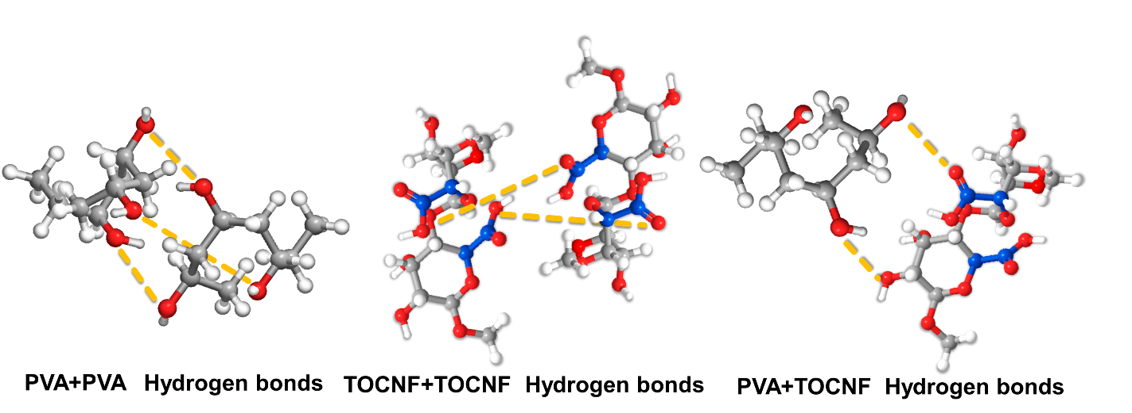
Fig. 17. The multiple hydrogen bonds in the polymer matrix acting as the dynamic cross-linking for energy dissipation.

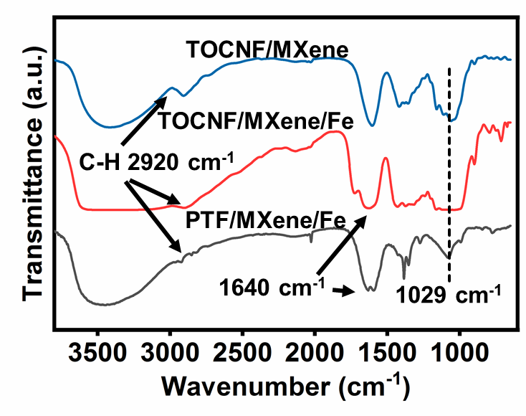
Fig. 18. FTIR spectra of TOCNF/MXene, TOCNF/MXene/Fe, and PTF/MXene/Fe, respectively.

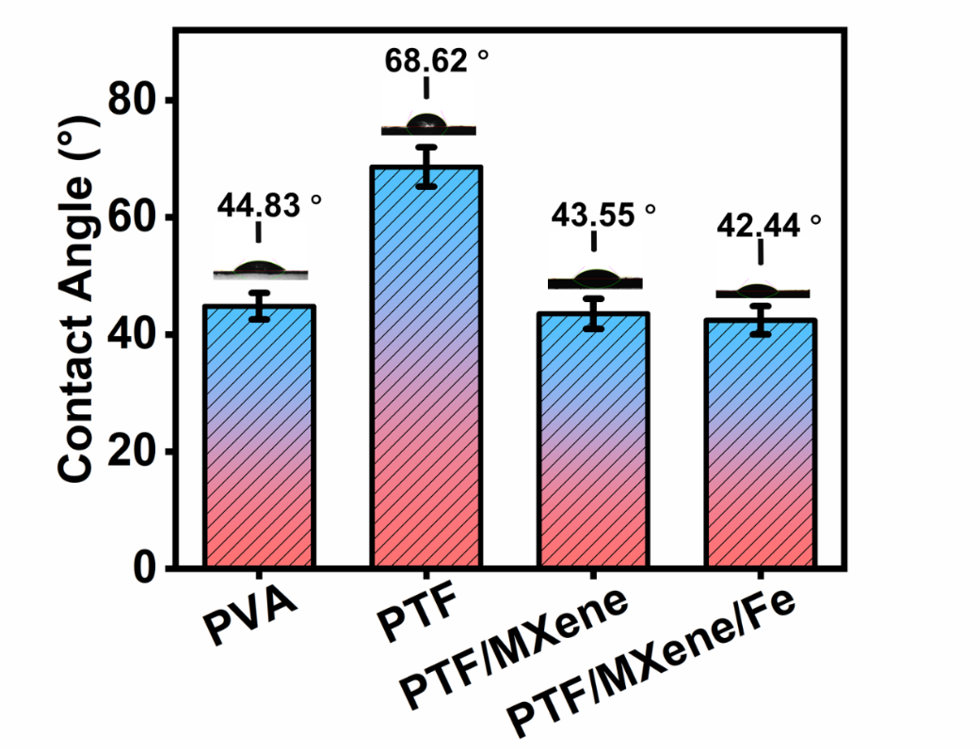
Fig. 19. Contact angle measurements for PVA, PTF, PTF/MXene, and PTF/MXene/Fe composites, respectively.

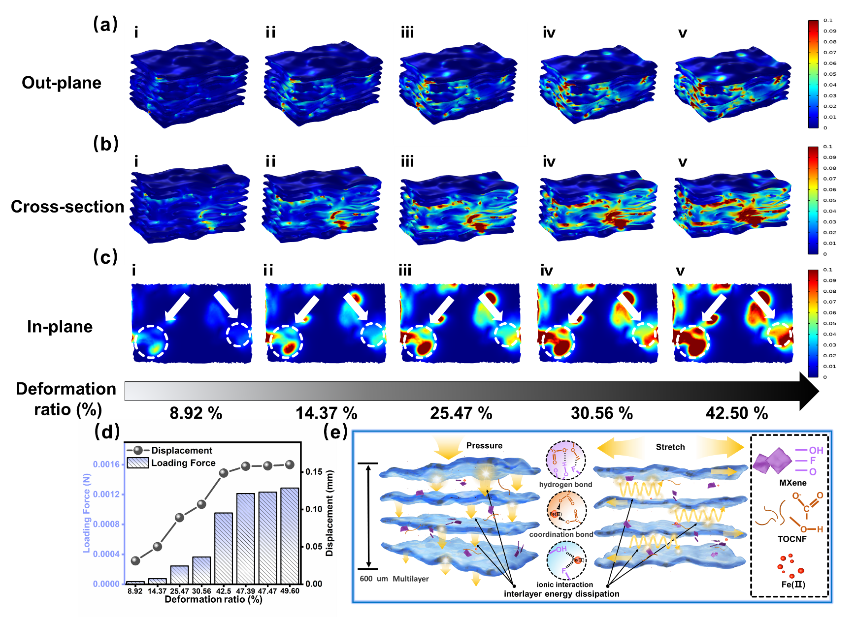
Fig. 20. Finite element simulation results of TES with alternating laminated architecture under normal stress. (a) The out-plane view, (b) cross-section view, and (c) in-plane view of stress diffusion at different deformation ratios. (d) Deformation ratio dependent loading force (left axis) and displacement (right axis) in finite element simulation. (e) Schematic diagram of energy dissipation among adjacent layers via multiple hydrogen bonding interactions, coordination bond, and ionic interaction.
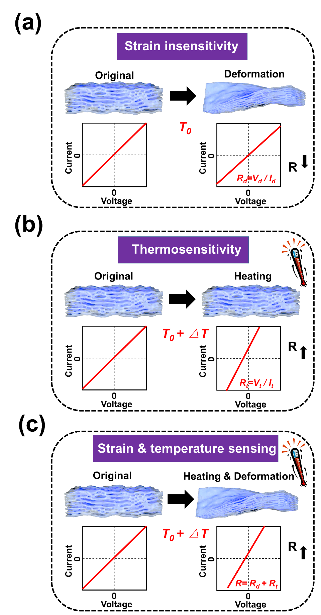
Fig. 21. Schematic illustration of the bimodal decoupled mechanism for the thermistor sensor when (a) a strain is applied, (b) a temperature gradient is applied, and (c) coupled strain and temperature stimuli are applied simultaneously.

Section S5 Universality and customizability
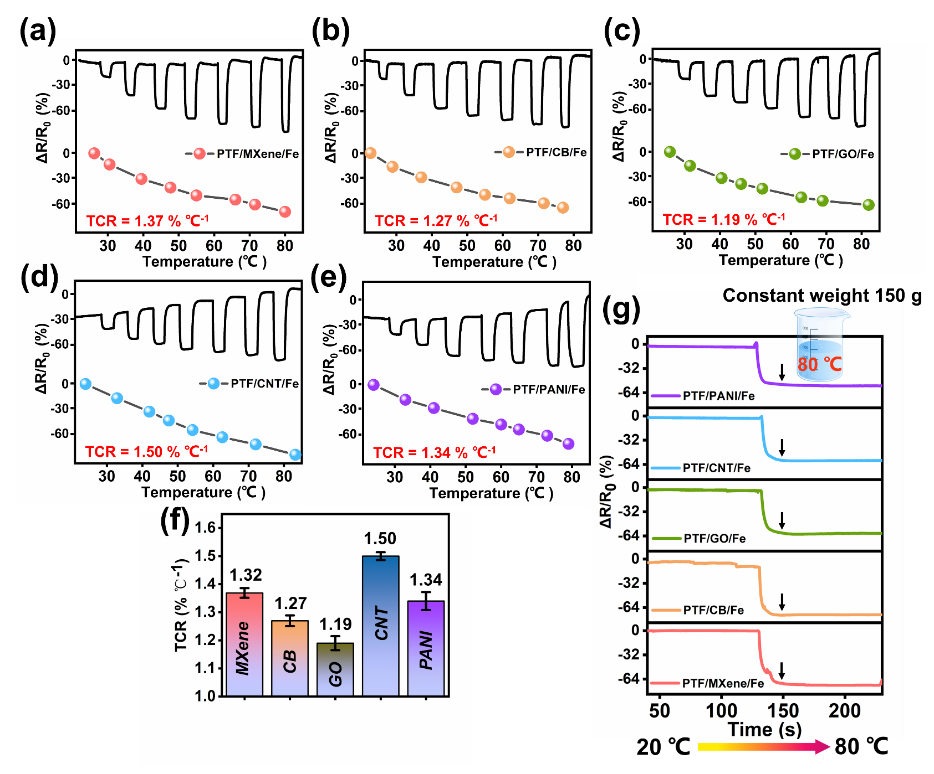
Fig. 22. Broad validity of the paradigm of the alternating laminated architecture. The relative resistance variations of TES integrated with various thermosensitive conductive components including (a) MXene nanosheets, (b) carbon black (CB), (c) graphene (GO), (d) carbon nanotube (CNT), and (e) polyaniline (PANI). (f) The corresponding TCR and (g) temperature monitoring without signal distortion confirmed by simultaneously applying heating (80 ℃) and pressure stimulus (150 g) on the TES integrated with various thermosensitive components.

Section S6 High fidelity temperature monitor
.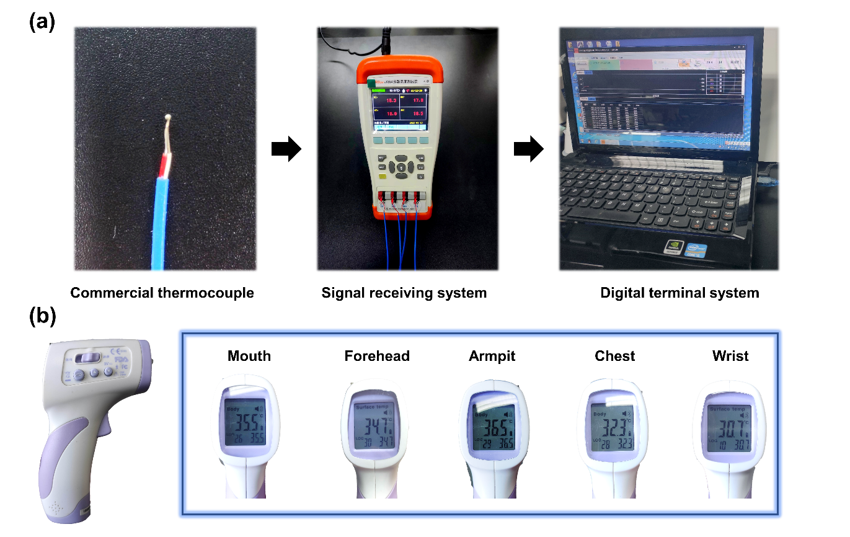
Fig. 23. (a) Illustration the ingredients of commercial thermocouple temperature measuring system. (b) Instant temperature monitoring on different body parts by a handheld infrared thermometer.

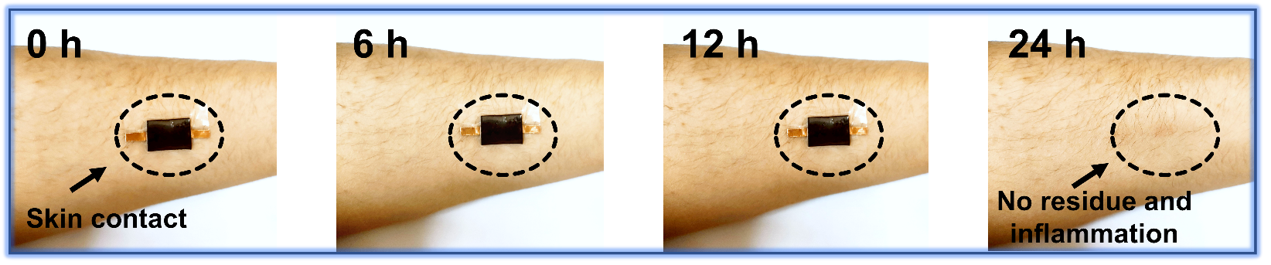
Fig. 24. The assembled thermistor elastomer sensor seamlessly contacted to the foream skin for 24 hours without residue and inflammation after detachment.

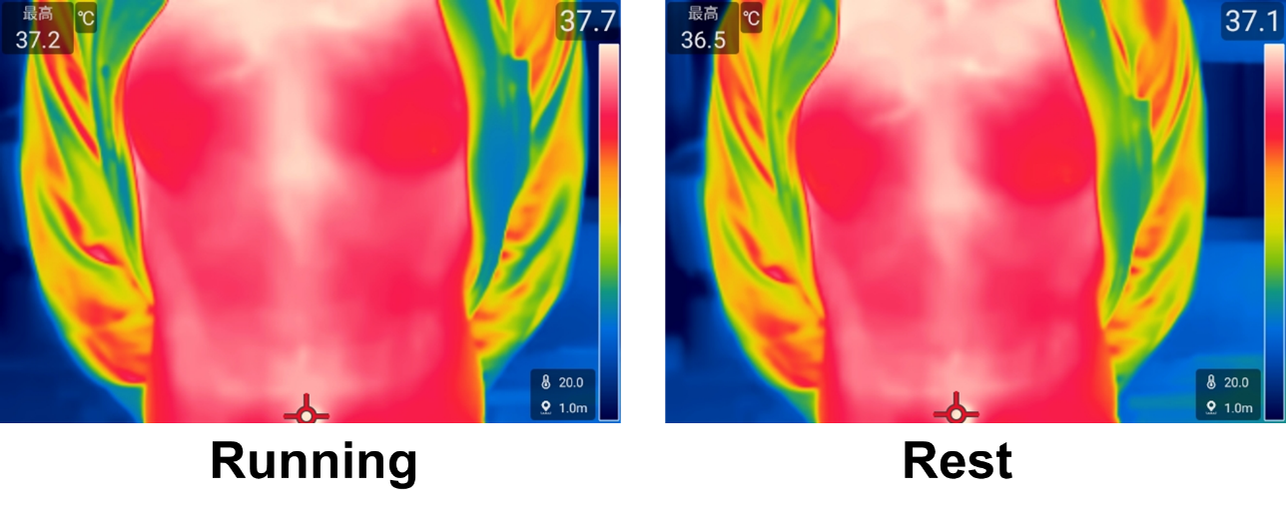
Fig. 25. Real-time infrared imaging of a volunteer’s trunk during running (37.7 °C) and after running (37.1 °C) to present the temperature variations.

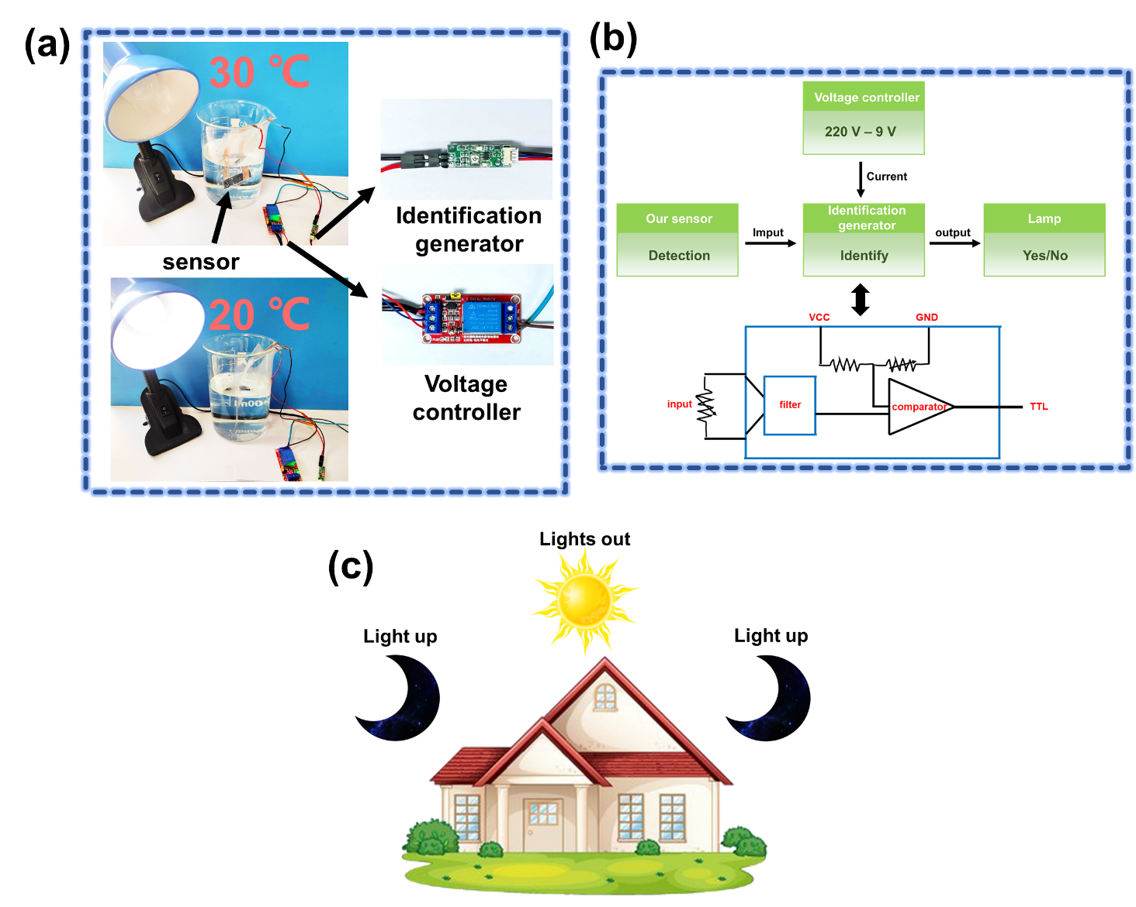

Fig. 26. (a) Photos of the assembled thermistor sensor control system realizing the lamp turn-on and turn-off control based on subtle temperature sensitivity mechanism. (b)The logic flow for realizing intelligent temperature sensing. (c) Schematic diagram of lighting up the street lamps in low temperature condition at night.

Section S7 Summary
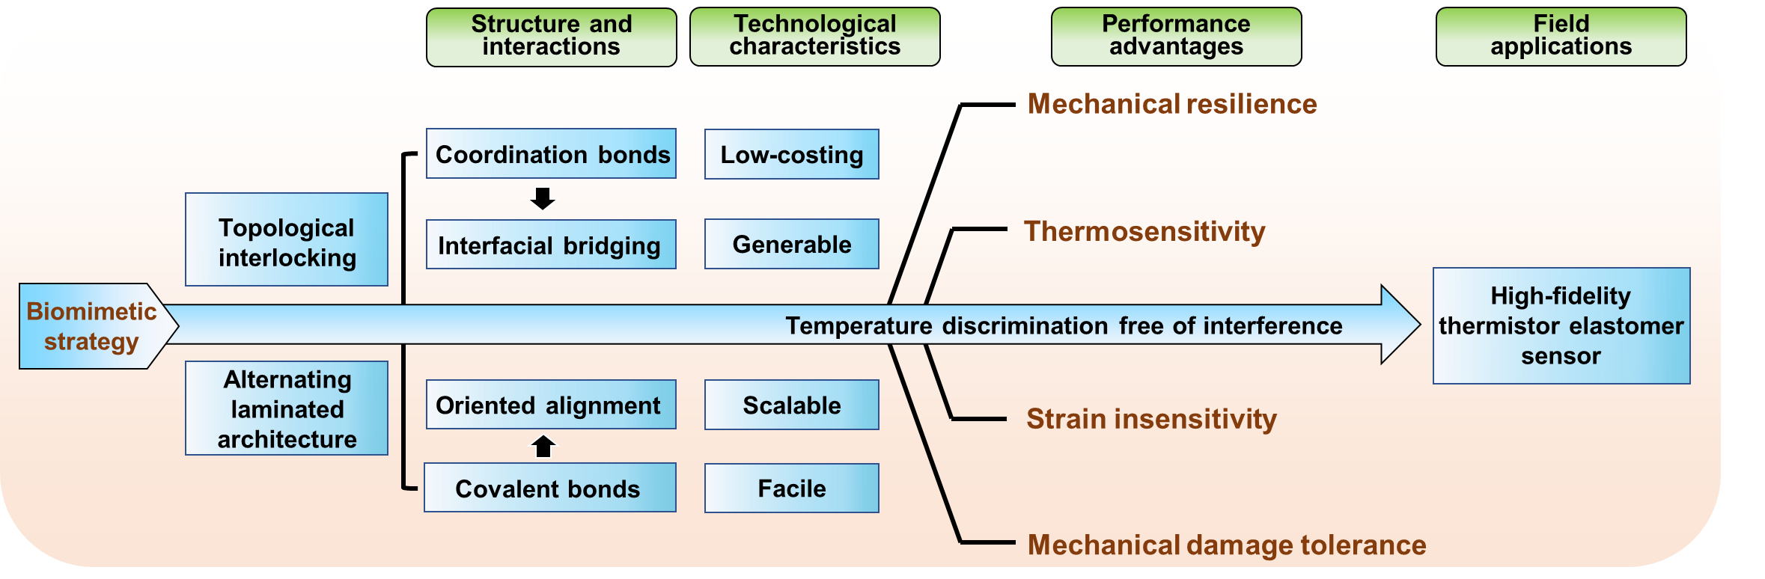
Fig. 27. The summary of structural characteristics and beneficial features of the proposed biomimetic laminated strategy.

Section S8 Tables
Table 1. Gibbs free energies of hydration for different metal ions.

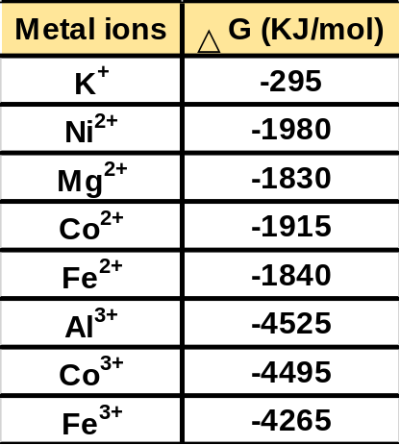

Table 2. Comparison of the thermosensitivity, resolution ratio, operating temperature range, and deformation insensitivity of TES in our work with previous reported thermistor sensors.
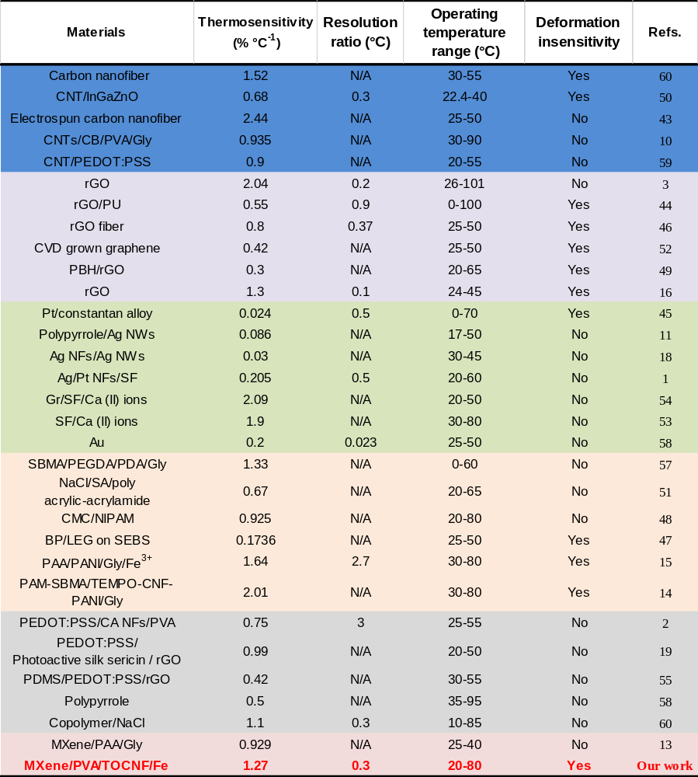
“Blue”: Carbon-based thermistor sensors. “Purple”: Graphene-based thermistor sensors. “Green”: Metallic-based thermistor sensors. “Orange”: Thermistor sensors prepared via other types of thermosensitive materials. “Gray”: Conductive polymer-based thermistor sensors. “Red”: MXene nanosheets-based thermistor sensors.
Table 3. Comparison of the competitive advantages of the assembled epidermal sensor in this work with previous sensors based on various structural strategies.
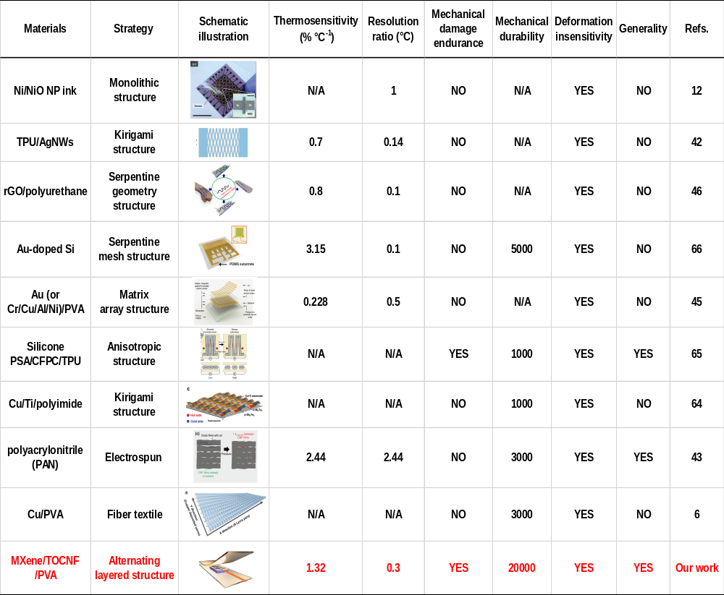

Section S9 References
[1] G. Li, B. C. Wyatt, F. Song, C. Yu, Z. Wu, X. Xie, B. Anasori, N. Zhang, Adv. Funct. Mater. 2021, 31, 2105043.
[2] T. Wang, Z. Cui, Y. Liu, D. Lu, M. Wang, C. Wan, W. R. Leow, C. Wang, L. Pan, X. Cao, Y. Huang, Z. Liu, A. I. Y. Tok, X. Chen, Adv. Mater. 2022, 34, 2106212.
[3] K. Wu, Y. Song, X. Zhang, S. Zhang, Z. Zheng, X. Gong, L. He, H. B. Yao, Y. Ni, Adv. Sci. 2022, 9, 2104867.
[4] Z. Guo, Y. Yu, W. Zhu, Q. Zhang, Y. Liu, J. Zhou, Y. Wang, J. Xing, Y. Deng, Adv. Energy Mater. 2021, 12, 2102993.
[5] T. Yang, W. Deng, X. Chu, X. Wang, Y. Hu, X. Fan, J. Song, Y. Gao, B. Zhang, G. Tian, D. Xiong, S. Zhong, L. Tang, Y. Hu, W. Yang, ACS Nano 2021, 15, 11555.
[6] S. Chai, G. Zan, K. Dong, T. Wu, Q. Wu, Nano Lett. 2021, 21, 8831.
[7] M. A. Darabi, A. Khosrozadeh, Y. Wang, N. Ashammakhi, H. Alem, A. Erdem, Q. Chang, K. Xu, Y. Liu, G. Luo, A. Khademhosseini, M. Xing, Adv. Sci. 2020, 7, 1902740.

Section S10 Movie captions
Movie 1
The in-plane stress dispersion of the PTF/MXene/Fe composites with alternating laminated architecture.
Movie 2
The fast gelation of TOCNF/MXene solutions by Fe(Ⅱ) cross-linking.
Movie 3
The sensitive temperature discrimination demonstration as the large and instant I-T profile fluctuations.
Movie 4
The high-fidelity temperature discrimination free of strain induced signal fusion, which can withstand consecutive hammering for restraining the signal fluctuation.
Movie 5
Demonstration of lamp turn-on and turn-off control device based on temperature gradient by immersing the assembled TES to water-filled beaks with different temperatures.

