Supplementary Information
Understanding the Rain-shelter and Water and Fertilizer Management in Reducing Root rot of Panax notoginseng
Yan Zhangª·Zang Zhennan^{b}·Zhenya Tang^{a*}·Qiliang Yang^{a*}
ªFaculty of Modern Agricultural Engineering, Kunming University of Science &Technology, Kunming Yunnan 650500, China
^{b}Faculty of Environmental Science and Engineering, Kunming University of Science and Technology, Kunming 650500, China

*Corresponding author
Zhenya Tang, Qiliang Yang
Faculty of Modern Agricultural Engineering, Kunming University of Science &Technology, Kunming Yunnan 650500, China
E-mail: zytang@kust.edu.cn, yangqilianglovena@163.com
This supporting information contains 9 pages
Text S1……………………………………………………………………………………S2
Text S2……………………………………………………………………………………S3
Table S1…………………………………………………………………….…………… S3
Figure S1…………………………………………………………………………………S4
Figure S2…………………………………………………………………………………S5
Figure S3…………………………………………………………………………………S6
Figure S4…………………………………………………………………………………S6
Figure S5…………………………………………………………………………………S7
Figure S6…………………………………………………………………………………S7
Figure S7…………………………………………………………………………………S8
Figure S8…………………………………………………………………………………S9

Text S1 Vertical distribution of soil available nutrients in root zone of Panax notoginseng in rainy season
It can be seen that the soil available nitrogen, phosphorus and potassium (Fig. S4, Fig. S5, Fig. S6) of each treatment all showed an "S" shaped distribution with the increase of soil depth, and reached the lowest value at the soil depth of 10-20cm. This is mainly because the root system of Panax notoginseng is concentrated here and absorbs nutrients for crop growth, which in turn leads to the reduction of available nutrients in this layer of soil. On the other hand, the available nutrients will migrate downward with the movement of water, resulting in the decrease of 10-20cm soil nutrients, and accumulation in the 20-30cm soil layer, reducing the nutrient utilization rate of the root system (Wang amd Zhou 2013). Compared with DW1 and DW2 treatments, with the increase of irrigation amount, soil nutrients of 20-30cm gradually decreased. This may be due to the low irrigation rate, which will cause the soil surface to evaporate rapidly, and the deep soil moisture will move upwards due to the suction of the upper soil, thereby driving the upward migration of nutrients in the lower layer (Zhao et al. 2020).
Under the same irrigation level, with the increase of fertilization amount, the content of available nutrients in the soil also increased gradually. Under the same fertilization level, soil nutrients decreased gradually with the increase of irrigation amount. This is mainly due to the fact that a hight soil moisture environment improves the rapid uptake of effective nutrients by crop roots (Kramer and Boyer 1995). And comparing the soil available nutrients under the sheltered and unshaded conditions, the surface soil nutrients in the unshaded condition were less than those in the shaded treatment. There may be two reasons explaining this phenomenon. On the one hand, the long-term high soil moisture environment led to the decrease of soil enzyme activity, resulting in the weakening of its ability to convert inorganic compounds into effective nutrients (Ma et al. 2001). On the other hand, due to frequent rainfall, the surface soil in the root zone of Panax notoginseng has been in a high moisture state for a long time, and it is significantly higher than the lower layer. The available nutrients in the soil may be denatured and continuously diffuse to the surrounding with the soil moisture (Zhao et al. 2020). Moisture and nutrients are of great significance to crop growth. Appropriate nutrients are the key factors for the healthy growth of crops, promoting the healthy growth of crops, reducing waste of fertilizers, and reducing agricultural environmental pollution, so as to achieve the goal of high-yield and high-quality production (Kidron et al. 2015).

Text S2 Vertical distribution of soil EC in root zone of Panax notoginseng in rainy seaso
Different irrigation and fertilization had significant effects on soil EC (Fig. S8). The soil EC value gradually increased with the increase of fertilization amount, while the surface soil EC gradually decreased with the increase of soil moisture. And there was a significant difference in soil EC between the sheltered environment and the non-rain sheltered environment (P<0.05). This is mainly due to the strong leaching of the topsoil by frequent and intense rainfall, resulting in the continuous movement of ions in the soil to the surrounding and deep soil along with water. However, the EC of the topsoil in DW1 is higher than that of DW2. This is because the small amount of irrigation water in DW1 makes the water in the topsoil evaporate quickly, and the ions in the lower soil move to the upper layer with the water, which is consistent with the distribution and movement of soil available nutrients. On the other hand, the amount of irrigation water in the rain-shelter treatment (DW2F) will make the excess soluble ions in the soil move to the lower soil layer with water, reduce the accumulation in the topsoil, and reduce the CE of the topsoil. With continuous planting for many years, soil EC is also increasing year by year, and suitable soil EC value is beneficial to crop growth and soil environment.

Table S1 Changes of soil pH in root zone of Panax notoginseng in rainy season
Handle | DW1F0 | DW1F1 | DW1F2 | DW1F3 | DW2F0 | DW2F1 | DW2F2 | DW2F3
(June) Soil pH | 6.62±0.11cCα | 6.9±0.13bBα | 7.05±0.15abAα | 7.19±0.22aBα | 6.76±0.11bBα | 7.12±0.1bAα | 7.02±0.13abAα | 7.14±0.2aAα
(August) Soil pH | 6.28±0.05cCα | 6.61±0.04bBα | 6.82±0.04abAα | 6.99±0.09aBα | 6.61±0.1bBα | 6.73±0.04aAα | 6.83±0.05bAα | 7.01±0.1aAα
△Soil pH | 0.34 | 0.29 | 0.23 | 0.2 | 0.15 | 0.39 | 0.19 | 0.13
Handle | RW1F0 | RW1F1 | RW1F2 | RW1F3 | RW2F0 | RW2F1 | RW2F2 | RW2F3
(June) Soil pH | 6.62±0.15bABβ | 6.94±0.13abAα | 7.17±0.11abAβ | 7.04±0.09aAβ | 6.46±0.13cAβ | 6.92±0.12abAβ | 7.03±0.1aAβ | 6.65±0.11bAβ
(August )Soil pH | 6.49±0.05cABβ | 6.63±0.06bAα | 6.71±0.02aAβ | 6.79±0.02bAβ | 6.04±0.02cAβ | 6.2±0.08aAβ | 6.67±0.06aAβ | 6.24±0.11bAβ
△Soil pH | 0.13 | 0.31 | 0.46 | 0.25 | 0.42 | 0.72 | 0.36 | 0.41

Fig. S1 Growth traits of Panax notoginseng under different water and fertilizer treatments (Treatments are described in the footnote of Fig. 1)

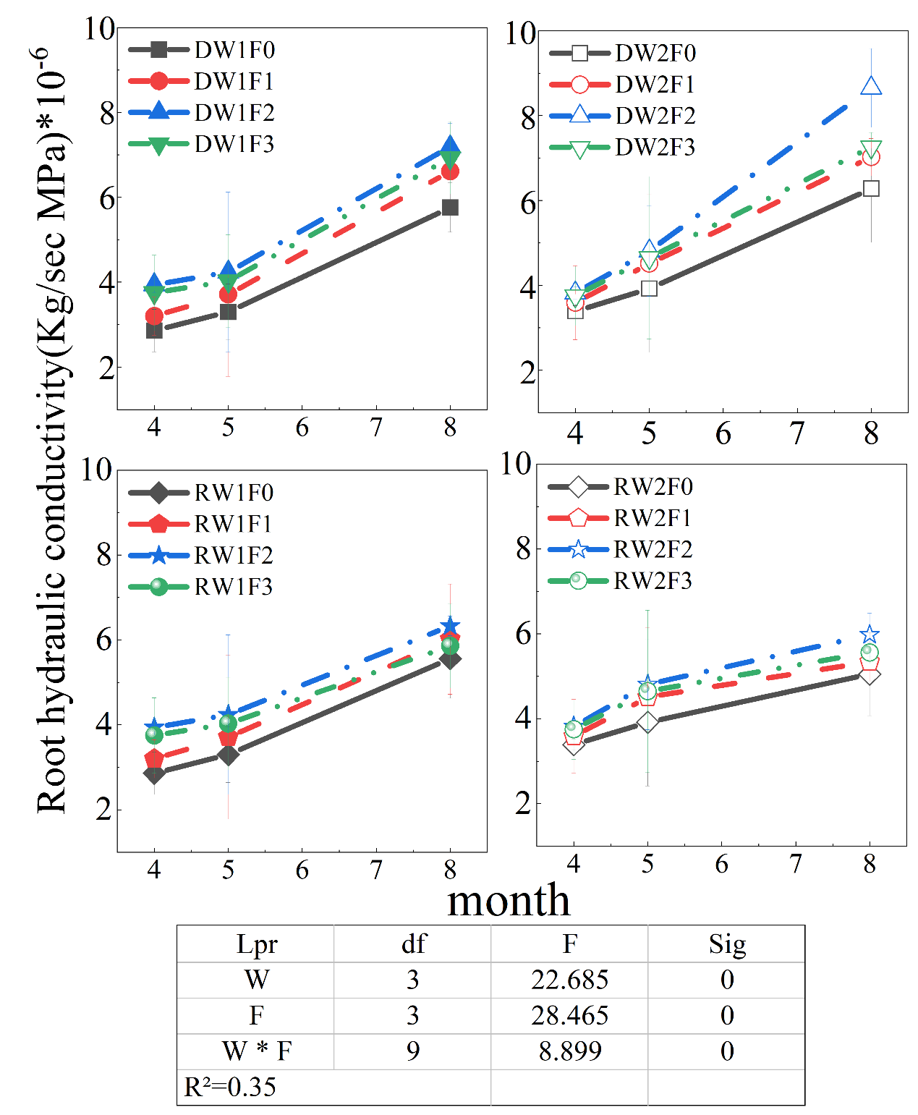
Fig. S2 Root hydraulic conductivity of Panax notoginseng (Treatments are described in the footnote of Fig. 1)

Fig. S3 Diurnal variation of net photosynthetic rate and transpiration rate of Panax notoginseng in rainy season (Treatments are described in the footnote of Fig.1)

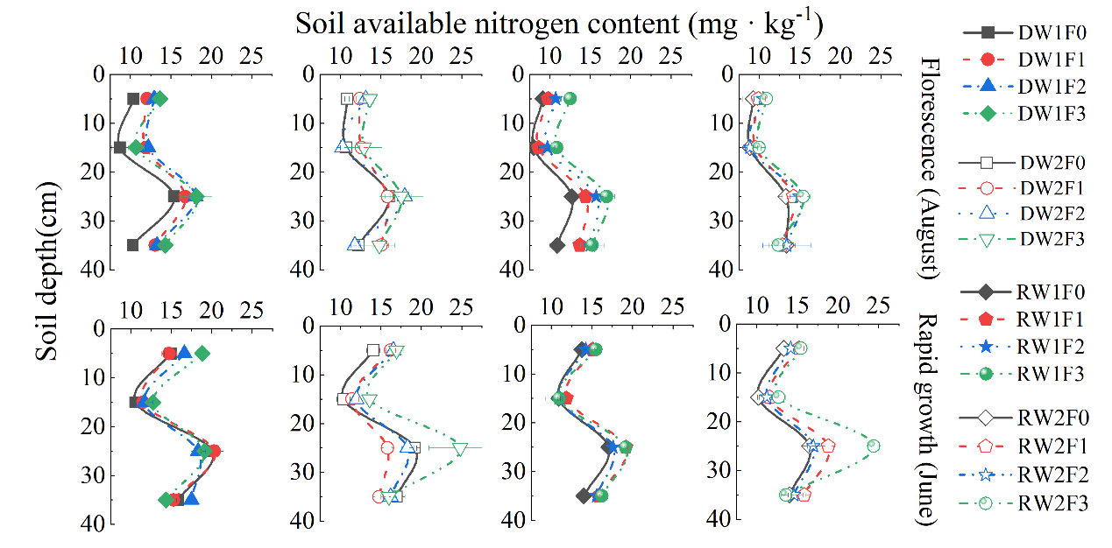 Fig. S4 Longitudinal distribution of soil available nitrogen in root zone of Panax notoginseng in rainy season (Treatments are described in the footnote of Fig. 1)

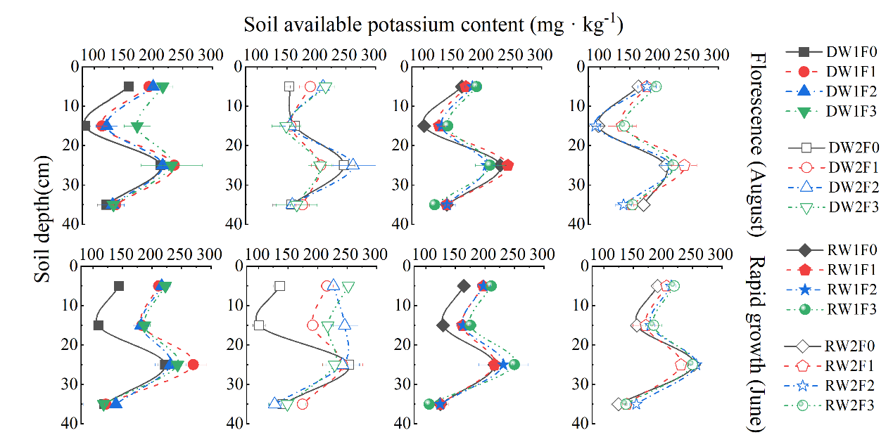
Fi. S5 Longitudinal distribution of soil available potassium in root zone of Panax notoginseng in rainy season (Treatments are described in the footnote of Fig. 1)
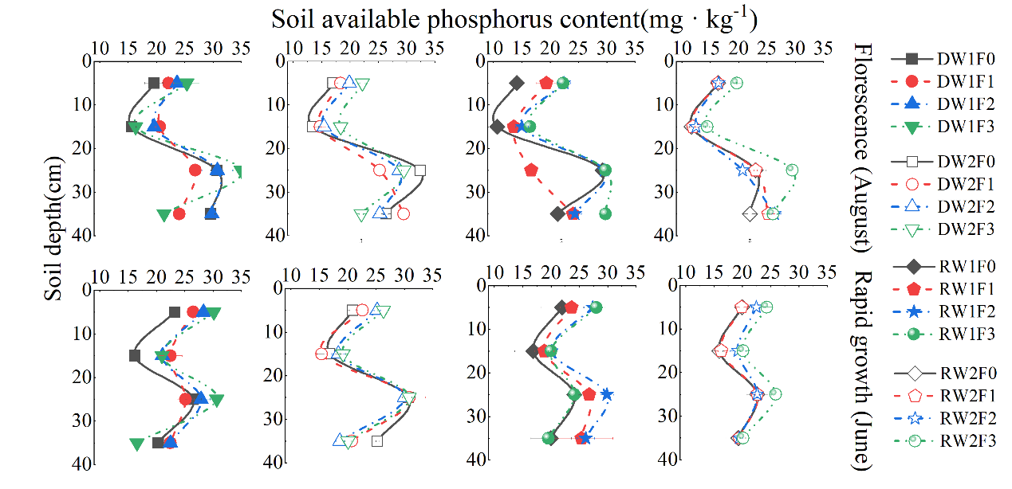
Fig. S6 Longitudinal distribution of soil available phosphorus in root zone of Panax notoginseng in rainy season (Treatments are described in the footnote of Fig. 1)

Fig. S7 Pearson's correlation coefficient between each research index and incidence rate

Fig. S8 Soil conductivity in root zone of Panax notoginseng in rainy season (Treatments are described in the footnote of Fig. 1)
References
Kidron G J, Li X R, Jia R L, Gao Y H, Zhang P (2015) Assessment of carbon gains from biocrusts inhabiting a dunefield in the Negev Desert. Geoderma, 253, 102-110. https://doi.org/10.1016/j.geoderma.2015.04.015
Kramer P J, Boyer J S (1995) Water relations of plants and soils. Academic press.
Ma J F, Ryan P R, Delhaize E (2001) Aluminium tolerance in plants and the complexing role of organic acids. Trends in plant science, 6(6), 273-278. https://doi.org/10.1016/S1360-1385(01)01961-6
Wang H Y, Zhou J M (2013) Root-zone fertilization a key and necessary approach to improve fertilizer use efficiency and reduce non-point source pollution from the cropland. Soils, 45(5), 785-790. https://doi.org/10.13758/j.cnki.tr.2013.05.004
Zhao Z, Zheng W, Ma Y, Wang X, Li Z, Zhai B, Wang Z (2020) Responses of soil water, nitrate and yield of apple orchard to integrated soil management in Loess Plateau, China. Agricultural Water Management, 240, 106325. https://doi.org/10.1016/j.agwat.2020.106325

