Supplementary Information

PGMG: A Pharmacophore-Guided Deep Learning Approach for Bioactive Molecular Generation
Huimin Zhu^{1,†}, Renyi Zhou^{1,†}, Jing Tang² and Min Li^{1,*}
¹ School of Computer Science and Engineering, Central South University, Changsha 410083, China
² Faculty of Medicine, University of Helsinki, Helsinki, 00290, Finland
† These two authors contribute equally to the work.
* Corresponding author, limin@mail.csu.edu.cn

Pharmacophore Description
We use Basefeatues.fdef in RDKit¹, which contains a series of defined molecular substructures and their corresponding pharmacophore features, to obtain all the pharmacophore features of a molecule. The description and count for each pharmacophore feature are recorded in Table S1. The typical pharmacophore features include aromatic center, posionizable center (positive charge center), hydrogen-bonded acceptors, hydrogen-bonded donor, and hydrophobic center including hydrophobe, LumpedHydrophobe. As negionizable center and znbinder are rare, we label them as unknown. As shows in the Table S1, aromatic center, hydrophobe, hydrogen bond acceptor, hydrogen bond donor, and Lumpedhydrophobe, five kinds of pharmacophore features almost always appear in every molecule.
Table S1. Distribution of pharmacophore features and detailed description.
type | description | Counts on training set | Counts on pharmacophore features | occurrence rate on training set | occurrence rate on pharmacophore
aromatic center | Number of Π-electrons conforming to the 2n+2 rule and has no exocyclic double bonds | 3148081 | 1153471 | 2.50 | 0.92
posionizable center | Atoms or functional groups ionized with formal positively charges | 183953 | 505109 | 0.40 | 0.15
hydrogen-bonded acceptor | Strongly electronegative atom that has at least one available ‘lone pair’ and formal charge of atom is not positive. | 4958778 | 1768234 | 3.94 | 1.40
hydrogen-bonded donor | Strongly electronegative atom that is covalently bonded to hydrogen atoms and its formal charge of atom is not negative | 2525490 | 880398 | 2.01 | 0.700
hydrophobe | A group of continuous lipophilic contribution atoms (such as carbon atom) that are not connected to charged atoms or electronegative centers (non-ring) | 5235429 | 1778375 | 4.16 | 1.41
Lumped-  Hydrophobe | A contiguous group of lipophilic contribution atoms (such as carbon atom) not attached to an electrically charged atom or electronegativity center, ring | 2336036 | 833539 | 1.85 | 0.66
unknown | Rare pharmacophore features, such as negionizable, znbinder | 283501 | 80726 | 0.22 | 0.064
Counts on the training set refer to statistics on all molecular pharmacophore features of the training set. Counts on pharmacophore features represent the number of pharmacophore features chosen at random from the training set. Occurrence rate on the training set is the average of the occurrence of a pharmacophore feature on a molecule. Occurrence rate on a pharmacophore represents the occurrence of a pharmacophore feature in the pharmacophore model.

Molecular pre-processing
We perform the following four steps to translate a molecule into a random pharmacophore model: 1) Use RDKit to obtain all of its pharmacophore features. 2) Select 3–7 pharmacophore features at random for each molecule; 3) Calculate the distances between the selected pharmacophore features. In this part, PGMG uses the sum of the bond lengths in the shortest path on the molecular graph between two pharmacophore features to substitute the Euclidean distances between pharmacophore features. 4) The pharmacophore model is coded as a complete graph, with the vertexes representing the pharmacophore features and the edges representing the distances between two pharmacophore features.
Table S2. Comparison of actual bond lengths with mapped bond lengths.
Covalent bond type | bond length（nm） | Relative bond length
Single bond | 0.154 | 1.00
Double bond | 0.134 | 0.87
Aromatic bond | 0.138 | 0.91
Triple Bond | 0.120 | 0.78
To verify the feasibility of this substitution, we select 1000 small molecules from the training set and obtain their 3D coordinates using RDKit¹. We calculate the Euclidean distances between the pharmacophore features of these molecules. At the same time, we calculate the distances between the pharmacophore features according to the mapping rules described in Table S2. As illustrated in Figure S1, the shortest-path distances between pharmacophore features are strongly correlated with the Euclidean distances with a Pearson correlation coefficient of 0.904, which justifies our substitution.
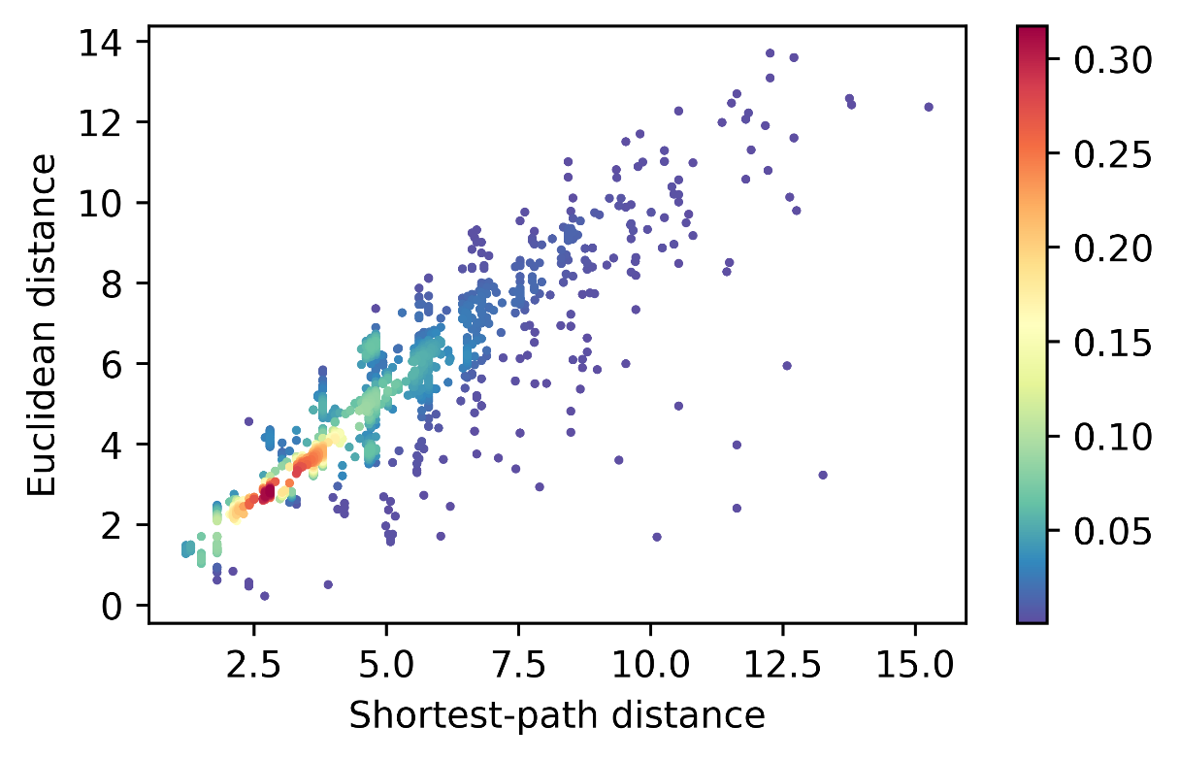
Figure S1 | Euclidean and mapping distances between pharmacophore features.

Calculation of match score
A molecule may have many pharmacophore features and a subset of them can be used to construct a pharmacophore model. We can convert all the pharmacophore features of a molecule into a fully connected graph $G_{f}=\{V_{f},E_{f}\}$ with anode set $V_{f}=\{v_{f_{1}},v_{f_{2}},…,v_{f_{n}}\}$ and an edge set $E_{m}=\{e_{f_{1,2}},e_{f_{1,3}},…,e_{f_{1,n}},e_{f_{2,3}},e_{f_{2,4}},…,e_{f_{n-1,n}}\}$. And a pharmacophore model be turned into a graph $G_{p}$ in the same way. Then the problem of calculating the matching degree between a given molecule and a given pharmacophore can be seen as finding the best match of a small graph in a large graph. Since molecules that we deal with usually contain a small number of heavy atoms, we simply use brute force to calculate the match score. The calculation steps are as follows：
Input: G: The pharmacophore graph to be matched; SMILES: SMILES to be verified
Output: The matching score for Pharmacophore and SMILES
MATCH SCORE (G, SMILES)
1 V_r = G.nodes()
2 E_r=G.edges()
3 Extract chemical features from SMILES using RDKit
4 Transform SMILES into a graph G_Q(V_q, E_q) with chemical features as nodes
5 type_list = [ ]
6 score_list = [ ]
7 for i = 1 to length(V_r):
8 type = [ ]
9 for j=1 to length(V_r):
10 if ref_type[i] == V_r[j]:
11 type.append(V_r[j])
12 type_list.append(type)
13 for k = 1 to (length(type_list[0])* (length(type_list[1])*…* (length(type_list[-1]):
14 dist_true=0
15 Extract one node and corresponding edge from different type_list at a time to get a candidate subgraph G_k(V_k, E_k)
16 for l = 1 to length(V_r):
17 for m = 1 to length( V_r):
18 if m≠l and |E_k(l, m)-E_r(l, m)|<1.2:
19 dist_true = dist_true+1
20 score=dist_true/length(E_k)
21 score_list.append(score)
22 return max(score_list)
To make the calculation process understandable, we give some examples about the calculation of the match score. The pharmacophore in Figure S2a contains four pharmacophore features, where green indicates the hydrophobic center, red indicates the aromatic ring, and blue indicates the hydrogen-bonded acceptors. Figure S2b, Figure S2c, and Figure S2d give three molecules generated by PGMG with match scores of 1.0, 0.5, and 0.5, respectively. The molecule in Figure S2b is an example of a perfect match, while the molecules in Figure S2c and Figure S2d have their problems. In Figure S2c, the hydrogen-bonded acceptor formed by the carbonyl group is too far from the other pharmacophores. In Figure S2d, the molecule lacks a hydrogen-bonded acceptor and therefore can’t match the lower right hydrogen-bonded acceptor in Figure S2a.

Figure S2 | Illustration of the matching score calculation process. (a) A pharmacophore model. (b) A molecule satisfying given pharmacophores. (c), (d) molecules unsatisfying given pharmacophores.

mapping
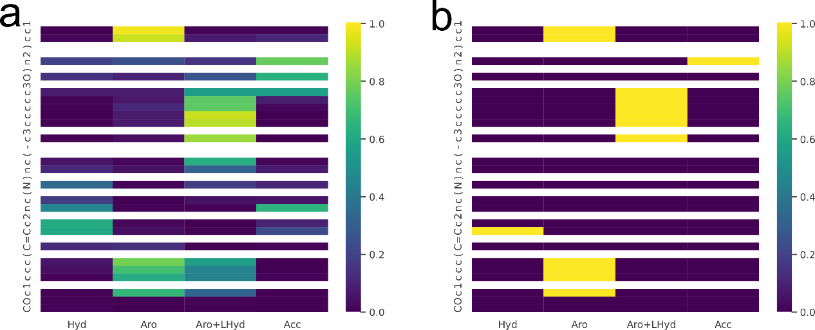

Figure S3 | An illustration of masked mapping scores and labels. Tokens that are not heavy atoms are masked and denoted in white. (a) masked mapping scores. (b) masked mapping labels.

Demonstration of generated molecules
Table S3 shows the average affinity calculated using Autodock vina³ of the top 1000 generated molecules and the affinity of the activity molecules with the specific targets obtained from the CHEMBL database. The average affinity of the top 1000 molecules with VEGFR2 and TGFβ 1 are not as good as the affinity of the reference ligand, while there are 70, 96 molecules with better affinity than the reference ligands. We calculate the RMSD of the top conformations of the reference ligand and the bioactive conformation acquired from PDB⁴. And the RMSD shows that the top conformations of the reference ligand are relatively close to the active conformations acquired from PDB (Figure S3), which indicates the reliability of our docking results. The IC50 values of the reference ligands for specific targets are also listed in the table to facilitate a comparison of the molecule's inhibition of the target. It is also worth mentioning that the IC50 values of the four reference ligands corresponding to the proteins are all at the nanomolar level, and the same level of affinity of the generated molecules implies that the molecules generated by PGMG are also likely to have good biological activity.
Table S3. molecular docking results of different receptors generated by PGMG.
target | PDB ID | average affinity of top 1000 molecules  (kcal/mol) | average affinity of bioactivity molecules  (kcal/mol) | affinity of reference ligand  (kcal/mol) | RMSD  (Å) | IC50 of reference ligand  (nM)
VEGFR2 | 1YWN | -10.0 | -8.0 | -10.8 | 0.59 | 3
CDK6 | 2EUF | -11.1 | -9.6 | -10.5 | 1.36 | 15
TGFβ 1 | 6B8Y | -11.0 | -9.2 | -11.5 | 0.45 | 0.56
BRD4 | 3MXF | -8.8 | -7.0 | -8.0 | 0.80 | 49

Figure S4 | A display of the four reference ligand conformations in the PDB, and the top affinity conformation using vina docking in the protein pocket. (a) the conformation in gray is the reference ligand of VEGFR2 (PDB: 1YWN), the conformation in green is acquired by autodock vina. (b) the conformation in gray is the reference ligand of CDK6 (PDB: 2EUF), the conformation in green is acquired by autodock vina. (c) the conformation in gray is the reference ligand of TGFβ 1 (PDB: 6B8Y), the conformation in green is acquired by autodock vina. (d) the conformation in gray is the reference ligand of BRD4 (PDB: 3MXF), the conformation in green is acquired by autodock vina.

Figure S5 | A display of 1YWN (PDB ID) generated novel molecules by PGMG. The molecules are chosen from the generated molecules with top binding affinity.
Figure S6 | A display of 2EUF (PDB ID) generated novel molecules by PGMG. The molecules are chosen from the generated molecules with top binding affinity.
Figure S7 | A display of 6B8Y (PDB ID) generated novel molecules by PGMG. The molecules are chosen from the generated molecules with top binding affinity.
Figure S8 | A display of 3MXF (PDB ID) generated novel molecules by PGMG. The molecules are chosen from the generated molecules with top binding affinity.
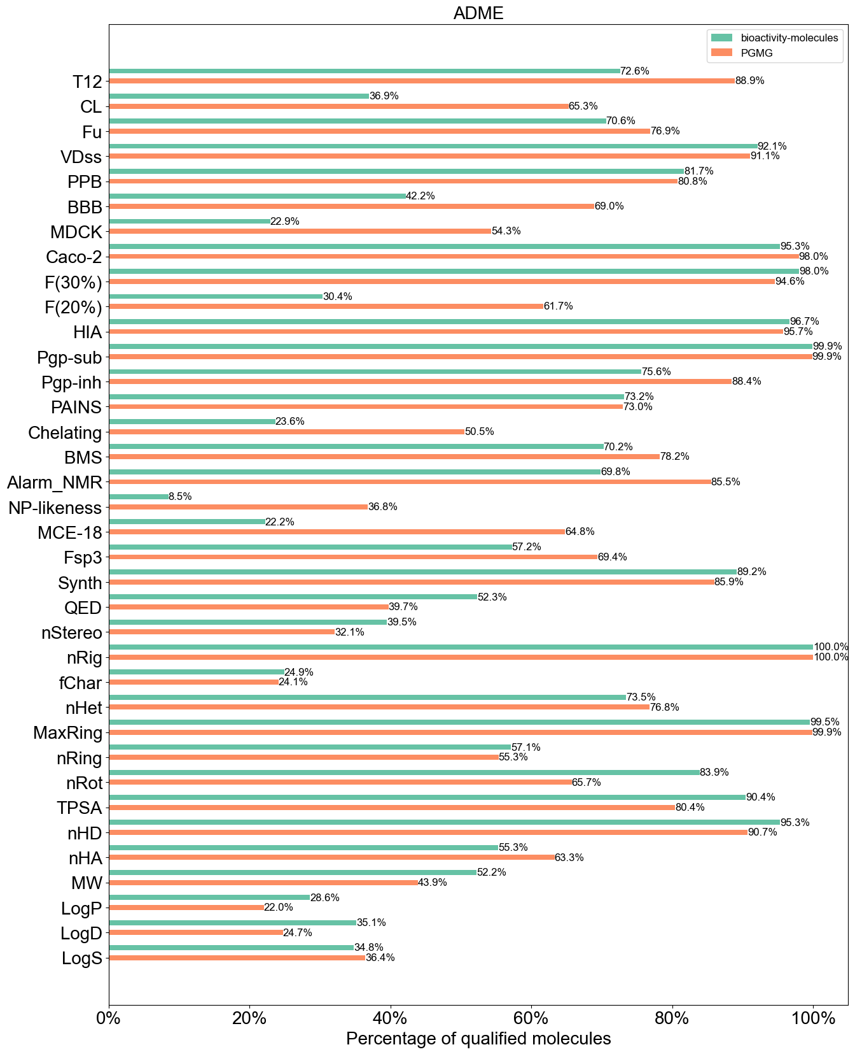
Figure S9 | Percentage of qualified molecules of generated molecules and the known active molecules in terms of absorption, distribution, metabolism, excretion (ADME) properties.
To assess the drug-like properties of generated molecules comprehensively, we use ADMETlab2.0⁵ to calculate the absorption, distribution, metabolism excretion and toxicity properties of 21,618 active molecules from the CHEMBL database and 38,193 molecules generated according to four protein structures (VEGFR2, CDK6, TGFβ 1, BRD4). We leave out indicators in the ADMETlab that are not given explicit thresholds and obtain 36 ADME indicators and 30 toxicity indicators.
Figure S9 shows the percentage of molecules fulfilled the ADME properties. Overall, the molecules generated by PGMG behave comparably to the active molecules. The acquired bioactive molecules perform better in quantitative estimate of drug-likeness (QED), number of rotatable bonds (nRot) while the generated molecules outperform the active molecules by more than 10% among 9 indicators, including the half-life of a drug (T12), the clearance of a drug (CL), blood–brain barrier penetration (BBB), the human oral bioavailability 20% (F(20%)), the probability of being the inhibitor of P-glycoprotein (Pgp-inhibitor), thiol reactive compounds (Alarm-NMR), the natural product-likeness score (NP-likeness), medicinal chemistry evolution 2018 (MCE-18), and sp3 hybridized carbons/total (Fsp3).
Figure S10 shows the percentage of qualified molecules that meet the toxicological criteria for PGMG generated molecules and the active molecules. The active molecules have advantages in the three toxicological criteria, NR-AhR, NR-PPAR-gamma, and SureChEMBL Rule (SureChEMBL). However, the generated molecules are significantly superior in 7 indicators including hERG Blockers (hERG), drug-induced liver injury (DILI), NR-AR-LBD, NR-Aromatase, skin sensitization rule (Skin_Sensitization), and acute toxicity rule (A_A_Toxicity). The above results demonstrate that PGMG has the ability to generate drug-like molecules.

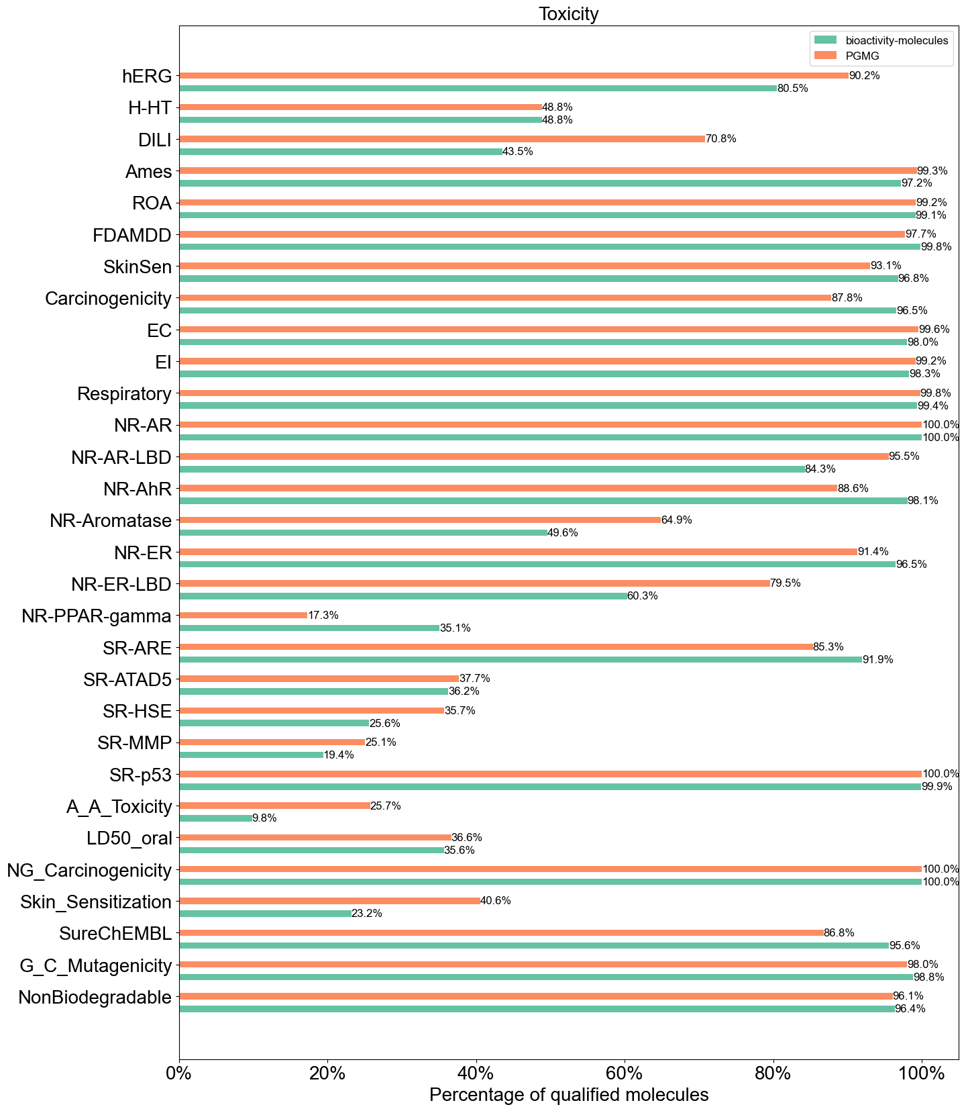
Figure S10 | Percentage of qualified molecules of PGMG-generated molecules and the known active molecules in terms of toxicological indicators.

reference
1. Landrum G. RDKit: Open-source cheminformatics. http://www.rdkit.org.
2. Sterling T, Irwin JJ. ZINC 15–ligand discovery for everyone. Journal of chemical information and modeling 55, 2324-2337 (2015).
3. Trott O, Olson AJ. AutoDock Vina: improving the speed and accuracy of docking with a new scoring function, efficient optimization, and multithreading. Journal of computational chemistry 31, 455-461 (2010).
4. Burley SK, Berman HM, Kleywegt GJ, Markley JL, Nakamura H, Velankar S. Protein Data Bank (PDB): the single global macromolecular structure archive. Protein Crystallography 1607, 627-641 (2017).
5. Xiong G, et al. ADMETlab 2.0: an integrated online platform for accurate and comprehensive predictions of ADMET properties. Nucleic Acids Research 49, W5-W14 (2021).

