Supplementary Information

Outcomes of SARS-CoV-2 Reinfection

Table of Contents | Page
Supplementary Figures
Supplementary Figure 1: Standardized mean differences between SARS-CoV-2 reinfection and first infection before and after weighting. | 2
Supplementary Figure 2: Standardized mean differences between those with first infection, two infections, and three or more infections and a non-infected control before and after weighting. | 3
Supplementary Figure 3: Cohort flowchart. | 4
Supplementary Figure 4: Timeline of analyses for risk and burden assessment comparing reinfection to first infection. | 5
Supplementary Figure 5: Timeline of analyses for risk and burden assessment by number of infections. | 6
Supplementary Tables
Supplementary Table 1:  Demographic and health characteristics of those with SARS-CoV-2 infection overall, first SARS-CoV-2 infection, SARS-CoV-2 reinfection, and the non-infected control group. | Excel sheet
Supplementary Table 2:  Demographic and health characteristics of SARS-CoV-2 reinfection after weighting. | Excel sheet
Supplementary Table 3  Risk and 6-month burden of death, hospitalization, at least one sequela, and sequelae by organ system in SARS-CoV-2 reinfection compared to those with first SARS-CoV-2 infection. | Excel sheet
Supplementary Table 4:  Risk and 6-month burden of death, hospitalization, at least one sequela, and sequelae by organ system in SARS-CoV-2 reinfection compared to first SARS-CoV-2 infection by vaccination status at time of reinfection. | Excel sheet
Supplementary Table 5:  Risk and 6-month burden of death, hospitalization, at least one sequela, and sequelae by organ system in SARS-CoV-2 reinfection compared to first SARS-CoV-2 infection by time since reinfection. | Excel sheet
Supplementary Table 6:  Demographic and health characteristics in those with first infection, two infections, three infections, and the non-infected control. | Excel sheet
Supplementary Table 7:  Demographic and health characteristics of those with first SARS-CoV-2 infection, two SARS-CoV-2 infections, three or more SARS-CoV-2 infections, and the non-infected control group after weighting. | Excel sheet
Supplementary Table 8  Risk and 6-month burden of hospitalization, at least one sequela, and sequelae by organ system in those with first SARS-CoV-2 infection compared to the non-infected control. | Excel sheet
Supplementary Table 9  Risk and 6-month burden of hospitalization, at least one sequela, and sequelae by organ system in those with two SARS-CoV-2 infections compared to the non-infected control. | Excel sheet
Supplementary Table 10  Risk and 6-month burden of hospitalization, at least one sequela, and sequelae by organ system in those with three or more SARS-CoV-2 infections compared to the non-infected control. | Excel sheet
Supplementary Table 11  Risk and 6-month burden of hospitalization, at least one sequela, and sequelae by organ system in those with two SARS-CoV-2 infections compared to those with first SARS-CoV-2 infection. | Excel sheet
Supplementary Table 12  Risk and 6-month burden of hospitalization, at least one sequela, and sequelae by organ system in those with three or more SARS-CoV-2 infections compared to those with first SARS-CoV-2 infection. | Excel sheet
Supplementary Table 13  Risk and 6-month burden of hospitalization, at least one sequela, and sequelae by organ system in those with three or more SARS-CoV-2 infections compared to those with two SARS-CoV-2 infections. | Excel sheet
Supplementary Table 14  Organ system disorder definitions | Excel sheet

Supplementary Figure 1: Standardized mean differences between SARS-CoV-2 reinfection and first infection before and after weighting.

Supplementary Figure 2: Standardized mean differences between those with first infection, two infections, and three or more infections and a non-infected control before and after weighting.

Supplementary Figure 3: Cohort flowchart.
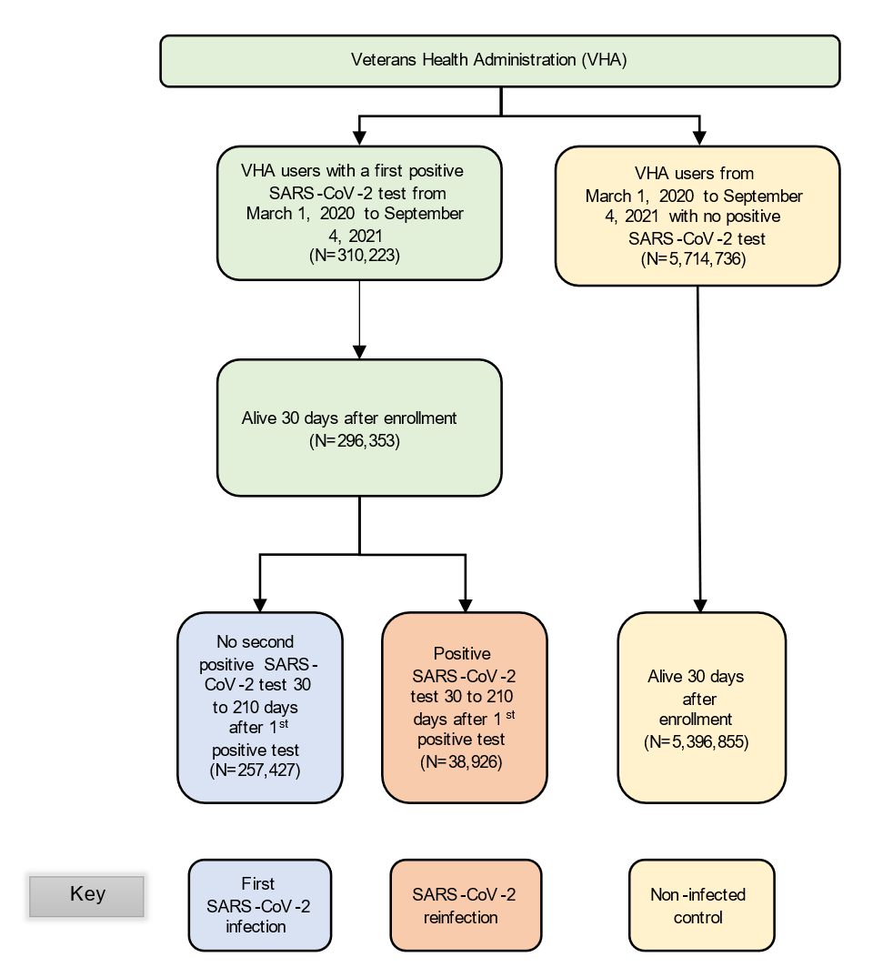

Supplementary Figure 4: Timeline of analyses for risk and burden assessment comparing reinfection to first infection. Timelines are plotted for the first infection and reinfection cohorts. Cohort participant characteristics were balanced at T₀, the date of their first infection. Risk and burdens were then estimated in the 180 days following T₁, the date of reinfection, in comparison to a similar T₁ in the first infection group.
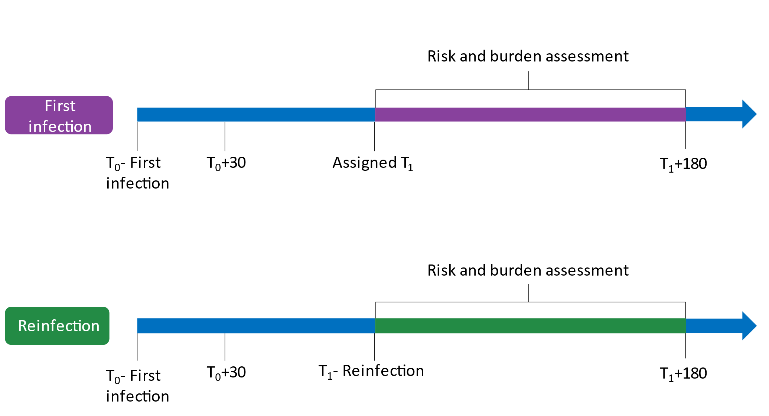

Supplementary Figure 5: Timeline of analyses for risk and burden assessment by number of infections. Timelines are plotted for the non-infected control, and in those with one, two, and three or more infections. Cohort participant characteristics were balanced at T₀, the date of their first infection. Risk and burdens were then estimated in the 180 days following the acute phase of the first infection (or corresponding time in the non-infected control).
