Extended Data Fig. 1 | Estimates of association between dental caries experience and the abundance of 16 significant species in the discovery (n=300) and the replication samples (n=116), illustrating the correspondence between coefficients in MTG and MTX analyses. *, **, and *** denote nominal p-values less than 0.1, 0.05, 0.01, respectively, and each pair of symbols next to the species names is a combination of metagenomics and metatranscriptomics results separated by /. The diagonal lines represent y = x. The 4 underlined taxa are the “top species” that were prioritized for in vitro virulence assays, biofilm studies, and potential in vivo experiments.
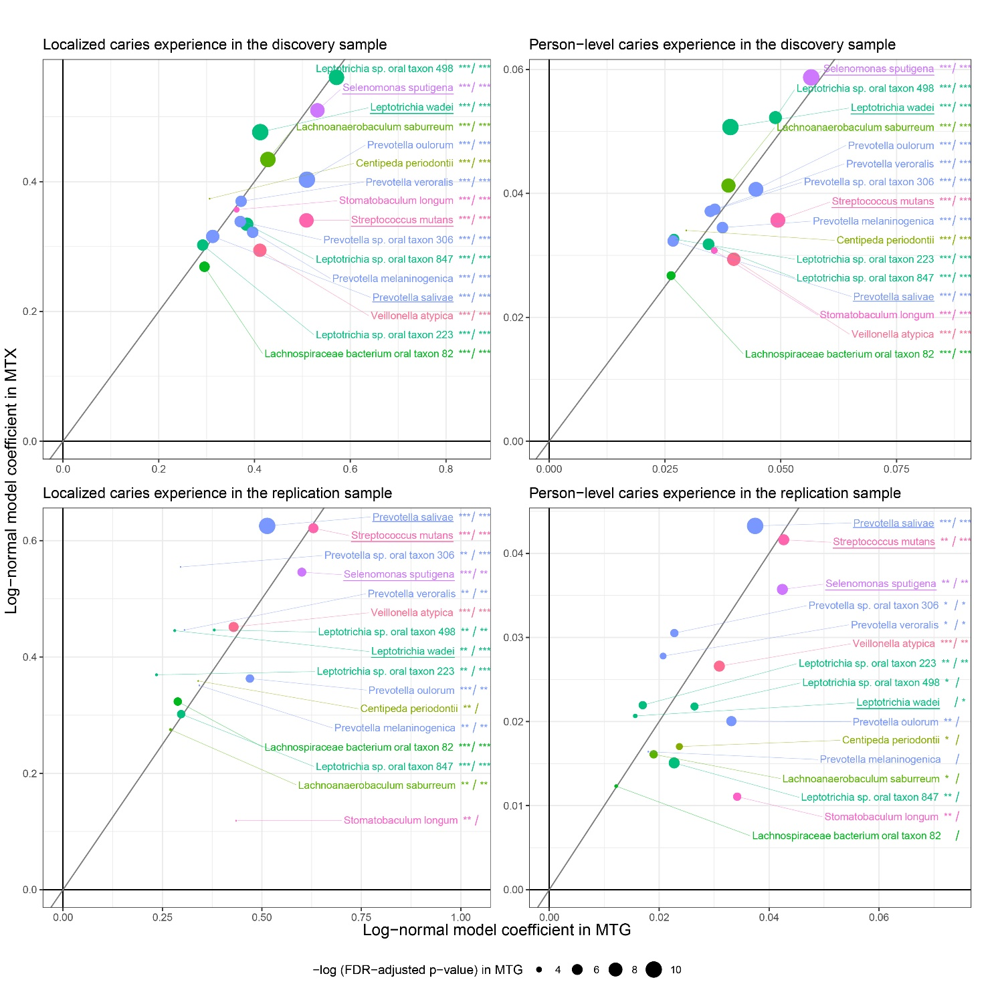

Extended Data Fig. 2 | Pathways involving the 16 significant species (top 30 in terms of proportional involvement) identified in taxonomic analyses (i.e., % significant species on the x-axis) and their association with caries experience (y-axis). Four pathways’ relative expression in MTX was significantly associated with caries experience (after FDR multiple correction test for 30 pathways): glycolysis IV (ranked #3 overall in terms of expression in MTX data), pyruvate fermentation to acetate and lactate II (ranked #9), chorismate biosynthesis from 3-dehydroquinate and UDP-N-acetyl-D-glucosamine biosynthesis I. Lactose and galactose degradation I, although not significantly associated with caries experience after FDR correction, was the pathway with the highest proportional participation of significant species (38%, L. wadei and S. mutans).

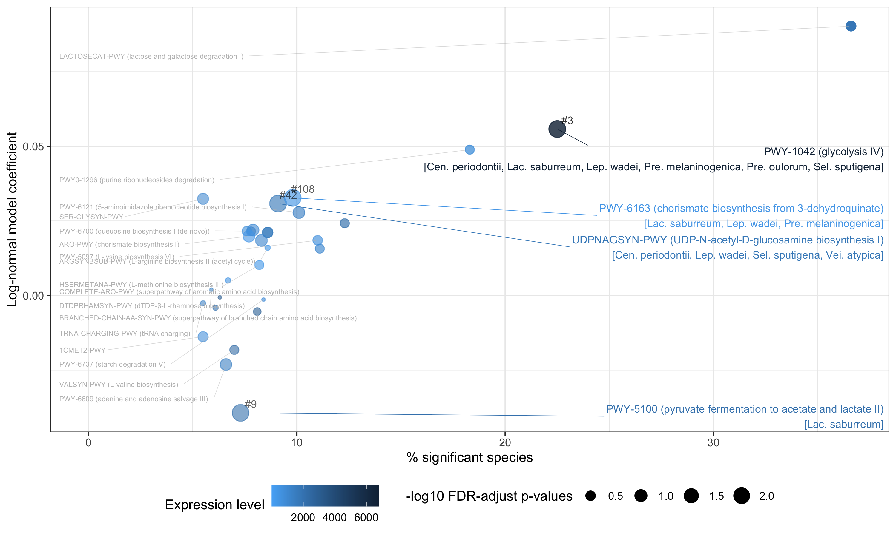

Extended Data Fig. 3 | Model of the primary (i.e., pediatric) dentition. The 5 tooth surfaces from which supragingival plaque biofilm was collected from are orange highlighted.

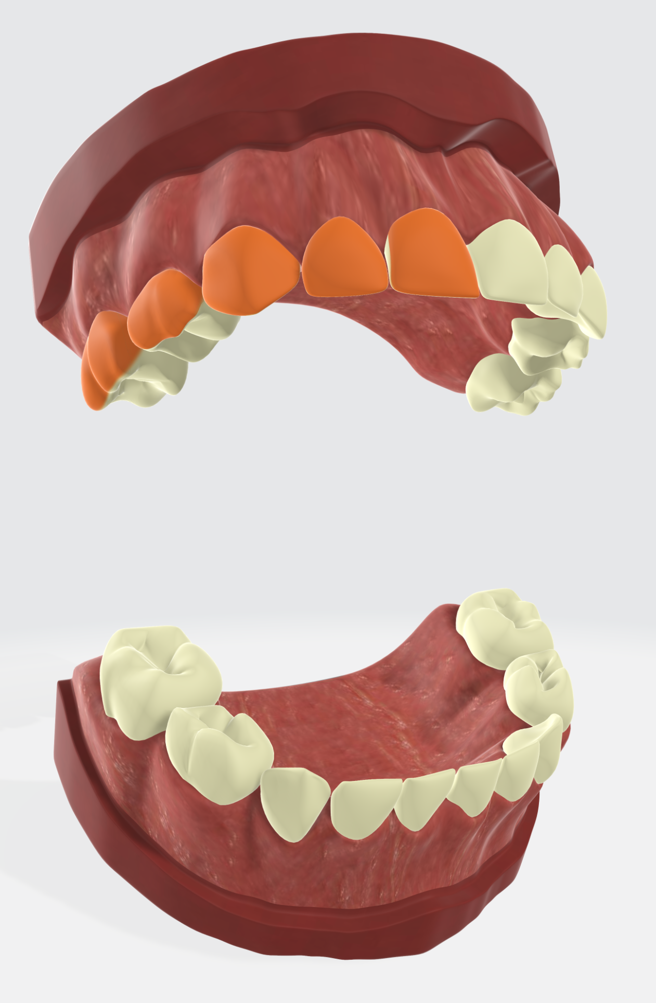

Extended Data Fig. 4 | Flowchart of high-throughput sequencing data (MTG) pre-processing in the discovery ZOE 2.0 sample (n=300)

Eligible participants with clinical data | (n = 300, # species = 6,914)
↓ | → | Exclusion of taxa:  viruses (# = 503)
Dataset including all non-viral taxa | (n = 300, # species = 6,411, mean RPK per subject = 8,004,958)
↓ | → | Normalization:  RPK to TPM
Per-participant normalized dataset | (n = 300, # species = 6,411, mean TPM per subject = 8,000,000)
↓ | → | Exclusion of taxa:  low prevalent (<10%) and  low abundant (<80 in TPM) species
Participant samples with informative species | (n = 300, # species = 418, mean TPM per subject = 7,962,295)

Extended Data Table 1 | Bacterial species significantly associated with dental caries experience. These 16 species were significantly associated with early childhood caries (ECC) experience defined as a quantitative localized trait (i.e., from the 5 tooth surfaces from which biofilm was collected) in shotgun metagenomics (DNAseq-MTG) analyses in the ZOE 2.0 study (n=300). The identified species associations were replicated in metatranscriptomics (RNA-seq-MTX) analyses, and for the person-level (i.e., entire mouth) equivalent quantitative trait of ECC in both metagenomics and metatranscriptomics analyses. Replication of these associations was further done in an independent sample of 116 similarly aged children. Underlined species were carried forward to in vitro assays and in vivo experiments.
 | localized caries experience |  |  |  |  |  |  |  | person-level caries experience
 | MTG |  |  |  | MTX |  |  |  | MTG |  |  |  | MTX
 | FDR-significant, discovery (n=300) | replication (n=116) |  |  | FDR-significant, discovery (n=297) | replication (n=116) |  |  | FDR-significant, discovery (n=300) | replication (n=116) |  |  | FDR-significant, discovery (n=297) | replication (n=116)
bacterial species | log-normal coef. (p, q) | SD | Sig | FDR | log-normal coef. (p, q) | SD | Sig | FDR | log-normal coef. (p, q) | SD | Sig | FDR | log-normal coef. (p, q) | SD | Sig | FDR
Prevotella salivae | 0.31 (8.5x10⁻⁶, 4.9x10⁻⁴) | ✓ | ✓ | ✓ | 0.32 (1.3x10⁻⁵, 7.1x10⁻⁴) | ✓ | ✓ | ✓ | 0.027 (8.9x10⁻⁵, 2.5x10-3) | ✓ | ✓ | ✓ | 0.032 (5.3x10⁻⁶, 2.3x10⁻⁴) | ✓ | ✓ | ✓
Streptococcus mutans | 0.51 (2.6x10⁻⁶, 2.2x10⁻⁴) | ✓ | ✓ | ✓ | 0.34 (1.0x10⁻³, 1.5x10⁻²) | ✓ | ✓ | ✓ | 0.049 (2.4x10⁻⁶, 2.5x10⁻⁴) | ✓ | ✓ |  | 0.036 (4.7x10⁻⁴, 8.0x10-3) | ✓ | ✓
Selenomonas sputigena | 0.53 (3.1x10⁻⁶, 2.2x10⁻⁴) | ✓ | ✓ | ✓ | 0.51 (1.1x10⁻⁴, 3.5x10⁻³) | ✓ | ✓ | ✓ | 0.057 (2.7x10⁻⁷, 7.8x10⁻⁵) | ✓ | ✓ |  | 0.059 (5.3x10⁻⁶, 2.3x10⁻⁴) | ✓ | ✓
Veillonella atypica | 0.41 (1.1x10⁻⁵, 4.9x10⁻⁴) | ✓ | ✓ | ✓ | 0.29 (2.0x10-3, 2.2x10⁻²) | ✓ | ✓ | ✓ | 0.040 (1.0x10⁻⁵, 7.3x10⁻⁴) | ✓ | ✓ |  | 0.029 (1.7x10-3, 1.9x10⁻²) | ✓ | ✓
Prevotella oulorum | 0.51 (1.5x10⁻⁷, 4.5x10⁻⁵) | ✓ | ✓ | ✓ | 0.40 (4.1x10⁻⁶, 3.1x10⁻⁴) | ✓ | ✓ | ✓ | 0.045 (2.3x10⁻⁶, 2.5x10⁻⁴) | ✓ | ✓ |  | 0.041 (2.2x10⁻⁶, 1.6x10⁻⁴) | ✓
Leptotrichia sp oral taxon 847 | 0.38 (9.9x10⁻⁶, 4.9x10⁻⁴) | ✓ | ✓ | ✓ | 0.33 (2.2x10⁻⁶, 2.1x10⁻⁴) | ✓ | ✓ | ✓ | 0.034 (4.5x10⁻⁵, 2.1x10-3) | ✓ | ✓ |  | 0.032 (4.8x10⁻⁶, 2.3x10⁻⁴) | ✓
Lachnospiraceae bacterium oral taxon 082 | 0.30 (1.1x10⁻⁴, 2.8x10⁻³) | ✓ | ✓ | ✓ | 0.27 (1.1x10⁻⁴, 3.5x10-3) | ✓ | ✓ | ✓ | 0.026 (3.8x10⁻⁴, 8.1x10-3) | ✓ |  |  | 0.027 (9.0x10⁻⁵, 3.1x10-3) | ✓
Leptotrichia sp oral taxon 223 | 0.29 (6.3x10⁻⁵, 1.8x10⁻³) | ✓ | ✓ |  | 0.30 (1.3x10⁻⁵, 7.1x10⁻⁴) | ✓ | ✓ | ✓ | 0.027 (1.4x10⁻⁴, 3.6x10-3) | ✓ | ✓ |  | 0.033 (1.6x10⁻⁶, 1.6x10⁻⁴) | ✓ | ✓
Leptotrichia wadei | 0.41 (2.2x10⁻⁷, 4.5x10⁻⁵) | ✓ | ✓ |  | 0.48 (1.0x10⁻⁸, 4.0x10⁻⁶) | ✓ | ✓ | ✓ | 0.039 (3.7x10⁻⁷, 7.8x10⁻⁵) | ✓ |  |  | 0.051 (4.7x10⁻¹⁰, 1.8x10⁻⁷) | ✓
Leptotrichia sp oral taxon 498 | 0.57 (9.1x10⁻⁷, 1.0x10⁻⁴) | ✓ | ✓ |  | 0.56 (6.6x10⁻⁷, 8.5x10⁻⁵) | ✓ | ✓ | ✓ | 0.049 (1.6x10⁻⁵, 9.4x10⁻⁴) | ✓ |  |  | 0.052 (2.5x10⁻⁶, 1.6x10⁻⁴) | ✓
Lachnoanaerobaculum saburreum | 0.43 (9.6x10⁻⁷, 1.0x10⁻⁴) | ✓ | ✓ |  | 0.43 (4.6x10⁻⁷, 8.5x10⁻⁵) | ✓ | ✓ | ✓ | 0.039 (5.0x10⁻⁶, 4.2x10⁻⁴) | ✓ |  |  | 0.041 (1.1x10⁻⁶, 1.6x10⁻⁴) | ✓
Prevotella sp oral taxon 306 | 0.37 (4.3x10⁻⁵, 1.6x10⁻³) | ✓ | ✓ |  | 0.34 (6.1x10⁻⁴, 1.1x10⁻²) | ✓ | ✓ | ✓ | 0.035 (7.2x10⁻⁵, 2.2x10⁻³) | ✓ |  |  | 0.037 (1.3x10⁻⁴, 3.7x10⁻³) | ✓
Prevotella veroralis | 0.37 (6.4x10⁻⁵, 1.8x10⁻³) | ✓ | ✓ |  | 0.37 (2.7x10⁻⁴, 6.4x10⁻³) | ✓ | ✓ | ✓ | 0.036 (7.2x10⁻⁵, 2.2x10⁻³) | ✓ |  |  | 0.037 (1.7x10⁻⁴, 4.5x10⁻³) | ✓
Prevotella melaninogenica | 0.40 (4.8x10⁻⁵, 1.6x10⁻³) | ✓ | ✓ |  | 0.32 (5.3x10⁻⁴, 1.1x10⁻²) | ✓ | ✓ |  | 0.037 (7.4x10⁻⁵, 2.2x10⁻³) | ✓ |  |  | 0.034 (1.6x10⁻⁴, 4.3x10⁻³) | ✓
Stomatobaculum longum | 0.36 (1.6x10⁻³, 1.8x10⁻²) | ✓ | ✓ |  | 0.36 (1.1x10⁻³, 1.5x10⁻²) | ✓ |  |  | 0.036 (1.4x10⁻³, 1.7x10⁻²) | ✓ | ✓ |  | 0.031 (4.2x10⁻³, 3.9x10⁻²) | ✓
Centipeda periodontii | 0.31 (3.8x10⁻³, 3.1x10⁻²) | ✓ | ✓ |  | 0.37 (2.5x10⁻³, 2.6x10⁻²) | ✓ |  |  | 0.030 (3.9x10⁻³, 3.6x10⁻²) | ✓ |  |  | 0.034 (5.3x10⁻³, 4.7x10⁻²) | ✓
SD, same direction in discovery and replication samples; Sig, nominally statistically significant in the replication sample; FDR, multiple testing-corrected statistically significant in the replication sample

Extended Data Table 2 | Pathways found to be associated with caries experience (localized, quantitative trait) after correction for multiple testing, i.e., the top 30 pathways in terms of abundance, involving the 16 significant species.
pathway | pathway description/link | p | beta | pathway expression rank | % significant species | significant species in pathway
PWY-1042 | glycolysis IV | 2.9x10⁻⁴ | 0.0558 | 3 | 23.2 | Cen. periodontii, Lac. saburreum, Lep. wadei, Pre. melaninogenica, Pre. oulorum, Sel. sputigena
PWY-5100 | pyruvate fermentation to acetate and lactate II | 4.9x10⁻⁴ | -0.0394 | 9 | 7.7 | Lac. saburreum
UDPNAGSYN-PWY | UDP-N-acetyl-D-glucosamine biosynthesis I | 5.5x10⁻⁴ | 0.0308 | 42 | 9.8 | Cen. periodontii, Lep. wadei, Sel. sputigena, Vei. atypica
PWY-6163 | chorismate biosynthesis from 3-dehydroquinate | 6.1x10⁻⁴ | 0.0327 | 108 | 8.9 | Lac. saburreum, Pre. melaninogenica

Extended Data Table 3 | Top species’ genes significantly differentially expressed in caries experience (FDR-adjusted p<0.05).
gene | species | p | direction | gene name
rnpB | S. mutans | 2.4x10⁻⁶ | up | RNase P RNA component class B
glnA | S. mutans | 3.0x10⁻³ | up | type I glutamate--ammonia ligase
F5989_RS09410 | S. mutans | 3.0x10⁻³ | up | glucose-1-phosphate adenylyltransferase
gtfC | S. mutans | 3.6x10⁻³ | up | glucosyltransferase GtfC
F5989_RS03555 | S. mutans | 6.0x10⁻³ | up | GBS Bsp-like repeat-containing protein
F5989_RS06655 | S. mutans | 8.2x10⁻³ | up | NAD-dependent succinate-semialdehyde dehydrogenase
lpdA | S. mutans | 8.5x10⁻³ | up | dihydrolipoyl dehydrogenase
F5989_RS01985 | S. mutans | 8.8x10⁻³ | up | ATP-dependent Clp protease ATP-binding subunit
F5989_RS08255 | S. mutans | 9.0x10⁻³ | down | 23S ribosomal RNA
rnpB | P. salivae | 1.1x10⁻³ | up | RNase P RNA component class A
HMPREF9145_RS11155 | P. salivae | 4.0x10⁻³ | down | TolC family protein
HMPREF9145_RS11160 | P. salivae | 4.1x10⁻³ | down | efflux RND transporter permease subunit
pckA | P. salivae | 6.1x10⁻³ | up | phosphoenolpyruvate carboxykinase (ATP)
HMPREF9145_RS09270 | P. salivae | 7.0x10⁻³ | up | OmpA family protein
tuf | P. salivae | 1.8x10⁻² | up | elongation factor Tu
rpsM | L. wadei | 7.3x10⁻⁵ | up | 30S ribosomal protein S13
No significantly differentially expressed gene in dental caries was found for Selenomonas sputigena after correction for multiple comparisons.

Extended Data Table 4 | Significant (FDR p<0.05) gene-gene expression interactions between S mutans and S sputigena
S mutans gene | S sputigena gene | p | direction | S mutans gene name | S sputigena gene name
F5989_RS09410 | SELSP_RS02150 | 1.6x10⁻⁷ | negative | glucose-1-phosphate adenylyltransferase | YDG domain-containing protein
F5989_RS09410 | eno | 2.0x10⁻⁶ | negative | glucose-1-phosphate adenylyltransferase | phosphopyruvate hydratase
F5989_RS09410 | gap | 3.0x10⁻⁶ | negative | glucose-1-phosphate adenylyltransferase | type I glyceraldehyde-3-phosphate dehydrogenase
F5989_RS09410 | SELSP_RS01640 | 3.7x10⁻⁶ | negative | glucose-1-phosphate adenylyltransferase | flagellin
glgD | rnpB | 1.9x10⁻⁵ | positive | glucose-1-phosphate adenylyltransferase subunit GlgD | RNase P RNA component class A
F5989_RS09410 | SELSP_RS01225 | 2.2x10⁻⁵ | negative | glucose-1-phosphate adenylyltransferase | iron transporter
F5989_RS09410 | SELSP_RS11020 | 2.3x10⁻⁵ | negative | glucose-1-phosphate adenylyltransferase | DUF3793 family protein
F5989_RS09410 | SELSP_RS08375 | 4.1x10⁻⁵ | negative | glucose-1-phosphate adenylyltransferase | malate dehydrogenase
F5989_RS09410 | SELSP_RS08335 | 7.2x10⁻⁵ | negative | glucose-1-phosphate adenylyltransferase | S-layer homology domain-containing protein
hprK | ssrS | 1.1x10⁻⁴ | positive | HPr(Ser) kinase/phosphatase | 6S RNA
F5989_RS09410 | SELSP_RS04605 | 1.4x10⁻⁴ | negative | glucose-1-phosphate adenylyltransferase | acyl-CoA mutase large subunit family protein
F5989_RS09410 | SELSP_RS01200 | 1.5x10⁻⁴ | negative | glucose-1-phosphate adenylyltransferase | DUF4198 domain-containing protein
glgD | SELSP_RS02150 | 3.5x10⁻⁴ | negative | glucose-1-phosphate adenylyltransferase subunit GlgD | YDG domain-containing protein

Extended Data Table 5 | Descriptive information of the discovery (n=300) and replication (n=116) samples used in human microbiome taxonomic discovery. Caries experience was defined using sensitive caries lesion detection criteria (i.e., including early-stage lesions, ICDAS≥1) among the surfaces from which plaque biofilm was collected (i.e., localized experience) and the entire dentition (i.e., person-level disease experience).
 | n |  | age | sex |  | Race/ethnicity |  |  | caries experience
 | MTG | MTX | months (SD) | male,  n (%) | female, n (%) | Non-Hispanic white | African American | Hispanic/other | localized, dmfs (SD) | person-level, dmfs (SD)
discovery | 300 | 297 | 52 (8) | 155 (52) | 145 (48) | 89 (30%) | 113 (38%) | 98 (33%) | 0.9 (1.5) | 14 (16)
replication | 116 | 116 | 55 (8) | 53 (46) | 63 (54) | 18 (16%) | 52 (45%) | 46 (40%) | 0.7 (1.2) | 8.9 (15)
ICDAS, the international caries detection and classification system wherein 1 is first visual change in enamel (“initial lesion”); MTG, metagenomics, whole genome shotgun sequencing data; MTX, metatranscriptomics, RNA-seq data; dmfs, the number of decayed, missing and filled (restored) tooth surfaces due to dental caries. Age, sex, and caries experience information is presented for participants with MTG data

