Appendix A: Modifying and updating parameters according to cloudy days for pixel 16.
Table A.1 shows all observed farmland values for Pixel 16 that cloudy days marked in red. The values have been collected at 16-day intervals according to Landsat 8 satellite imagery (first line).

Table A.1. Values observed by Landsat 8 for pixel 16 during different stages of crop growth (209 days (
97 | 81 | 65 | 49 | 33 | 17 | 1 | Pixel 16
Sunny | Sunny | Sunny | Overcast | Sunny | Overcast | sunny | Cloud_status
0.163327 | 0.205171 | 0.195663 | 0.085294 | 0.180907 | 0.078997 | 0.011602 | NSAVI
0.124771 | 0.215742 | 0.194401 | -0.02706 | 0.162078 | -0.03844 | 0.030241 | NLAI
209 | 193 | 177 | 161 | 145 | 129 | 113 | Pixel 16
Sunny | Sunny | Overcast | Sunny | Sunny | Sunny | Sunny | Cloud_status
0.19466 | 0.491598 | 0.073615 | 0.687585 | 0.534694 | 0.361758 | 0.19466 | NSAVI
0.192173 | 1.197614 | -0.04807 | 6.042331 | 1.466728 | 0.644363 | 0.192173 | NLAI

The first step of the update is performed on day 17. Because it is the first overcast day and the observed values should be converted to actual values by cubic spline interpolation (Table A.2)

Table A.2. Updating (the first step)
17 | 1 | pixel16_update1
Overcast | sunny | Cloud_status
0.148461 | 0. 11601 | NSAVI
0.09616 | 0.030241 | NLAI

Tables A.3, A.4, etc. show the continuation of the update steps, respectively.

Table A.3. Updating (the second step)
49 | 33 | 17 | 1 | pixel16_update2
Overcast | Sunny | Overcast | sunny | Cloud_status
0.213353 | 0.180907 | 0.148461 | 0.11601 | NSAVI
0.227997 | 0.162078 | 0.09616 | 0.030241 | NLAI

Table A.4. Updating (the fourth step)
65 | 49 | 33 | 17 | 1 | pixel16_update3
Sunny | Overcast | Sunny | Overcast | sunny | Cloud_status
0.245799 | 0.213353 | 0.180907 | 0.148461 | 0.11601 | NSAVI
0.293915 | 0.227997 | 0.162078 | 0.09616 | 0.030241 | NLAI

Table A.5. Updating (the fifth step)
81 | 65 | 49 | 33 | 17 | 1 | pixel16_update4
Sunny | Sunny | Overcast | Sunny | Overcast | sunny | Cloud_status
0.278245 | 0.245799 | 0.213353 | 0.180907 | 0.148461 | 0.11601 | NSAVI
0.359834 | 0.293915 | 0.227997 | 0.162078 | 0.09616 | 0.030241 | NLAI

Table A.6. Updating (the sixth step)
81 | 65 | 49 | 33 | 17 | 1 | pixel16_update5
Sunny | Sunny | Overcast | Sunny | Overcast | sunny | Cloud_status
0.278245 | 0.245799 | 0.213353 | 0.180907 | 0.148461 | 0.11601 | NSAVI
0.359834 | 0.293915 | 0.227997 | 0.162078 | 0.09616 | 0.030241 | NLAI
 |  |  |  |  | 97 | pixel16_update5
 |  |  |  |  | sunny | Cloud_status
 |  |  |  |  | 0.310691 | NSAVI
 |  |  |  |  | 0.425752 | NLAI

Table A.7. Updating (the seventh step)
81 | 65 | 49 | 33 | 17 | 1 | pixel16_update6
Sunny | Sunny | Overcast | Sunny | Overcast | sunny | Cloud_status
0.278245 | 0.245799 | 0.213353 | 0.180907 | 0.148461 | 0.11601 | 0.278245
0.359834 | 0.293915 | 0.227997 | 0.162078 | 0.09616 | 0.030241 | 0.359834
 |  |  |  | 113 | 97 | pixel16_update6
 |  |  |  | sunny | sunny | Cloud_status
 |  |  |  | 0.343137 | 0.310691 | NSAVI
 |  |  |  | 0.491671 | 0.425752 | NLAI

Table A.8. Updating (the eighth step)
81 | 65 | 49 | 33 | 17 | 1 | pixel16_update7
Sunny | Sunny | Overcast | Sunny | Overcast | sunny | Cloud_status
0.278245 | 0.245799 | 0.213353 | 0.180907 | 0.148461 | 0.11601 | NSAVI
0.359834 | 0.293915 | 0.227997 | 0.162078 | 0.09616 | 0.030241 | NLAI
 |  |  | 129 | 113 | 97 | pixel16_update7
 |  |  | sunny | sunny | sunny | Cloud_status
 |  |  | 0.361758 | 0.343137 | 0.310691 | NSAVI
 |  |  | 0.644363 | 0.491671 | 0.425752 | NLAI

Table A.9. Updating (the ninth step)
81 | 65 | 49 | 33 | 17 | 1 | pixel16_update8
Sunny | Sunny | Overcast | Sunny | Overcast | sunny | Cloud_status
0.278245 | 0.245799 | 0.213353 | 0.180907 | 0.148461 | 0.11601 | NSAVI
0.359834 | 0.293915 | 0.227997 | 0.162078 | 0.09616 | 0.030241 | NLAI
 | 161 | 145 | 129 | 113 | 97 | pixel16_update8
 | sunny | sunny | sunny | sunny | sunny | Cloud_status
 | 0.687585 | 0.534694 | 0.361758 | 0.343137 | 0.310691 | NSAVI
 | 6.042331 | 1.466728 | 0.644363 | 0.491671 | 0.425752 | NLAI

Table A.10. Updating (the tenth step)
81 | 65 | 49 | 33 | 17 | 1 | pixel16_update9
Sunny | Sunny | Overcast | Sunny | Overcast | sunny | Cloud_status
0.278245 | 0.245799 | 0.213353 | 0.180907 | 0.148461 | 0.11601 | NSAVI
0.359834 | 0.293915 | 0.227997 | 0.162078 | 0.09616 | 0.030241 | NLAI
177 | 161 | 145 | 129 | 113 | 97 | pixel16_update9
Overcast | sunny | sunny | sunny | sunny | sunny | Cloud_status
0.540968 | 0.687585 | 0.534694 | 0.361758 | 0.343137 | 0.310691 | NSAVI
18.09084 | 6.042331 | 1.466728 | 0.644363 | 0.491671 | 0.425752 | NLAI

In the tenth step, the LAI value is more than 7. So, the algorithm stops (according to the Lemma1).

Appendix B: Z-table

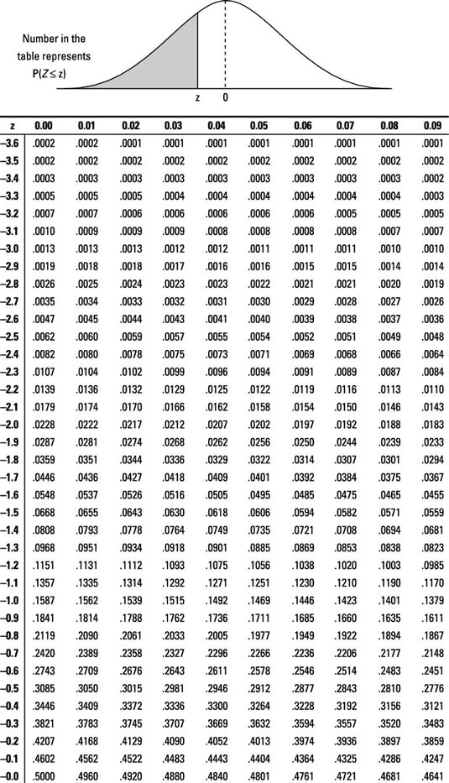

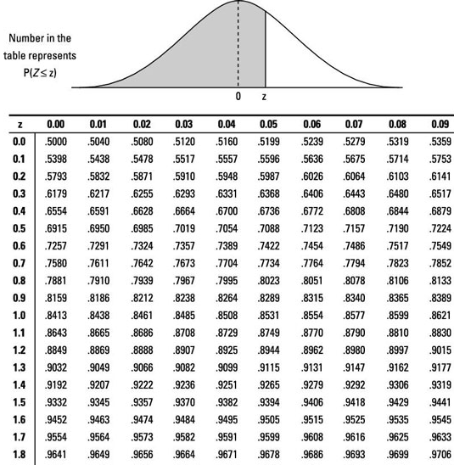

Appendix C: t-student table
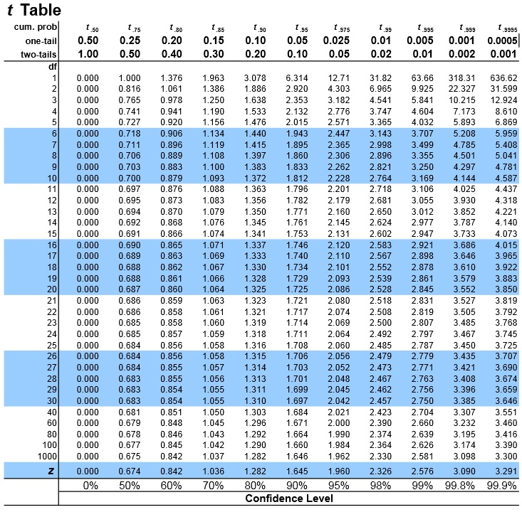

Appendix D. CDI values for the overcast area in Figure 12

-10.1499 | -10.1294 | -10.1124 | -10.1211 | -10.1341 | -10.1323 | -10.0577 | -10.0723
-10.1162 | -10.1478 | -10.1286 | -10.1132 | -10.0754 | -10.0757 | -10.072 | -10.0551
-10.1062 | -10.1776 | -10.1165 | -10.0036 | -9.999 | -10.0674 | -10.0761 | -10.0037
-10.1944 | -10.1051 | -10.0392 | -10.0072 | -10.0195 | -10.0432 | -10.0654 | -10.0237
-10.056 | -9.98957 | -10.0358 | -9.99687 | -10.029 | -10.0637 | -10.0645 | -10.059
-10.0387 | -10.0409 | -10.0805 | -10.0381 | -9.9819 | -9.98956 | -10.0715 | -10.0972
-9.99215 | -10.0449 | -10.0885 | -10.1141 | -10.0634 | -9.99756 | -10.035 | -10.0985
-9.92738 | -10.0216 | -10.0668 | -10.1314 | -10.1456 | -10.0649 | -10.0475 | -10.1293
-10.0761 | -10.1011 | -10.1174 | -10.0913 | -10.0853 | -10.024 | -10.0328 | -10.022
-10.1238 | -10.151 | -10.1103 | -10.0816 | -10.0868 | -10.0402 | -10.0565 | -10.085
-10.0712 | -10.11 | -10.0813 | -10.083 | -10.0722 | -10.088 | -10.0959 | -10.0743
-10.0224 | -10.0851 | -10.1081 | -10.1184 | -10.0815 | -10.0822 | -10.0795 | -10.0522
-10.0322 | -10.0742 | -10.0979 | -10.1238 | -10.1074 | -10.0717 | -9.99289 | -9.9737
-10.1098 | -10.0826 | -10.1209 | -10.1473 | -10.1127 | -9.97602 | -9.87698 | -9.81782
-10.1352 | -10.1251 | -10.1235 | -10.0919 | -10.0042 | -9.90559 | -9.91993 | -9.86709
-10.1139 | -10.0996 | -10.0949 | -9.9835 | -9.78251 | -9.80899 | -9.88491 | -9.86099
-9.83102 | -9.83895 | -9.88057 | -9.92665 | -9.91696 | -9.88391 | -9.95967 | -10.05
-9.81275 | -9.79054 | -9.84608 | -9.91737 | -9.88096 | -9.87756 | -9.80494 | -9.97695
-9.83006 | -9.81339 | -9.90103 | -9.97695 | -9.9524 | -9.91664 | -9.8865 | -9.92475
-9.78112 | -9.76921 | -9.91005 | -9.98738 | -9.42005 | -9.82488 | -9.83725 | -9.79973
-9.71562 | -9.80959 | -9.9359 | -9.98624 | -9.46197 | -9.74274 | -9.82636 | -9.87277
-9.76094 | -9.87738 | -9.93772 | -10.0422 | -9.72309 | -9.79056 | -9.80726 | -9.92479
-9.738 | -9.88771 | -9.98486 | -10.0537 | -9.74565 | -9.85253 | -9.84747 | -9.839
-9.82509 | -9.91114 | -9.99877 | -10.0258 | -9.75714 | -9.86956 | -9.88808 | -9.90955
-10.1274 | -10.0604 | -10.0182 | -9.8476 | -9.60004 | -9.6568 | -9.89952 | -9.91454
-10.1415 | -10.0802 | -9.85345 | -9.82859 | -9.66843 | -9.81632 | -9.96144 | -9.96756
-10.1351 | -10.1105 | -10.0072 | -9.91087 | -9.8522 | -9.87196 | -9.97794 | -9.92337
-10.1088 | -10.1262 | -10.1322 | -10.058 | -9.979 | -9.95808 | -9.98104 | -9.86092
-10.1237 | -10.1322 | -10.1343 | -10.1086 | -10.0883 | -9.99581 | -9.83835 | -9.70775
-10.1638 | -10.161 | -10.1918 | -10.1272 | -10.0857 | -10.0053 | -9.76768 | -9.61849
-10.2031 | -10.1745 | -10.1832 | -10.1843 | -10.0827 | -10.0279 | -9.91412 | -9.71892
-10.1957 | -10.195 | -10.2052 | -10.1894 | -10.1363 | -10.0423 | -9.87498 | -9.84777
-9.98608 | -10.0446 | -10.0809 | -10.1425 | -10.21 | -10.181 | -10.1924 | -10.1728
-9.98246 | -10.0093 | -10.0704 | -10.131 | -10.1785 | -10.2272 | -10.2188 | -10.2101
-10.0586 | -10.1336 | -10.1479 | -10.1319 | -10.1163 | -10.1421 | -10.1851 | -10.185
-10.0847 | -10.1413 | -10.2044 | -10.1759 | -10.1529 | -10.1114 | -10.1424 | -10.1569
-10.0989 | -10.106 | -10.1823 | -10.1951 | -10.1626 | -10.1439 | -10.1341 | -10.1547
-10.1136 | -10.0899 | -10.1654 | -10.2106 | -10.2105 | -10.2541 | -10.2443 | -10.1941
-10.0963 | -10.1065 | -10.1271 | -10.1587 | -10.1559 | -10.1356 | -10.2298 | -10.2223
-10.1479 | -10.1278 | -10.0932 | -10.1153 | -10.1113 | -10.1659 | -10.198 | -10.1735
-10.1413 | -10.1367 | -10.1361 | -10.0875 | -10.0487 | -10.0063 | -9.84582 | -9.83773
-10.1219 | -10.1043 | -10.109 | -9.97873 | -9.87903 | -9.82202 | -9.55562 | -9.69656
-10.1259 | -10.1367 | -10.0626 | -9.97583 | -9.89652 | -9.84952 | -9.69925 | -9.80245
-10.1427 | -10.1498 | -10.1065 | -9.9759 | -9.92981 | -9.92525 | -9.77981 | -9.37483
-10.1267 | -10.1162 | -10.1012 | -9.99823 | -9.97211 | -9.94475 | -9.82688 | -9.70489
-10.1452 | -10.1647 | -10.1178 | -10.0197 | -9.97686 | -9.91788 | -9.77262 | -9.72493
-10.1089 | -10.1325 | -10.0895 | -10.0491 | -9.99279 | -9.90376 | -9.81525 | -9.70781
-10.0965 | -10.1263 | -10.1519 | -10.1582 | -10.1606 | -10.1479 | -10.0714 | -10.1119
-10.0832 | -10.1237 | -10.2116 | -10.216 | -10.218 | -10.1649 | -10.1137 | -10.1336
-10.1476 | -10.2607 | -10.2208 | -10.2151 | -10.2343 | -10.2139 | -10.1988 | -10.1476
-10.1204 | -10.199 | -10.2286 | -10.2382 | -10.2643 | -10.2056 | -10.1229 | -10.1402
-10.1893 | -10.2035 | -10.201 | -10.2231 | -10.2564 | -10.1858 | -10.1518 | -10.1582
-10.2146 | -10.1493 | -10.2039 | -10.2265 | -10.1955 | -10.15 | -10.1336 | -10.1388
-10.236 | -10.21 | -10.2312 | -10.2261 | -10.1936 | -10.1424 | -10.089 | -10.0845
-10.2463 | -10.2671 | -10.2356 | -10.1737 | -10.1837 | -10.1669 | -10.0719 | -10.121

Appendix E. CDI values for the partly cloudy area in Figure 14
-8.66631 | -8.9245 | -9.00994 | -9.13909 | -9.17697 | -9.13364 | -9.05979 | -8.84953
-8.81394 | -8.92191 | -9.1164 | -9.28833 | -9.23919 | -9.19931 | -9.05646 | -8.89867
-9.08042 | -9.13107 | -9.13475 | -9.13305 | -9.17145 | -9.20858 | -9.15237 | -9.04441
-9.23608 | -9.30924 | -9.1459 | -9.1421 | -9.25104 | -9.32503 | -9.30886 | -9.18
-9.20389 | -9.15905 | -9.02138 | -9.24838 | -9.38123 | -9.33733 | -9.24931 | -9.16872
-9.26947 | -9.1952 | -9.16874 | -9.14812 | -9.33587 | -9.40623 | -9.32334 | -9.14385
-9.38139 | -9.23362 | -9.09463 | -9.14882 | -9.30971 | -9.34912 | -9.14423 | -9.17051
-9.50561 | -9.46602 | -9.44192 | -9.39361 | -9.38375 | -9.35189 | -9.16861 | -9.18686
-8.85446 | -8.88316 | -8.80092 | -8.67668 | -8.53058 | -8.4461 | -8.44308 | -8.28533
-8.979 | -8.85174 | -8.58673 | -8.50269 | -8.50092 | -8.48273 | -8.41746 | -8.41169
-9.0826 | -8.9971 | -8.76195 | -8.71269 | -8.5749 | -8.45681 | -8.45112 | -8.33983
-9.06324 | -9.05685 | -8.7895 | -8.77746 | -8.69068 | -8.55907 | -8.5108 | -8.40554
-8.98197 | -9.00273 | -8.84919 | -8.7764 | -8.67691 | -8.67044 | -8.48754 | -8.38479
-9.17451 | -9.2238 | -9.05464 | -8.85158 | -8.68418 | -8.88088 | -8.77806 | -8.46111
-9.27676 | -9.2866 | -9.16287 | -9.11503 | -8.99432 | -8.89221 | -8.91381 | -8.91362
-9.3065 | -9.32461 | -9.23972 | -9.22526 | -9.07595 | -8.92817 | -9.0647 | -9.10375
-9.52815 | -9.54103 | -9.52578 | -9.50202 | -9.45604 | -9.42384 | -9.31042 | -8.45197
-9.29226 | -9.45948 | -9.41515 | -9.44539 | -9.52387 | -9.51654 | -9.43182 | -8.40967
-8.99607 | -9.21334 | -9.25404 | -9.36045 | -9.47579 | -9.50799 | -9.48987 | -8.40106
-8.87815 | -9.26383 | -9.20455 | -9.2473 | -9.40303 | -9.48001 | -9.45059 | -8.36261
-8.91629 | -9.253 | -9.23272 | -9.20775 | -9.32807 | -9.46203 | -9.44783 | -8.29661
-9.00615 | -9.24934 | -9.27097 | -9.29533 | -9.35731 | -9.44939 | -9.41607 | -8.28831
-9.00526 | -9.30542 | -9.375 | -9.31286 | -9.36691 | -9.39064 | -9.33647 | -8.72044
-9.12722 | -9.1903 | -9.20991 | -9.25808 | -9.26191 | -9.33501 | -9.20313 | -9.02912
-9.36464 | -9.39514 | -9.38295 | -9.34993 | -9.1857 | -9.01967 | -9.13313 | -9.19303
-9.45071 | -9.4239 | -9.40462 | -9.37599 | -9.25322 | -9.16444 | -9.1789 | -9.16221
-9.37308 | -9.39723 | -9.3416 | -9.2393 | -9.23618 | -9.07403 | -9.13773 | -9.06856
-9.31478 | -9.33854 | -9.16385 | -9.17774 | -9.10839 | -8.93123 | -8.97335 | -9.01692
-9.27147 | -9.17633 | -8.9821 | -8.90848 | -8.8946 | -8.7635 | -8.81937 | -8.76794
-9.1731 | -9.12128 | -8.94579 | -8.83853 | -8.77829 | -8.57951 | -8.62413 | -8.62883
-9.01333 | -8.9649 | -9.00155 | -8.77 | -8.682 | -8.50258 | -8.52189 | -8.582
-8.63184 | -8.69698 | -9.02406 | -8.86301 | -8.70954 | -8.62797 | -8.40125 | -8.49655
-9.08099 | -9.36035 | -9.26822 | -9.41195 | -9.36288 | -9.29367 | -9.10756 | -8.76859
-8.71877 | -9.05927 | -9.29963 | -9.28557 | -9.42777 | -9.37755 | -9.10492 | -8.77666
-9.12673 | -9.06569 | -9.14202 | -9.26513 | -9.37902 | -9.28839 | -9.06785 | -8.911
-9.42738 | -9.34465 | -9.33125 | -9.28987 | -9.29793 | -9.12392 | -8.90739 | -8.94468
-8.7502 | -8.72384 | -8.96717 | -9.02218 | -8.90714 | -8.6799 | -8.37671 | -8.32171
-8.70081 | -8.78329 | -9.01128 | -9.12834 | -8.97673 | -8.8003 | -8.61764 | -8.44915
-8.75313 | -8.83656 | -9.01164 | -9.06832 | -9.05716 | -8.92493 | -8.72499 | -8.45791
-8.90091 | -8.92857 | -9.14331 | -9.09229 | -9.12021 | -9.07076 | -8.91799 | -8.64869

