Supplementary Table 1 The prevalence of EAR in children with different birth outcomes under different definitions of EAR [n (%)]
Birth outcomes |  | Sample size | AR appeared before 48 months | AR appeared before 60 months | AR appeared before 72 months | AR did not appear before 72 months
Total |  | 2705 | 1079(39.9) | 1809(66.9) | 2273(84.0) | 432(16.0)
Birth weight
 | LBW | 60 | 46(76.7) | 53(88.3) | 58(96.7) | 2(3.3)
 | ABW | 2430 | 972(40.0) | 1647(67.8) | 2056(84.6) | 374(15.4)
 | HBW | 215 | 61(28.4) | 109(50.7) | 159(74.0) | 56(26.0)
Gestational age
 | PTB | 111 | 67(60.4) | 89(80.2) | 101(91.0) | 10(9.0)
 | NPTB | 2594 | 1012(39.0) | 1720(66.3) | 2172(83.7) | 422(16.3)
Birth weight by gestational age
 | SGA | 264 | 138(52.3) | 207(78.4) | 241(91.3) | 23(8.7)
 | AGA | 2002 | 793(39.6) | 1355(67.7) | 1696(84.7) | 306(15.3)
 | LGA | 439 | 148(33.7) | 247(56.3) | 336(76.5) | 103(23.5)

PTB: premature birth; Non-PTB: non-premature birth; HBW: high birth weight; ABW: adequate birth weight; LBW: low birth weight; LGA: large for gestational age; AGA: appropriate for gestational age; SGA: small for gestational age; AR: adiposity rebound.

Supplementary Table 2 Sensitivity analysis on the association between birth outcomes and EAR [OR (95%CI)]
Birth outcomes |  | EAR [OR (95%CI)]
 |  | Adjusted model✝
Categorical variables
Birth weight
 | LBW | 5.03(2.68,9.48)**
 | ABW | Reference
 | HBW | 0.54(0.37,0.77)**
Gestational age
 | PTB | 2.31(1.48,3.60)**
 | NPTB | Reference
Birth weight by gestational age
 | SGA | 1.96(1.47,2.62)**
 | AGA | Reference
 | LGA | 0.67(0.52,0.86)**
Continuous variables
Weight, kg |  | 0.45(0.36,0.55)**
Length, cm |  | 0.90(0.85,0.95)**
Head circumference, cm |  | 0.86(0.81,0.92)**
Gestational age, weeks |  | 0.93(0.87,0.99)**
PTB: premature birth; Non-PTB: non-premature birth; HBW: high birth weight; ABW: adequate birth weight; LBW: low birth weight; LGA: large for gestational age; AGA: appropriate for gestational age; SGA: small for gestational age; EAR: early age at adiposity rebound.
✝: adjusted for maternal age, family monthly income per capita, race, parental education level, maternal pre-pregnancy BMI, paternal BMI, parity, maternal metabolic dysfunctions, alcohol use and tobacco use during pregnancy, children’s sex, breastfeeding duration ≥6 months, main caregivers before 3 years, time spent in screening, and time spent in outdoor activities.
*: P <0.05; **: P <0.01.
Supplementary Table 3 The association between BMI in each age and age at AR by linear regression analyses
Physical growth indicators | Time | Age at AR [β (95%CI)]
Physical growth indicators | Time | Model 1 | Model 2 | Model 3
Continuous variables
BMI | Birth | 1.56(1.16,1.95)** | 1.98(1.59,2.37)** | 2.11(1.66,2.56)**
BMI | 42 days | 2.15(1.73,2.56)** | 2.50(2.09,2.92)** | 2.52(2.06,2.97)**
BMI | 3 months | 1.67(1.31,2.03)** | 2.02(1.66,2.39)** | 2.01(1.62,2.41)**
BMI | 6 months | 1.06(0.72,1.39)** | 1.38(1.05,1.70)** | 1.34(0.98,1.70)**
BMI | 9 months | 0.39(0.02,0.76)* | 0.75(0.38,1.12)** | 0.71(0.31,1.12)**
BMI | 12 months | -0.23(-0.63,0.17) | 0.19(-0.22,0.59) | 0.16(-0.29,0.60)
BMI | 18 months | -1.94(-2.40,-1.48)** | -1.45(-1.92,-0.99)** | -1.36(-1.87,-0.86)**
BMI | 24 months | -3.46(-3.90,-3.01)** | -2.97(-3.43,-2.51)** | -3.08(-3.58,-2.58)**
Head circumference | Birth | 0.83(0.49,1.17)** | 1.02(0.68,1.36)** | 1.02(0.65,1.40)**
Head circumference | 42 days | 1.83(1.32,2.34)** | 2.04(1.51,2.57)** | 1.83(1.25,2.40)**
Head circumference | 3 months | 1.51(1.03,2.00)** | 1.82(1.30,2.33)** | 1.68(1.12,2.24)**
Head circumference | 6 months | 1.06(0.61,1.51)** | 1.32(0.83,1.81)** | 1.17(0.64,1.70)**
Head circumference | 9 months | 0.72(0.26,1.17)** | 0.91(0.41,1.40)** | 0.77(0.23,1.30)**
Head circumference | 12 months | 0.26(-0.18,0.71) | 0.37(-0.12,0.85) | 0.22(-0.31,0.75)
Head circumference | 18 months | -0.27(-0.72,0.18) | -0.25(-0.73,0.23) | -0.34(-0.86,0.18)
Head circumference | 24 months | -0.62(-1.07,-0.16)** | -0.51(-0.99,-0.02)* | -0.62(-1.14,-0.09)*
EAR: early age at adiposity rebound.
Model 1: No factors were adjusted.
Model 2: Adjusted for maternal age, family monthly income per capita, maternal education level, father’s education level, maternal pre-pregnancy BMI, father’s BMI, parity, maternal metabolic dysfunctions, alcohol use and tobacco use during pregnancy, and children’s sex.
Model 3: Adjusted for maternal age, family monthly income per capita, maternal education level, father’s education level, maternal pre-pregnancy BMI, father’s BMI, parity, maternal metabolic dysfunctions, alcohol use and tobacco use during pregnancy, children’s sex, breastfeeding duration ≥6 months, main caregivers before 3 years, time spent in screening, and time spent in outdoor activities.
*: P <0.05; **: P <0.01.

Supplementary Table 4 The association between BMI in each age and EAR by binary logistic regression analyses
Physical growth indicators | Time | EAR [OR (95%CI)]
Physical growth indicators | Time | Model 1 | Model 2 | Model 3
Continuous variables
BMI | Birth | 0.80(0.75,0.85)** | 0.75(0.70,0.80)** | 0.75(0.69,0.80)**
BMI | 42 days | 0.79(0.74,0.84)** | 0.74(0.69,0.79)** | 0.74(0.68,0.79)**
BMI | 3 months | 0.84(0.80,0.89)** | 0.79(0.75,0.84)** | 0.79(0.75,0.85)**
BMI | 6 months | 0.89(0.85,0.94)** | 0.85(0.81,0.90)** | 0.85(0.80,0.90)**
BMI | 9 months | 0.95(0.91,1.01)# | 0.91(0.86,0.96)** | 0.91(0.86,0.97)**
BMI | 12 months | 1.03(0.97,1.09) | 0.98(0.92,1.04) | 0.98(0.91,1.04)
BMI | 18 months | 1.26(1.18,1.35)** | 1.20(1.12,1.29)** | 1.17(1.09,1.27)**
BMI | 24 months | 1.48(1.37,1.59)** | 1.41(1.30,1.52)** | 1.41(1.30,1.53)**
Head | Birth | 0.89(0.85,0.94)** | 0.87(0.82,0.92)** | 0.86(0.81,0.92)**
Head | 42 days | 0.79(0.74,0.86)** | 0.76(0.70,0.83)** | 0.78(0.71,0.85)**
Head | 3 months | 0.84(0.78,0.90)** | 0.80(0.74,0.86)** | 0.80(0.73,0.87)**
Head | 6 months | 0.90(0.84,0.96)** | 0.87(0.81,0.93)** | 0.87(0.80,0.94)**
Head | 9 months | 0.91(0.86,0.97)** | 0.90(0.83,0.97)** | 0.89(0.82,0.97)**
Head | 12 months | 0.98(0.92,1.05) | 0.98(0.91,1.05) | 0.98(0.91,1.06)
Head | 18 months | 1.05(0.99,1.12) | 1.06(0.99,1.14)# | 1.06(0.98,1.15)
Head | 24 months | 1.09(1.02,1.16)* | 1.08(1.00,1.16)* | 1,08(1.00,1.17)#
EAR: early age at adiposity rebound.
Model 1: No factors were adjusted.
Model 2: Adjusted for maternal age, family monthly income per capita, maternal education level, father’s education level, maternal pre-pregnancy BMI, father’s BMI, parity, maternal metabolic dysfunctions, alcohol use and tobacco use during pregnancy, and children’s sex.
Model 3: Adjusted for maternal age, family monthly income per capita, maternal education level, father’s education level, maternal pre-pregnancy BMI, father’s BMI, parity, maternal metabolic dysfunctions, alcohol use and tobacco use during pregnancy, children’s sex, breastfeeding duration ≥6 months, main caregivers before 3 years, time spent in screening, and time spent in outdoor activities.
*: P <0.05; **: P <0.01; #:P <0.1

Supplementary Table 5 The association between BMI in each age and EAR by binary logistic regression analyses
Physical growth indicators | Time | EAR [OR (95%CI)]
Physical growth indicators | Time | Model 1 | Model 2 | Model 3
Categorical variables
Overweight & obesity  vs  Normal weight & underweight | Birth | 0.66(0.53,0.82)** | 0.56(0.43,0.70)** | 0.57(0.44,0.74)**
Overweight & obesity  vs  Normal weight & underweight | Birth | Ref | Ref | Ref
Overweight & obesity  vs  Normal weight & underweight | 42 days | 0.56(0.45,0.70)** | 0.47(0.37,0.59)** | 0.48(0.37,0.62)**
Overweight & obesity  vs  Normal weight & underweight | 42 days | Ref | Ref | Ref
Overweight & obesity  vs  Normal weight & underweight | 3 months | 0.73(0.61,0.88)** | 0.65(0.54,0.79)** | 0.67(0.54,0.82)**
Overweight & obesity  vs  Normal weight & underweight | 3 months | Ref | Ref | Ref
Overweight & obesity  vs  Normal weight & underweight | 6 months | 0.75(0.63,0.90)** | 0.66(0.55,0.80)** | 0.63(0.51,0.72)**
Overweight & obesity  vs  Normal weight & underweight | 6 months | Ref | Ref | Ref
Overweight & obesity  vs  Normal weight & underweight | 9 months | 0.89(0.74,1.06) | 0.78(0.65,0.95)* | 0.79(0.64,0.97)*
Overweight & obesity  vs  Normal weight & underweight | 9 months | Ref | Ref | Ref
Overweight & obesity  vs  Normal weight & underweight | 12 months | 1.03(0.87,1.23) | 0.91(0.76,1.10) | 0.91(0.74,1.11)
Overweight & obesity  vs  Normal weight & underweight | 12 months | Ref | Ref | Ref
Overweight & obesity  vs  Normal weight & underweight | 18 months | 1.72(1.42,2.09)** | 1.49(1.22,1.82)** | 1.49(1.20,1.86)**
Overweight & obesity  vs  Normal weight & underweight | 18 months | Ref | Ref | Ref
Overweight & obesity  vs  Normal weight & underweight | 24 months | 2.42(1.94,3.01)** | 2.09(1.67,2.63)** | 2.09(1.63,2.68)**
Overweight & obesity  vs  Normal weight & underweight | 24 months | Ref | Ref | Ref
EAR: early age at adiposity rebound.
Model 1: No factors were adjusted.
Model 2: Adjusted for maternal age, family monthly income per capita, maternal education level, father’s education level, maternal pre-pregnancy BMI, father’s BMI, parity, maternal metabolic dysfunctions, alcohol use and tobacco use during pregnancy, and children’s sex.
Model 3: Adjusted for maternal age, family monthly income per capita, maternal education level, father’s education level, maternal pre-pregnancy BMI, father’s BMI, parity, maternal metabolic dysfunctions, alcohol use and tobacco use during pregnancy, children’s sex, breastfeeding duration ≥6 months, main caregivers before 3 years, time spent in screening, and time spent in outdoor activities.
*: P <0.05; **: P <0.01.

Supplementary Table 6 Sensitivity analysis on the association between RWG and EAR [OR (95%CI)]
Physical growth indicators | Exposure classification | Time | EAR [OR (95%CI)]
Physical growth indicators | Exposure classification | Time | Adjusted model✝
WAZ | RWG | Birth-12 months | 1.40(1.17,1.67)**
WAZ | NRWG | Birth-12 months | Ref
WAZ | RWG | Birth-18 months | 1.94(1.61,2.33)
WAZ | NRWG | Birth-18 months | Ref
WAZ | RWG | Birth-24 months | 2.29(1.89,2.76)**
WAZ | NRWG | Birth-24 months | Ref
WAZ | RWG | 12-24 months | 4.30(2.82,6.56)**
WAZ | NRWG | 12-24 months | Ref
BMI trajectory | Low BMI trajectory | Birth-24 months | 1.58(1.20,2.06)**
BMI trajectory | Rising BMI trajectory | Birth-24 months | 2.18(1.56,3.04)**
BMI trajectory | Medium BMI trajectory | Birth-24 months | Ref
BMI trajectory | High BMI trajectory | Birth-24 months | 0.94(0.76,1.17)
BMI trajectory | Very high BMI trajectory | Birth-24 months | 1.03(0.75,1.41)
RWG: rapid weight gain; NRWG: no rapid weight gain; WAZ: z-scores for weight-for-age; EAR: early age at adiposity rebound.
✝: adjusted for maternal age, family monthly income per capita, race, parental education level, maternal pre-pregnancy BMI, paternal BMI, parity, maternal metabolic dysfunctions, alcohol use and tobacco use during pregnancy, children’s sex, breastfeeding duration ≥6 months, main caregivers before 3 years, time spent in screening, and time spent in outdoor activities.
*: P <0.05; **: P <0.01.

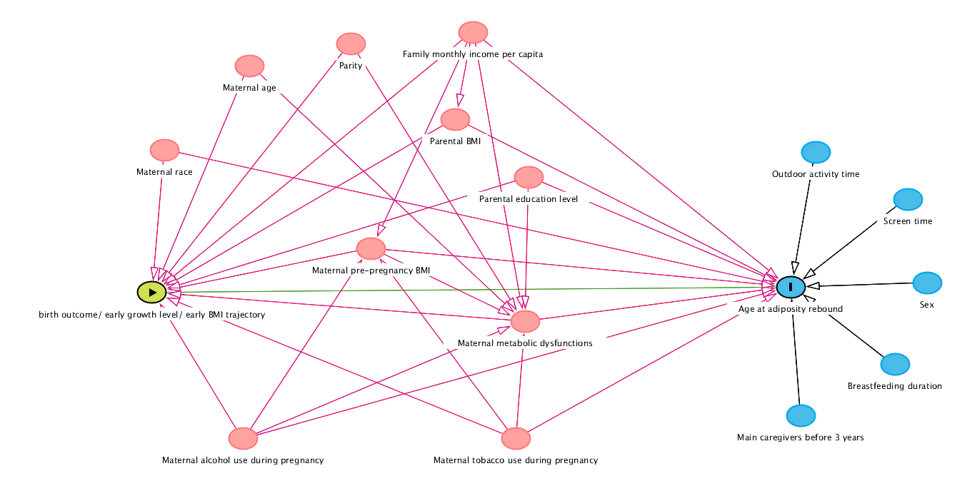
Figure S1 Directed acyclic graph of the relationship between birth outcome/early growth patterns and age at adiposity rebound

Figure S2 The overall trajectory plot based on the BMI fit of 2705 children

