MACF1 Deficiency Suppresses Tooth Mineralization through IGF1 mediated Crosstalk Between Odontoblasts and Ameloblasts

Appendix Figure
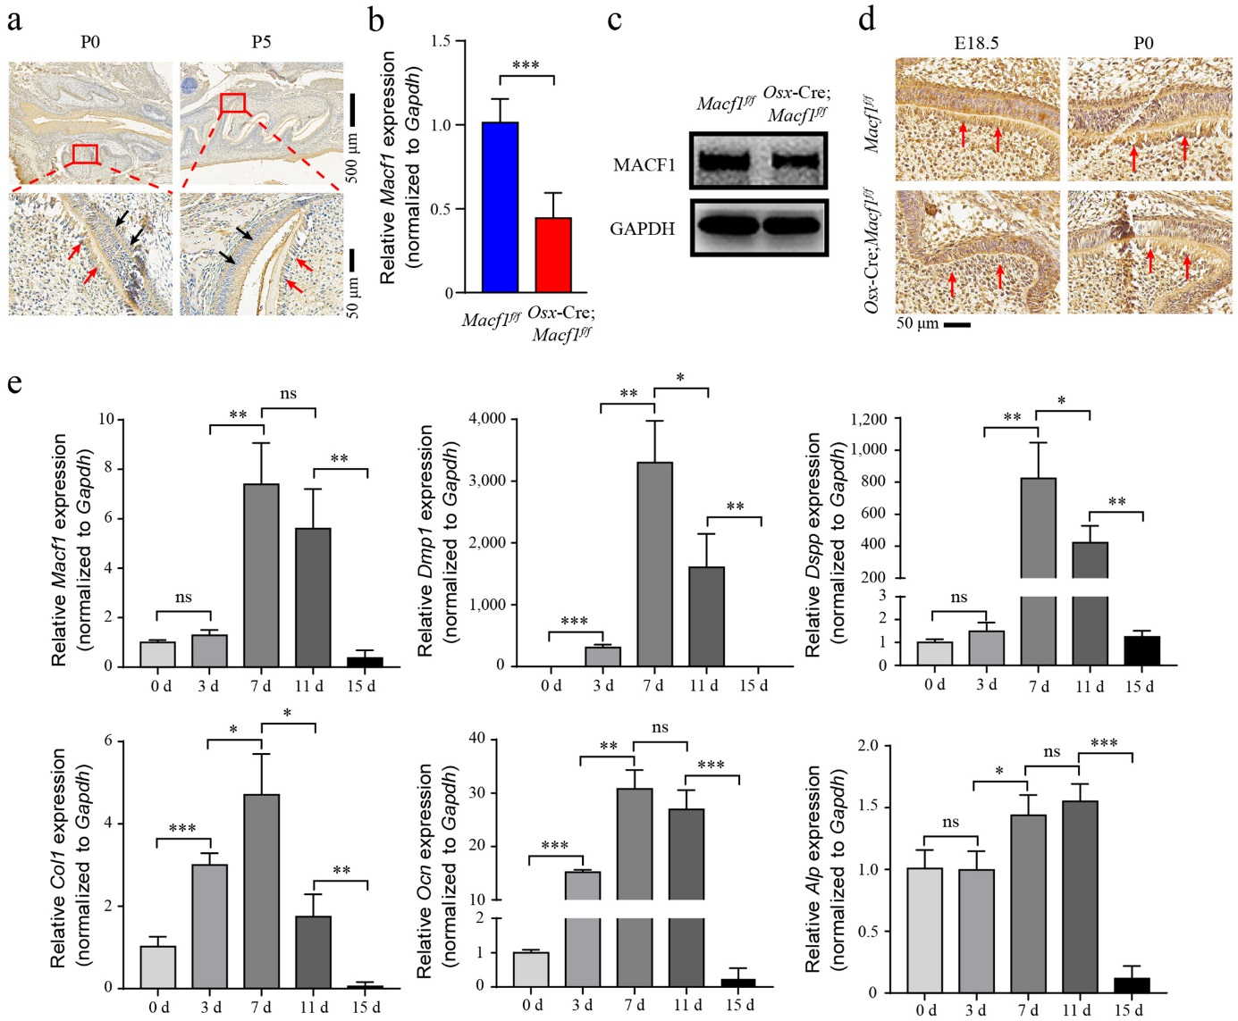
Fig. S1
MACF1 expression during tooth development and odontoblast differentiation. (a) Expression of MACF1 protein in tooth germ of wide type mice at P0 and P5 detected by IHC. Red arrow, MACF1 expression in odontoblasts. Black arrow, MACF1 expression in ameloblasts. The mRNA and protein expression of MACF1 in tooth germ of Macf1^{f/f} and Macf1^{f/f}Osx-Cre mice measured by qPCR (b) and western blot (c). (d) Expression of MACF1 protein in the first lower molar tooth germ of Macf1^{f/f} mice and Macf1^{f/f}Osx-Cre mice at E18.5 and P0 detected by IHC. Red arrow, MACF1 expression in odontoblasts. (e) The mRNA expression of Macf1 and odontoblast differentiation marker genes in DPCs during odontoblastic differentiation measured by qPCR. Data are presented as means ± SD. Unpaired Student’s t-tests were used to compare data between two groups. ns: not significant, *P<0.05, **P<0.01, ***P＜0.001.

