Supplementary Information 1. Geometrical and mathematical bases for grid design analysis.

The base grid is built from an orthonormal basis, defined by orthogonal vectors in the primary directions of the grid and of unit length $\sqrt{A}$, A being the area of one base grid cell. The origin of the grid is set at point O(0, 0), but could potentially be any of its points. The coordinates of any point of the base grid can then be written as an ordered pair of integers.

As a square subgrid is fully defined by two points of the plane, and if we consider O as the origin, we are looking for a point belonging to the base grid and whose integer coordinates (a, b), having [a, b] $∈Z$, must verify
$n=a^{2}+b^{2}$ (1)
where n is the distance between the origin and that point.
Thus, n is an integer written as the sum of two squares. This problem corresponds to the “sum of two squares” theorem, a generalization to any integer of Fermat's theorem limited to primes. It states that: “n cannot be written as the sum of two squares if and only if the prime-power decomposition of n contains a prime congruent to 3 (mod 4) to an odd power.'' (Dudley 1978).

It follows that any n must verify this property in order to be a valid divider of a square grid and to define n square interpenetrating subgrids each composed of a 1/n^{th} of the points of the initial grid.

The solutions of equation (1) further admit 4 properties:

- Property 1. For some values of n, the unordered pair (a, b) (where [a, b] $∈N$) is not necessarily unique. This is for example the case of n=25 whose corresponding pairs of integers are (0, 5) and (3, 4).
- Property 2. If n is itself a square, at least one valid pair contains one 0 (a=0 or b=0) and the 2 previous grids reduce to only one, with the same orientation as the base grid.
- Property 3. If a = b, the 2 previous grids also simplify in only one grid, rotated by $\frac{π}{4}$. This is particularly the case of n = 2.
- Property 4. If n and m are two valid positive integers such as (n = a² + b²) and (m = c² + d²) then nm is also the sum of two squares:
nm = (ac+bd)² + (ad-bc)²

Dudley, U. (1978). Elementary Number Theory, W. H.

Supplementary Information 2. Theoretical suite of sampling efforts reduction from the base grid.

Here we described how Figure 5 of the article has been obtained and how the simulation study was performed.

The simulation was based on a grid directly inspired by the French NFI one but of much smaller size to reduce drastically the calculation time. The complete base square grid has 20450 nodes once the buffer zone excluded. It was subsequently divided into n = 10 interpenetrating panels of 2045 points. Each panel is itself organized into a succession of nested sub-grids using eq. 2 with m=2 (a=1 and b=1).
The simulation itself only considers one of the 10 annual panels and its recursive fractionation that reduces approximately by 2 the number of nodes at each level (Supp Table 1).

Supp Table 1. Reduction of the number of grid nodes for each fractionation by a level of m=2 from the initial panel grid.
Recursive level | Number of nodes at level = k
Level 1 (one panel) | 2045
Level 2 | 1037
Level 3 | 519
Level 4 | 260
Level 5 | 130
Level 6 | 65
Level 7 | 32
Level 8 | 16
Level 9 | 8
Level 10 | 5
Level 11 | 3
Level 12 | 2

The reduction intensity was applied between level k = 2 (1037 nodes) and k + 1 = 3 (519 nodes) of the selected fractions in order to mimic the reduction applied to the second-phase sampling in forest (level 2 of the annual NFI grid).

For the selected fraction, the number of nodes beyond level 10 is very low (5 nodes) and the simulation study therefore further considered levels from 2 to 10 only. The simulation study subsequently used all the possible combinations of levels subtraction (levels 4 to 10) in order to generate a ranked increasing intensity of node reduction. There were in total up to 128 possible combinations, plus a last one corresponding to the subtraction of all nodes of one of a level-3 grid allowing for the maximum reduction of 50 %). Supp. Table 2 presents the first 10 combinations along with the resulting theoretical reduction intensity.

For each combination, the mean distance of each node to its four nearest neighbors (Supp Figure 1) was for calculated using the inner 100 x 100 nodes to avoid border effects, thus representing 1000 nodes at level 1 among the initial 2045.
At the beginning of the simulation, there is one point at each node of the panel at level 1, and the points are being discarded successively (Supp Figure 1).

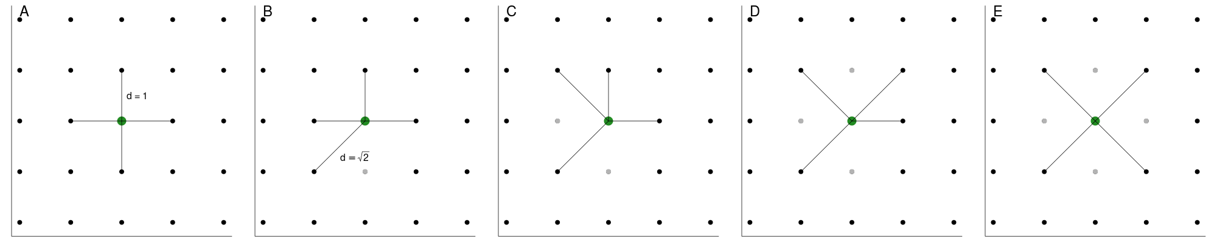
Supp Figure 1. Evolution of the distance and distance distribution along a gradient of nodes reduction. The unit distance on the complete grid (d=1) is less and less frequent (A-D). When one node over two is removed (E) the unit distance is again unique and equals $\sqrt{2}$.

Supp Table 2. Theoretical reduction intensity of the level 2 grid, for the first 11 combinations (sorted in increasing intensity) and for the last one.

Combination | Reduction intensity (%)
Level 2 - 10 | 0.196
Level 2 - 9 | 0.391
Level 2 – (9+10) | 0.586
Level 2 - 8 | 0.781
Level 2 – (8+10) | 0.977
Level 2 – (8+9) | 1.172
Level 2 – (8+9+10) | 1.367
Level 2 - 7 | 1.563
Level 2 - (7+10) | 1.758
Level 2 - (7+9) | 1,953
Level 2 - (7+8) | 2.344
Level 2 - 3 | 50.000

Figure 5 represents the values obtained along the theoretical gradient of reduction ranging from 0% (complete level-2 grid) to 50 % (complete level-3 grid ie level-2 grid from which a level-3 grid has been removed). Figure 5 A gives the distribution (on a relative scale) of the mean distances ranging from 1 (the level-2 grid is complete and all points are at the same initial distance set to 1) to $\sqrt{2}$ (all points are also at the same distance but of the level-3 grid thus at square root of 2 in the level-2 grid scale). Figure 5B illustrates the variability of the distances (heterogeneity of the grid) in terms of relative standard deviation.

