SUPPLEMENTAL MATERIAL

Cyclodextrin inclusion complex of a multi-component natural product by hot-melt extrusion
Rhayssa de Oliveira Nonatoª, Anna Paula Krawczyk-Santosª, Gleidson Cardosoª, Ana Carolina Kogawa^{b}, Karina Ricommini^{c}, Ádley Antonini Neves de Lima^{d}, Luana Heimfarth^{e}, Lucindo José Quintans-Júnior^{e}, Marcílio Cunha-Filho^{f}, Stephania Fleury Taveiraª, Ricardo Neves Marreto^{a,*}.

ªLaboratory of Nanosystems and Drug Delivery Devices (NanoSYS), School of Pharmacy, Universidade Federal de Goiás (UFG), Goiânia, GO, Brazil.
^{b}School of Pharmacy, Universidade Federal de Goiás (UFG), Goiânia, GO, Brazil
^{c} Pharmaceutical Application Laboratory, Ashland Specialty Ingredients, São Paulo, SP, Brazil
^{d}Pharmacy Department, Universidade Federal do Rio Grande do Norte, Natal, RN, Brazil
^{e}Department of Physiology (DFS), Laboratory of Neuroscience and Pharmacological Assays (LANEF), Universidade Federal de Sergipe, São Cristóvão, SE, Brazil
^{f}Laboratory of Food, Drug, and Cosmetics (LTMAC), School of Health Sciences, Universidade de Brasilia, Brasília, DF, Brazil.

Fig. S1. Linearity residual graph for ginger oleoresin analysis. (a) 6-gingerol; (b) 6-shogaol.
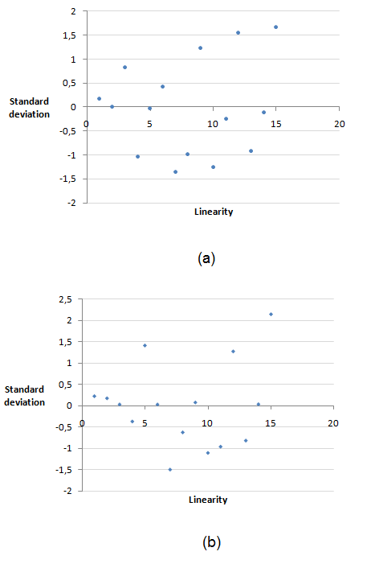

Fig. S2. Chromatograms of ginger oleoresin (GOR) and excipients used in the preparation of cyclodextrin complexes. C18 column (250 × 4.6 mm, 5 μm), mobile phase gradient of acetonitrile: methanol: water 30:30:40 (v/v/v) (in the first 10 min.) and acetonitrile: water 53.5: 46.5 (v/v) for further 14 min. oven temperature at 38 °C, with injection volume of 20 μL and detection at 280 nm

Fig. S3 Shogaol plus gingerol recovery (%R) from OR/HPβCD complexes obtained using slurry complexation (SL) or hot-melt extrusion (HME) methods at different molar ratios.

Fig. S4. TGA and DTG curves of ginger OR.

