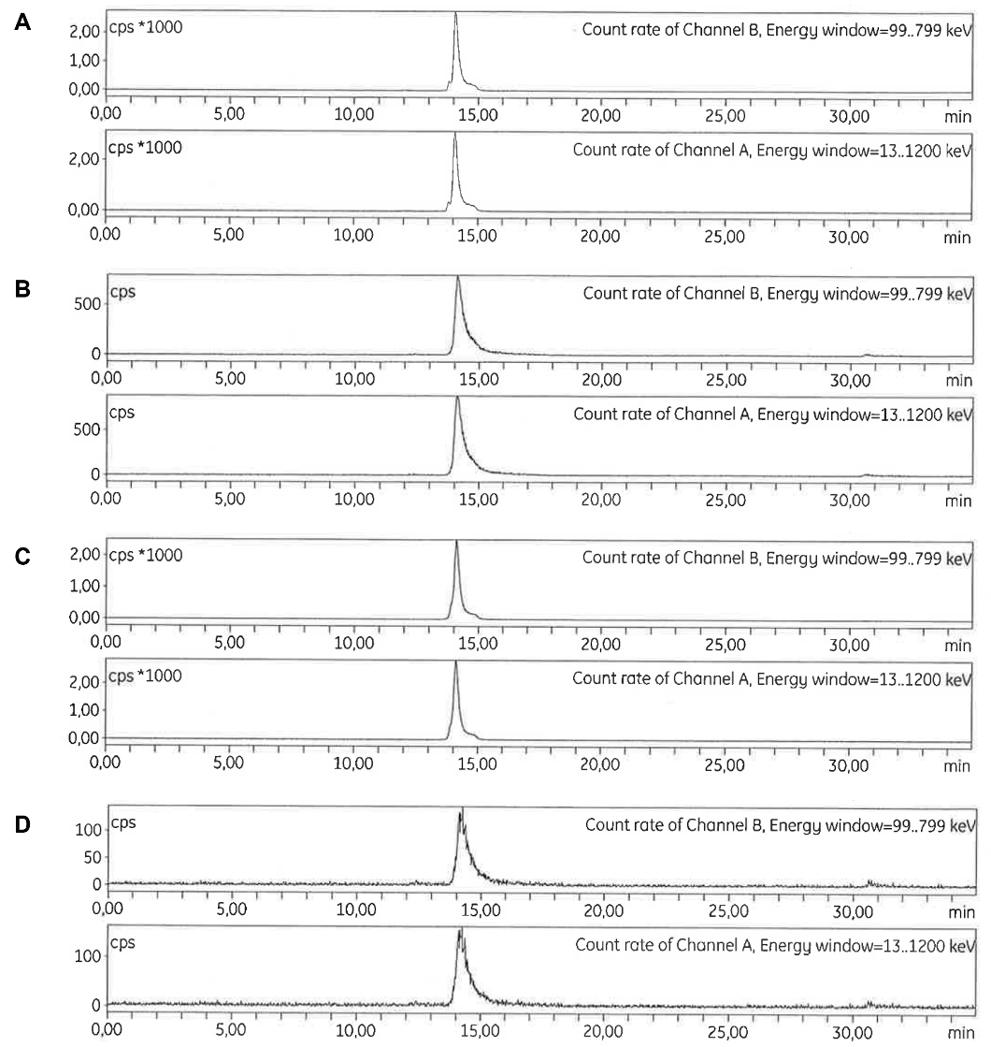
SUPPLEMENTARY FIGURE 1. All exendin analogues show uniform, radioactively labelled products. HPLC profile of radiolabelled exendin-4 (A), exendin-4-Pen (B), exendin(9-39) (C), and exendin(9-39)-Pen (D).
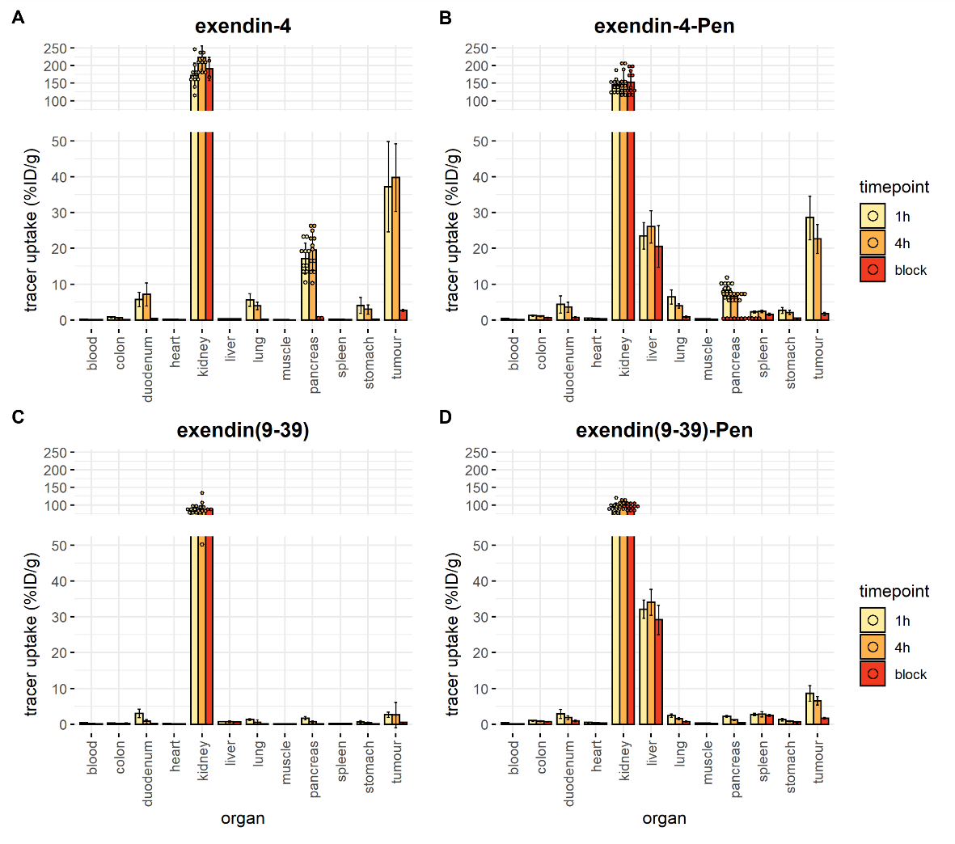
SUPPLEMENTARY FIGURE 2. In vivo biodistribution, overview per exendin variant. Balb/c nude mice with subcutaneous INS-1 tumours were injected with 20 pmol of the corresponding compound. For the blocking condition, a 100x excess of either unlabelled exendin-4 (for exendin-4 and exendin-4-Pen groups) or unlabelled exendin(9-39) (for exendin(9-39) and exendin (9-39)-Pen groups) was administered together with the labelled compound. Blocking condition was only measured at 4h. A) overview for exendin-4 B) overview for exendin-4-pen C) overview for exendin(9-39) D) overview for exendin(9-39)-pen.

SUPPLEMENTARY TABLE 1. Sequences of the exendin variants used. The CPP (penetratin) is underlined. The chelator diethylenetriaminepentaacetic acid (DTPA) was attached to the side-chain of an extra lysin in the case of the unconjugated variants (exendin-4 and exendin(9-39). For the conjugated variants (exendin-4-Pen and exendin(9-39)-Pen, the side chain of the last lysin present in the original sequence was used to attach the DTPA molecule.

