Table 4. Synthesis of title compounds (4a-j)ª
S. No. | Structure of  Aldehydes (2a-j) | Entry | Structures of products (4a-j) | Recationtime^{b}  (min) | Yield^{c}  (%)
2a | 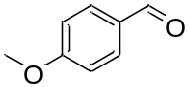 | 4a | 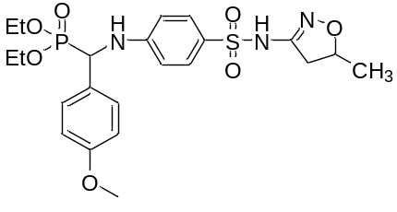 | 30 | 93
2b | 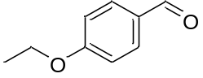 | 4b | 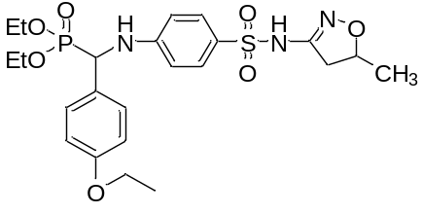 | 30 | 90
2c | 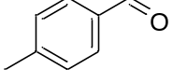 | 4c | 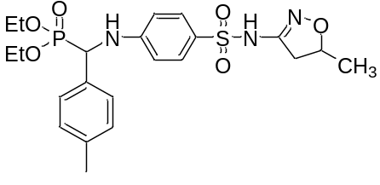 | 30 | 91
2d | 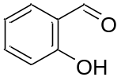 | 4d | 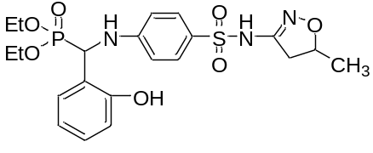 | 30 | 94
2e | 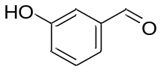 | 4e | 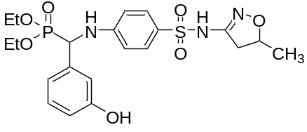 | 30 | 90
2f | 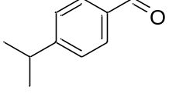 | 4f | 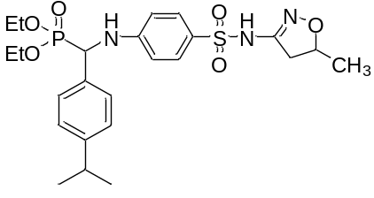 | 30 | 89
2g | 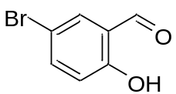 | 4g | 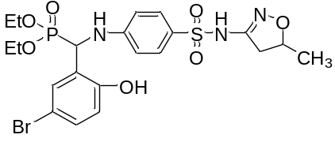 | 30 | 92
2h | 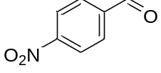 | 4g | 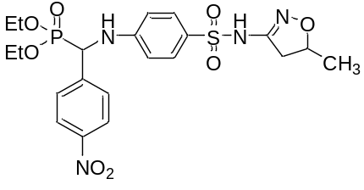 | 30 | 85
2i | 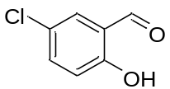 | 4h | 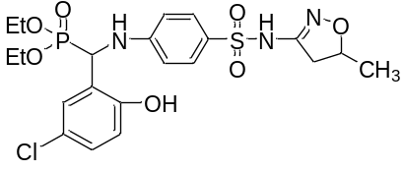 | 30 | 90
2j | 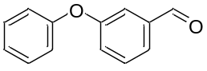 | 4j | 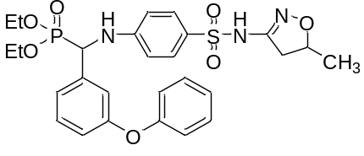 | 30 | 89
ªReaction conditions: 4-Amino-N-(5-methyl-4,5-dihydroisoxazol-3yl)benzenesulfonamide (2 mmol), aldehyde (2a-j; 2 mmol), diethyl phosphite (1.2 mmol).Reaction time^{b} (30 min) ^{c}Isolated Yield.

