Figure S 4A. Age standardized incidence rates according to age groups in 22 Arab countries
compared to world ad US populations, both sexes.
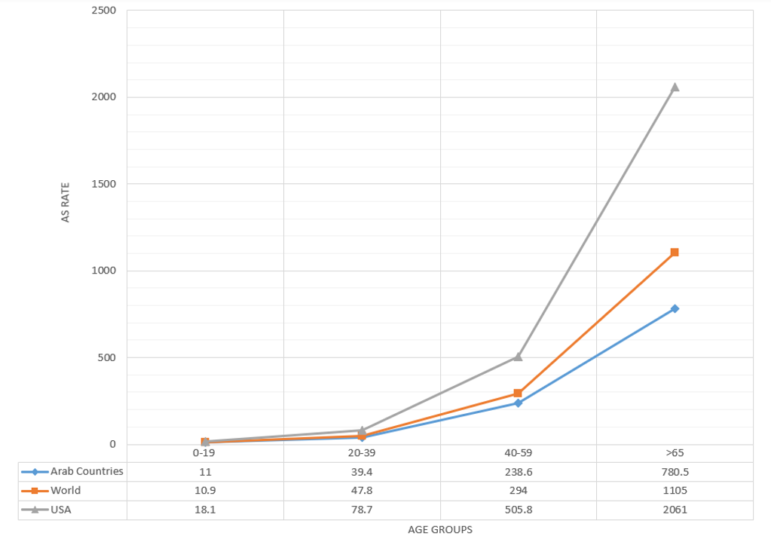

Figure S 4B. Age standardized incidence rates according to age groups in 22 Arab countries.

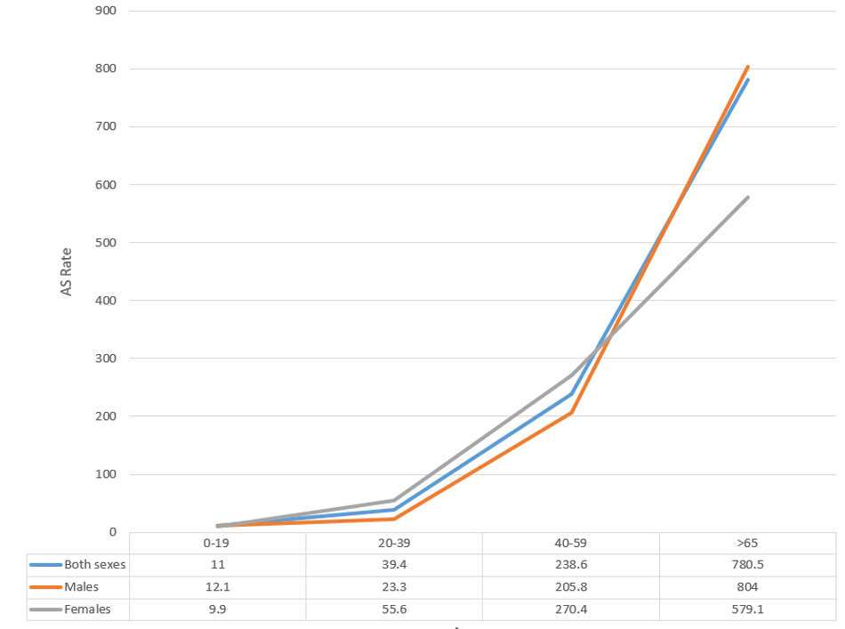

Figure S 5A. Age standardized mortality rates according to age groups in 22 Arab countries
compared to world ad US populations, both sexes.
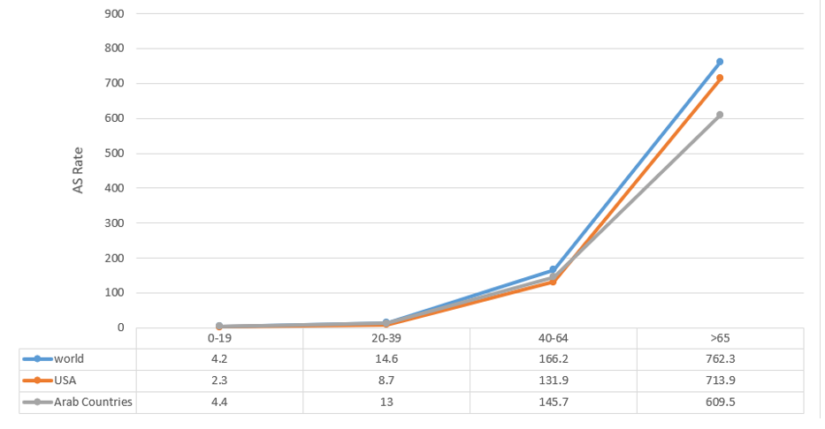

Figure S 5B. Age standardized mortality rates according to age groups in 22 Arab countries.
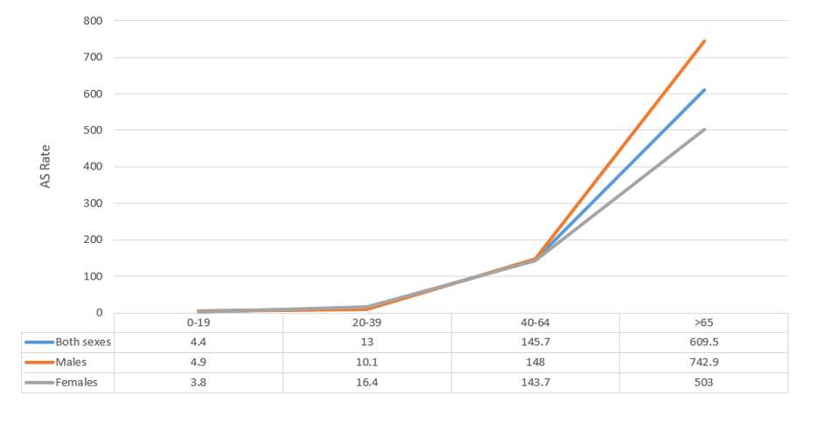

Figure S 6B. Number and frequency of new cases, for the 5 most common cancers in Arab
countries 2020, males.

Figure S 6C. Number and frequency of new cases, for the 5 most common cancers in Arab
countries 2020, females.

Figure S 7B. Number and frequency of deaths from the top 5 cancers in Arab countries 2020,
males.

Figure S 7C. Number and frequency of deaths from the top 5 cancers in Arab countries 2020,
females.

Figure S 8B. ASIRs and ASMRs of the top five cancers in 22 Arab countries, males

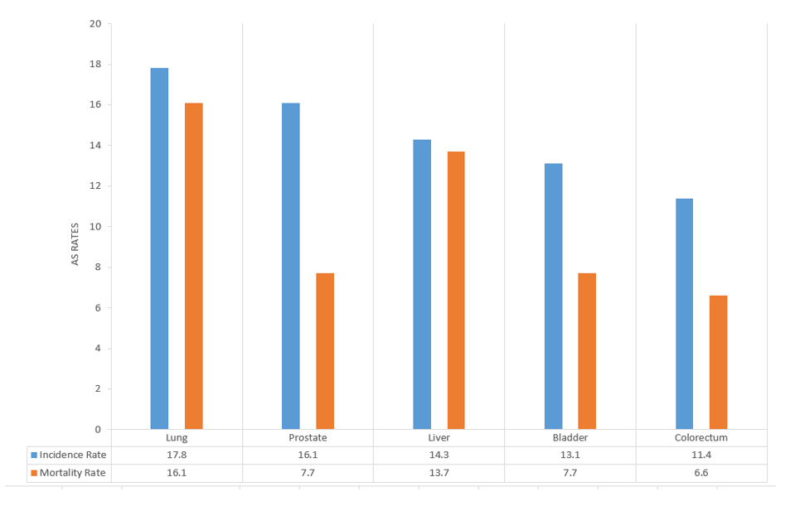

Figure S 8C. ASIRs and ASMRs of the top five cancers in 22 Arab countries, females

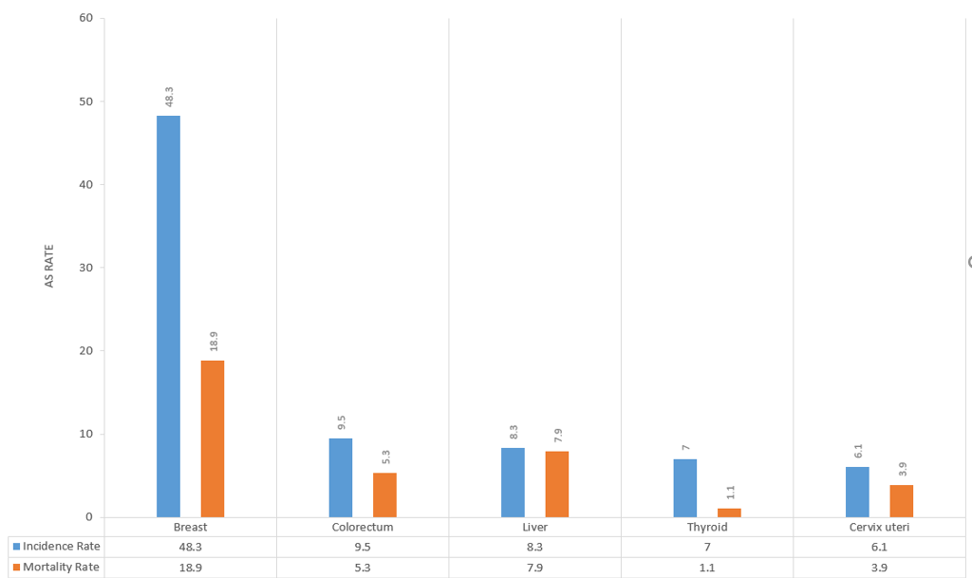

Figure S 9A. ASIRs and ASMRs of the top five cancers in African Arab countries, both sexes.

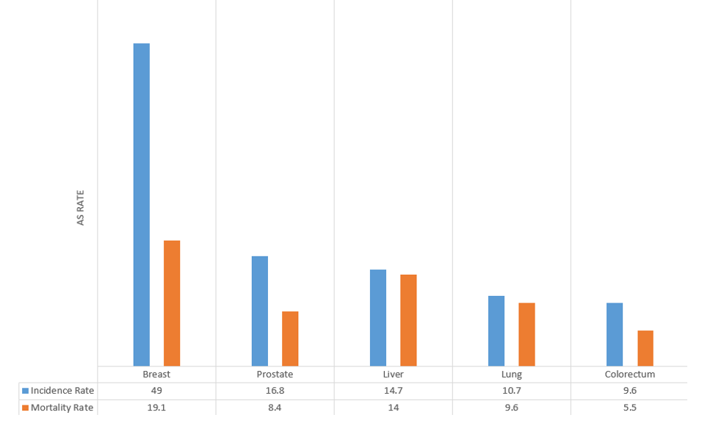

Figure S 9B. ASIRs and ASMRs of the top five cancers in African Arab countries, males.

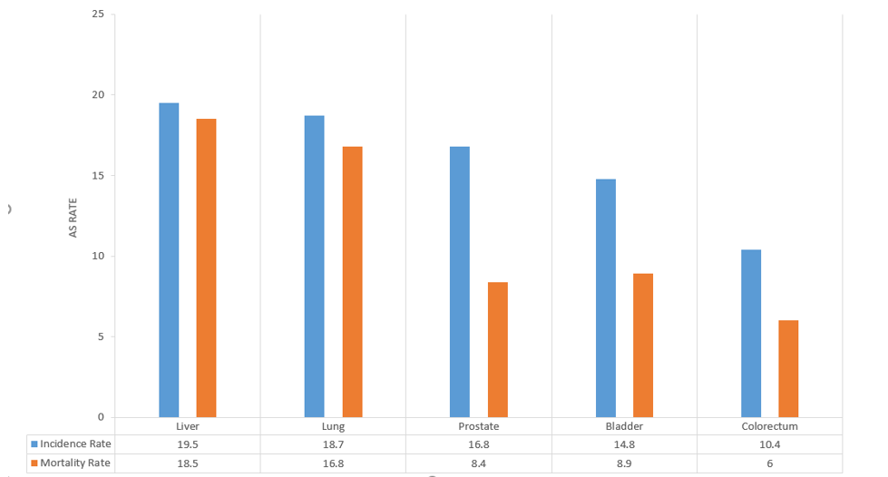

Figure S 9C. ASIRs and ASMRs of the top five cancers in African Arab countries, females.

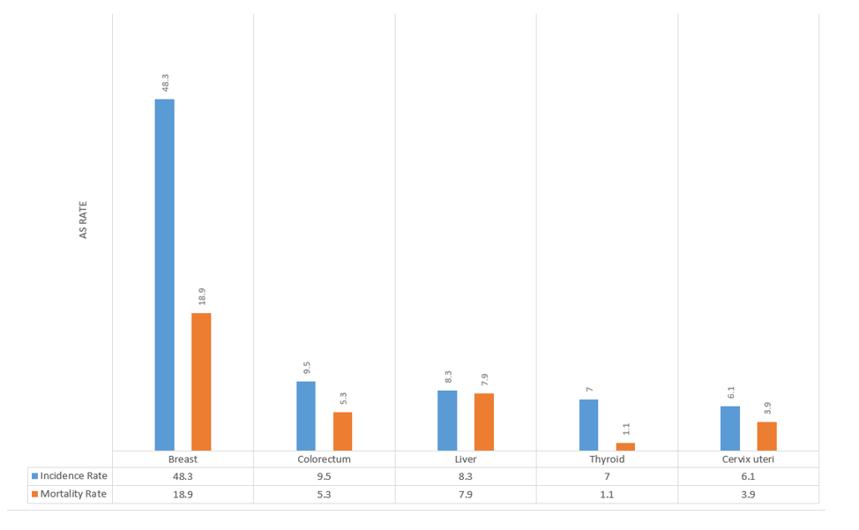

Figure S 10A. ASIRs and ASMRs of the top five cancers in Asian Arab countries, both sexes.

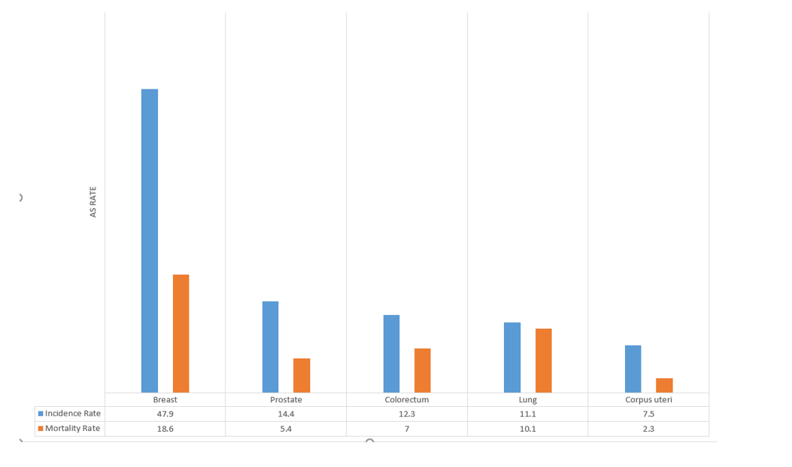

Figure S 10B. ASIRs and ASMRs of the top five cancers in Asian Arab countries, males.

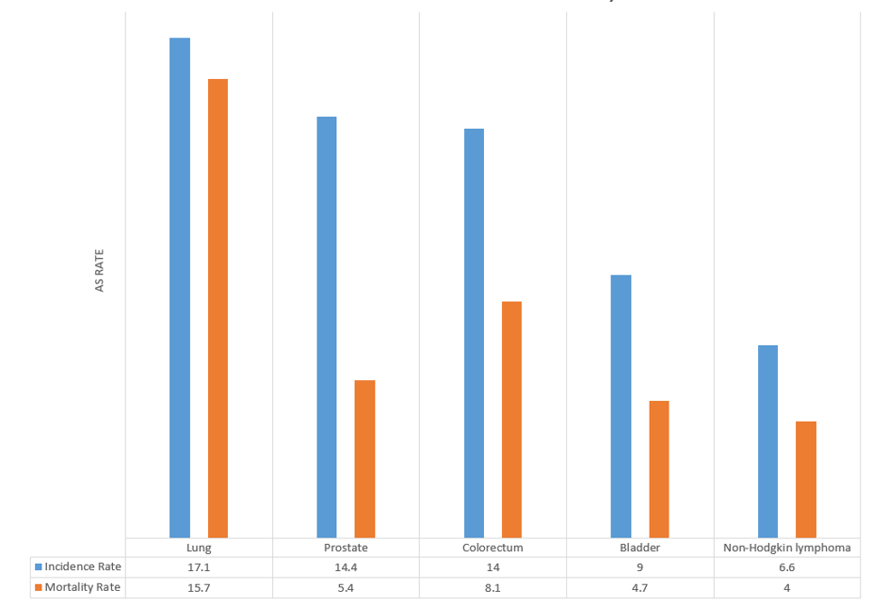

Figure S 10C. ASIRs and ASMRs of the top five cancers in Asian Arab countries, females.
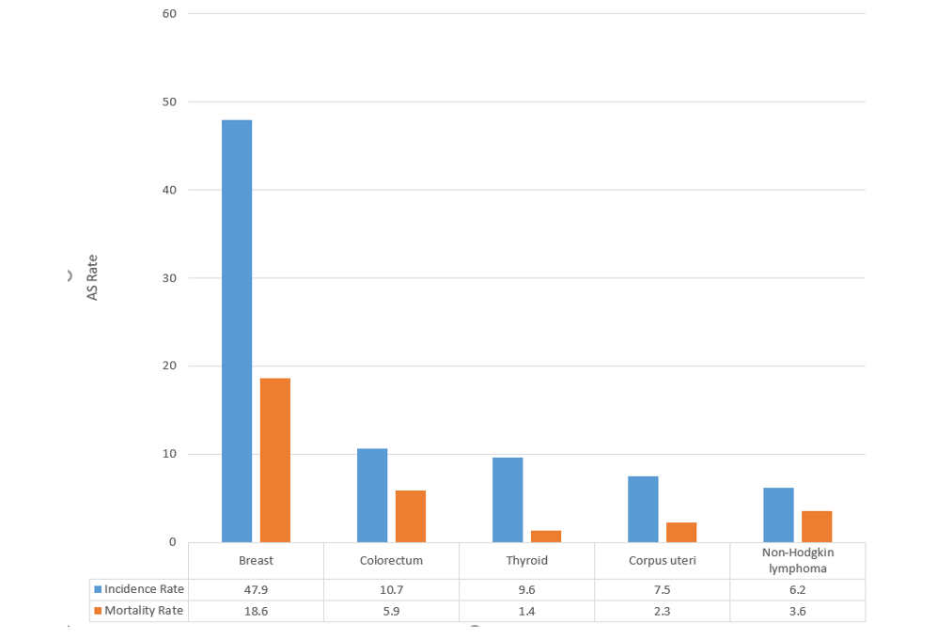

Figure S 13. ASIR and ASMR of breast cancer in each of the 22 Arab countries.

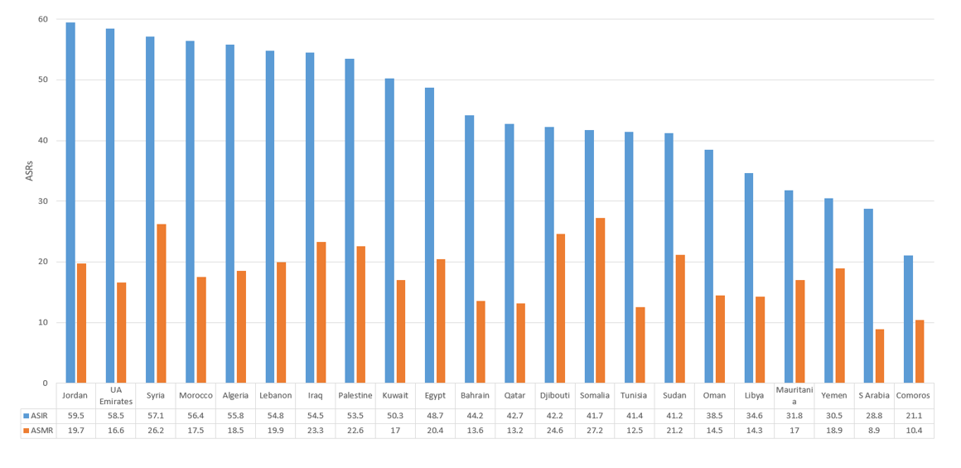

Figure S 14. ASIR and ASMR of prostate cancer in each of the 22 Arab countries

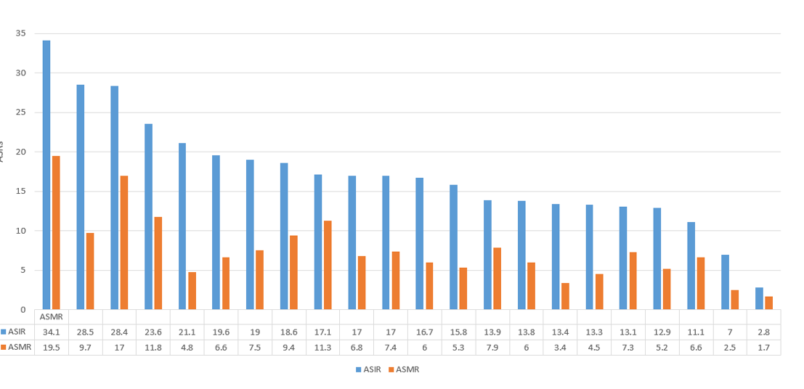

Figure S 15. ASIR and ASMR of liver cancer in each of the 22 Arab countries

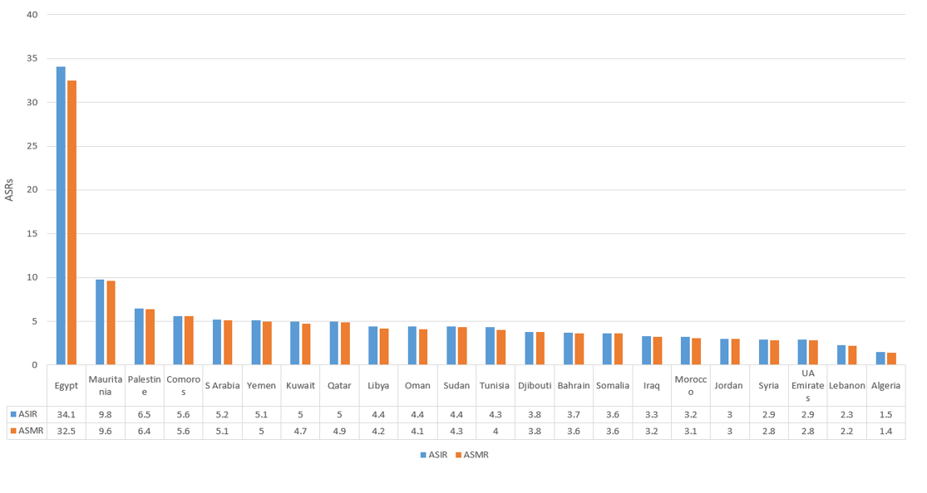

Figure S 16. ASIR and ASMR of lung cancer in each of the 22 Arab countries

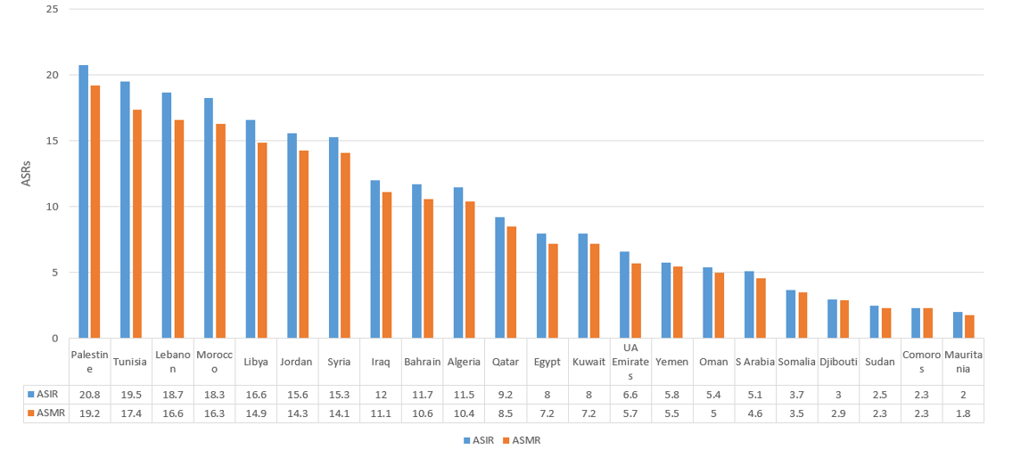

Figure S 17. ASIR and ASMR of colorectal cancer in each of the 22 Arab countries

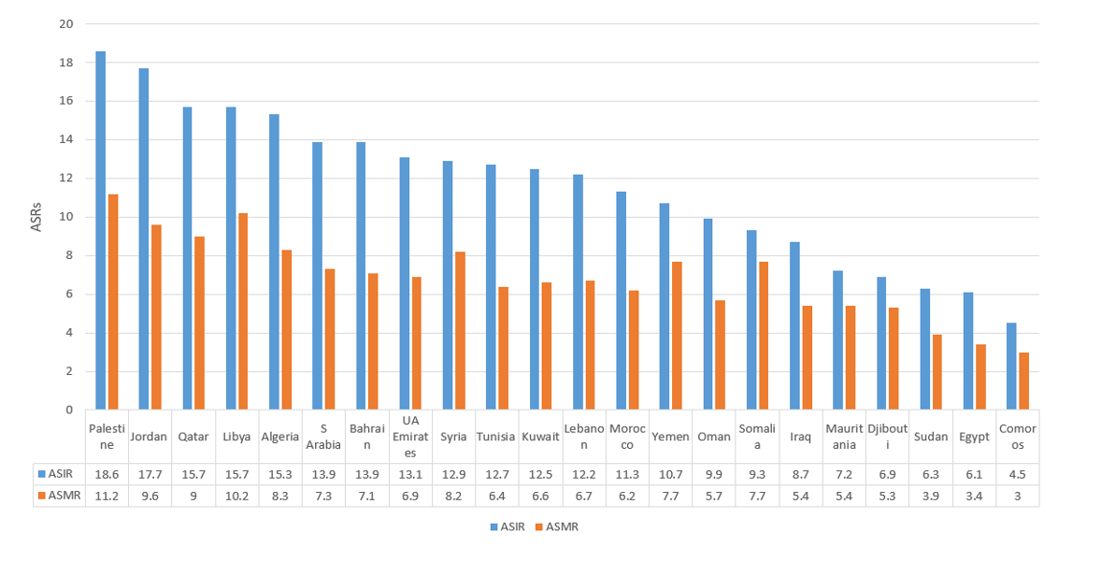

Figure S 18. ASIR and ASMR of bladder cancer in each of the 22 Arab countries
