Supplementary Information
Photocatalytic degradation of tetracycline antibiotic and organic dyes using biogenic synthesized CuO/Fe₂O₃ nanocomposite: Pathways and mechanism Sandeep Kaushal ^{a,}*, Avdhesh Kumar ª, Himani Bains ª, Prit Pal Singh ^{a,}*,
ª Sri Guru Granth Sahib World University, Fatehgarh Sahib, Punjab, India
^{b} JLC College Chapra, JP University, Chapra, Bihar, India
Address for Correspondence:
Dr. Sandeep Kaushal
Assistant Professor
Department of Chemistry
Sri Guru Granth Sahib World University, Fatehgarh Sahib (Punjab) India.
Mobile no: +91-7009795652
Email: kaushalsandeep33@gmail.com
&
Dr. Prit Pal Singh
Professor and Head
Department of Chemistry
Sri Guru Granth Sahib World University, Fatehgarh Sahib (Punjab) India.
Mobile no: +91-8427000415
Email: dhillonps2003@gmail.com

Fig. S1 a) UV-vis absorption spectra; b) curve of (αhν)² versus (hν) of Fe NPs, Cu NPs and CuO/Fe₂O₃ nanocomposite

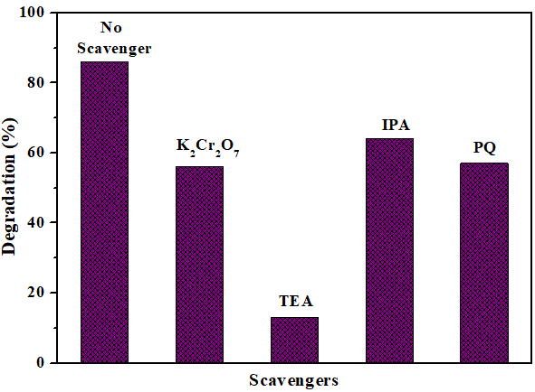

Fig.S2 Effects of various scavengers on the degradation of TC on CuO/Fe₂O₃ nanocomposite under UV irradiation

Fig. S3 LC-MS spectra of TC on CuO/Fe₂O₃ nanocomposite

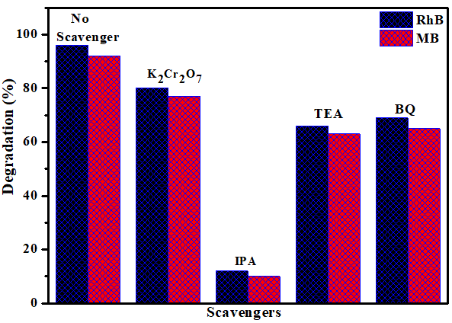
Fig. S4 Effects of various active scavengers on the degradation of RhB and MB dyes on CuO/Fe₂O₃ nanocomposite under visible irradiation

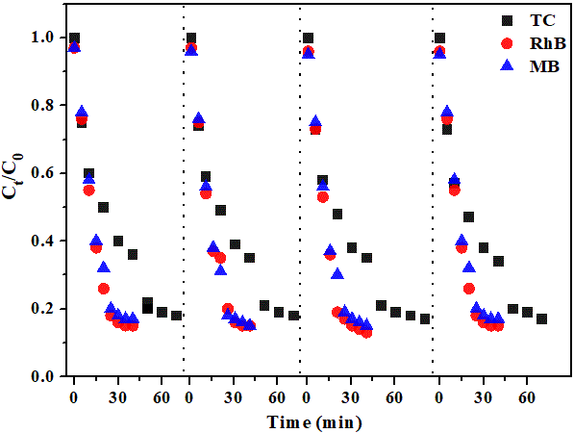
Fig. S5 Reusability of the CuO/Fe₂O₃ nanocomposite photocatalyst after four consecutive cycles.

