Mechanism causing the spatial distribution non-uniformity of the prompt optical crosstalk effect in G-APD cells of Multi-Pixel Photon Counters: Supplementary materials
Xinyue Cao¹, Guoqing Zhang *¹,Yaxian Yang¹, Chen Zhang¹, Lina Liu², Chunling Zhang³, Lianbi Li¹, Giacomo Gallina⁴
1 School of Science, Xi’an Polytechnic University,710048, China
2 School of Science, Xi’an University of Technology, Xi’an, 710048, China
3 School of Science, Xi’an University of Architecture and Technology, 710311, China
4 TRIUMF, Vancouver, British Columbia, V6T2A3, Canada
* zhangg_356@163.com

1 Introduction
This document provides supplementary information to “Mechanism causing the spatial distribution non-uniformity of the prompt optical crosstalk effect in avalanche photodiode cells of Multi-Pixel Photon Counters”. The intensity spatial distribution of the laser spot was obtained by deconvolution of the pulse counting rate (at 0.5p.e.) mapping of MPPC(Model:S12571-100C,Hamamatsu Photonics. ), as shown in Fig. 1S. The full width at half maximum (FWHM) of the focused laser spot is about 0.98μm, according to the Gaussian fit for the deconvolution results. The comparison of the pulse counting rate from MPPC with and without correction equation (Eq.2 in the main text) is shown in Fig. 2S. We can see that the PCR difference cannot be neglected.
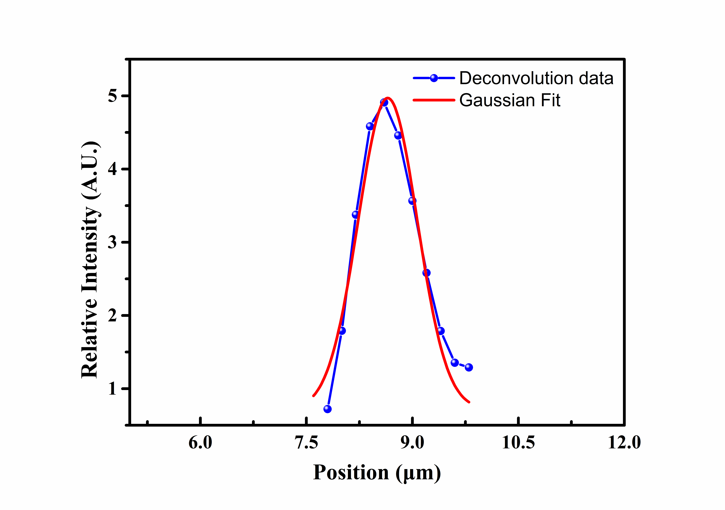
Fig. 1S. One-dimensional (1D) intensity spatial distribution of the focused laser spot.
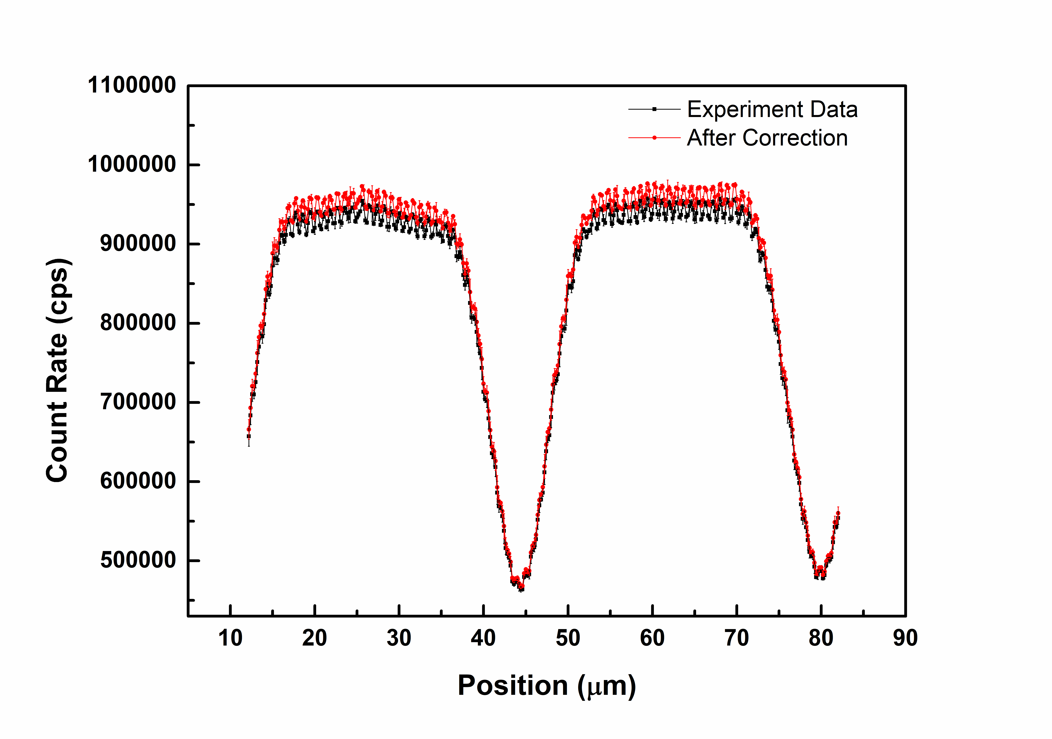
Fig. 2S. 1D pulse counting rate (PCR) curve of the SiPM (FBK LF-HD SiPM) at 0.5 p.e. with or without the correction equation (Eq.2 in the main text).

