Supplementary Information for
Greater extreme precipitation from Borneo Vortices in a warmer climate

Ju Liang^{1*}, Jennifer L. Catto¹, Matthew K. Hawcroft^{2,3}, Mou Leong Tan⁴, Kevin I. Hodges⁵, James M. Haywood^{1,2}.
¹ College of Engineering, Mathematics and Physical Sciences, University of Exeter, Exeter EX4 4QE, UK
² Met Office, Exeter EX1 3PB, United Kingdom
³University of Southern Queensland, Toowoomba QLD 4300, Australia
⁴ GeoInformatic Unit, Geography Section, School of Humanities, Universiti Sains Malaysia, 11800 USM, Pulau Pinang, Malaysia
⁵ Department of Meteorology, University of Reading, Reading RG6 6ET, United Kingdom

* Corresponding author at: College of Engineering, Mathematics and Physical Sciences, University of Exeter, Exeter EX4 4QE, UK

- Why a sufficiently high horizontal resolution is important for adequately simulating Borneo Vortices?
The recent study by Liang et al.¹ has revealed that the simulated characteristics of Borneo Vortices (BVs), including their frequency and the associated precipitation, can be inhibited in global climate model (GCM) with low horizontal resolutions. This can possibly be attributed to the weaker synoptic-scale winds through the combined effect of fluid continuity and “emergent scaling properties of the wind field”² as grid spacing increases. On the other hand, the simulated largescale environments controlling BVs have no apparent sensitivity to the changes in model resolution. Such a resolution-dependence of simulated BVs can be further confirmed by comparing the high-resolution versions (hereafter HR-GCMs) of the six HighResMIP GCMs (used for the future projection of BVs in this study) with their low-resolution versions (LR-GCMs). Information on the used GCMs is summarised in Table 1.

Table 1. Summary of the used CMIP6 HighResMIP experiments in this study.
Developers | Model Name | Version | Horizontal Resolution (Longitude×Latitude) | Atmospheric Vertical Levels
The UK Met Office Hadley Centre for Climate Change | HadGEM3-GC3.1³ | Low-Res. | 1.875°×1.25° | 85
The UK Met Office Hadley Centre for Climate Change | HadGEM3-GC3.1³ | High-Res. | 0.35°×0.23° | 85
French National Centre for Meteorological Research | CNRM-CM6-1⁴ | Low-Res. | 1.406°×1.406° | 91
French National Centre for Meteorological Research | CNRM-CM6-1⁴ | High-Res. | 0.5°×0.5° | 91
27 institutes in Europe | EC-Earth3P⁵ | Low-Res. | 0.703°×0.703° | 91
27 institutes in Europe | EC-Earth3P⁵ | High-Res. | 0.352°×0.352° | 91
Meteorological Research Institute (Japan) | MRI-AGCM3-2⁶ | Low-Res. | 0.563°×0.563° | 60
Meteorological Research Institute (Japan) | MRI-AGCM3-2⁶ | High-Res. | 0.188°×0.188° | 60
Max Planck Institute for Meteorology (Germany) | MPI-ESM-XR⁷ | Low-Res. | 0.5°×0.5° | 32
Max Planck Institute for Meteorology (Germany) | MPI-ESM-XR⁷ | High-Res. | 0.234°×0.234° | 32
Euro‑Mediterranean Center on Climate Change (Italy) | CMCC-CM2⁸ | Low-Res. | 1.25°×0.938° | 26
Euro‑Mediterranean Center on Climate Change (Italy) | CMCC-CM2⁸ | High-Res. | 0.313°×0.234° | 26

We first evaluate the abilities of LR-GCMs and HR-GCMs to simulate the spatial distribution of BVs during ONDJFM through their comparison with those detected in the ERA5 reanalysis dataset during the historical period 1979-1990. Fig. S1 shows the genesis, track, and lysis densities calculated on the model grids by counting the number of the genesis, track, and lysis feature points within a 3.5° geodesic radius from the detected BV centres. The ensemble mean of LR-GCMs (Fig. S1d-f) shows a pronounced underestimation of the occurrences of BVs compared to ERA5 with lower maximum genesis, track and lysis densities, which are only about 50% of those in ERA5. In contrast, the ensemble mean of HR-GCMs presents more reasonable density distributions with the maximum densities closer to those in ERA5, although underestimations (by around 10-15%) still exist.
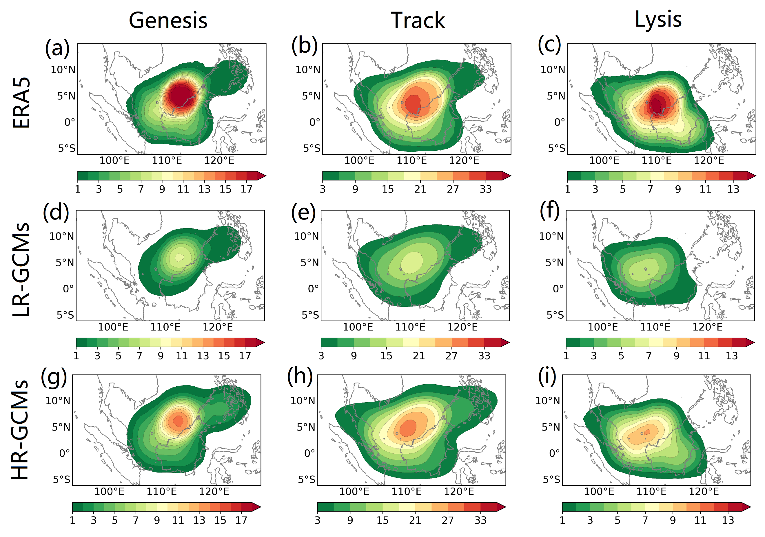
Fig. S1. Historical densities during ONDJFM (unit: number per season per 3.5° spherical area) for BV geneses, tracks and lyses from ERA5 (a-c) and the ensemble mean of LR-GCMs (d-f) and HR-GCMs (g-i).

As the secondary circulation of BVs, i.e. the associated radial and vertical motions embedded within the primary largescale circulation, are usually observed from the surface to 700-hPa^{9,10}, the lower-tropospheric horizontal structures of BVs are analysed by computing the composite fields near the centres of the selected 50 most intense BVs (ranked by the 50 greatest records of the maximum central relative vorticity). Fig. S2 shows the composite structures in terms of the 850-hPa wind fields (Fig. S2a, e, i), MSLP and its absolute horizontal gradient (Fig. S2b, f, j), the divergence of horizontal winds (Fig. S2c, g, k) and precipitation (Fig. S2d, h, l). Compared to ERA5, the ensemble mean of LR-GCMs represents a slightly stronger (by about 1 m/s) maximum wind speed at 850-hPa near the centres of the 50th most intense BVs. Due to the relatively coarse horizontal resolutions, LR-GCMs simulate a larger storm eye (central area with wind speeds < 5 m/s) and a poorly resolved near-centre strong winds (with a distance of > 4° to the centre) compared to ERA5 (maximum wind distance of about 2-4°). In addition, a weaker near-centre convergence is also seen, with a possible association with the relatively high grid spaces, which results in a weaker near-centre maximum precipitation intensity of about 76% of that in ERA5. Improved representation of the horizontal composite structures of BVs is seen for the ensemble mean of HR-GCMs. However, there are noticeable biases for HR-GCMs compared to ERA5, including the overestimation of the near-centre MSLP gradients and the smaller near-centre convergence zone leading to overly concentrated precipitation near the simulated BV centres.
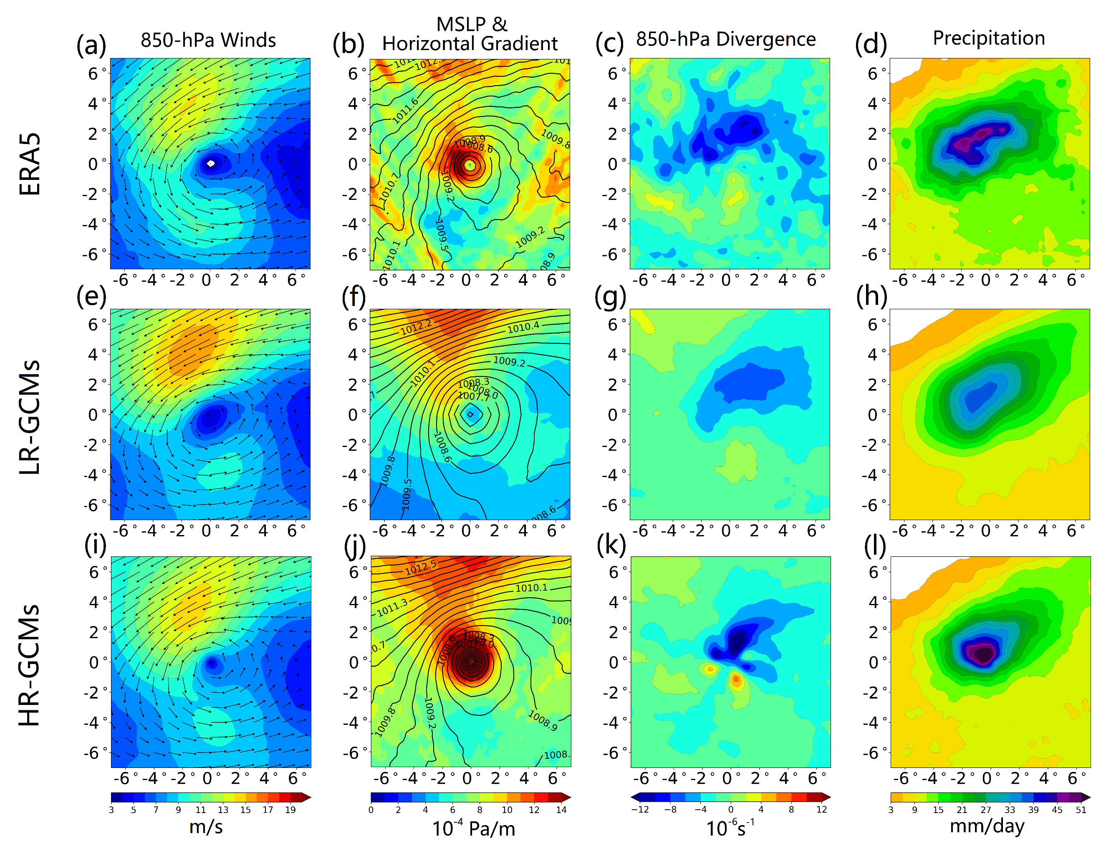
Fig. S2. Centre-relative horizontal composites averaged over the 50 most intense BVs for DJF during the historical period (1979–1999) in the time steps corresponding to the highest central relative vorticity at 850-hPa during their lifetimes, including 850-hPa winds (a, e, i), MSLP (black contours) and the absolute horizontal MSLP gradient (b, f, j), 850-hPa divergence (c, g, k) and precipitation (d, h, l).
There are also improvements in the simulation of BV-associated precipitation presented by HR-GCMs compared with LR-GCMs. First, compared to ERA5 (Fig. S3b), HR-GCMs (Fig. S3j) reasonably simulate the maximum accumulation of BV-associated precipitation on the northwestern coast of Borneo, though overestimations are found on the east coast of Peninsular Malaysia and the precipitation affecting Borneo is still underestimated. In contrast, LR-GCMs (Fig. S3f) show pronounced underestimations of the BV-associated precipitation amount. However, both LR-GCMs and HR-GCMs show apparent overestimation of the mean precipitation intensity of BVs (Fig. S3c, g, k), which is possibly related to their lower fractions for the relatively weak BVs with respect to all BVs than that in ERA5 (Fig. S8). Also, in contrast to ERA5 and LR-GCMs, HR-GCMs capture a higher contribution of BVs to the total precipitation during ONDJFM (Fig. S3d, h, l). This may be due to the considerable underestimation of total precipitation in all the models considered (Fig. S3a, e, i).
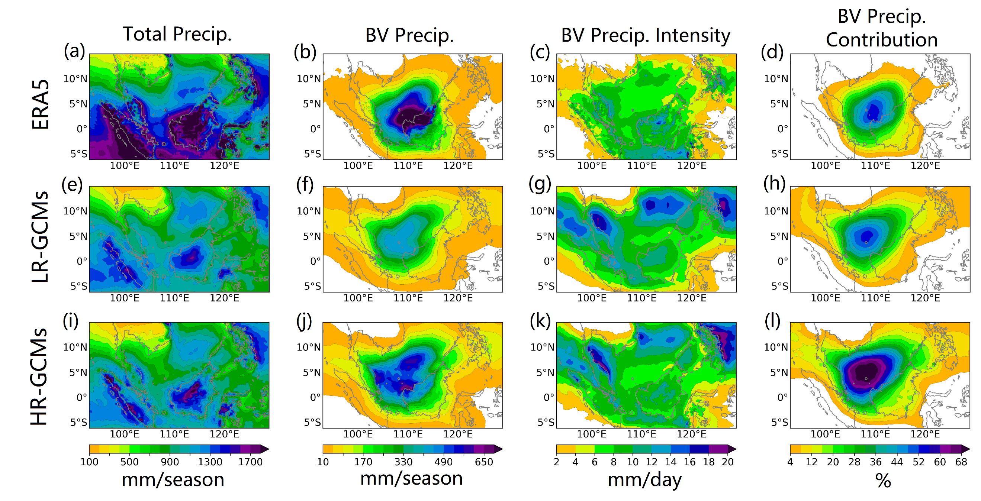
Fig. S3. Distributions of precipitation during ONDJFM, including the total precipitation (a, e, i), accumulated BV-associated precipitation (b, f, j), mean intensity of BV-associated precipitation (c, g, k) and the fractional contribution of BVs to total precipitation (d, h, l).

Fig. S4 presents the analyses of heavy rain days (HRDs) during ONDJFM. The simulated seasonally total HRDs to the North of 7°N are overestimated in all the models. HR-GCMs show a reasonable representation of the local maximum of HRD in North Borneo and on the east coast of Peninsular Malaysia (Fig. S4g), while LR-GCMs exhibit obvious underestimations in these regions (Fig. S4d). For the BV-associated HRDs, better simulations are seen for HR-GCMs (Fig. S4h) given the pronounced underestimation in LR-GCMs (Fig. S4e), especially for the coastal region of Borneo. Similar improvements by HR-GCMs are also seen for the simulated fractional contribution of BVs to HRDs (Fig. S4i), though these models still underestimate the fraction (by approximately 20% in terms of the absolute biases) in the study region. The stronger ability of HR-GCMs in simulating the extreme precipitation associated with BVs can be partly explained by the better representation of the enhanced BV-associated precipitation (Fig. S5c) by the northeasterly cold surges (Methods) than that in LR-GCMs (Fig. S5b), although all the simulations tend to underestimate such enhancements compared to ERA5 (Fig. S5a).
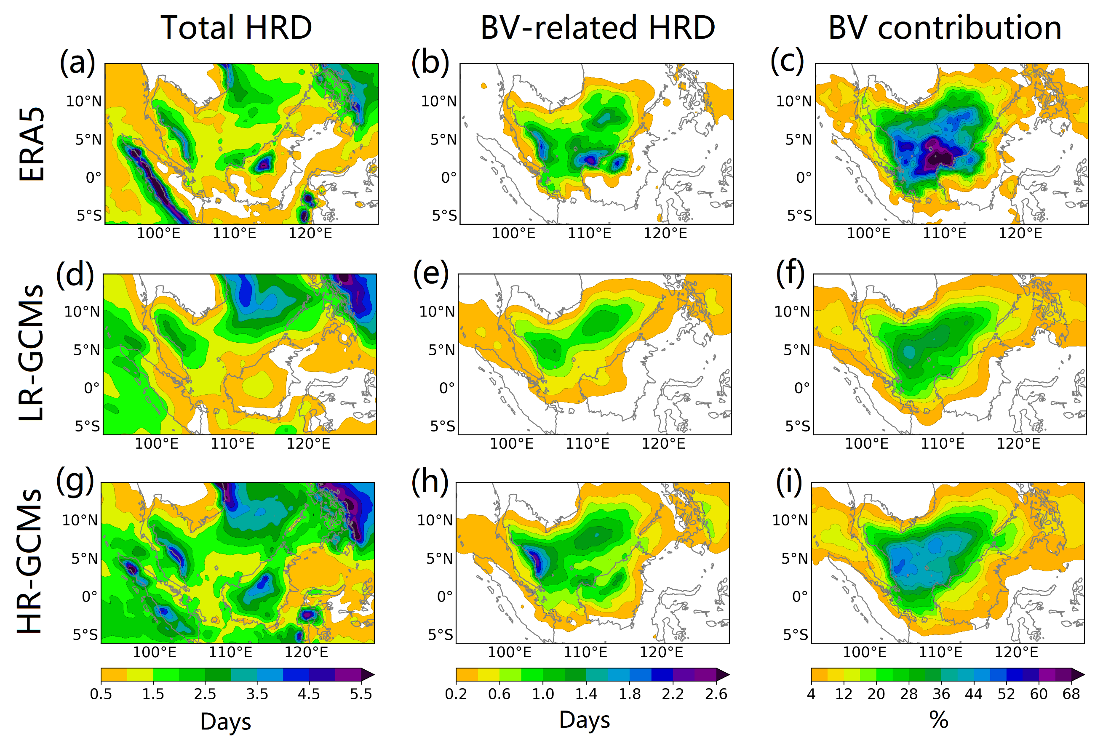
Fig. S4. Distributions of extreme precipitation during ONDJFM in terms of heavy rain day (HRD), including the total HRD (a, e, i), accumulated BV-associated HRD (b, f, j) and the fractional contribution of BVs to total HRD (c, f, i).
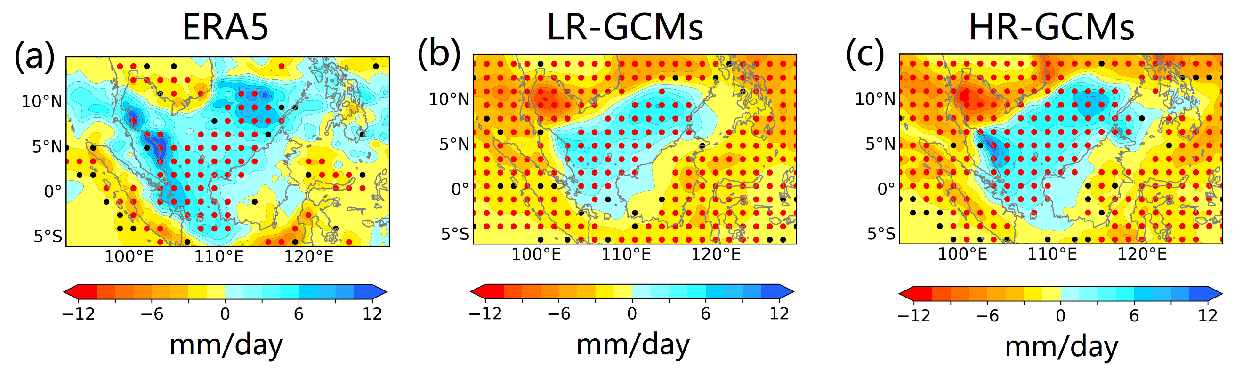
Fig. S5. Anomaly distributions for the mean BV-associated precipitation during the occurrences of cold surges relative to the seasonal mean BV-associated precipitation intensity for ONDJFM from 1979 to 1999. Stippling indicates statistically significant anomalies with confidence levels above 90% (black) and 95% (red).
In summary, GCMs with higher horizontal resolutions exhibit a better representation of the detected features of BVs and the BV-associated precipitation during the northeast monsoon seasons. These findings agree well with our previous evaluation work based on simulations from a single GCM (i.e. the HadGEM3-GC3.1 experiments1) at three different horizontal resolutions over the same region, while in this supplementary section we display a more robust analysis of the resolution-dependence of simulated BVs using two sets of multi-GCM ensembles considering the resolution changes but with fixed model dynamical cores and physical parameterizations. The result also indicates the importance of the use of high-resolution climate models for robust investigations of the changing characteristics of BVs, especially the impact of extreme precipitation triggered by BVs. Thus, the projected near-future changes in BV characteristics reported in the main text of this paper are based on the HR-GCMs experiments.

- Supplementary table and figures for the future projection of BV characteristics
Table 2. Projected trends (unit: number per decade) in 5-year BV frequencies from 1979 to 2050. Asterisks show the statistically significant trends at confidence levels above 95% (Mann-Kendall test).
Model | All-regions | Peninsular Malaysia-Sumatra | North Borneo
HadGEM3-GC3.1 | 0.67* | -0.33 | 0.37*
CNRM-CM6-1 | -1.59* | -0.80* | -1.31*
EC-Earth3P | -0.32* | -0.34* | -0.11
MRI-AGCM3-2 | -0.08* | -0.26 | -0.42*
MPI-ESM-XR | -0.73* | -0.54* | -0.87*
CMCC-CM2 | -0.67* | -0.46* | -0.15
Ensemble | -0.45* | -0.46* | -0.42*

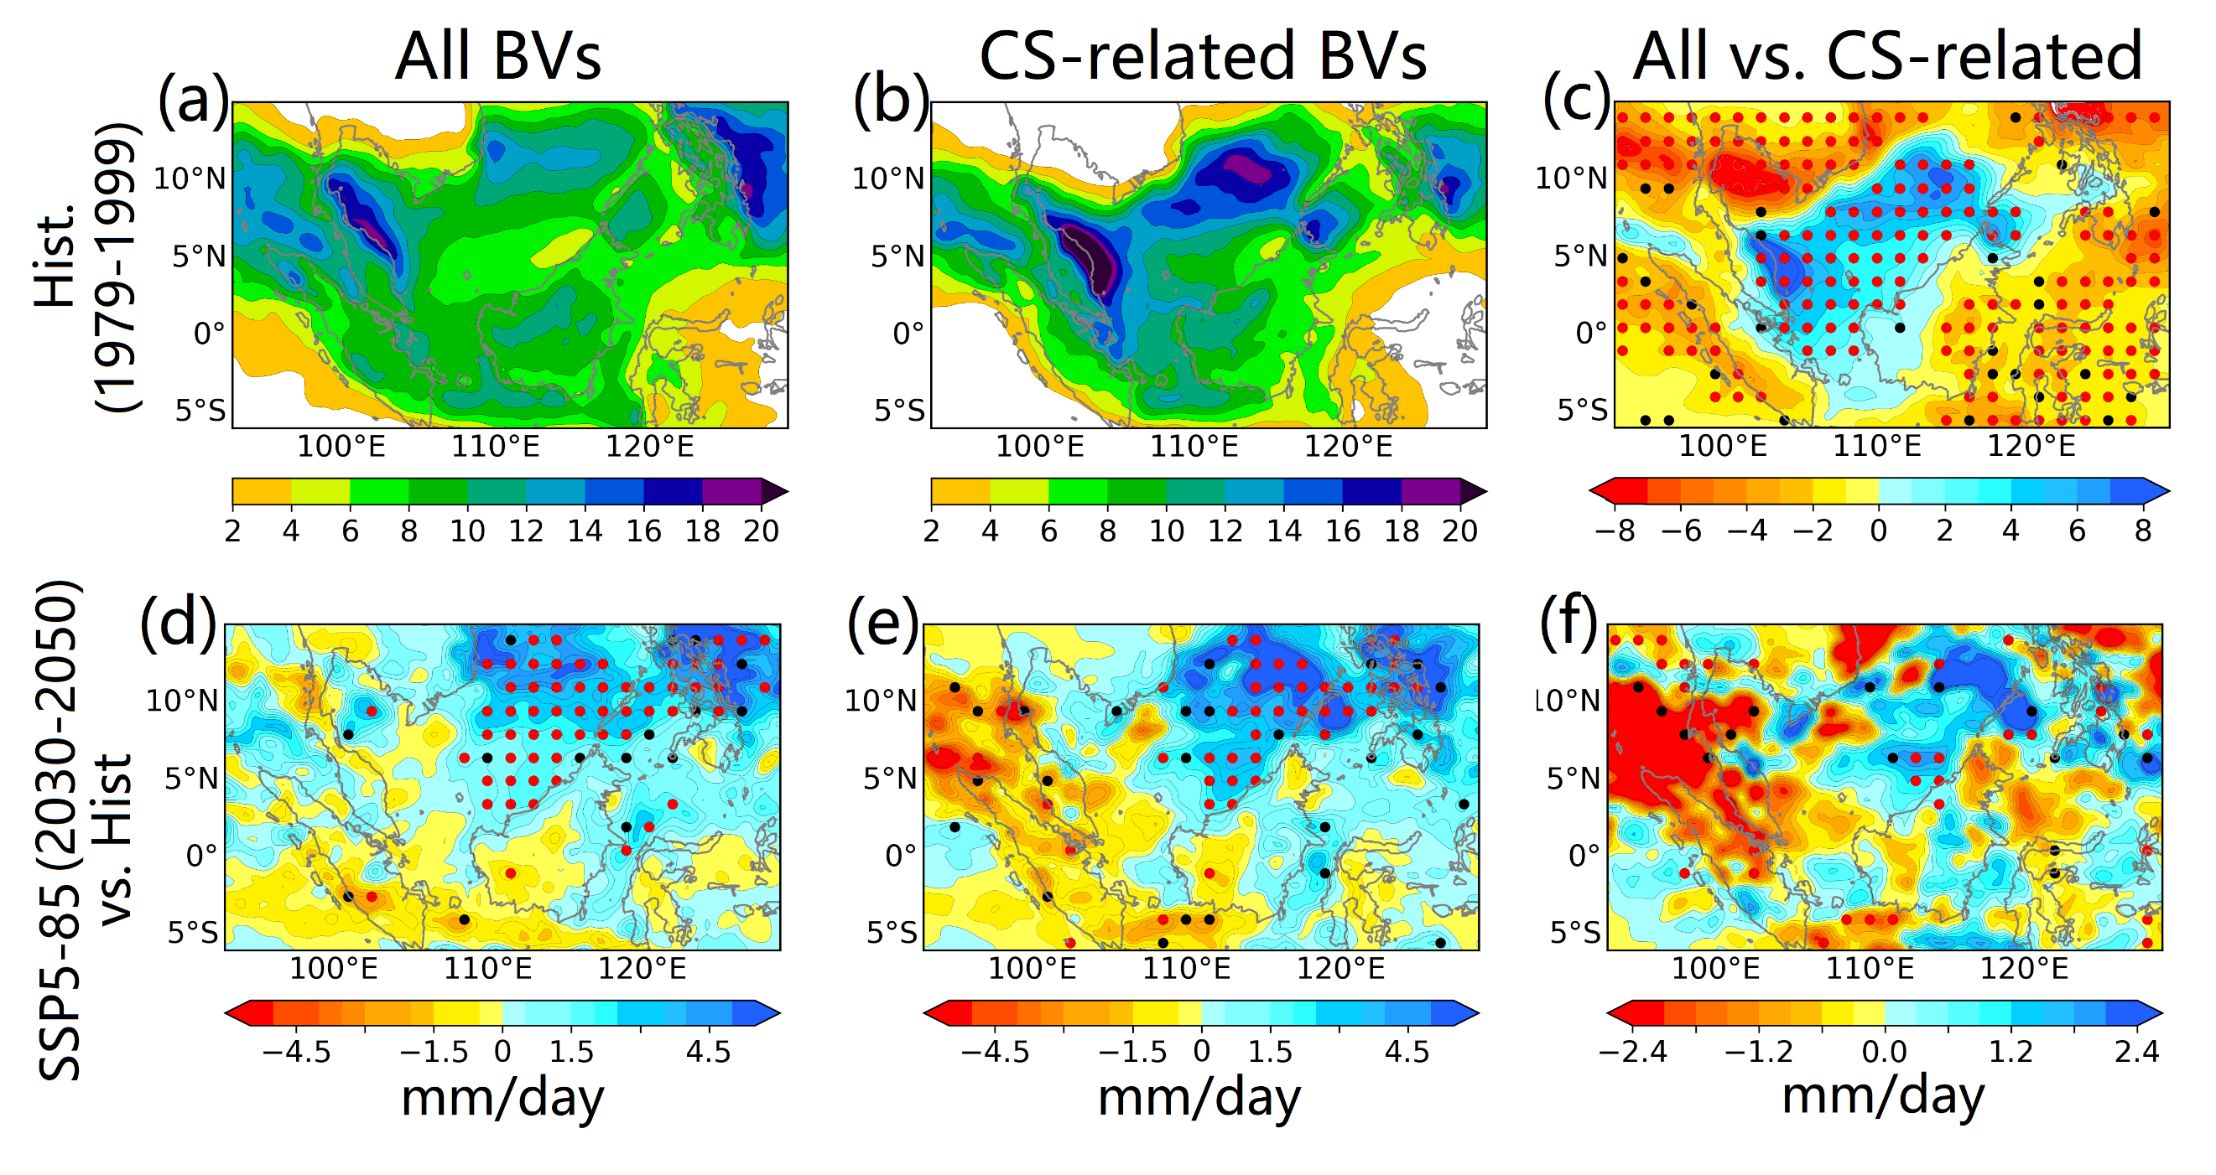
Fig. S6. Distributions of the mean precipitation intensities associated with all BVs during ONDJFM (a, d) and those associated with cold surges (b, e). The absolute differences between the mean precipitation intensities for all BVs and those associated with cold-surge-related BVs are shown in (c, f): a-c, historical period during 1979-1999. d-f, the projected absolute changes under the SSP5-85 scenario (2030-2050) relative to the historical period.

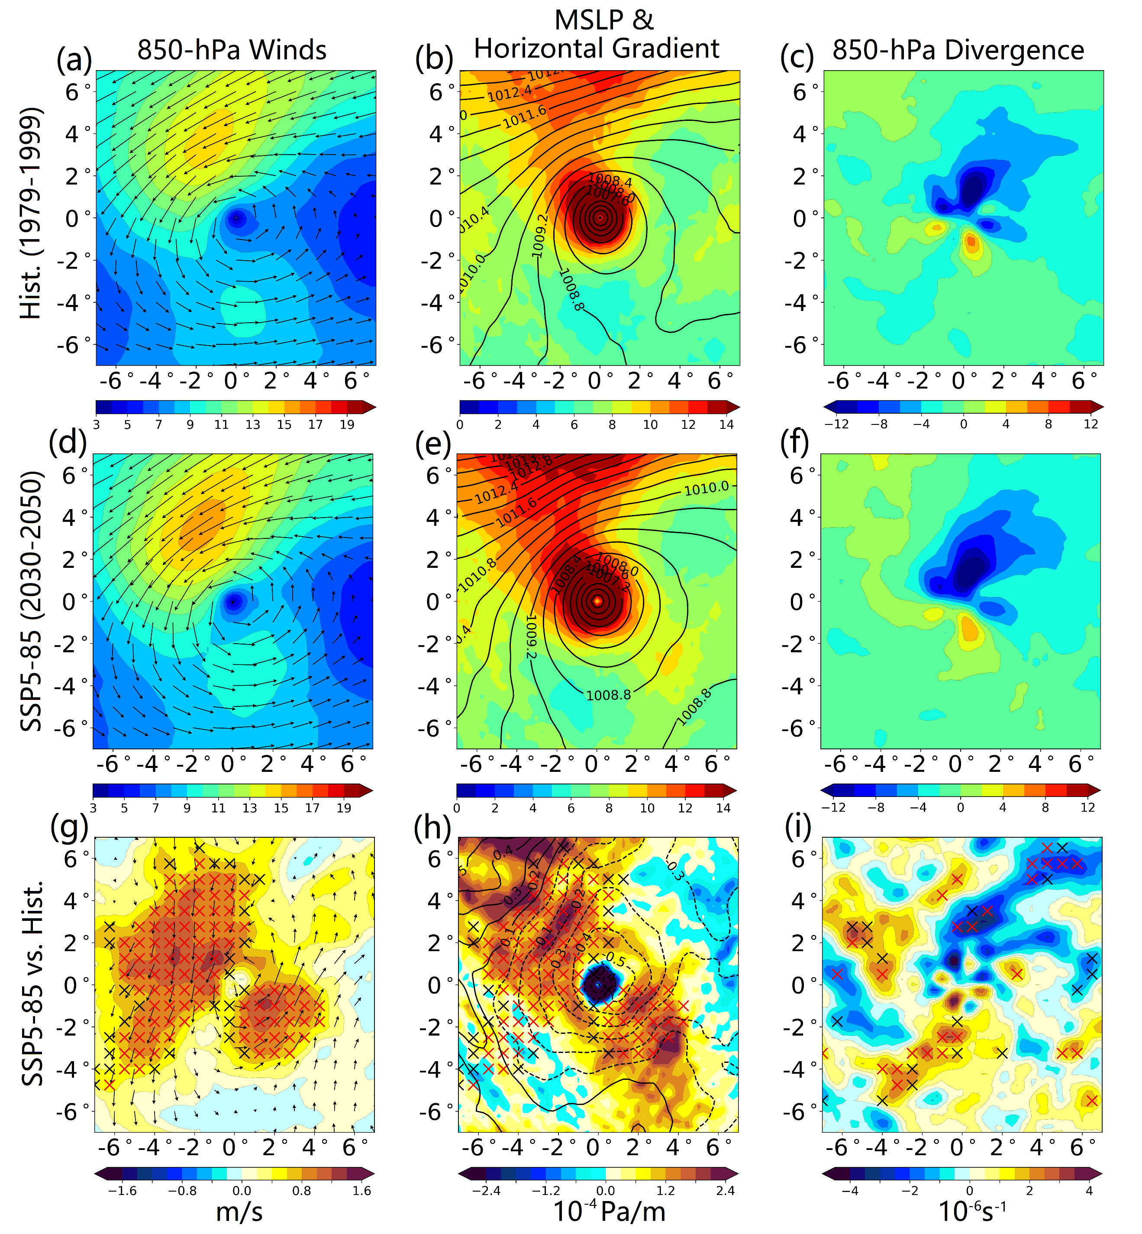
Fig. S7. As Figure S2i-k, but for historical period during 1979-1999 (a-c), future period during 2030-2050 (SSP5-85, d-f) and the projected absolute changes for SSP5-85 relative to the historical period. Cross symbols indicate statistically significant trends with confidence levels above 90% (black) and 95% (red).
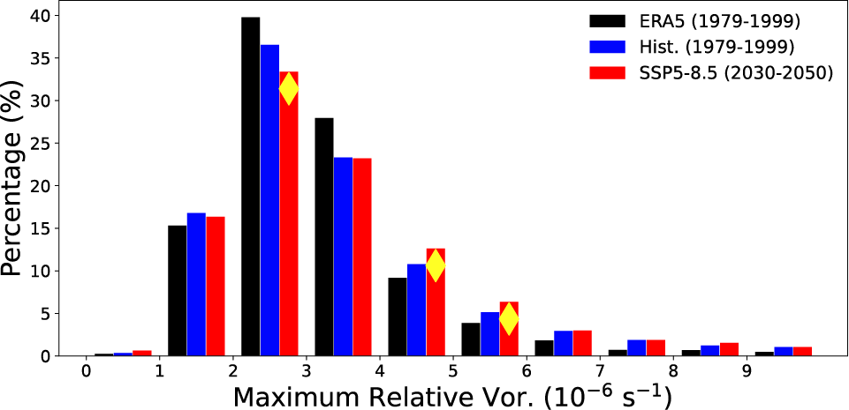
Fig. S8. Fraction distribution of categorized BVs with respect to all BVs during ONDJFM in 1979–1999 by the near-centre maximum relative vorticity at 850 hPa. Yellow diamonds indicate statistically significant changes for ensemble mean of SSP5-85 (2030-2050, red) relative to that of historical period (1979-1999, blue) with confidence levels above 95%. Black bars show the distribution for ERA5.
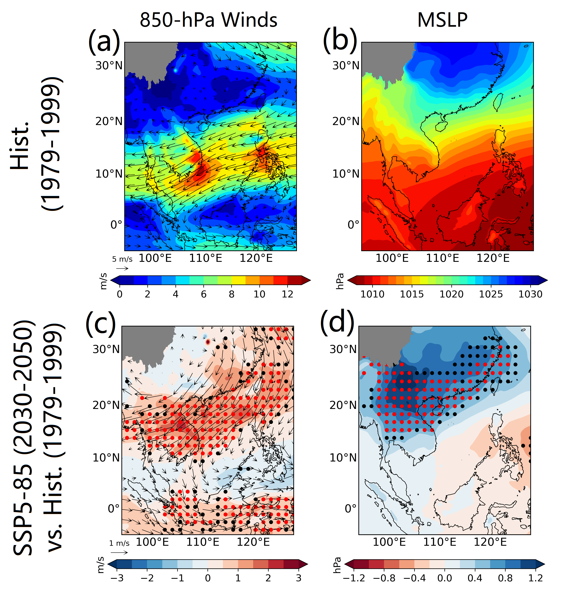
Fig. S9. Average 850-hPa wind fields (a, c) and MSLP (b, d) for 24-hour prior to the genesis phases of the 200 most intense BVs during DJF for the period 1979–1999: a,b, ensemble mean for the historical period during 1979-1999. c,d, ensemble mean for the projected absolute changes for SSP5-85 (2030-2050) relative to the historical period. Stippling indicates statistically significant changes with confidence levels above 90% (black) and 95% (red).
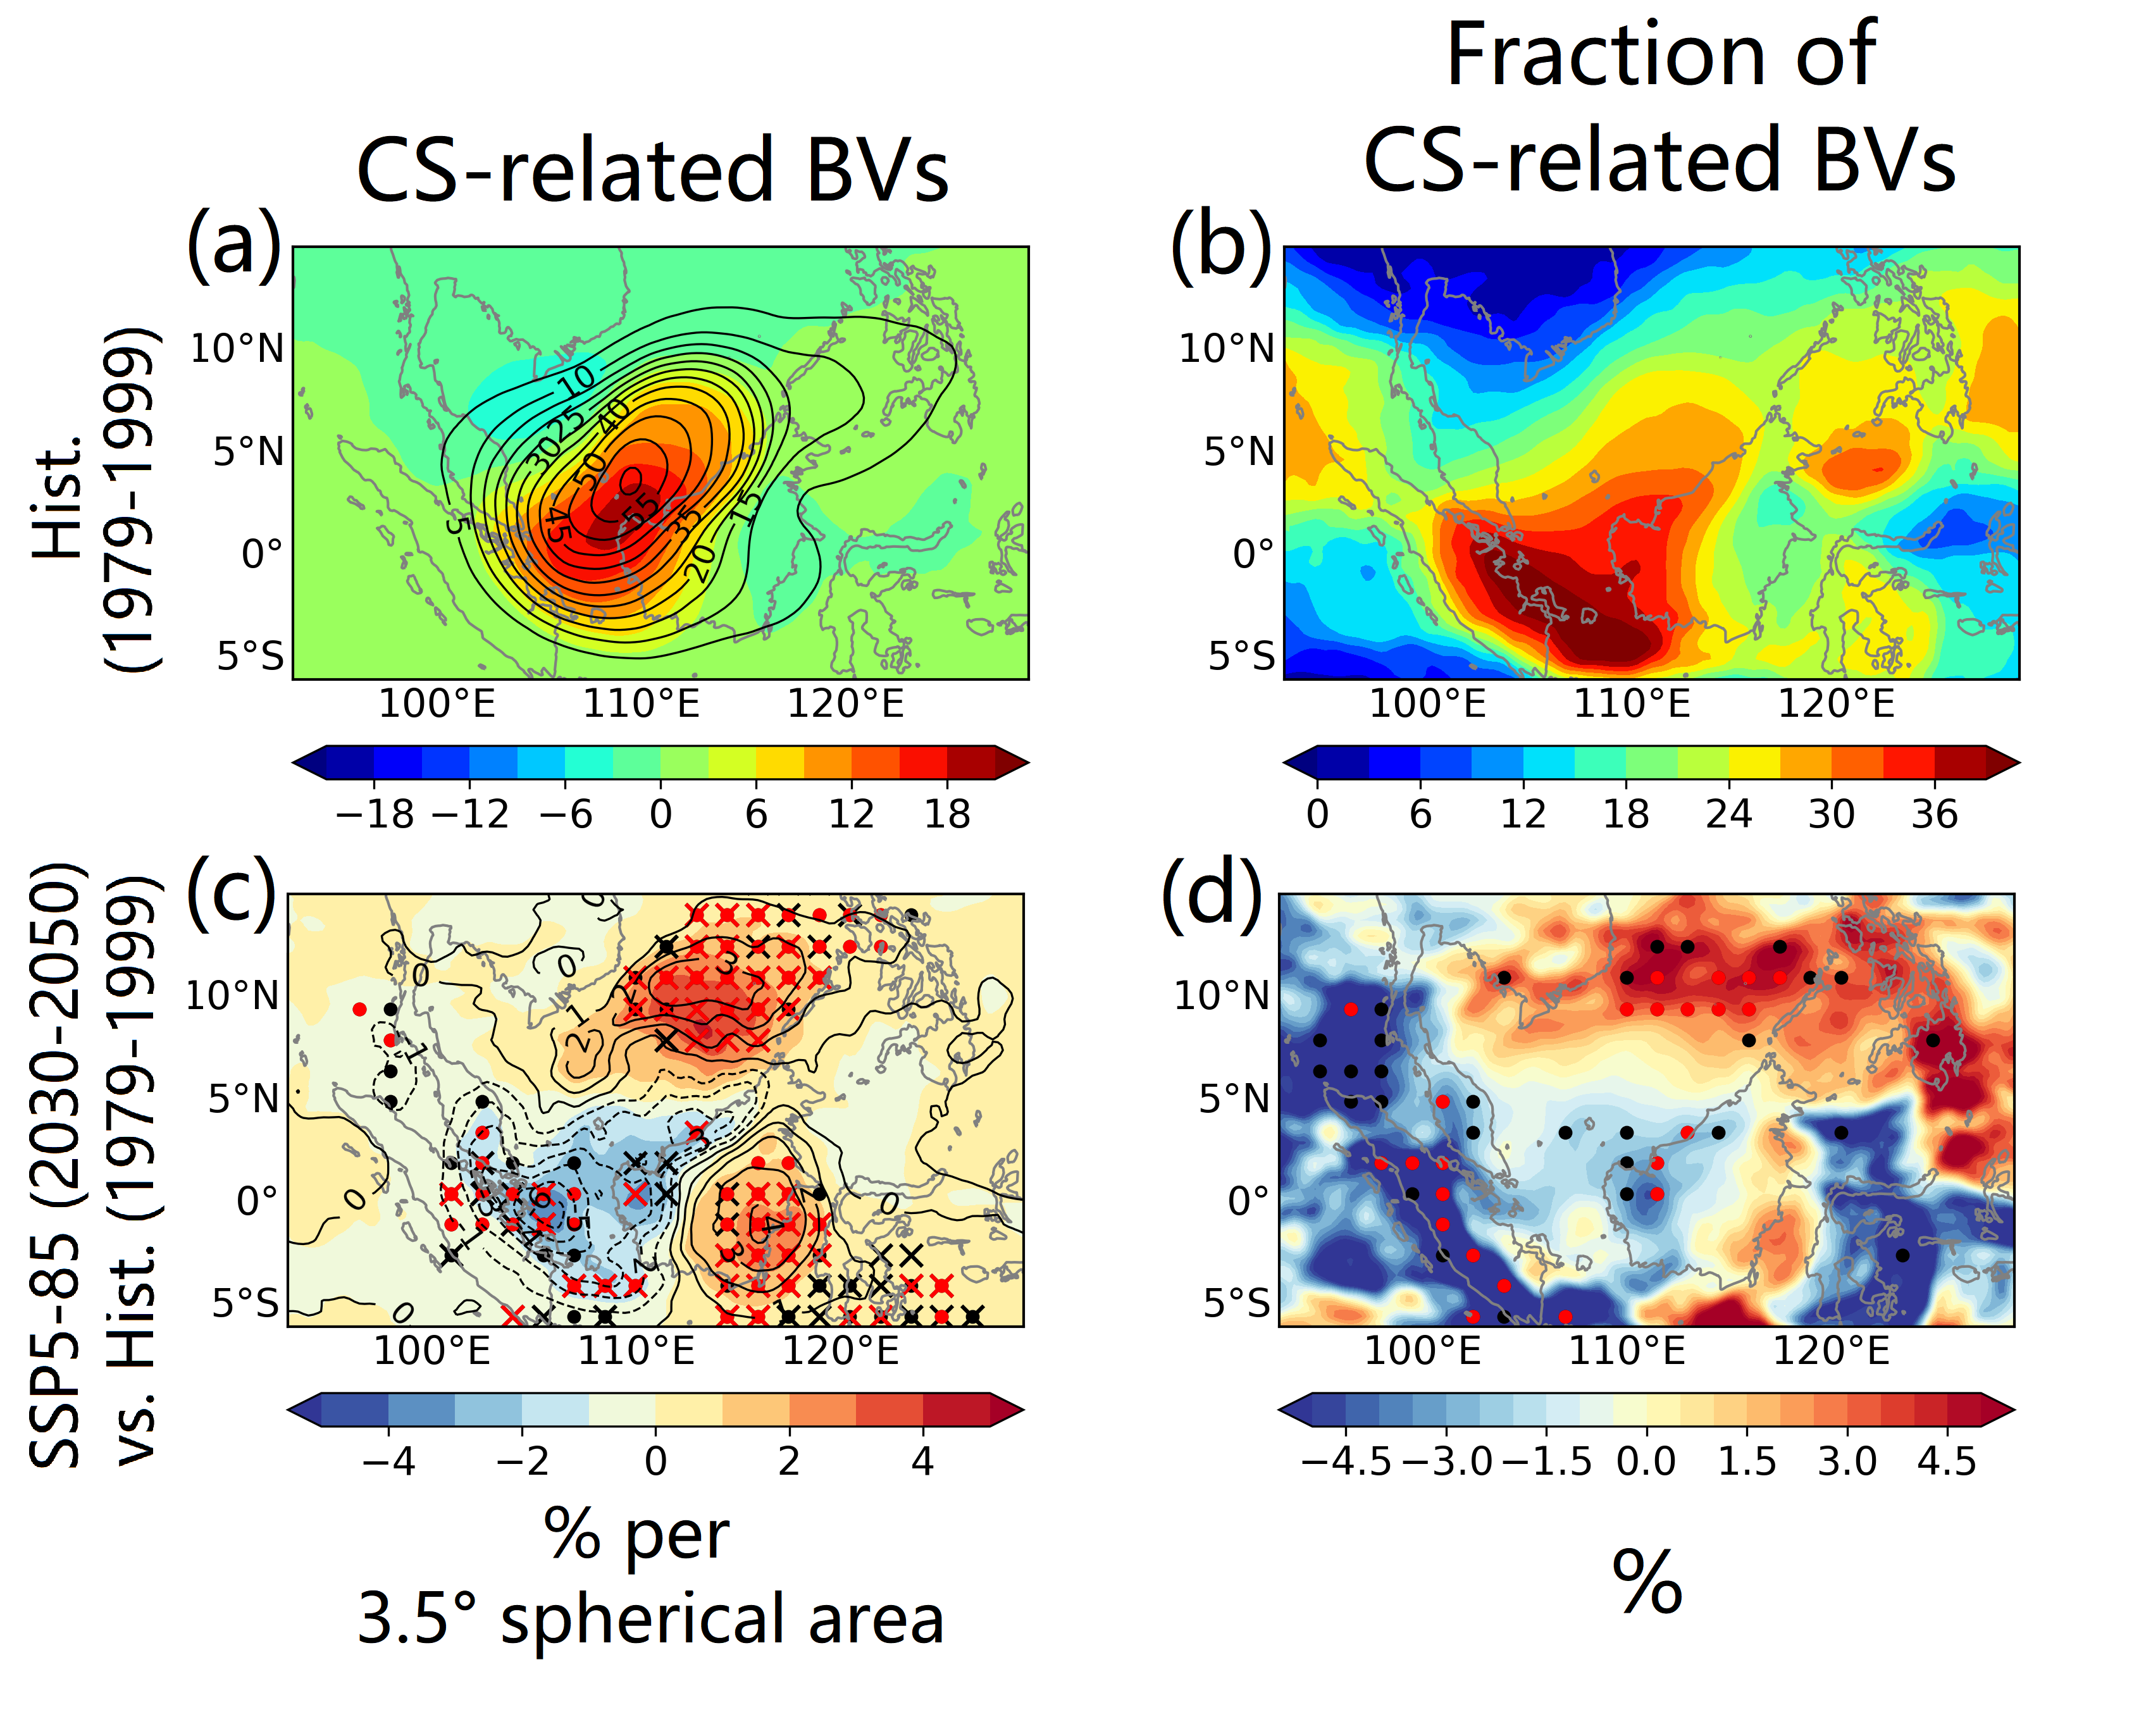
Fig. S10. Anomalies of daily mean track density (shaded; unit: percent per 3.5° spherical area per day) of BVs during cold surge events (a, c) and the distribution of fraction for cold-surge-related BVs (b, d) relative to all BVs during ONDJFM. Black contours in (a, c) show the daily mean track densities for cold-surge-related BVs during ONDJFM: a,b, ensemble mean for the historical period during 1979-1999. c,d, ensemble mean for the projected absolute changes for SSP5-85 (2030-2050) relative to the historical period. Stippling (for shaded) and crosses (for black contours) indicate statistically significant changes with confidence levels above 90% (black) and 95% (red).

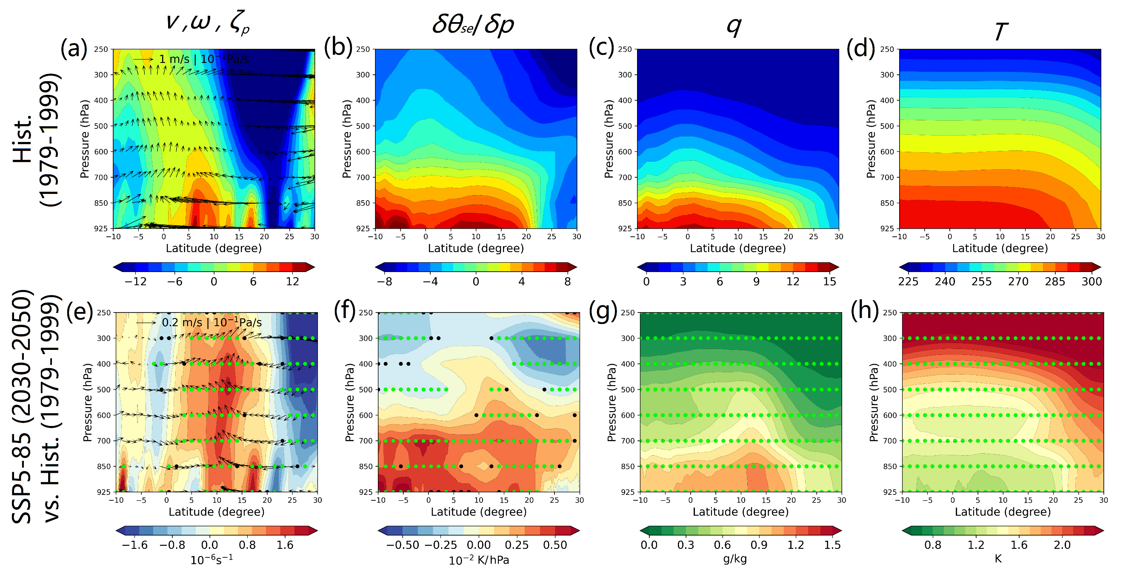
Fig. S11. Zonally averaged (over 110-120°E) seasonal mean fields during ONDJFM, including relative vorticity and winds (a, e), moist static instability (b, f), specific humidity (c, g) and air temperature (d, h): a-d, ensemble mean for the historical period during 1979-1999. e-h, ensemble mean for the projected absolute changes for SSP5-85 (2030-2050) relative to the historical period. Stippling indicate statistically significant changes with confidence levels above 90% (black) and 95% (green).
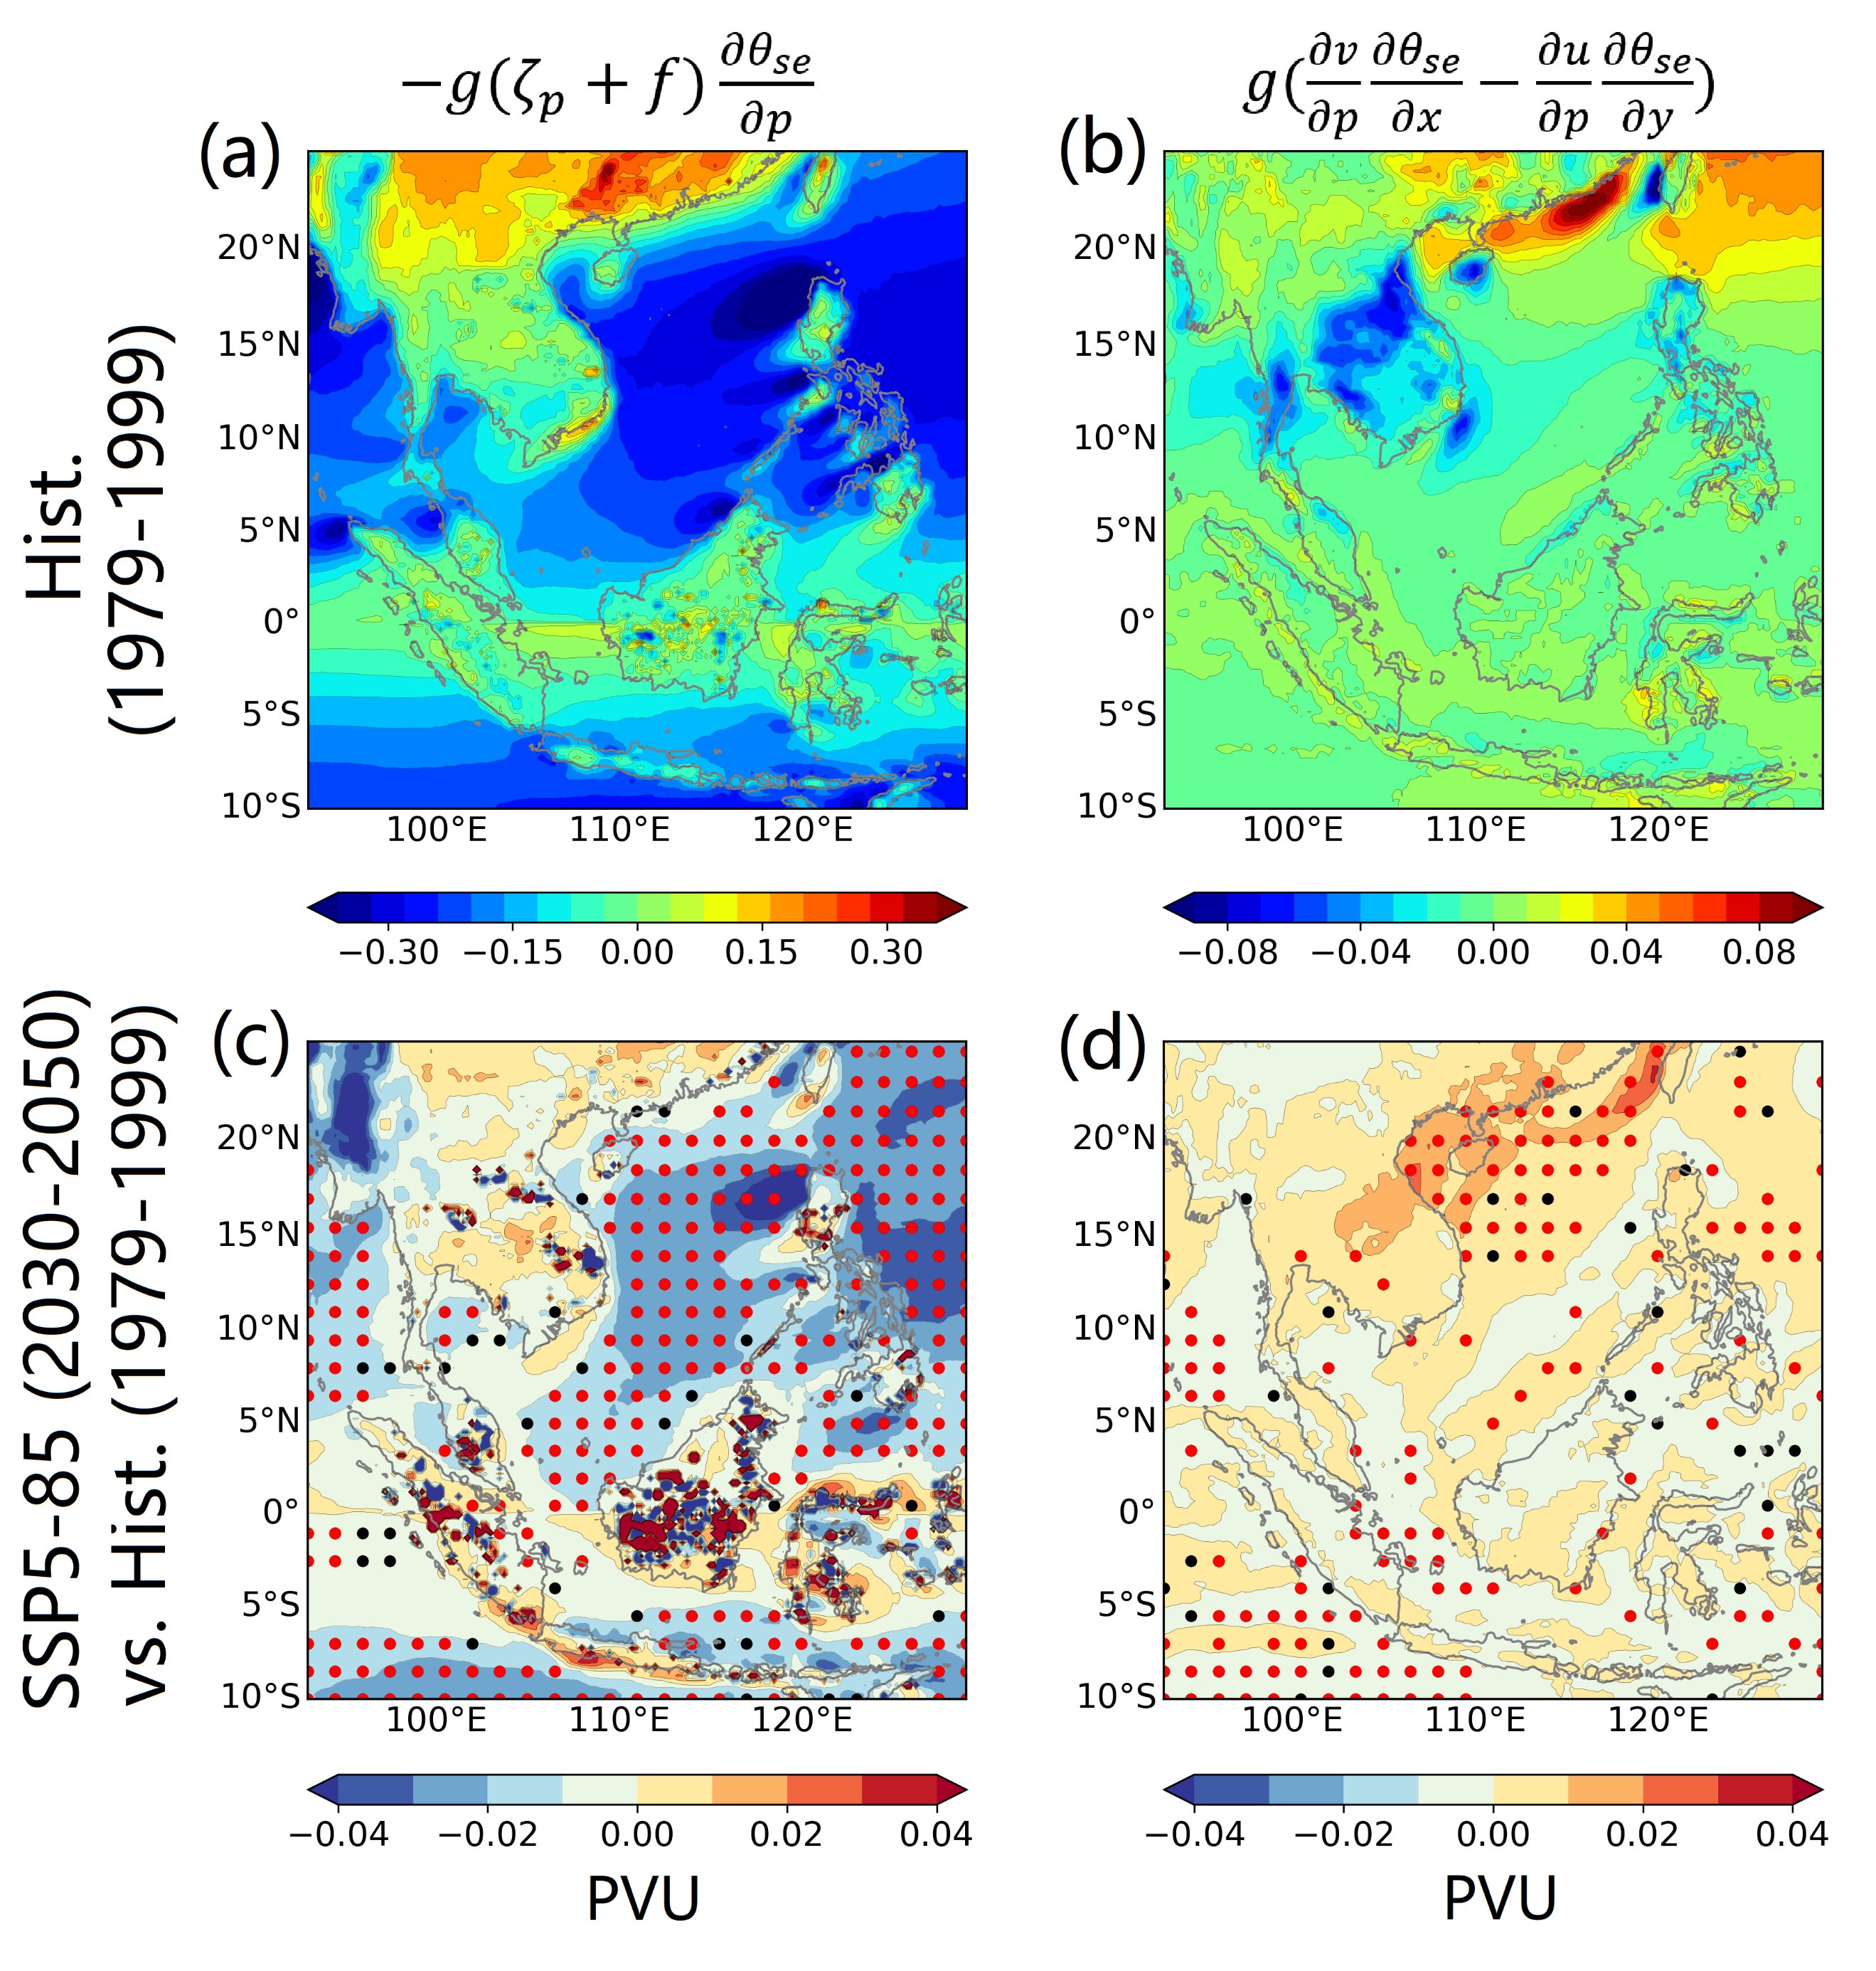
Fig. S12. Seasonal mean fields of the barotropic (MPV₁, a, c) and baroclinic moist potential vorticity (MPV₂, c, d) during ONDJFM: a, b, ensemble mean for the historical period during 1979-1999. c, d, the projected absolute changes for SSP5-85 (2030-2050) relative to the historical period. Stippling indicates statistically significant changes with confidence levels above 90% (black) and 95% (red). See Methods for definitions of MPV₁ and MPV₂
References
- Liang, J. et al. Climatology of Borneo Vortices in the HadGEM3-GC31 general circulation model. J. Clim. 34, 3401–3419 (2021).
- Rauscher, S. A. et al. A multimodel intercomparison of resolution effects on precipitation: simulations and theory. Clim. Dyn. 47, 2205–2218 (2016).
- Andrews, M. B. et al. Historical simulations with HadGEM3-GC3.1 for CMIP6. J. Adv. Model. Earth Syst. 12, e2019MS001995 (2020).
- Voldoire, A. et al. Evaluation of CMIP6 DECK Experiments With CNRM-CM6-1. J. Adv. Model. Earth Syst. 11, 2177–2213 (2019).
- Haarsma, R. et al. HighResMIP versions of EC-Earth: EC-Earth3P and EC-Earth3P-HR - Description, model computational performance and basic validation. Geosci. Model Dev. 13, 3507–3527 (2020).
- Mizuta, R. et al. Climate simulations using MRI-AGCM3.2 with 20-km grid. J. Meteorol. Soc. Japan 90, 233–258 (2012).
- Gutjahr, O. et al. Max Planck Institute Earth System Model (MPI-ESM1.2) for the High-Resolution Model Intercomparison Project (HighResMIP). Geosci. Model Dev. 12, 3241–3281 (2019).
- Scoccimarro, E. et al. Extreme events representation in CMCC-CM2 standard and high-resolution general circulation models. Geosci. Model Dev. 15, 1841–1854 (2022).
- Trilaksono, N. J., Otsuka, S. & Yoden, S. A time-lagged ensemble simulation on the modulation of precipitation over west Java in January-February 2007. Mon. Weather Rev. 140, 601–616 (2012).
- Koseki, S., Koh, T. Y. & Teo, C. K. Borneo vortex and mesoscale convective rainfall. Atmos. Chem. Phys. 14, 4539–4562 (2014).

