Supplementary Information for
Formation, Chemical Evolution, and Solidification of the Calcium Carbonate Dense Liquid Phase

Biao Jin¹†, Ying Chen¹†, Harley Pyles², Marcel D. Baer¹, Benjamin A. Legg¹, Zheming Wang¹, Nancy M. Washton¹, Karl T. Mueller¹, David Baker², Gregory K. Schenter¹, Christopher J. Mundy^{1,3}*, James J. De Yoreo^{1,2}*
¹Physical Sciences Division, Pacific Northwest National Laboratory; Richland, Washington, 99352, USA.
²Department of Materials Science and Engineering, University of Washington; Seattle, Washington, 98195, USA.
³Department of Chemical Engineering, University of Washington; Seattle, Washington, 98195, USA.
†These authors contributed equally to this work.
*Corresponding author. Email: James.DeYoreo@pnnl.gov.

This PDF file includes:
Supplementary Text
Extended data Figures 1 to 8
Extended data Tables S1 to S2
Captions for Movie S1 to S4
References (1-17)

Other supplementary material for this manuscript includes the following:
Movie S1-S4

Supplementary Text
Evidences to imply the formation of DLP at early stage
We initiated the precipitation reaction through mixing 100 mM CaCl₂ and 100 mM NaHCO₃ solution. Initially, a highly supersaturated Ca(HCO₃)₂ solution separated into a emulsion, presumably amorphous DLP, as illustrated by in situ liquid ATR-FTIR (fig. S4h). The prensence of broad peak at ~1640 cm⁻¹ may be attributed to the existence of HCO₃⁻ and H₂O, implying the formation of DLP containing HCO₃⁻ and H₂O. As a control experiment, when 100 mM NaHCO₃ was replaced by 100 mM Na₂CO₃, the quick formation of calcite was observed by in situ ATR-FTIR. In addition, ex situ TEM investigations show the existence of an amorphous DLP precursor: the obvious wetting behavior (fig. S1b), the presence of continuous amorphous (fig. S1c) and vaterite films (fig. S1d) and round amorphous particle with low contrast in Cryo-TEM image (fig. S1e).
The estimation of viscosityof DLP droplets
According to previous report ¹, we define Henky strain as $H=\ln{L_{1}}/2r_{0}$, where 𝐿₁ is the length of the long axis of a deformed droplet, and 𝑟₀ is the radius of the undeformed spherical particle. The relaxation is expected to obey:
$$H=H_{0}e^{(t/{τ_{2}})}$$
Where the relaxation timescale is:

$$τ_{2}=\frac{{r_{0}η}_{m }}{γ}\frac{\left(19\frac{η_{d}}{η_{m}}+16\right)\left(2\frac{η_{d}}{η_{m}}+3\right)}{40\left(\frac{η_{d}}{η_{m}}+1\right)}$$

𝛾 = interfacial tension of droplet
η_{𝑚} = viscosity of H₂O (~0.0001 Pa⋅s in bulk at room temperature)
η_{𝑑} = viscosity of DLP droplet
In simplifying case where η_{𝑚}≪η_{𝑑}
$$τ_{2}=\frac{{r_{0}η}_{d }}{γ}\frac{19}{20}$$

Solving for viscosity: $$η_{d}=\frac{{20γτ}_{2}}{19r_{0}}$$

For the present case examined (Fig. S2c, table S1 and Fig. 1e), $τ_{2}$ is fitted to about 102 s:

$$η_{d}=\frac{20⋅(0.1 J/m^{2})⋅\left(102 s\right)}{19⋅(820⋅{10}^{-9} m)}=1.3⋅{10}^{7} Pa⋅s$$

This is dramatically higher than the viscosity of water (0.0001 Pa⋅s), and so we can assume the approximation of η_{m} ≪ η_{𝑑} holds. Another case shows a viscosity of 0.97⋅10⁷ Pa⋅s (fig. S2d-e).
The estimation of shell volume percentage
We measured the radius (R) of the hollow particles and the thickness (T) of the shell (fig. S6b-c), and then calculated that the volume of the shell relative to that of the particle is given by 1-r³/R³, where r = R-T. By calculating 13 hollow particles, we estimated the averaged value is 76 %. The results show that the shell constitutes about 76 % of the particles volume, which indicates that a thin shell has a large volume.
The calculation of water content and DLP density
Based on our in situ NMR results, the DLP consists of a highly hydrated Ca(HCO₃)₂⋅nH₂O droplet. The introduction of H₂O has a big effect on the DLP stability, and thus water content in DLP is an important parameter. During the transformation process of DLP into hydrated ACC solids, a pathway could be described by the following reaction.
Ca(HCO₃)₂⋅nH₂O(DLP) CaCO₃⋅H₂O_{(hydrated ACC solid)} + CO₂ + nH₂O
During this reaction, the release of CO₂ and H₂O can reduce the mass and volume of the initial DLP. As reported before, the volume change of DLP arises from the removal of H₂O. LP-TEM technique is an effective approach to in situ follow the size change of individual particles. To determine the water content, we quantitatively analyzed the dehydration process of DLP through in situ measuring the radius change of DLP droplets. Due to the comparable volume between DLP droplets and hollow particles (fig. S6 and Fig. 3a), we followed the volume evolution of 15 hollow particles to hydrated ACC solids. The following equations (1-2) are used to estimate the water content, revealing the n is 7.5±1.7. Furthermore, from the averaged n value, the DLP density is determined to be about 1.36 g/cm³ based on equations (3-4)².
$$\frac{ρ_{ACC}V_{ACC}}{ρ_{H2O}V_{H2O}}=\frac{m_{ACC}}{m_{H2O}}=\frac{118}{18n}$$ | (1)
 | (2)
  $$n=\frac{118ρ_{H2O}V_{H2O}}{18ρ_{ACC}V_{ACC}}=4.3\frac{V_{H2O}}{V_{ACC}}=4.3\left(\frac{V_{DLP}}{V_{ACC}}-1\right)=4.3\left(\frac{r_{DLP}^{3}}{r_{ACC}^{3}}-1\right)$$
$$\frac{ρ_{DLP}}{ρ_{ACC}}=\frac{m_{DLP}V_{ACC}}{m_{ACC}V_{DLP}}=\frac{m_{DLP}r_{ACC}^{3}}{m_{ACC}r_{DLP}^{3}}$$ | (3)
$$ρ_{DLP}=ρ_{ACC}\frac{m_{DLP}r_{ACC}^{3}}{m_{ACC}r_{DLP}^{3}}$$ | (4)
Based on the chemical reaction of DLP to ACC as described above, we can also propose the below equations (5-8) for estimating the water content (n) as a comparison:
$$\frac{m_{DLP}}{m_{ACC}}=\frac{\frac{ρ_{DLP}}{ρ_{Bkgrd}}V_{DLP}}{\frac{ρ_{ACC}}{ρ_{Bkgrd}}V_{shell}}= 1+\frac{m_{CO2+H2O}}{m_{ACC}}$$
$=1+\frac{\left({m_{ACC}}/{M_{ACC}}\right)•\left(M_{CO2}+nM_{H2O}\right)}{ρ_{ACC}V_{shell}}$
$=1+\frac{\left({ρ_{ACC}V_{shell}}/{M_{ACC}}\right)•\left(M_{CO2}+nM_{H2O}\right)}{ρ_{ACC}V_{shell}}$
$=1+\frac{\left(M_{CO2}+nM_{H2O}\right)}{M_{ACC}}$ (5)
$\frac{\frac{ρ_{DLP}}{ρ_{Bkgrd}}V_{DLP}}{\frac{ρ_{ACC}}{ρ_{Bkgrd}}V_{shell}}=1+\frac{\left(M_{CO2}+nM_{H2O}\right)}{M_{ACC}}$ (6)
$n=\frac{M_{ACC}}{M_{H2O}}\left[\frac{\left(\frac{ρ_{DLP}}{ρ_{Bkgrd}}\right)}{\left(\frac{ρ_{ACC}}{ρ_{Bkgrd}}\right)}\frac{V_{DLP}}{V_{shell}}-1\right]-\frac{M_{CO2}}{M_{H2O}}$ (7)

And then plugging the ratios of the molecular weights M_{ACC} = 118, M_{H2O} = 18, M_{CO2} = 44, we can get:

$n=6.6\left[\frac{\left(\frac{ρ_{DLP}}{ρ_{Bkgrd}}\right)}{\left(\frac{ρ_{ACC}}{ρ_{Bkgrd}}\right)}\frac{V_{DLP}}{V_{shell}}-1\right]-2.4$ (8)
We calculated an upper limit of n based on a relative density of 1.0 due to the similarity of the gray scale values in the shell and at the rim of the droplet as seen in Fig. 3b, and another value based on above estimate of DLP density (1.36 g/cm³), which gives a relative density of 0.91. We also notice that the average value of the relative volume of the DLP droplet to the resulting ACC is 2.7 (Fig. 3d), that is the upper limit of (V_{DLP}/V_{shell}). Based on the proposed relative densities of DLP to ACC of between 0.9 and 1.0 and the V_{DLP}/V_{shell} of 2.7, we can estimate a range of n values between 7.0 and 8.8, consistent with the above calculation method. A representative example is showed in Fig. S6d, where V_{DLP}/V_{shell} is 2.4, giving a n of 6.8. Also note, however, that the size of the shell has some uncertainty as it is difficult to know at which moment it should be measured, since is thickens with time. In the calculation, we have calculated the value at the time it first forms, prior to its thickening into ACC.
¹³C chemical shift analysis
First, based on the ¹³C chemical shift δ(¹³C) of pure HCO₃⁻ at pH 7.0 (161.10 ppm) and δ(¹³C) of pure CO₃²⁻ at pH 14.0 (169.18 ppm) and recognizing that the apparent δ(¹³C) is a weighted average of δ(HCO₃⁻) and δ(CO₃²⁻), we calculated δ(¹³C) as a function of fraction of CO₃²⁻ (fig. S3a). Coordination to Ca²⁺ may shift δ(CO₃²⁻) between 167.98 ppm and 171.10 ppm, as observed in ACC or monohydrocalcite³, but because no other resonance was detected between 160 – 170 ppm (fig. S3e), the signal between 161.10 and 161.40 ppm reveals that HCO₃⁻ dominates (> 96%) and that no liquid-phase CO₃²⁻ was detected during the course of the reaction.
Second, after considering the isotope effect of D₂O vs H₂O on the dissociation constant of HCO₃^{-4,5}, δ(¹³C) as a function of pH is calculated using 1.60 × 10⁻¹¹ for K₂ (HCO₃⁻) (fig. S3b). Along with the measured pH change with time (fig. S3c), we can see that the estimated δ(¹³C) based on pH only changed slightly from 161.105 to 161.100 ppm with time when the exchange between free HCO₃⁻ and CO₃²⁻ is the only factor influencing δ(¹³C) (fig. S3d). When comparing the first ¹³C spectrum after mixing NaHCO₃ with CaCl₂ and with NaCl (fig. S3f), the shift of 0.29 ppm to a higher frequency in the mixed solution with CaCl₂ is clear evidence that this 161.40 ppm signal can be attributed to HCO₃⁻ in a different coordination environment (coordinating to Ca²⁺) than that of free HCO₃⁻. Previous quantum mechanical calculations⁶ of chemical shifts also reported a difference of less than 0.30 ppm in δ(¹³C) when substituting Na⁺ for Ca²⁺ at a remote site from HCO₃⁻.
Third, because coordinated HCO₃⁻ exchanges with free HCO₃⁻, which is located at 161.105 – 161.100 ppm over the pH range used here, the observed signal is a weighted average of both. The shift of the center of gravity of the signal from 161.40 to 161.10 ppm with time (Fig. 2b) reflects the change in the fraction of the coordinating HCO₃⁻.
Due to the very low natural abundance of ⁴³Ca (0.135%), a measurement time of about 15 hours is required to acquire a ⁴³Ca NMR spectrum with a reasonable signal to noise ratio for the natural-abundant solutions of 50 mM Ca²⁺. Comparison between the ⁴³Ca NMR spectra of 50 mM CaCl₂, 100 mM CaCl₂ with 100 mM NaHCO₃ in the absence and presence of PAA (fig. S4c) shows that 70 – 80% of Ca²⁺ precipitate as CaCO₃ in the solution with no PAA, the rest 10 – 15 mM of Ca²⁺ stay in the solution considering that the solubility of Ca(HCO₃)₂ is around 10 mM at 25 °C^{7,8}. In contrast, 25 μg/mL 1.8 kDa PAA (350 μM COO⁻) allows the majority of 50 mM Ca²⁺ stay in the solution during the measurement. A shift of 0.44 ppm in the ⁴³Ca spectrum with PAA to a higher frequency suggests that Ca²⁺ experience different coordination environment from fully solvated Ca²⁺ in water. Combined with δ(¹³C) of HCO₃⁻ which maintains a shift of 0.1 – 0.3 ppm to a higher frequency (from free HCO₃⁻) during 10 hours after mixing, we may conclude that Ca²⁺ coordinate to carboxyl groups from PAA and HCO₃⁻ for about 10 hours. Considering the small molar ratio of COO⁻ from PAA to Ca²⁺ (1: 143), the stabilization capability of PAA is extremely powerful.
In order to determine whether an equivalent pathway involving a CaCO₃ DLP can arise, we increased the solution pH and thereby the ratio of CO₃²⁻ to HCO₃⁻ in the starting NaHCO₃ solution. In 100 mM NaHCO₃ at pH 11 ± 0.2, the fraction of CO₃²⁻ increases to 50 – 72% with δ(¹³C) located at 165.2 – 166.9 ppm. However, after mixing with 100 mM CaCl₂ solution, no signal between 162 and 172 ppm was detected by liquid-state ¹³C NMR. Nevertheless, the initial concentration of the observed HCO₃⁻ signal was reduced to 10 – 20 mM (fig. S4-5), suggesting that most CaCO₃ precipitates immediately upon formation and, thus, never exists in a liquid phase or does so for too short a time to be detected in our experiments. Due to the detection limit of ¹³C NMR (about 1 mM under our experimental condition), our quantitative analysis of HCO₃⁻ and CO₂ are not accurate at these dilute starting concentrations. However, we observed the same temporal trend for the smaller HCO₃⁻ signal as at low pH: broadening followed by resharpening, as well as continuous shifting to a lower frequency. Moreover, the initial shift of HCO₃⁻ to a higher frequency was more extreme at the higher initial pH: 1.0 ppm for pH 11.2 and 0.6 ppm for pH 10.8 vs. 0.3 ppm for pH 8.7. These changes may be explained by a very small amount of Ca∙CO₃ ion pairs trapped and released at the higher initial pH from a composite DLP with a mixed composition, such as (Ca∙HCO₃)_{n}∙Ca∙CO₃∙(Ca∙HCO₃)_{m}. In other words, while the majority of CaCO₃ precipitates immediately from solution, a small amount of Ca∙CO₃ ion pairs associate with Ca∙HCO₃ ion pairs, which form a DLP, leading to the broadening of the HCO₃⁻ signal. With further precipitation of this small amount of CaCO₃ at an initial pH of 11.2, or upon decomposition from Ca(HCO₃)₂ to form CaCO₃ at an initial pH 10.8 where the starting HCO₃⁻ is relatively higher, this composite DLP “dissolves” and most HCO₃⁻ becomes free, leading to sharpening of the HCO₃⁻ signal and eventually stabilized at 161.10 ppm. The ¹H T₂ of water experiences an initial increase instead of a drop at the higher pH, probably because a large amount of water molecules are released from hydrated ACC during the precipitation of the majority CaCO₃, which should significantly increase the water ¹H T₂.
This composite DLP structure is similar to what’s reported by Denis Gebauer, et al. recently⁶. Although we both study CaCO₃ formation from bicarbonate at near-neutral pH, our experimental conditions are different. In Gebauer’s work, the solutions have much smaller starting and final concentrations. For example, the concentration of CaCl₂ is between 0.9 – 4.5 mM in their NMR samples, while we have 50 mM CaCl₂ in the mixed solutions. Another major difference is that they utilize slow titration of CaCl₂ into NaHCO₃ solution, while we perform rapid mixing of Ca²⁺ and HCO₃⁻ of high concentrations at a molar ratio of 1:1. With the smaller concentration and much slower mixing at constant pH, each Ca²⁺ may have enough time to reach its lowest free energy (coordination to CO₃²⁻) before another added Ca²⁺, therefore CaCO₃ DLP may form with Ca(HCO₃)₂ terminating the surface (with a higher fraction of HCO₃ at a lower pH). In contrast, fast mixing of 100 mM Ca²⁺ (pH 6.9) and 100 mM HCO₃⁻ (pH 8.7) of equal volume allows the formation and growth of a metastable Ca(HCO₃)₂ DLP before CaCO₃ solidification even though CaCO₃ ion pair has lower Gibbs free energy than CaHCO₃⁺ ion pair (-18.43 vs -7.42 kJ/mol)⁶, primarily because water solvation of Ca∙HCO₃ ion associations lowers the free energy, as shown in our MD simulation and the previously reported DFT simulation of Ca∙HCO₃ clusters⁹. On the other hand, when we increase pH of 100 mM HCO₃⁻ to 11.0 ± 0.2, with the immediate drop in the concentration of HCO₃⁻, we observe the similar composite DLP involving both CO₃²⁻ and HCO₃⁻, but with HCO₃⁻ dominating over CO₃²⁻ under our experimental conditions.
While liquid-state NMR cannot detect amorphous solids or crystals where molecular mobilities are much slower than in liquids or DLP, solid-state magic angle spinning (MAS) ¹³C NMR spectra can directly monitor if these solid phases are involved over the course of the reaction. The disadvantages of MAS measurements of the mixed phase reactions include: 1) the spinning may mix the solutions much more vigorously than in the static state, 2) the shearing stress from the spinning may act differently on the solids, liquids and gases and thereby alter the reaction pathway, 3) the great gravity from the spinning may separate these phases into different layers and further change the reaction pathway. But in some cases, the spinning may just change the reaction rate and allows for the detection of the solid phases.
Equal volumes of 100 mM CaCl₂ and 100 mM ¹³C-enriched NaHCO₃ in 90% D₂O (10% H₂O) solutions were mixed in a 5mm WHiMS NMR rotor (which can prevent liquid from leakage during spinning) ¹⁰ and time-resolved ¹³C single-pulse NMR were then carried out immediately at a spinning speed of 3550 Hz with an interval of 5 – 6 minutes between each ¹³C scan and 4 – 8 scans for each spectrum.
In the case of lower pH, we observe the same decrease in HCO₃⁻ (liquid) and increase in CO₂ (dissolved gas) with time as in the liquid-state NMR, but we also detect an increase in a broader signal located at 168.7 ppm (fig. S5f), which can be assigned to well-crystalized calcite^{3,11}. On the other hand, at a higher pH, we observe an even broader signal at 167 – 170 ppm, and all three signals do not experience significant change with time (fig. S5h). The signal averaging for the next 18 hours increases the signal to noise ratio of the ¹³C spectra for quantitative analysis (fig. S5g and S5i). As expected, the molar ratio of CaCO₃ and CO₂ is close to 1:1 at the lower pH (table S2) because CaCO₃ are mainly produced from the decomposition reaction within Ca(HCO₃)₂ DLP. In contrast, CaCO₃ dominates with a small amount of CO₂ (less than 10%) at the higher pH, and the broader signals can be assigned to different types of ACC.

Extended data Figures
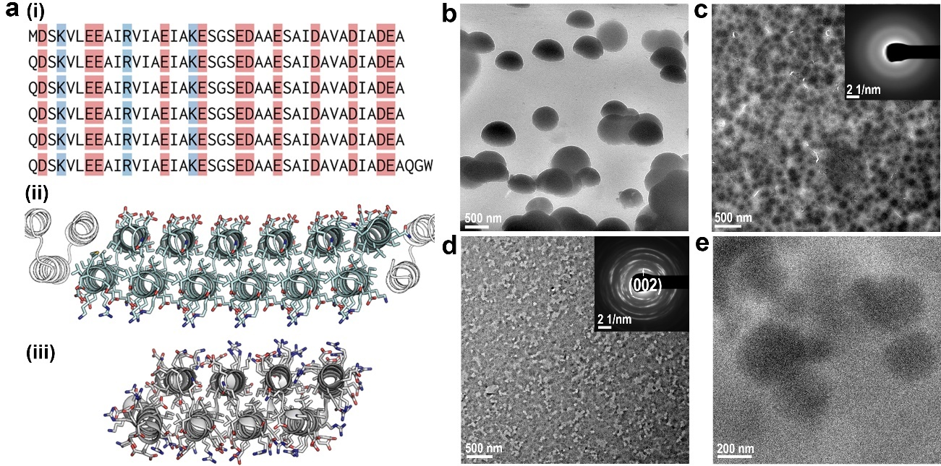
Extended Data Fig. 1. The designed protein structure and TEM images of initial formed particles. (a) Sequence and structure of aspartate rich, non-capped (NC), designed helical repeat (DHR) protein DHR49NC-Asp: (i) Full length (243 amino acids) sequence of DHR49NC-Asp displayed with negative (red) and positive (blue) residues. It has a total of 72 negative sidechains containing carboxylic acid groups and 18 positive sidechains containing amino or guanidino groups and a theorectical isoelectric point (pI) of 3.7. (iii) Alpha-fold¹² predicted structure of DHR49NC-Asp. Each protein is composed of six tandem repeats of a 40 amino-acid helix-turn-helix motif. All of aspartatic acid residues are localized to the upper side of the protein. Helices shown as outlines are from other copies of the protein assembled through head-to-tail interfaces. (iii) Structure of the scaffold protein DHR49 (PDB id: 5CWJ)¹³ which was modified to create DHR49NC-Asp. (b) The obvious wetting behavior of droplets when contacted with hydrophilic carbon film. (c) Contineous amorphous film. (d) Contineous vaterite film. (e) Cryo-TEM image showing the foramtion of amorphous DLP droplets with low contrast and round morphology, which are similar to previous observed condensed liquid phase¹⁴.
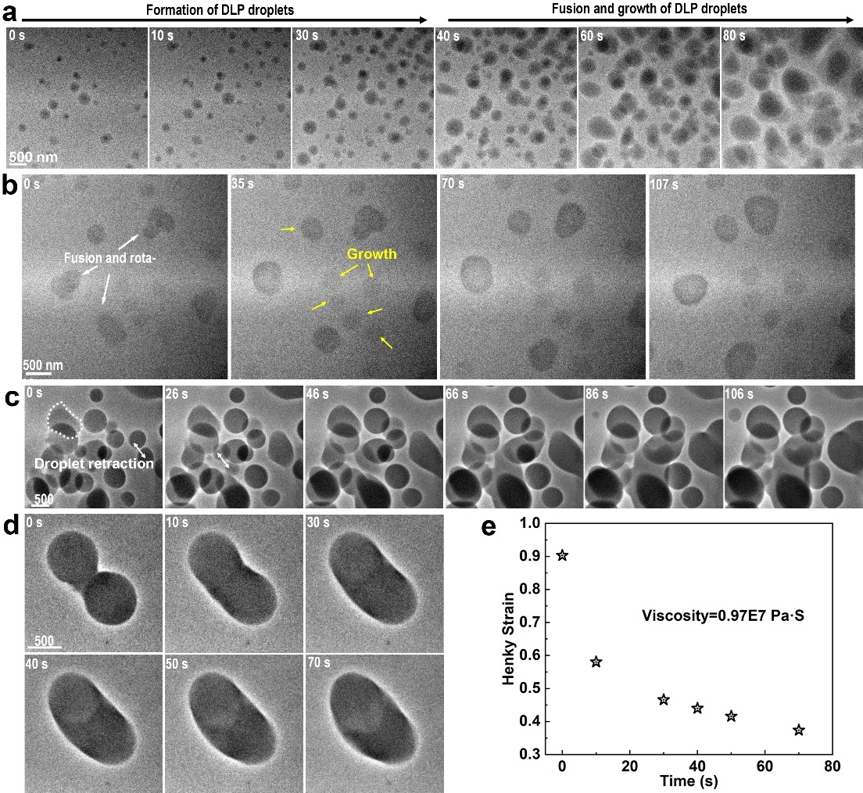
Extended Data Fig. 2. LP-TEM shows the dynamical behavior of DLP droplets in solution. (a) The formation and fusion of DLP droplets. (b) The direct growth, fusion and rotation of multiple DLP droplets. (c) Time-dependent TEM images showing the fusion process of DLP droplets. The retraction process of a fused droplet marked by dot lines was used to calculate the DLP viscosity which is indicated by Figure 1e in main text. The fusion of multiple droplets were highlighted by arrows. (d-e) One more case for calculating DLP viscosity.

Extended Data Fig. 3. ¹³C NMR chemical shift analysis. δ(¹³C) as a function of (a) fraction of CO₃²⁻ and (b) solution pH, estimated based on δ(¹³C) of pure HCO₃⁻ at pH 7.0 (161.10 ppm) and pure CO₃²⁻ at pH 14.0 (169.18 ppm), as well as the equilibrium constant of HCO₃⁻ CO₃²⁻ + H⁺ (1.60 × 10⁻¹¹). (c) Measured pH changes and (d) calculated δ(¹³C) based on the measured pH values over time after mixing 100 mM NaHCO₃ and 100 mM CaCl₂. (e) Time dependent ¹³C NMR spectra after mixing 100 mM NaHCO₃ (pH 8.7) and 100 mM CaCl₂ (pH 6.9), same as Fig. 2a but the broader range showing that no liquid-phase CO₃²⁻ (including DLP of CO₃²⁻) is detected during the reaction. (f) The first ¹³C NMR spectra (~1 min) after mixing (I) 100 mM NaHCO₃ (pH 8.7) and 150 mM NaCl (pH 6.9), (II) 100 mM NaHCO₃ (pH 8.7) and 100 mM CaCl₂ (pH 6.9) (III) 100 mM NaHCO₃ with 0.8 μM DHR49NC-Asp (pH 8.7) and 100 mM CaCl₂ (pH 6.9), (IV) 100 mM NaHCO₃ with 5 μg/ml 1.8 kDa PAA (pH 8.7) and 100 mM CaCl₂ (pH 6.9). (g-h) Line fitting of ¹³C resonances of HCO₃⁻ within DLP (g) and dissolved CO₂ (h) at 30 minutes after mixing 100 mM NaHCO₃ and 100 mM CaCl₂.

Extended Data Fig. 4. The effects of additives on CaCO₃ formation process. (a) Time dependent ¹³C NMR spectra after mixing 100 mM NaHCO₃ with 0.8 μM DHR49NC-Asp (pH 8.7) and 100 mM CaCl₂ (pH 6.9). (b-d) Time dependent ¹³C NMR spectra (b) and the changes of HCO₃⁻ (c) and CO₂ concentration (d) within 250 min after mixing 100 mM NaHCO₃ with 5.0 μg/mL 1.8 kDa PAA (pH 8.7) and 100 mM CaCl₂ (pH 6.9). (e) Time dependent ¹³C NMR spectra and the changes of HCO₃⁻ and CO₂ concentration within 250 min after mixing 100 mM NaHCO₃ with 50 μg/mL 1.8 kDa PAA (pH 8.7) and 100 mM CaCl₂ (pH 6.9). (f) Time-dependent ATR-FTIR analysis using 50 mM NaHCO₃ and CaCl₂ as precursors with H₂O as background. Therotically bending peak of H₂O at 1640 cm⁻¹ is sharp and symmetric, whereas the peak in our case is very broad, implying that it may be caused by the combination of accumulated HCO₃⁻ and H₂O at ATR diamond crystal-solution interface. (g) Time-dependent ATR-FTIR analysis showing the formation process of CaCO₃ with DHR49NC-Asp protein using 50 mM NaHCO₃ and CaCl₂ as precursors with H₂O as background. The broad beak at 1400-1500 cm⁻¹ shows the amorphous particles formation. The positive intensity at ~1640 cm⁻¹ means that amorphous particles contain a lot of H₂O, dictating the formation of DLP. (h) TEM image shows the ACC particles at 25 min in the presence of DHR49NC-Asp protein. (i) ⁴³Ca NMR spectra of CaCl₂ (50 mM) and the mixed solutions of NaHCO₃ and CaCl₂ in the absence and presence of PAA. Because the experimental time was 15 hr for each spectrum, we could not detect the change in ⁴³Ca with time. During the 15 hr of measurements, the smaller ⁴³Ca signal of the solution of CaCl₂ and NaHCO₃ with no additives is caused by the precipitation of CaCO₃, the remaining 20 – 30% signal is consistent with the solubility of Ca(HCO₃)₂ (~10 mM). (I) 50 mM CaCl₂ (pH 6.9). (II) 100 mM NaHCO₃ (pH 8.7) and 100 mM CaCl₂ (pH 6.9). (III) 100 mM NaHCO₃ with 50 μg/ml 1.8 kDa PAA (pH 8.7) and 100 mM CaCl₂ (pH 6.9).

Extended Data Fig. 5. The pH effects on CaCO₃ formation process. (a-c) Time dependent ¹³C NMR spectra (a) and the concentration evolution of HCO₃⁻ and CO₂ species (b) and H₂O ¹H spin-spin relaxation T₂ over time (c) after mixing 100 mM NaHCO₃ (pH 11.2) and 100 mM CaCl₂ (pH 6.9). (d-e) Time dependent ¹³C NMR spectra (d) and the concentration evolution of HCO₃⁻ and CO₂ species (e) after mixing 100 mM NaHCO₃ with 0.8 μM DHR49NC-Asp (pH 10.8) and 100 mM CaCl₂ (pH 6.9). (f-i) In-situ solid-state MAS ¹³C spectra of the mixture 100 mM NaHCO₃ at pH 9.0 and 100 mM CaCl₂ at pH 6.9 collected after mixing for varying times (f-g) and of the mixture 100 mM NaHCO₃ at pH 10.8 and 100 mM CaCl₂ at pH 6.9 (h-i). Line fitting of the CaCO₃ resonances reveals a well-crystalized species with sharp peak at the lower pH (right column in g) and two ACC species with broad peaks at the higher pH (right column in i). The measurements were performed at a spinning speed of 3550 Hz, with spinning side bands of CaCO₃ resonances marked with asterisks in (g) and (i). Experimental time was 0.5 hr for each spectrum in (f) and (h), and 18 hr in (g) and (i).

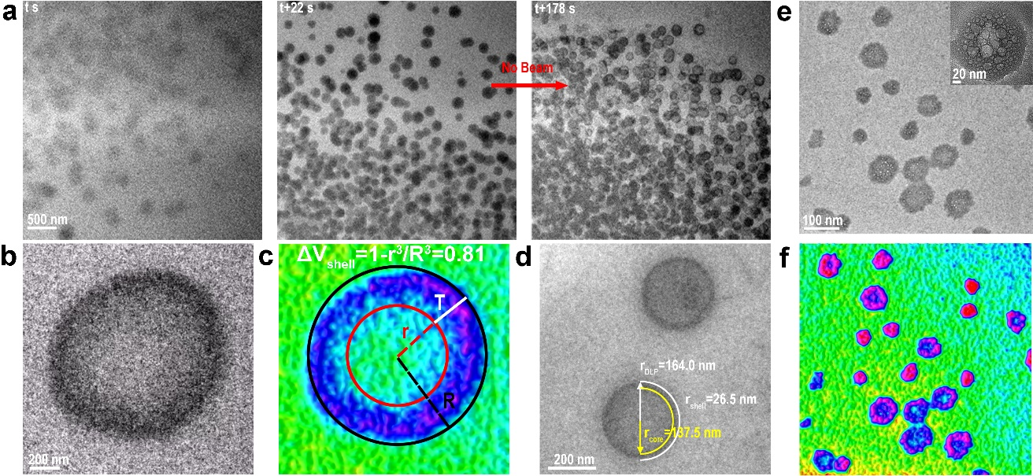
Extended Data Fig. 6. Hollow structures. (a) Time-dependent TEM images shows the formation of DLP in the liquid cell, following by the evolution into hollow structure where beam is blank. During this experiment, the electron beam was blocked by blanking the beam, and the electron beam was only applied while searching the area of interest, adjusting the focus and acquiring images. The estimation of shell volume percentage. (b) A representative TEM image shows an individual hollow particle. (c) Schematic illustration for the calculations of shell volume percentage. (d) The measurements illustration of DLP radius and shell thickness, revealing the relative volume of DLP to shell of 2.4. Ex situ TEM (e) and false-colored images (f) show the hollow ACC solids.

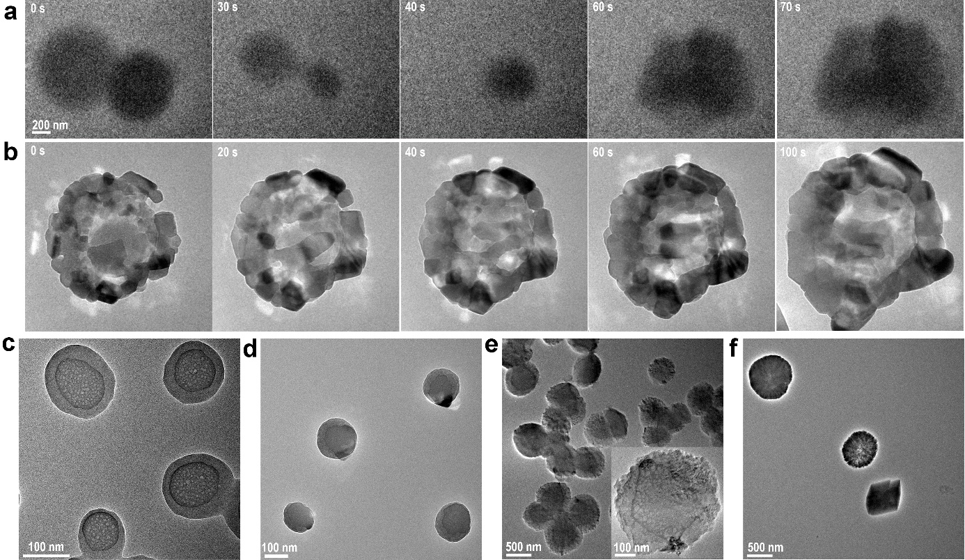
Extended Data Fig. 7. The phase transformation of amorphous phase or DLP into crystals. (a) The dissolution of amorphous particles, followed by the recrystallization into calcite in solution. (b) The dissolution of amorphous particles, leading to the growth of crystals at the interface of amorphous and crystalline particles. (c) Core-shell like amorphous particles. (d) Some crystals with higher contrasts were observed on the surface. (e) Vaterite crystals containing liquid-like core. (f) The resulted vaterite and calcite.

Extended Data Fig. 8. A schematic for the workflow for our reduced model for DLP structure and diffusion constants extraction. (a) The potential of mean-force (PMF) between ions as done in Henzler et al. with the Coulomb term subtracted out. The PMF is sampled at lattice points (a=3.1Å) as shown by the points. (b) This is used as input for u_{SR} the frustrated charge Ising model (FCI)¹⁵. The long-range contribution is the Coulomb interaction modulated by the dielectric constant. (c) The FCI is used to generate ensembles of charges interacting on a lattice with the mean-field water (through the PMF) at the experimental number density. Ca²⁺ is depicte by cyan sphere, HCO₃⁻ (and/or CO₃²⁻ ) is denoted by red sphere. Ensembles are then with molecules with random orientations (here HCO₃⁻ and Ca²⁺). (d) Water is added and the simulations are converged with standard all-atom force fields¹⁶. (e) The computed the PMF between Ca--HCO₃ as shown in ref ¹⁷. Beyond 6 Å we utilize a Coulombic term. (f) Mean square deviation of solution species as a function of time in molecular dynamics simulation of bulk DLP models ((CaHCO₃)₂∙7H₂O)). The calculated diffusion coefficient of H₂O is smaller than that of HCO₃⁻. The offsets denote local/rotational/vibrational degrees of freedom which are substantially larger for water than for bicarbonate. (g) Mean square deviation of solution species as a function of time in molecular dynamics simulation of bulk DLP models with different hydration levels raging from 4 to 12 H₂O per ion pair. (h) AIMD calculations during numerical titration experiments. CO₃²⁻ free energy as a function of net charge state, W(q), determined by sampling AIMD simulations of an ion in bulk water at three notional pH values, ranging from “acidic” (black) to “neutral” (red) to “basic” (green). The global minimum in the W(q) curves represents predicted stable charge states. Certain intermediate titration experiments show multiple local minima, thus predicting mixed populations of accessible charge states.

Extended data Table S1. The length change during fused droplet retraction process in Fig S2c and calculated Henky strain
Time (s) | L₁ long Axis (nm) | L₂ Short Axis (nm) | H (Henky Strain)
0 | 961 | 642 | 0.2689241
26 | 959 | 693 | 0.2165741
46 | 982 | 757 | 0.1734854
66 | 968 | 795 | 0.13126
86 | 990 | 812 | 0.1321364
106 | 960 | 837 | 0.0914061

Extended data Table S2. The fraction of CaCO₃, HCO₃⁻ and CO₂, together with δ(¹³C), linewidth, estimated species of the CaCO₃ resonances obtained from ¹³C spectra.
Mixture of  100 mM CaCl₂ | CaCO₃ (%) | HCO₃⁻ (%) | CO₂  (%) | δ(¹³C) of CaCO₃ (ppm) | Linewidth of CaCO₃ (Hz) | Species
NaHCO₃  (100 mM, pH 8.7) | 34 | 30 | 36 | 168.7 | 21 | calcite
NaHCO₃  (100 mM, pH 10.8) | 70 | 24 | 6 | 169.0, 168.4 | 56, 110 | pv-ACC,  pc-ACC

Movies Captions
Movie S1. LP-TEM showing the formation and growth of DLP droplets in the liquid-cell.
Movie S2. LP-TEM showing the evolution process of DLP droplets into hollow structure.
Movie S3. LP-TEM showing the evolution process of individial hollowstructure into hydrated ACC solids.
Movie S4. LP-TEM showing the transformation of multiple hollower particles into hydrated ACC solids.

References
- Assighaou, S. & Benyahia, L. Universal retraction process of a droplet shape after a large strain jump. Phys. Rev. E. 77, 036305 (2008).
- Rao, A., Huang, Y. C. & Cölfen, H. Additive speciation and phase behavior modulating mineralization. J. Phys. Chem. C 121, 21641-21649 (2017).
- Nebel, H., Neumann, M., Mayer, C. & Epple, M. On the structure of amorphous calcium carbonate—a detailed study by solid-state nmr spectroscopy. Inorg. Chem 47, 7874-7879 (2008).
- Högfeldt, E. & Bigeleisen, J. Acidity constants of some hammett indicators in heavy water. the hammett acidity function, D0, for DCl and D₂SO4 solutions. J. Am. Chem. Soc. 82, 15-20 (1960).
- Abbott, T. M., Buchanan, G. W., Kruus, P. & Lee, K. C. ¹³C nuclear magnetic resonance and Raman investigations of aqueous carbon dioxide systems. Canad. J. Chem. 60, 1000-1006 (1982).
- Huang, Y. C. et al. Uncovering the role of bicarbonate in calcium carbonate formation at near-neutral pH. Angew. Chem. Int. Ed. 60, 16707-16713 (2021).
- Zhao, D. F. et al. Novel method of generation of Ca(HCO₃)₂ and CaCO₃ aerosols and first determination of hygroscopic and cloud condensation nuclei activation properties. Atmos. Chem. Phys. 10, 8601-8616 (2010).
- Wolf, S. E. et al. Strong stabilization of amorphous calcium carbonate emulsion by ovalbumin: gaining insight into the mechanism of ‘polymer-induced liquid precursor’ processes. J. Am. Chem. Soc. 133, 12642-12649 (2011).
- Tommaso, D. D. & de Leeuw, N. H. The Onset of calcium carbonate nucleation: a density functional theory molecular dynamics and hybrid microsolvation/continuum study. J. Phys. Chem. B 112, 6965-6975 (2008).
- Walter, E. D. et al. Operando MAS NMR reaction studies at high temperatures and pressures. J. Phys. Chem. C 122, 8209-8215 (2018).
- Mohanram, H., Georges, T., Pervushin, K., Azaïs, T. & Miserez, A. Self-assembly of a barnacle cement protein (mrcp20) into adhesive nanofibrils with concomitant regulation of CaCO₃ polymorphism. Chem. Mater. 33, 9715-9724 (2021).
- Jumper, J. et al. Highly accurate protein structure prediction with AlphaFold. Nature 596, 583-589 (2021).
- Brunette, T. et al. Exploring the repeat protein universe through computational protein design. Nature 528, 580-584 (2015).
- Smeets, P. J. et al. A classical view on nonclassical nucleation. Proc. Nat. Ac. Sci. 114, E7882-E7890 (2017).
- Ludwig, N. B., Dasbiswas, K., Talapin, D. V. & Vaikuntanathan, S. Describing screening in dense ionic fluids with a charge-frustrated Ising model. J. Chem. Phys. 149, 164505 (2018).
- Raiteri, P., Gale, J. D., Quigley, D. & Rodger, P. M. Derivation of an accurate force-field for simulating the growth of calcium carbonate from aqueous solution: A new model for the calcite−Water interface. J. Phys. Chem. C 114, 5997-6010 (2010).
- Henzler, K. et al. Supersaturated calcium carbonate solutions are classical. Sci. Adv. 4, eaao6283 (2018).

