High Prevalence of Vitamin D deficiency among normotensive and hypertensive pregnant women in Ghana
Linda Ahenkorah Fondjo^{1*} Worlanyo Tashie¹, William K. B. A. Owiredu¹, Enoch Appiah Adu-Gyamfi², Laila Seidu³

¹Department of Molecular Medicine, SMD, KNUST Ghana,²Department of Physiology, University of Cape Coast, Ghana, ³Comboni Hospital, Ho, Volta Region.

*Corresponding Author
linda.ahenkorahfondjo@yahoo.com
Department of Molecular Medicine, KNUST-Ghana
0000-0003-0252-3190

Smoothed percentiles of estimated birth weight (grams) for gestational age
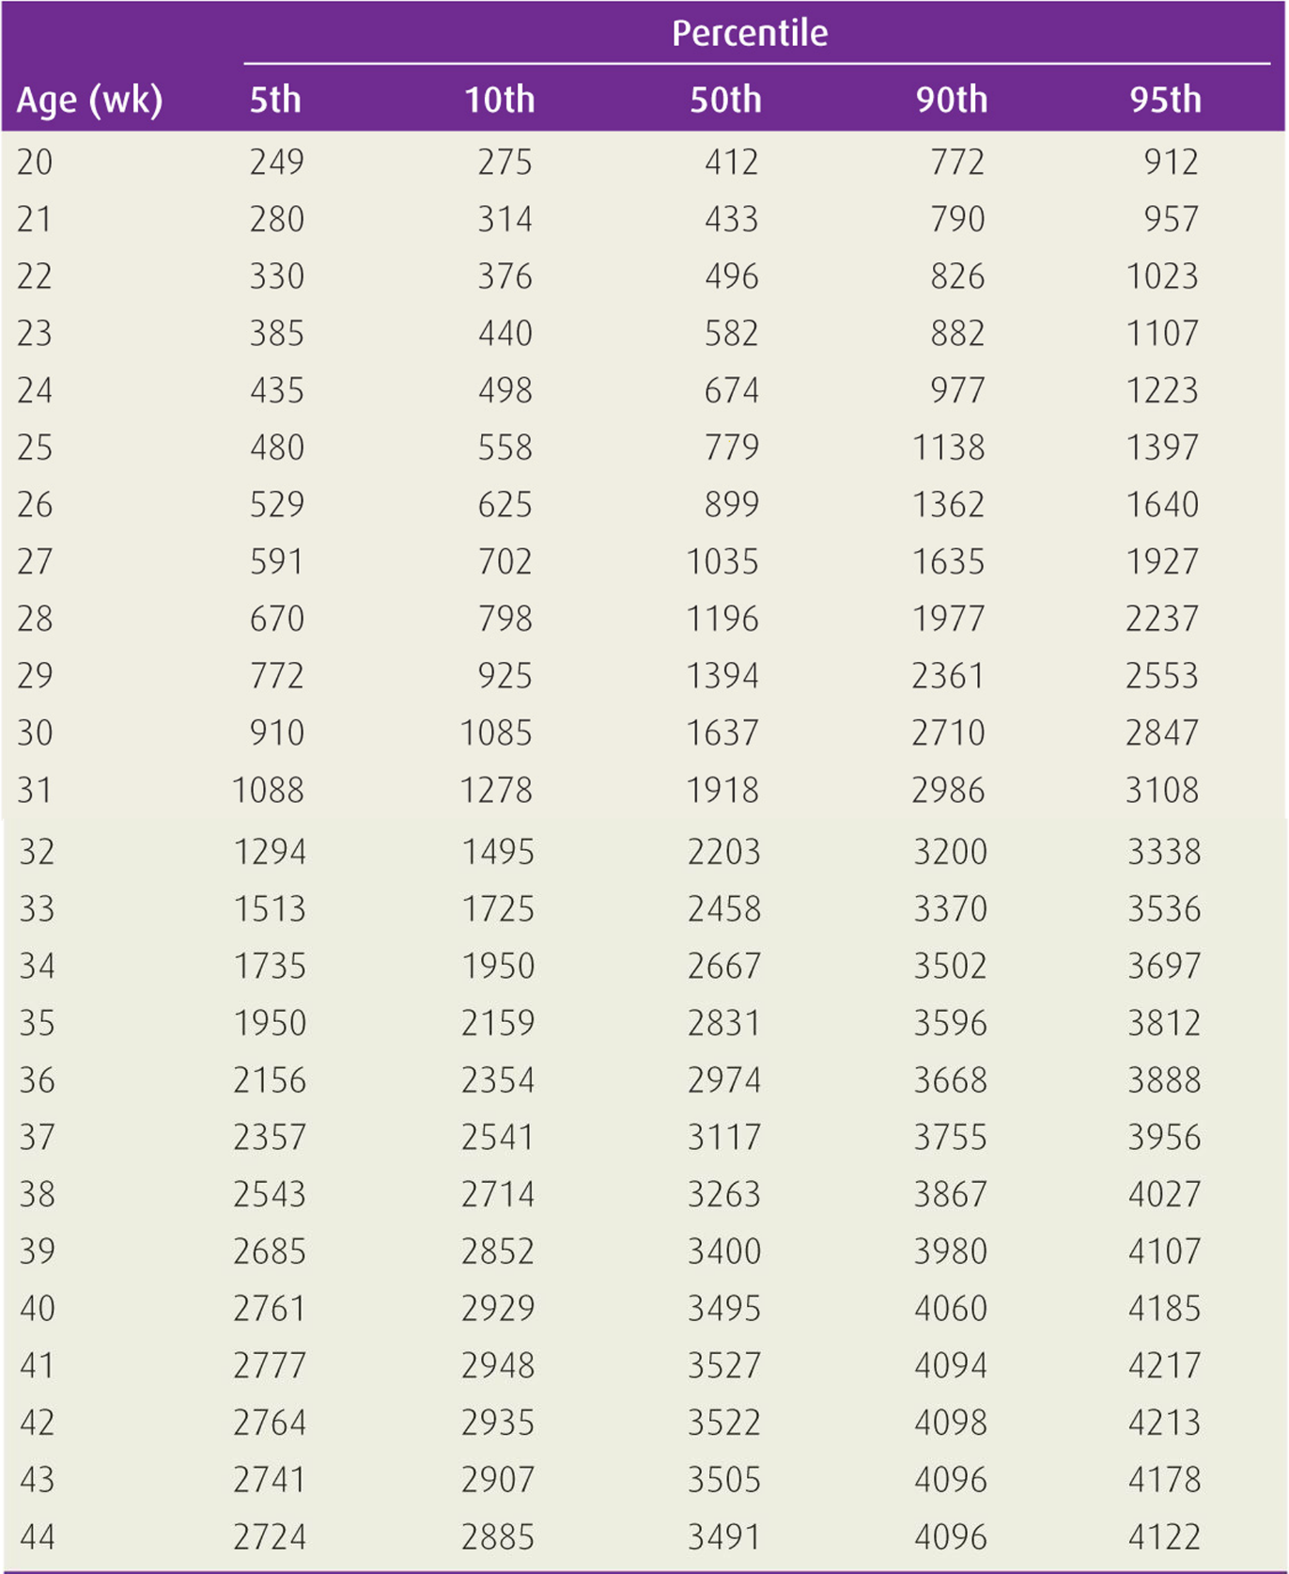
Source: Alexander GR, Himes JH, Kaufman RB, Mor J, Kogan M. A United States national reference for fetal growth. Obstetrics and gynecology. 1996;87(2):163-8 (49).

