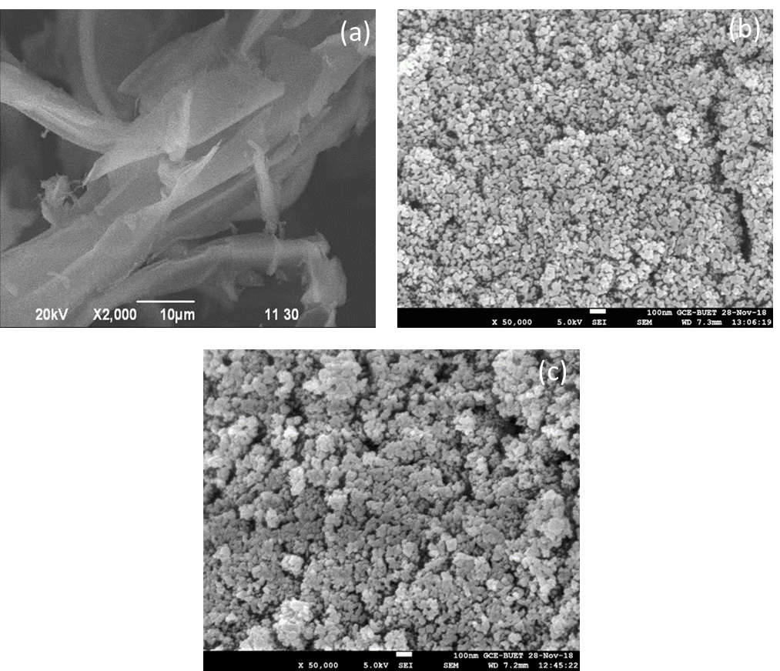

Fig S1. (a, b & c) SEM images of Raw JSP, MB-JSP and AMB-JSP

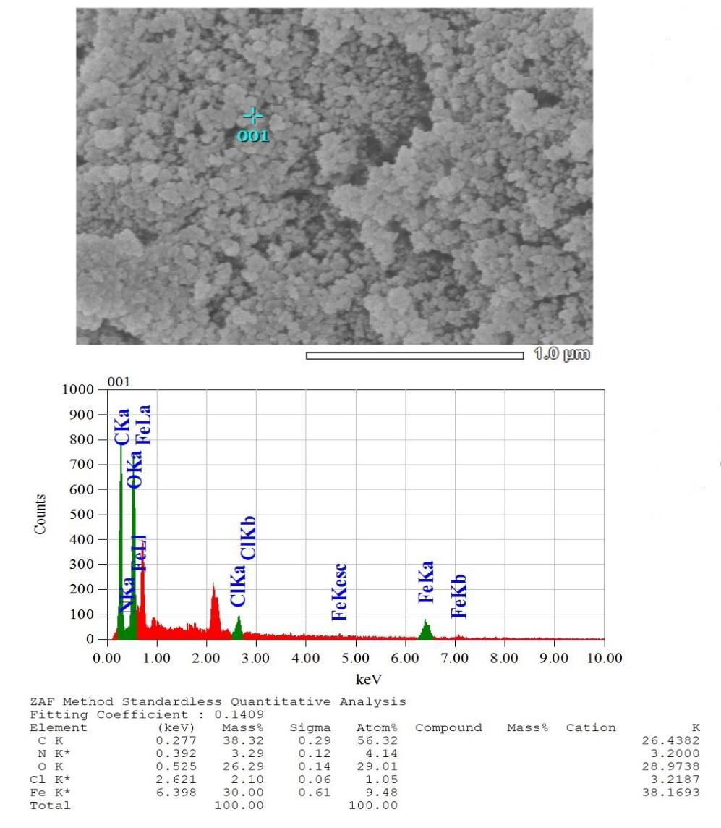

Fig S2. EDX investigation represents the composition of elements present in AMB-JSP

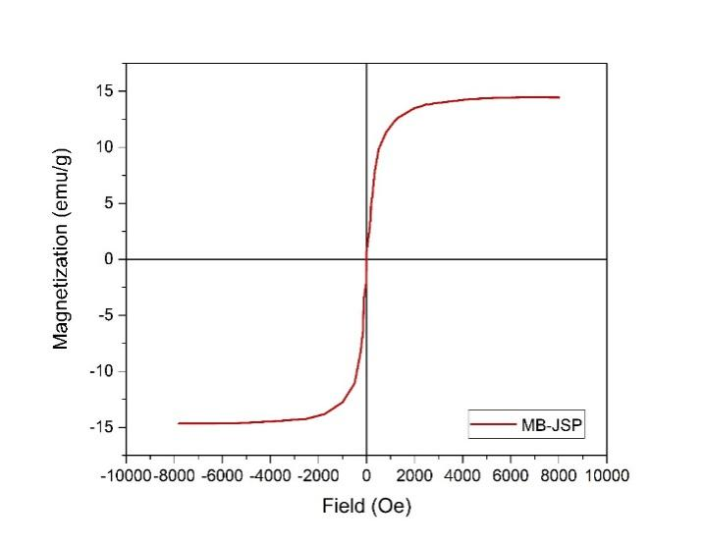
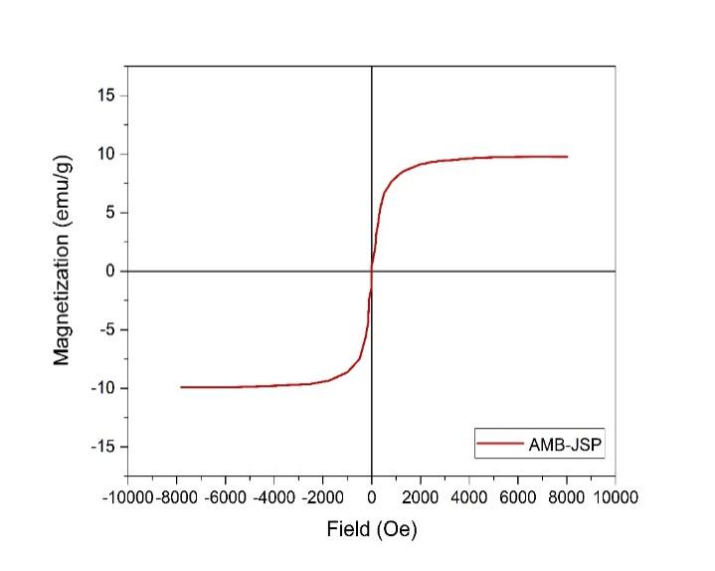

Fig S3. The magnetization curves represent the magnetic characterization of MB-JSP and AMB-JSP

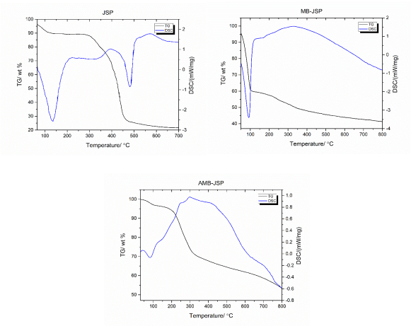
Fig S4. TG and DSC analysis for the thermal stability study of JSP, MB-JSP and AMB-JSP.

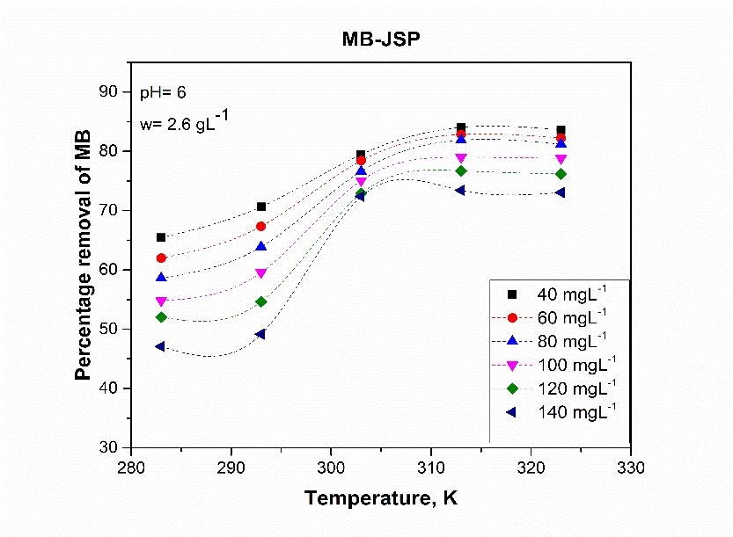
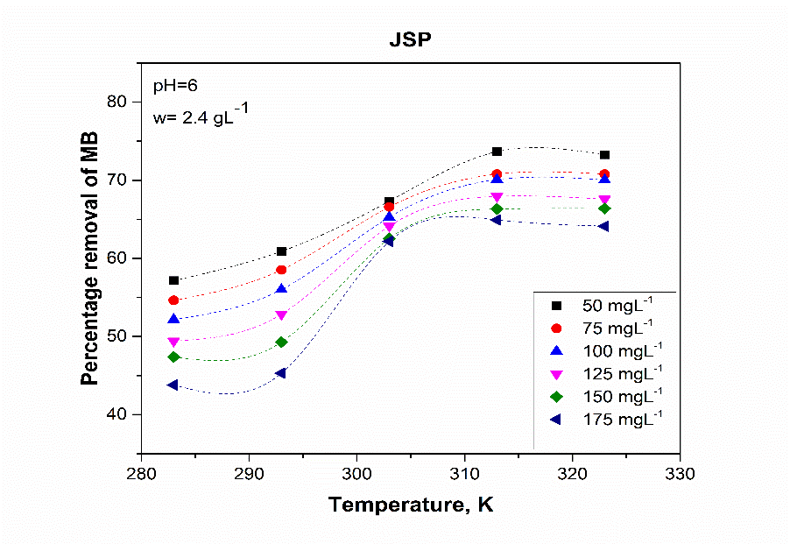
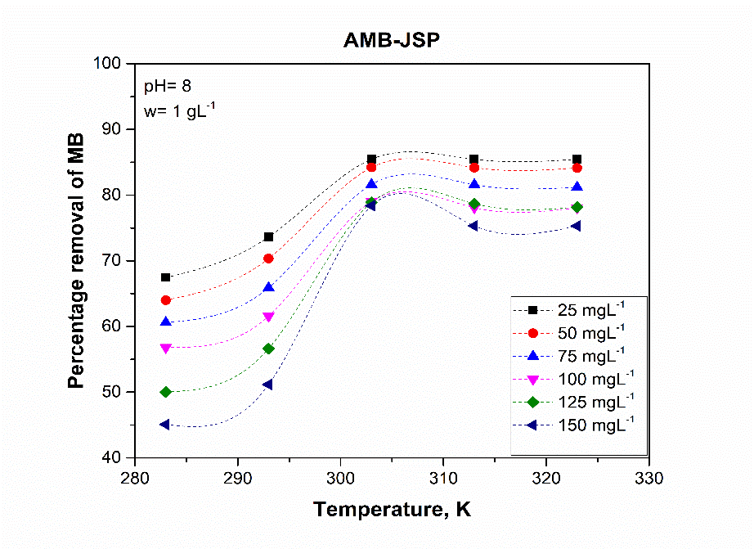

Fig S5. Effect of temperature on the MeB removal by JSP, MB- JSP & AMB-JSP at various initial concentrations.

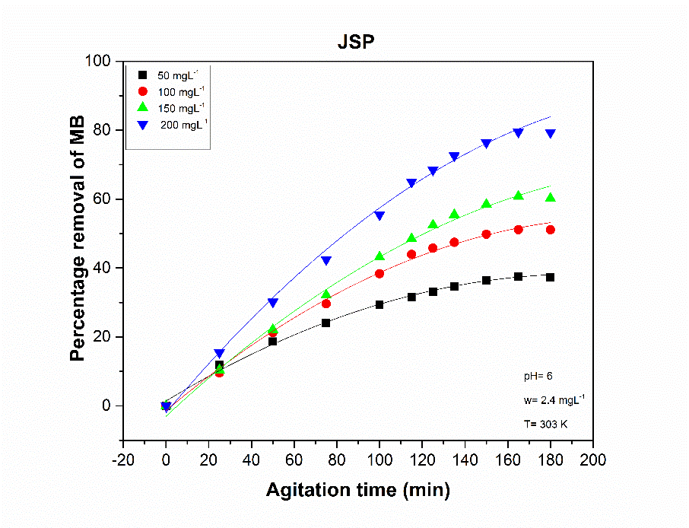
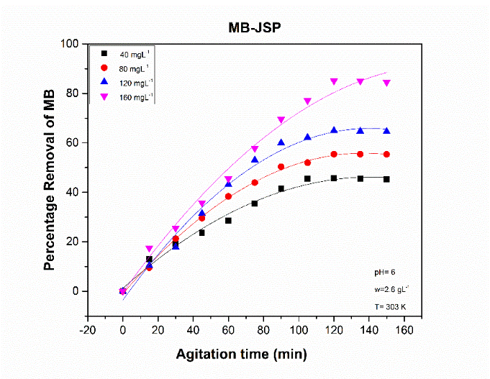
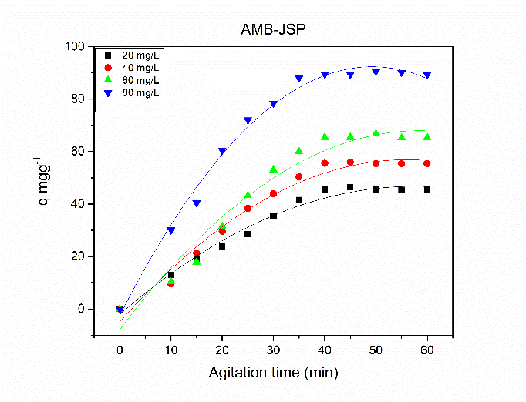

Fig S6. Effect of agitation time onthe MeB removal by JSP, MB-JSP and AMB-JSP at different initial concentration of MeB.

Table 1. Langmuir Adsorption isotherm parameter of JSP, MB-JSP and AMB-JSP
Adsorbents | S. No. | Temperature T, K | Kf (mgg⁻¹) | n | _{R}²
 | 1 | 283 | 13.17771 | 2.700076 | 0.88558
 | 2 | 293 | 14.58075 | 2.596458 | 0.92154
JSP | 3 | 303 | 15.68953 | 1.822124 | 0.93069
 | 4 | 313 | 16.58403 | 1.930726 | 0.94328
 | 5 | 323 | 16.59167 | 1.940655 | 0.94345
 | 1 | 283 | 2.42075 | 1.782754 | 0.979
 | 2 | 293 | 3.414837 | 2.001762 | 0.954
MB-JSP | 3 | 303 | 2.697926 | 1.365617 | 0.995
 | 4 | 313 | 4.283019 | 1.580128 | 0.975
 | 5 | 323 | 4.097321 | 1.559965 | 0.978
 | 1 | 283 | 1.649719 | 1.521398 | 0.98802
 | 2 | 293 | 2.207496 | 1.644493 | 0.97332
AMB-JSP | 3 | 303 | 2.207496 | 1.208547 | 0.99792
 | 4 | 313 | 2.207496 | 1.356631 | 0.99769
 | 5 | 323 | 2.207496 | 1.364108 | 0.99562

Table 2. Freundlich isotherms and its coefficients for JSP, MB-JSP and AMB-JSP
Adsorbents | S. No. | Temperature T, K | qmax(mgg⁻¹) | b (Lg⁻¹) | R_{L} | _{R}2
 | 1 | 283 | 61.38 | 0.011367 | <1 | 0.99380
 | 2 | 293 | 56.24 | 0.015572 | <1 | 0.99024
JSP | 3 | 303 | 157.23 | 0.006019 | <1 | 0.98286
 | 4 | 313 | 113.12 | 0.011526 | <1 | 0.98162
 | 5 | 323 | 109.40 | 0.011919 | <1 | 0.98893
 | 1 | 283 | 79.73 | 0.02491 | <1 | 0.99501
 | 2 | 293 | 137.12 | 0.037334 | <1 | 0.99427
MB-JSP | 3 | 303 | 169.45 | 0.019245 | <1 | 0.98407
 | 4 | 313 | 127.88 | 0.038377 | <1 | 0.99253
 | 5 | 323 | 68.87 | 0.036175 | <1 | 0.99369
 | 1 | 283 | 84.39 | 0.045647 | <1 | 0.95562
 | 2 | 293 | 96.15 | 0.049214 | <1 | 0.95678
AMB-JSP | 3 | 303 | 181.49 | 0.044514 | <1 | 0.76301
 | 4 | 313 | 164.74 | 0.050638 | <1 | 0.85304
 | 5 | 323 | 164.20 | 0.050256 | <1 | 0.85053

Table 3. Temkin isotherms and its coefficients for JSP, MB-JSP and AMB-JSP
Adsorbents | S. No. | Temperature T, K | b_{T} | A_{T} (Lmg⁻¹) | _{R}2
 | 1 | 283 | 249.1214 | 0.206115 | 0.99482
 | 2 | 293 | 271.756 | 0.295937 | 0.98925
JSP | 3 | 303 | 149.4322 | 0.233192 | 0.97977
 | 4 | 313 | 170.0839 | 0.354029 | 0.99773
 | 5 | 323 | 174.3911 | 0.338278 | 0.9974
 | 1 | 283 | 174.2742 | 0.108161888 | 0.9945
 | 2 | 293 | 185.1554 | 0.133273575 | 0.99715
MB-JSP | 3 | 303 | 114.5602 | 0.107033226 | 0.97564
 | 4 | 313 | 124.7856 | 0.143685337 | 0.97581
 | 5 | 323 | 130.0719 | 0.143760966 | 0.98222
 | 1 | 283 | 136.9227 | 0.563073 | 0.88378
 | 2 | 293 | 124.151 | 0.597276 | 0.90144
AMB-JSP | 3 | 303 | 69.77135 | 0.536915 | 0.83951
 | 4 | 313 | 77.12284 | 0.581616 | 0.87261
 | 5 | 323 | 80.16604 | 0.582571 | 0.87037

Table 4. Parameters of different kinetic models for the adsorption of MeB by JSP
 | JSP
Kinetic models | C₀ (mgL⁻¹) | R² | k₁(min⁻¹⁾ | q_{e},cal (mgg⁻¹) | q_{e},exp  (mgg⁻¹)
Pseudo first order | 50 | 0.918 | 0.0543 | 403.422 | 7.845
Pseudo first order | 100 | 0.677 | 0.0437 | 189.994 | 21.301
Pseudo first order | 150 | 0.887 | 0.0275 | 112.520 | 37.993
Pseudo first order | 200 | 0.744 | 0.0349 | 339.406 | 66.213
 | C₀ (mgL⁻¹) | R² | K₂ (min⁻¹⁾ | q_{e},cal (mgg⁻¹) | q_{e},exp  ( mgg⁻¹)
Pseudo second order | 50 | 0.987 | 0.000691794 | 12.943 | 7.8
Pseudo second order | 100 | 0.681 | 0.0000402 | 69.348 | 21.301
Pseudo second order | 150 | 0.506 | 0.0000085 | 186.915 | 37.993
Pseudo second order | 200 | 0.806 | 0.0000104 | 233.644 | 66.213
 | C₀ (mgL⁻¹) | R² | k_{id}  (mgg⁻¹min⁻¹) | Constant, C(mgg⁻¹) | …..
Intraparticle diffusion model | 50 | 0.92468 | 0.08344 | 1.32336 | ….
Intraparticle diffusion model | 100 | 0.94488 | 0.24917 | 2.01221 | ….
Intraparticle diffusion model | 150 | 0.9646 | 0.44864 | 2.36529 | ….
Intraparticle diffusion model | 200 | 0.96558 | 0.7749 | 4.84943

Table 5. Parameters of different kinetic models for the adsorption of MeB by MB-JSP
 | MB-JSP
Kinetic models | C₀ (mgL⁻¹) | R² | k₁(min⁻¹⁾ | q_{e},cal (mgg⁻¹) | q_{e},exp
Pseudo first order | 40 | 0.559 | 0.076091 | 423.262 | 9.513
Pseudo first order | 80 | 0.853 | 0.05246 | 108.051 | 23.112
Pseudo first order | 120 | 0.942 | 0.042190 | 116.460 | 40.597
Pseudo first order | 160 | 0.711 | 0.047695 | 328.405 | 70.916
 | C₀ ( mgL⁻¹) | R² | k₂(min⁻¹⁾ | q_{e},cal (mgg⁻¹) | q_{e},exp
Pseudo Second order | 40 | 0.93385 | 0.00079 | 15.408 | 9.513
Pseudo Second order | 80 | 0.86504 | 0.00016 | 46.707 | 23.112
Pseudo Second order | 120 | 0.58965 | 0.000040 | 111.856 | 40.597
 | 160 | 0.81213 | 0.000030 | 171.232 | 70.916
 | C₀ ( mgL⁻¹) | R² | k_{id} ( mgg⁻¹min⁻¹) | Constant, C(mgg⁻¹) | …..
Intraparticle diffusion model | 40 | 0.890 | 0.10824 | 2.68936 | ……
Intraparticle diffusion model | 80 | 0.867 | 0.27886 | 5.63794 | ……
Intraparticle diffusion model | 120 | 0.852 | 0.52875 | 7.69819 | ……
 | 160 | 0.943 | 0.92451 | 10.49791 | …….

Table 6. Parameters of different kinetic models for the adsorption of MeB by AMB-JSP
Kinetic models | AMB-JSP
 | C₀ (mgL⁻¹) | R² | k₁(min⁻¹⁾ | q_{e},cal (mgg⁻¹) | q_{e},exp
Pseudo first order | 50 | 0.80645 | 0.1702 | 2839.618 | 19.356
Pseudo first order | 100 | 0.8631 | 0.1068 | 143.021 | 46.666
Pseudo first order | 150 | 0.82911 | 0.1191 | 332.659 | 82.433
Pseudo first order | 200 | 0.59157 | 0.1383 | 558.920 | 150.76
 | C₀ (mgL⁻¹) | R² | k₂(min⁻¹⁾ | q_{e},cal (mgg⁻¹) | q_{e},exp
Pseudo Second order | 50 | 0.79032 | 0.000387 | 42.211 | 19.356
Pseudo Second order | 100 | 0.09882 | 0.000032 | 195.694 | 46.666
Pseudo Second order | 150 | 0.10324 | 0.000621 | 1695.584 | 82.433
Pseudo Second order | 200 | 0.87061 | 0.000125 | 248.756 | 150.76
 | C₀ (mgL⁻¹) | R² | k_{id} (mgg⁻¹min⁻¹) | Constant, C(mgg⁻¹) | …..
Intraparticle diffusion model | 50 | 0.84483 | 0.57451 | 4.70973 | ……
Intraparticle diffusion model | 100 | 0.81046 | 1.48666 | 9.66638 | ……
Intraparticle diffusion model | 150 | 0.80639 | 2.84481 | 11.99772 | …..
Intraparticle diffusion model | 200 | 0.7438 | 3.83316 | 57.08151 | ……

