Table 1

Illustration of a representative cotyledon /seedling | Visual rating description
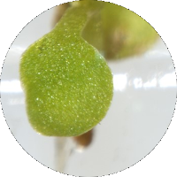 | Rating = 0  No mycelium colonization nor necrosis on seedlings  No impact on seedling development, four-leaf stage seedlings in general
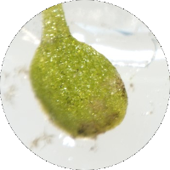 | Rating = 1  Minimal mycelium colonization and necrosis on seedlings ( < 25% of surface area)  No impact on seedling development, four-leaf stage seedlings in general
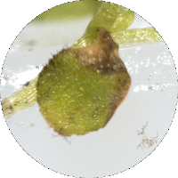 | Rating = 2  Mycelium colonization and necrosis on seedlings  (25% < necrosis < 50% of surface area)  Small impact on seedling development, smaller four-leaf stage seedlings in general
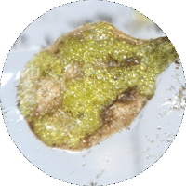 | Rating = 3  Important mycelium colonization and necrosis on seedlings  (50% < necrosis < 75% of surface area)  Impact on seedling development, two-leaf stage seedlings in general
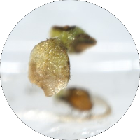 | Rating = 4  Almost total mycelium colonization and necrosis on seedlings  (75% < necrosis < 99% of surface area)  Important impact on seedling development, cotyledon stage seedlings in general
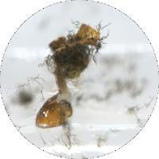 | Rating = 5  Total mycelium colonization and necrosis on seedlings  ( = 100% of surface area)  Dead cotyledon stage seedlings

