World Journal of Microbiology and Biotechnology
Supplementary Information
for

Structural characterization and physicochemical properties of exopolysaccharide from moderate halophile Chromohalobacter salexigens, strain 3EQS1

Ibrahim M. Ibrahim^{a,b}, Yuliya P. Fedonenko^{c}, Elena N. Sigida^{c}, Maxim S. Kokoulin^{d}, Vyacheslav S. Grinev^{b,c}, Ivan G. Mokrushin^{e}, Gennadiy L. Burygin^{c}, Andrey M. Zakharevich^{b}, Aleksander A. Shirokov^{b,c}, Svetlana A. Konnova^{b,c}

ªDepartment of Agricultural Microbiology, Faculty of Agriculture, Fayoum University, Fayoum 63514, Egypt
^{b}Chernyshevsky Saratov State University, 83 Ulitsa Astrakhanskaya, Saratov 410012, Russia
^{c}Institute of Biochemistry and Physiology of Plants and Microorganisms, Russian Academy of Sciences, 13 Prospekt Entuziastov, Saratov 410049, Russia
^{d}G.B. Elyakov Pacific Institute of Bioorganic Chemistry, Far Eastern Branch of Russian Academy of Sciences, Prospekt 100 let Vladivostoku 159, Vladivostok, 690022, Russia
^{e}Perm State University, 15 Bukireva St., Perm 614068, Russia
*Corresponding author. Tel.: +78452970444; fax: +78452970383.
E-mail address: fedonenko_yu@ibppm.ru (Yu.P. Fedonenko)
ORCID ID: 0000-0003-0255-8190

Content

- Figure S1 TGA-MS diagram of the EPS from Chromohalobacter salexigens 3EQS1..........S2
- Figure S2 SEC elution profile of the levan from C. salexigens 3EQS1 and of dextran standards (a). Calibration curve of lg Mp of dextran standards versus elution time (R_{t}).......S3
- Figure S3 ¹H,¹³C HSQC spectrum of the C. salexigens 3EQS1 EPS…………….….……...S4
- Figure S4 CAC determination for the EPS (a); number-weighted diameter distribution of the EPS aggregates in aqueous solution (b)..…………………………………………...……….S5

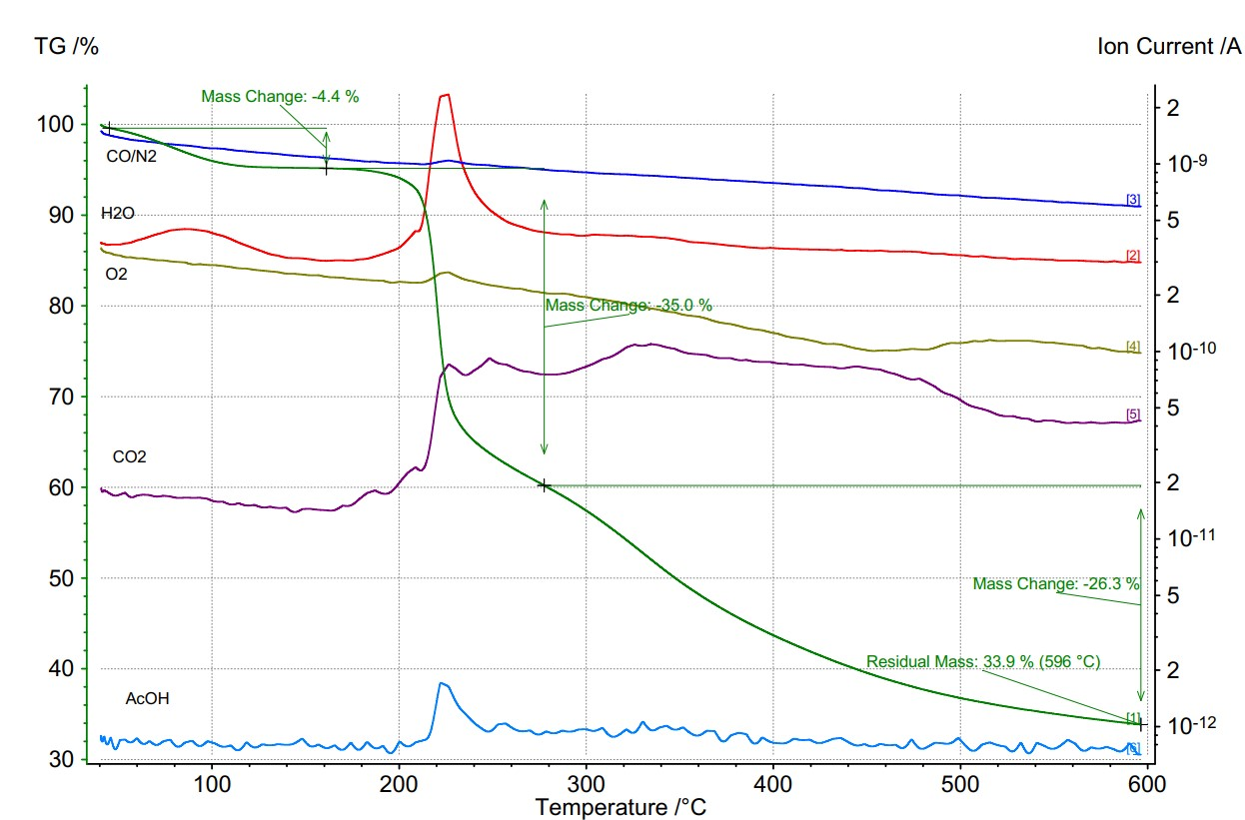

Fig. S1 TGA-MS diagram of EPS from Chromohalobacter sp. strain 3EQS1

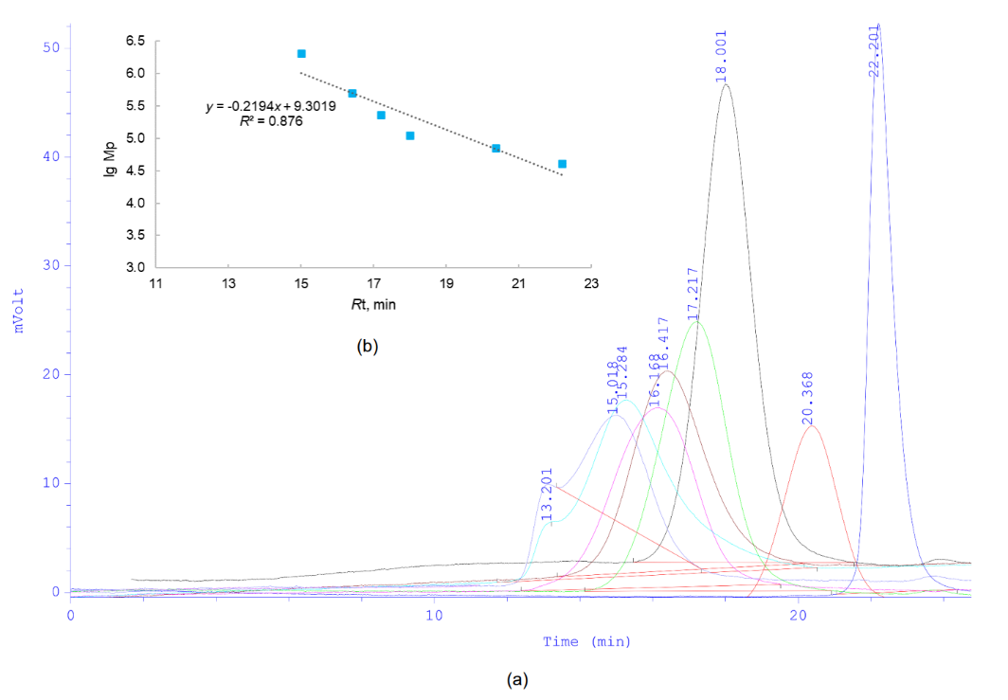

Fig. S2 SEC elution profile of the levan from C. salexigens 3EQS1 (cyan) and of dextran standards (kDa): pale blue 2000; purple 500; brown 229; green 110; black 70; red 40, and blue 20 (a). Calibration curve of lg Mp of dextran standards versus elution time (R_{t}), lg Mp = –0.2194x + 9.3019, correlation coefficient R² = 0.876 (b)

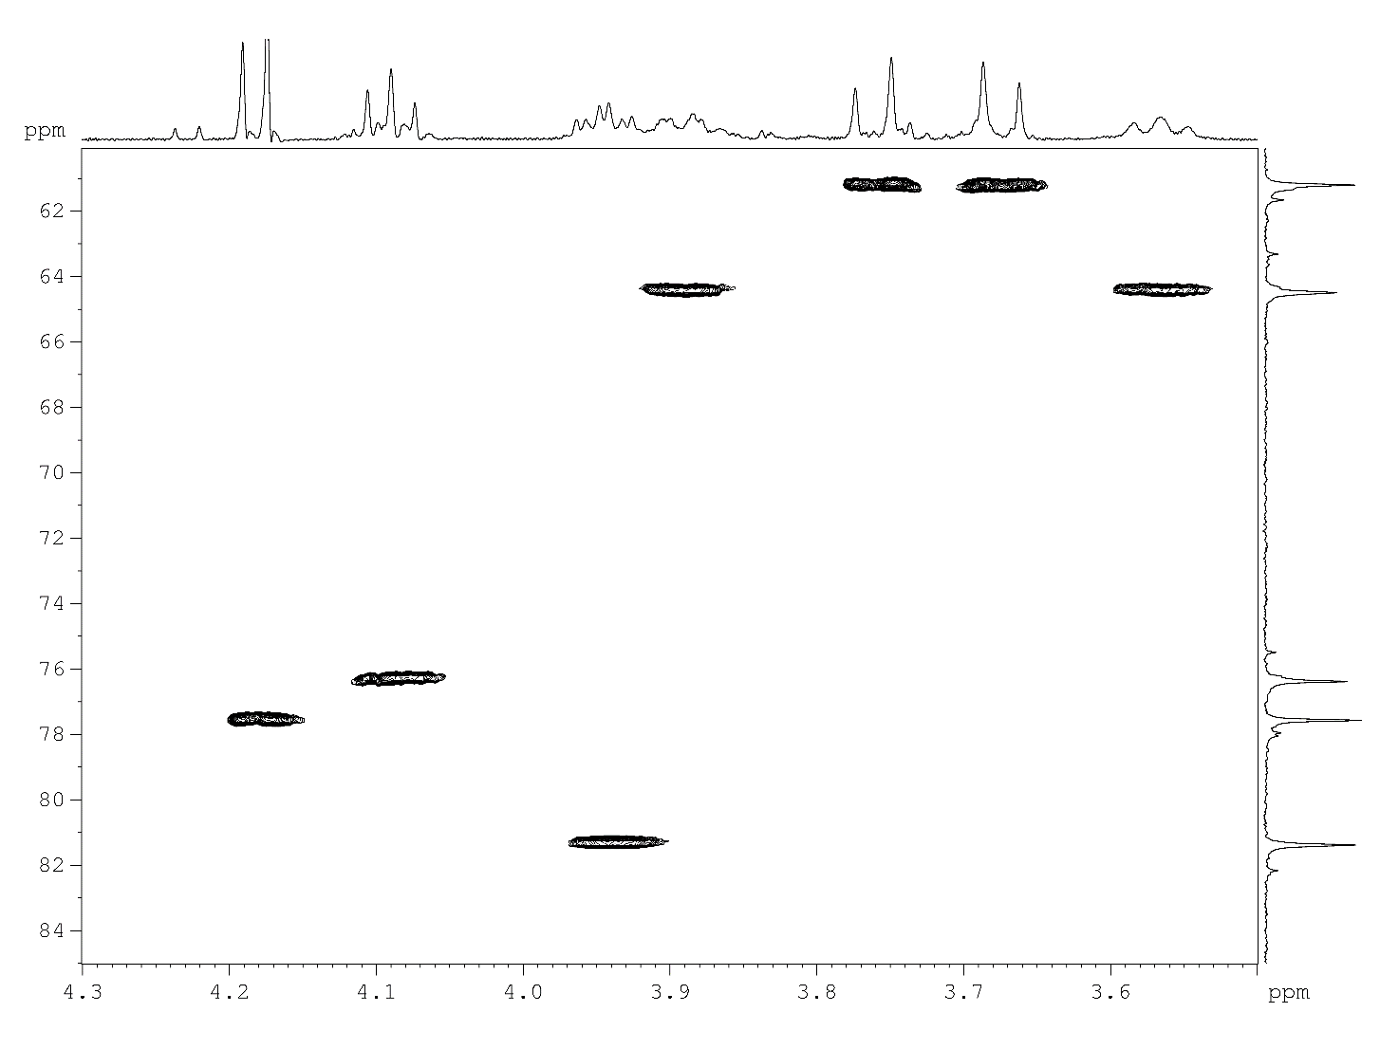
Fig. S3 ¹H,¹³C HSQC spectrum of the C. salexigens 3EQS1 EPS

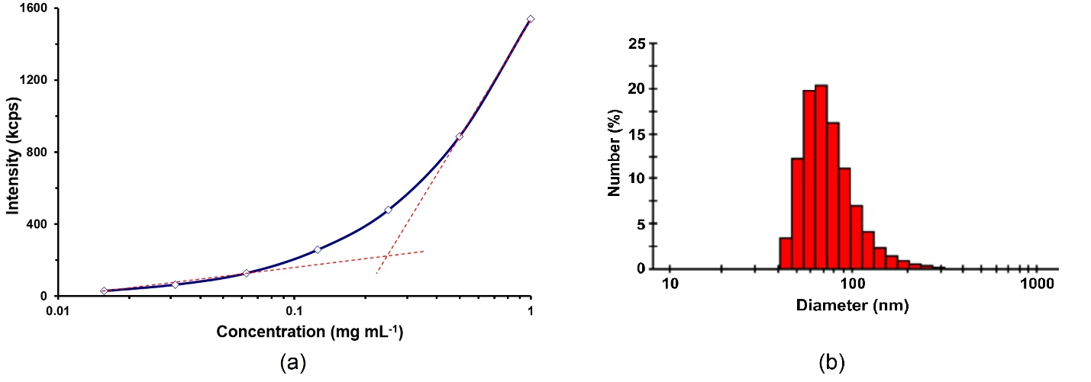
Fig. S4 CAC determination for EPS. The intensity (kcps, kilo counts per second) of light scattering is presented as a function of concentration for EPS at 25 °C in water. The CAC can be found at the intersection point of two slope lines (a). Number-weighted diameter distribution of the EPS aggregates in aqueous solution (1 mg mL⁻¹) at 25 °C (b)

