Appendix 1

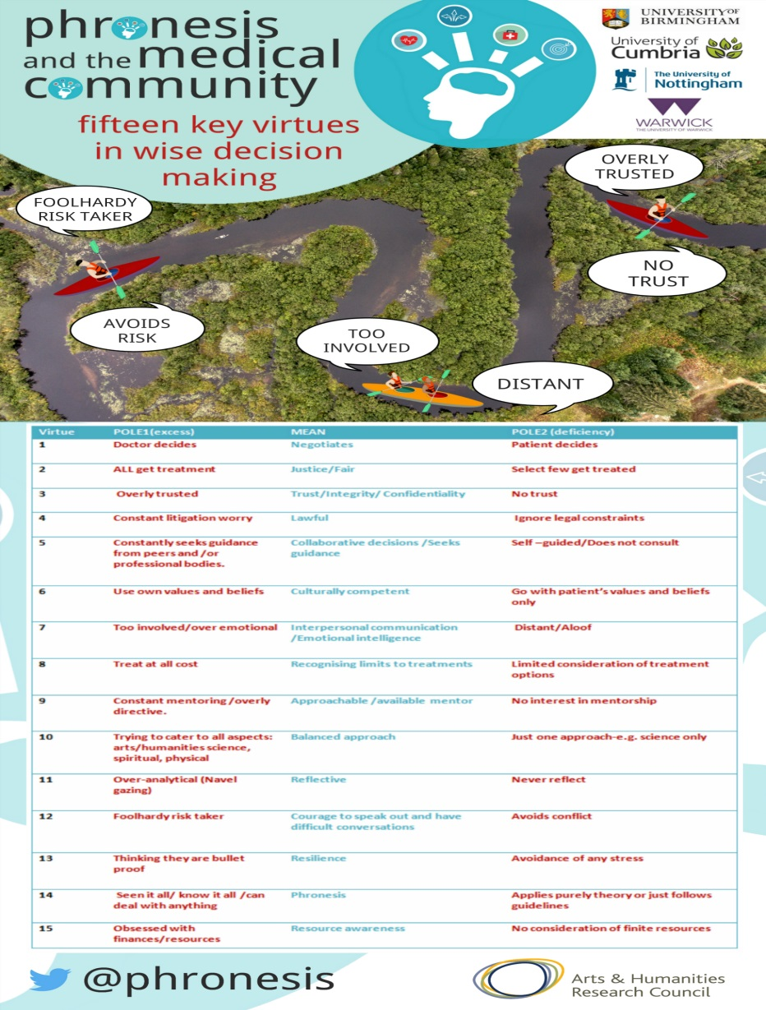

Phronesis and the Medical Community

Evaluation form

- The video was engaging

Episode | Strongly Disagree | Disagree | Neutral | Agree | Strongly Agree
1
2
3
6

- The videos and tutorials enabled debate regarding wise decision making

Strongly Disagree | Disagree | Neutral | Agree | Strongly Agree

- I would recommend this course

Strongly Disagree | Disagree | Neutral | Agree | Strongly Agree

- In what ways could the videos and tutorials be improved ?

- The learning outcomes are realistic

Strongly Disagree | Disagree | Neutral | Agree | Strongly Agree

- I would like to use these materials again

Strongly Disagree | Disagree | Neutral | Agree | Strongly Agree

- Do you have any suggestions as to when, where and for whom these materials might have most impact ?

- Do you have any other comments or suggestions to make ?

- What is your job role?

- I would like to participate in the evaluation of these materials

Yes | No | Maybe ( please clarify )

Name (Added to separate s/s)
Email Address (Added to separate s/s)

