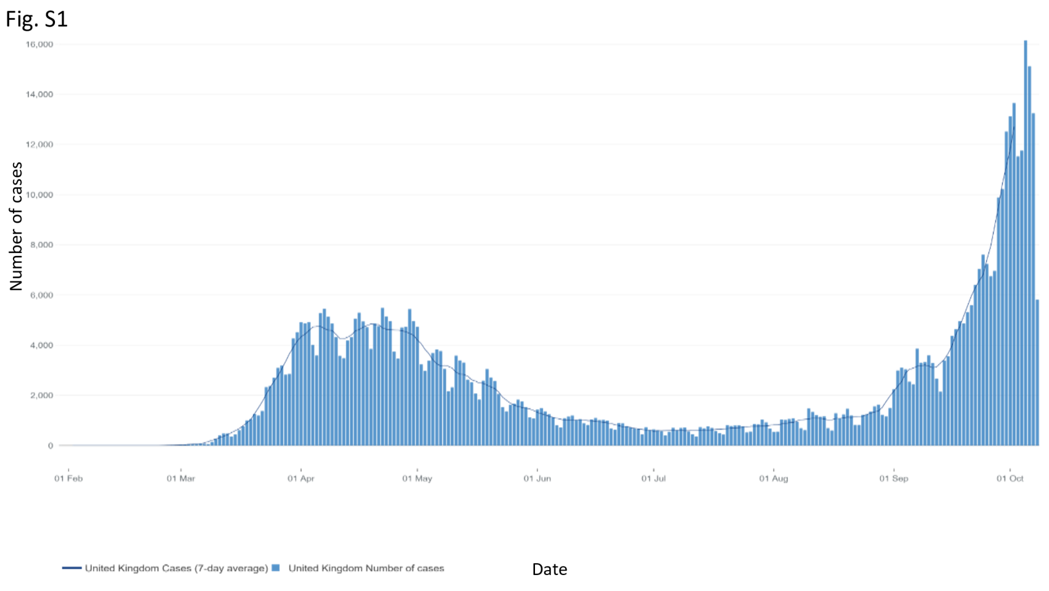

Figure S1: Daily Covid-19 cases and seven day rolling average of cases in the UK

