Supplementary Materials.
Epidemic Diffusion Network of Spain: a mobility model to characterize transmission routes of disease. A COVID-19 case study.

Javier Del-Águila-Mejía ^{1,2,3}, David García-García ^{2,4}, Ayelén Rojas-Benedicto ^{2,4,5} , Nicolás Rosillo ⁶, María Guerrero-Vadillo ² , Marina Peñuelas ² ,Rebeca Ramis ^{2,4} ,Diana Gómez-Barroso ^{2,4} ,Juan de Mata Donado Campos ^{1,4}
- Departamento de Medicina Preventiva y Salud Pública y Microbiología, Facultad de Medicina. Universidad Autónoma de Madrid. C. Arzobispo Morcillo, 4, 28029 Madrid
- Centro Nacional de Epidemiología, Instituto de Salud Carlos IIII. Calle de Melchor Fernández Almagro, 5, 28029. Madrid, Spain.
- Servicio de Medicina Preventiva, Hospital Universitario de Móstoles. Calle Río Júcar, s/n, 28935. Móstoles, Spain
- Consorcio de Investigación Biomédica en Red de Epidemiología y Salud Pública (CIBERESP). Instituto de Salud Carlos III. Calle Monforte de Lemos 3-5. 28029. Madrid, Spain.
- Universidad Nacional de Educación a Distancia (UNED). Calle de Bravo Murillo, 38. 28015. Madrid, Spain.
- Servicio de Medicina Preventiva, Hospital Universitario 12 de Octubre. Avenida de Córdoba, s/n, 28041. Madrid, Spain.
Corresponding author: Javier Del Águila Mejía. javidelaguila@gmail.com
Co-senior authors: Juan de Mata Donado Campos and Diana Gómez-Barroso

Content table
Defining a Mobility Matrix to sum up mobility in Spain 2
Stable matrix of connections 7
From the Mobility Matrix to the Epidemic Diffusion Network 8
Table S1. Epidemic Diffusion Network measures by province and community 9
Community structure from the EDN: hierarchical clustering 11

Defining a Mobility Matrix to sum up mobility in Spain
To define a Mobility Matrix (MM) implies the assumption that stable patterns can be derived from brute daily number of travels in Spain. Figure 1 in main text depicts this aggregated brute mobility, but it fails to reflect the behavior at the underlying province level which we considered the geographical unit of study.
Between any two provinces $m$ and $n$, there is a flux of total travelers $F_{nm}$ moving from m to n, and $F_{mn}$ in the opposite direction. These fluxes allow to understand true mobility dynamics and their characteristics. We will be using data from Madrid (capital of Spain) and one adjacent province, Guadalajara, to discuss some properties relevant to posterior analysis. It is important to notice that Madrid is a mega-region of 6,6 million inhabitants with a daily mean of around 450.000 travelers (14,6% of its total population), while Guadalajara is only 260.000 inhabitants with around 100.000 daily travelers (39% of its population).
Figure S1 depicts weekly travelers between the two provinces during 2020 and daily travelers during the summer. Both fluxes show an almost perfect overlap between the two provinces. We can observe several effects: Weekly-aggregated travels follow the same national trend shown in figure 1 in the main text, affected by travel restrictions put in place by the government. When observing the daily mobility pattern, first we notice the weekend pattern with peak mobility over Fridays and Sundays, and also a flux being of higher magnitude (the one from Madrid). Finally, a seasonal variation can be seen during the month of August, with a decline in regular mobility that is restored in September.

Figure S1. Travels between Madrid and Guadalajara during 2020.
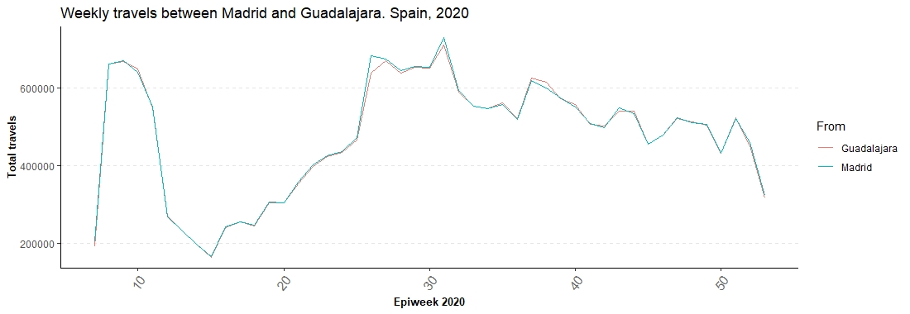
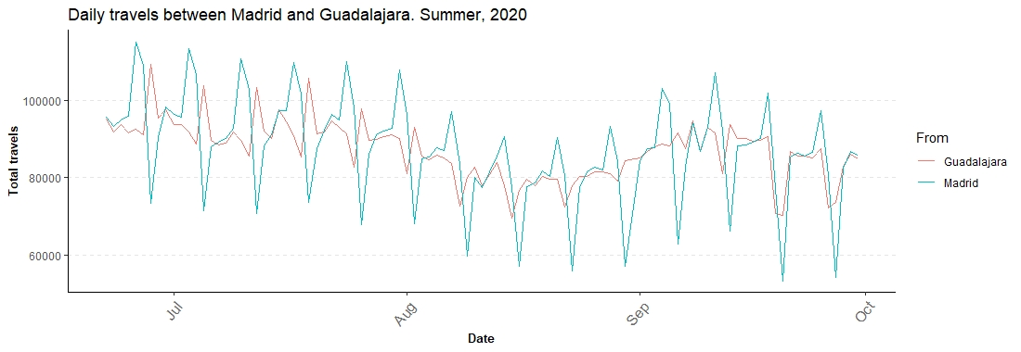
So, we can describe multiple sources of mobility variance: national or higher order (travel restrictions in place), seasonal (summer time) and weekday-related variation (weekends). For the two provinces, sharing these fluxes of travelers must have different implications given their enormous differences. To further understand them, we convert the fluxes $F_{nm}$ to the percentage those travelers represent among all people leaving the provinces, $P_{nm}$:
$$P_{nm}= \frac{Total travelers moving from m to n}{All people leaving m to any other province}.$$
Thus, $P_{nm}$ represents the weight that a given flux of travelers has for a province, a measure of the relative importance of the connection between a pair of provinces in terms of mobility. When turned into the percentages $P_{nm}$, overlapping fluxes $F_{nm}$ between Madrid and Guadalajara now acquire a different magnitude and a new significance (fig S2)
Figure S2. Percentage of daily/weekly travelers between Madrid and Guadalajara
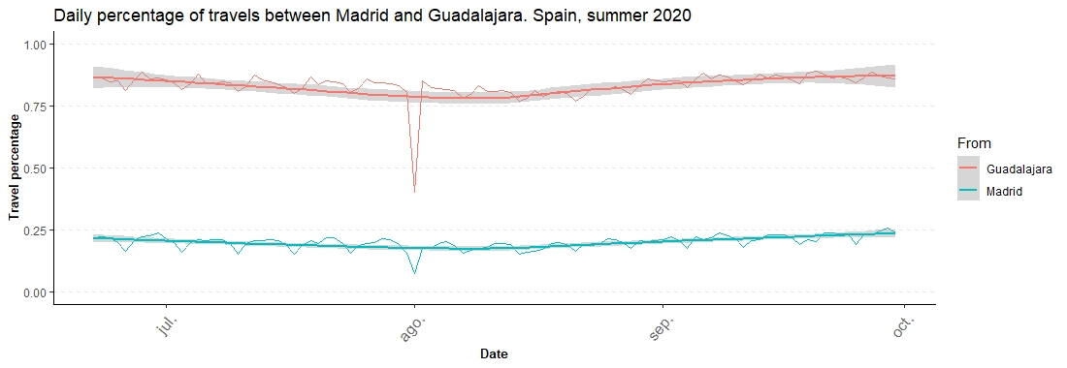
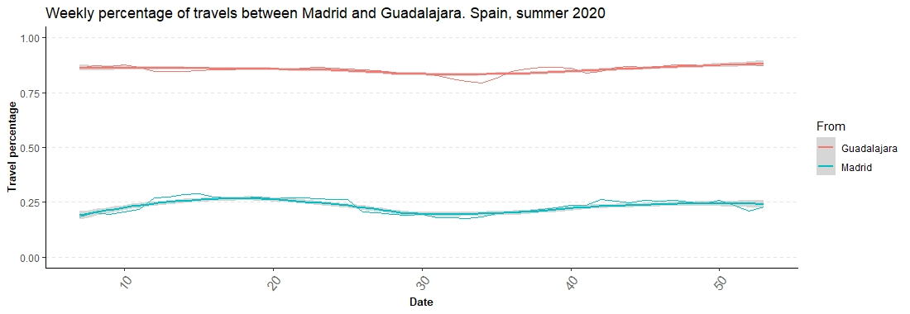
Initially overlapping fluxes now represent a very different share of each province’s travels. While travels from Guadalajara represent almost an 80% of their total travels, for Madrid this is only a bare 23%. This shows how very similar fluxes $F$ do not translate to similar percentages of fluxes $P$, so:
$$F_{nm}=F_{mn}$$
but,
$$P_{nm}≠P_{mn}.$$
This has strong implications in transmission phenomena: symmetrical fluxes (individual travelers) now imply asymmetrical weights and unequal transmission probabilities. The “cost” of traveling from one province to the other differs and a given spreading event has much higher chances to move from the small province of Guadalajara to Madrid than vice-versa. So, for every possible emanating province, the set of its connections expressed as the percentages $P$ represents the first approximation to our MM. If we take a look to Madrid’s and Guadalajara´s (fig S3) distributions of all $P$ emanating from each one:
Figure S3. Weekly percentage of travels from Madrid (A) and Guadalajara (B) by epiweek, 2020
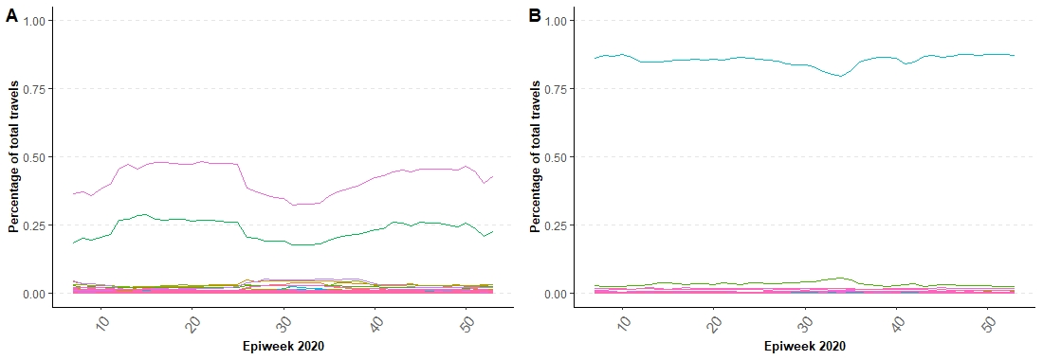
Guadalajara sends most of its travelers (83%) to only one place, Madrid. Madrid only sends back its 23%, and another 45% to a different neighboring province, Toledo. One and two main connections, respectively. The rest of connections from both provinces represent a multiplicity of very low-value connections that, in practice, have little to no effect on any hypothetical transmission phenomena.
From these properties we can classify each province according to the distribution of all their outgoing connections and, also, all pairs of provinces by their relationship. Figure S4 shows other examples of pair-to-pair connections of different magnitude and figure S5, the set of all connections for other provinces. Percentages $P_{nm}$ remain more stable through time than the raw fluxes $F_{nm}$, and therefore allow to uncover inherent characteristics associated to mobility patterns in Spain.
Figure S4. Daily percentage of travels between two provinces. Spain, 2020
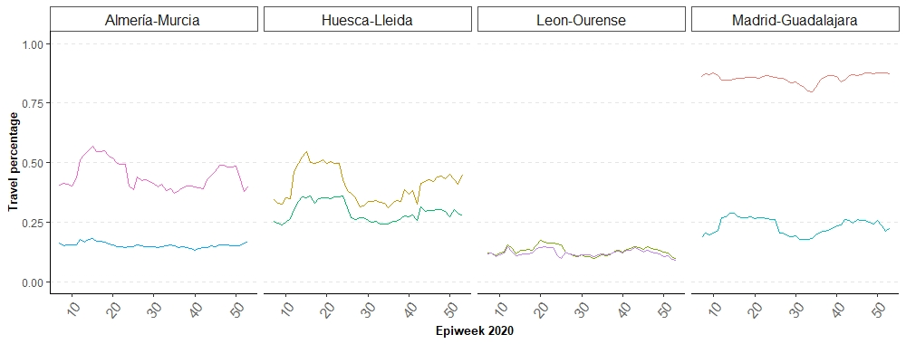
Figure S5. Weekly percentage of travels from each province
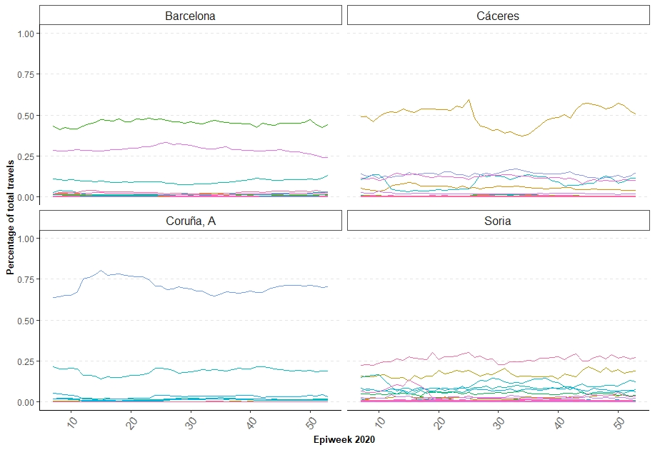
Each province has a unique set of relations with their neighbors. If we want to study transmission phenomena, this is of crucial importance since diffusion usually takes place forward. We can look at the distribution of all percentage-connections in the network to find a mean value of 3% and a median of 0.2%. That means that, even if people move through all provinces, it is clear that there are a set of important fluxes that will determine geographical mobility patters and thus, govern transmission phenomena linked to human mobility.

Stable matrix of connections
We have shown how percentages $P_{nm}$ exhibit a smaller variation during a year period when compared with fluxes $F_{nm}$ quantitatively (coefficient of variation 3.44 vs 4.98) and qualitatively (Figures S1-5). A mean $P_{nm}$ matrix was calculated for the period 2020 as the mean percentage for every connection present at any time in the network. Secondary mean matrices were obtained for the following periods: February (control data previous to pandemic arrival), April (full lock-down mandated), Summer time (21st June - 30th August, relative normality) and November (second travel ban issued).
From each $P_{nm}$ matrix above, Effective Distances (ED) were calculated as expressed in the main paper. To compare the four periods with the mean 2020 matrix, the ratio between ED for each secondary matrix and the mean matrix was obtained to test for divergences in values for each pair $n$, $m$. If the values compared were to be akin, their ratio should be 1 or very close to 1. We explored mean and standard deviation for all compared periods with all of them being around 1 with small standard deviations, concluding that no relevant differences could be appreciated. April was the most differentiated period, as travelling was strictly prohibited. Thus, any $P_{nm}$ matrix could be representative of the mobility patterns in Spain for the year 2020.
Table S1. Comparison of Effective Distance Matrixes during 2020
 | Mean ED for 2020
 | ED February | ED April | ED Summer | ED November
Ratio ED | 1.01 | 0.98 | 1 | 1.01
Standard deviation | 0.05 | 0.08 | 0.05 | 0.04

Therefore, we select the mean 2020 $P_{nm}$ (and its ED derivative) as the Mobility Matrix that sums up qualitative properties, behavior and emerging properties of mobility patterns in Spain, regardless of time period, restrictions in place or other elements of variance.

From the Mobility Matrix to the Epidemic Diffusion Network
The defined MM is very rich in connections. Between the 52 Spanish provinces, 2264 connections arise. We saw how the mean (3%) and median (0,3%) $P_{nm}$ values (for $d_{nm}$, these values are 7.17 and 7.54, respectively) of the MM pointed towards an absolute dominance of major travel fluxes through only a limited set of connections. If we focus on relevant connections only, e.g., those with $P$ over 10% (or $d_{nm}$ < 3.10), only 137 out of 2264 (6%) present connections arise. Therefore, to define a network model for studying geographical diffusion, only provinces connected by percentage of at least 10% of total travelers were considered. The connection can exist only in one direction or its reciprocal and the effective distance acts as the connection weight, pondering the relationships. This defines our Epidemic Diffusion Network (EDN) which we explore by means of network measures and communities, as explained in the main paper.

Table S2. Epidemic Diffusion Network measures by province and community
Province | Degree | Strength | Flow betweenness | Community
Madrid | 11 | 25,6 | 65 | Central-East community
Valladolid | 9 | 24,2 | 259 | Central-West community
Araba/Álava | 8 | 20,2 | 140 | North community
Málaga | 8 | 19,3 | 64 | South community
Sevilla | 8 | 18 | 1231 | South community
Valencia/València | 8 | 19,3 | 840 | Central-East community
Albacete | 7 | 19,2 | 52 | Central-East community
Ávila | 7 | 19,9 | 76 | Central-West community
León | 7 | 20,1 | 553 | Central-West community
Salamanca | 7 | 19,3 | 1155 | Central-West community
Bizkaia | 7 | 15,6 | 385 | North community
Zaragoza | 7 | 17 | 797 | Northeast community
Barcelona | 6 | 10,6 | 90 | Northeast community
Córdoba | 6 | 15 | 50 | South community
Granada | 6 | 14,2 | 1057 | South community
Gipuzkoa | 6 | 15,5 | 37 | North community
Lugo | 6 | 14,1 | 166 | Northwest community
Navarra | 6 | 14 | 810 | North community
Ourense | 6 | 15,9 | 166 | Northwest community
Asturias | 6 | 15,6 | 527 | Central-West community
Toledo | 6 | 14,3 | 11 | Central-East community
Zamora | 6 | 15,4 | 148 | Central-West community
Alicante/Alacant | 5 | 10,2 | 859 | Central-East community
Almería | 5 | 11,6 | 1026 | South community
Burgos | 5 | 13,3 | 109 | North community
Cáceres | 5 | 12,1 | 1212 | Central-West community
Cádiz | 5 | 9,4 | 48 | South community
Castellón/Castelló | 5 | 12,3 | 267 | Northeast community
Cuenca | 5 | 13,3 | 3 | Central-East community
Murcia | 5 | 10,4 | 995 | South community
Cantabria | 5 | 12,6 | 422 | Central-West community
Segovia | 5 | 13,3 | 44 | Central-West community
Tarragona | 5 | 12,5 | 195 | Northeast community
Badajoz | 4 | 9,7 | 1209 | South community
Ciudad Real | 4 | 11,1 | 4 | Central-East community
Coruña, A | 4 | 7,3 | 57 | Northwest community
Huesca | 4 | 8,7 | 162 | Northeast community
Jaén | 4 | 9,6 | 11 | South community
Lleida | 4 | 8,9 | 118 | Northeast community
Rioja, La | 4 | 8,4 | 23 | North community
Palencia | 4 | 10 | 132 | Central-West community
Pontevedra | 4 | 7,3 | 57 | Northwest community
Teruel | 4 | 10,6 | 2 | Northeast community
Balears, Illes | 3 | 7,5 | 0 | Central-East community
Huelva | 3 | 7 | 906 | South community
Palmas, Las | 3 | 5,9 | 3 | Canary Islands community
Soria | 3 | 8,3 | 0 | Central-East community
Girona | 2 | 2,9 | 0 | Northeast community
Guadalajara | 2 | 3,6 | 0 | Central-East community
Santa Cruz de Tenerife | 2 | 2,7 | 0 | Canary Islands community
Melilla | 2 | 3,9 | 0 | South community
Ceuta | 1 | 1,2 | 0 | South community

Community structure from the EDN: hierarchical clustering
When testing for communities and modularity in the EDN, as expressed in the main paper, a total of seven communities arises. Hierarchical clustering dendrogram (Fig S6) shows how provinces are grouped by a similarity degree (y axis), forming wider groups as the y axis ascends. Finally, each group of provinces conforms the branch and leaf of a tree. The colors used to label communities are the same than in the main paper, this is, from left to right: south, north-east, Canary Islands, north-west, north, central-east and central-west communities
From the dendrogram we can derive some conclusions: first of all, the south community is differentiated from the rest of the network. Only two provinces bridge the south community with the network, and it is the biggest community (12 members,) which makes this community one of the most independent and difficult to reach from any point of the network. It is no surprise that 7 provinces of this community score higher in betweenness, since travelling (in and out) is very costly in terms of number of steps.
The second main branch, encompassing the rest of the provinces, is first split up leaving the north-east community as an independent group. This region has some differential properties i.e., no clear mobility hub emerges (not even Barcelona, 2nd largest city in Spain), but a rather horizontal relation between all provinces emerges.
Finally, the las two branches, central east and west, even forming two groups, share a high degree of similarity and remain utterly proximal. It could barely conform an unique group. Indeed, if we look at figure 5 in the main text, these two communities have the lesser mean differences in CI14 curves between its members and the rest. Encompassing most of the peninsula and many different regions, it points towards a differentiated dynamic when compared with the rest.
Fig S6. Hierarchical clustering dendrogram from the ED
