Design of inherent fire retarding and degradable bio-based epoxy vitrimer with excellent self-healing and mechanical reprocessability
Weijun Yang¹*, Hui Ding¹, Wei Zhou¹, Tianxi Liu¹, Pengwu Xu¹, Debora Puglia², Jose M Kenny², Piming Ma¹*
^{1,} The Key Laboratory of Synthetic and Biological Colloids, Ministry of Education, School of Chemical and Material Engineering, Jiangnan University, Wuxi 214122, China.
^{2,} Civil and Environmental Engineering Department, Materials Engineering Center, Perugia University, UdR INSTM, Terni 05100, Italy
*Email: weijun.yang@jiangnan.edu.cn; p.ma@jiangnan.edu.cn

Characterizations
Fourier infrared spectroscopy (FT-IR). The FT-IR spectrometer (Nicolet 6700 Thermo Fisher Scientific USA) was used to analyze the chemical structure of VAD, VDP, VAD-EP, VDP-EP and cured epoxy samples in attenuated total reflection mode, within a range of 400-4000 cm⁻¹ at a 4 cm⁻¹ resolution, using 16 scans.
Nuclear magnetic resonance spectroscopy (NMR). The ¹H NMR, ¹³C NMR and ³¹P NMR spectra of various simples were obtained by using a 400 MHz AVANCE III Bruker NMR spectrometer (Bruker, Switzerland). Measurements were performed at room temperature, using dimethyl sulfoxide (DMSO) or deuterated chloroform (CDCl₃) as the solvent and tetramethysilane (TMS) as an internal standard.
LOI tests. The LOI tests were carried out with a JF-3 oxygen index tester (Jiangning Analysis Instrument Company, China) with sample dimensions of 100 mm × 10 mm× 4 mm, in accordance with ASTM D2863-97 standard.
UL-94 vertical burning test. UL-94 vertical burning tests were carried out on a CZF-4 type vertical burning tester (Shangyuan Analysis Instrument Company, China) with the samples dimensions of 130 mm × 13 mm× 3 mm according to ASTM D3801-2010.
Cone calorimeter test (CCT). The combustion and charring behaviors were tested by using a FTT cone calorimeter according to ISO 5660. Cured epoxy vitrimer materials with dimensions of 100 mm × 100 mm × 4 mm were used for this test under the irradiation of a heat flux of 50 kW/m².
Thermogravimetric analysis (TGA). Thermal stability of the cured epoxy vitrimer was evaluated by using a TGA instrument (1100SF，Mettler-Toledo, Switzerland), scanning from 30 °C to 800 °C at 10 °C/min under a nitrogen atmosphere.
Differential scanning calorimetry (DSC). The glass transition temperature (T_{g}) of cured epoxy vitrimer (about 5 mg) was studied by DSC measurements (DSC-8000, PE Instrument, USA). The cured epoxy vitrimers were heated from 30 °C to 250 °C at a heating rate of 20 °C/min under a nitrogen flow.
Scanning electron microscopy (SEM). The fractured surfaces of cured epoxy vitrimer materials and the microstructures after CCT were investigated by SEM (S-4800, HITACHI，Japan). All materials were sputtered with a thin layer of gold before observation.
Energy dispersive X-Ray spectroscopy (EDS). The dispersibility of phosphorus (P) and nitrogen (N) in EP matrix was investigated by an energy dispersive spectroscopy instrument (S-4800, HITACHI，Japan). All materials were sputtered with a thin layer of gold before scanning.
Dynamic mechanical analysis (DMA). The evaluation of T_{g} temperatures, elastic modulus E’ and stress relaxation for cured epoxy vitrimer were carried out on a TA Instrument (TA Q800, USA) at a heating rate of 3 °C/min from 30 °C to 250 °C. Samples with dimensions of 30 mm×10 mm×2 mm were tested by using film tensile clamp, frequency of 1 Hz and amplitude of 10 μm. Stress relaxation was tested under 0.001 N preload force at 2% constant strain. When the furnace temperature reached 90, 100, 110, 120, 130 and 140 °C followed by relaxation for 10 min, the relaxation modulus was recorded.
Optical microscope. The sample A₇P₃-D230 was gently scratch with a knife, and was put in a drying oven at 60 ºC for 24 h. Changes of sample scratch before and after healing were observed by optical microscope (VHX-1000C, Keens company, Hong Kong).
Solvent resistance. Solvent resistance: the sample A₇P₃-D230 (30 mm×10 mm×1 mm) was placed in 15 ml of different solvents, such as water, dimethyl sulfoxide, N, N’-dimethylformamide, ethanol, n-hexane, ethyl acetate, dichloromethane and toluene, at ambient temperature for 48 h to observe the change of sample.
Tensile test. The tensile test of standard dumbbell cured epoxy vitrimer, CFRCs and CF multifilament was performed by using a universal material testing machine (Instron 5967, USA), according to ASTM D638, at a crosshead rate of 10 mm/min. The flexural characterization of CFRCs having dimensions of 80 mm×10 mm×4 mm was performed by using a universal material testing machine (Instron 5967, USA) in three-point bending mode, according to ASTM D790, using a crosshead rate of 2 mm/min. All samples were tested for at least 5 repetitions, and their average value for the mechanical parameters was calculated.
Raman test. The chemical structure of CF before and after degradation was studied by using reflection Raman spectrometer (inVia, Renishaw, England) with a laser at 785 nm wavelength, 60 s exposure time and 12 mW laser energy.

Table S1 Formulations of cured epoxy systems
Samples | VAD-EP(g) | VDP-EP(g) | D230(g) | P (%) | N (%)
A₁₀P₀-D230 | 10 | / | 1.91 | / | 4.06
A₉P₁-D230 | 9 | 1 | 1.82 | 0.33 | 3.98
A₈P₂-D230 | 8 | 2 | 1.74 | 0.66 | 3.90
A₇P₃-D230 | 7 | 3 | 1.65 | 1.00 | 3.82

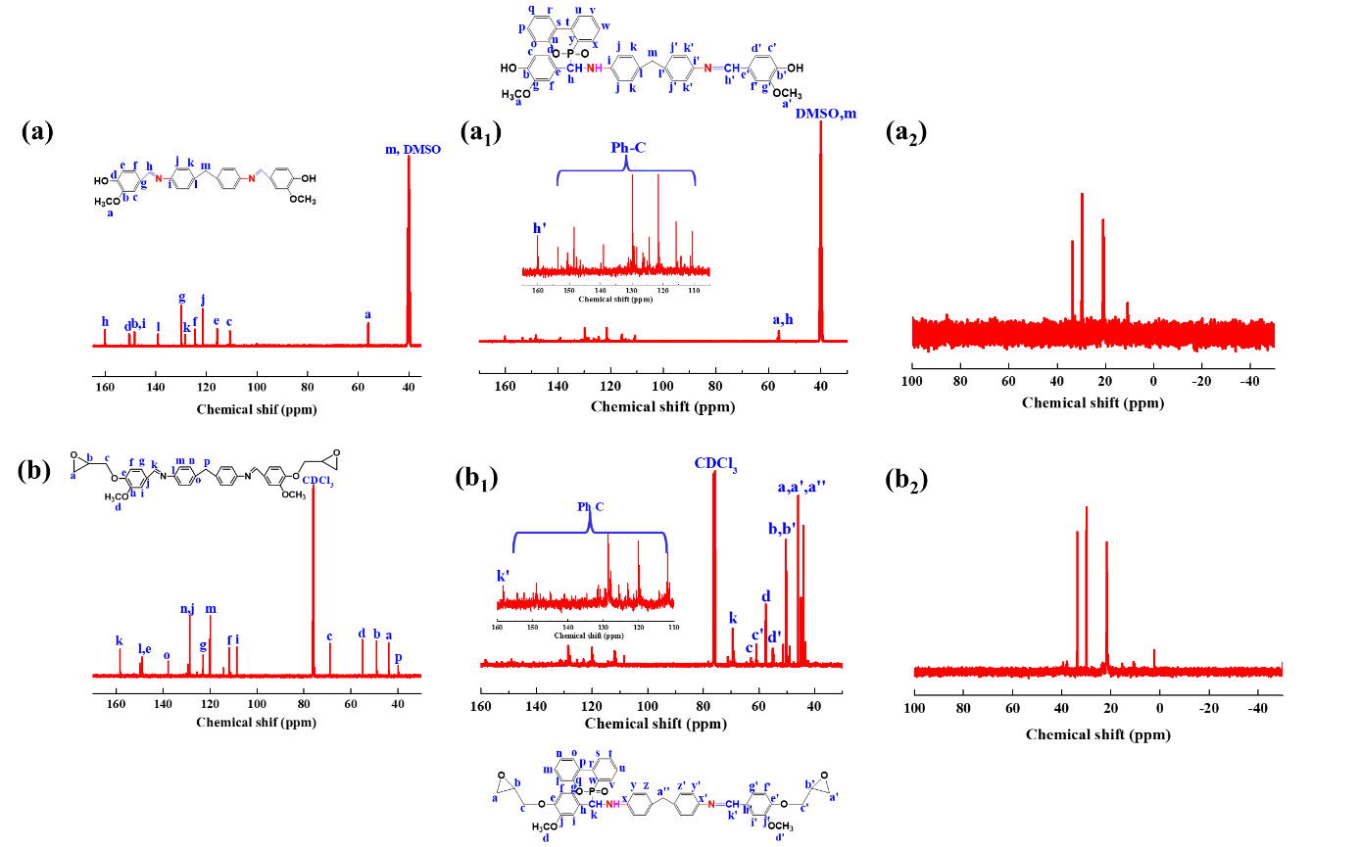
Fig. S1 The ¹³C NMR spectra of (a) VAD, (a₁) VDP, (b) VAD-EP, (b₁) VDP-EP; The ³¹P NMR spectra of (a₂) VDP, (b₂) VDP-EP.

Fig. S1 (a) and (b) were the ¹³C NMR of VAD and VAD-EP respectively, and the specific data are as follows: VAD, ¹³C NMR (101 MHz, DMSO) δ= 39.60 (s), 56.02 (s), 110.77 (s), 115.80 (s), 121.46 (s), 124.50 (s), 128.45 (s), 129.89 (s), 139.08 (s), 148.46 (s), 150.34 (s), 150.59 (s), 160.12 (s). VAD-EP, ¹³C NMR (101 MHz, CDCl₃) δ= 39.96 (s), 43.83 (d), 48.96 (d), 55.05 (s), 69.00 (s), 108.52 (s), 111.79 (s), 119.94 (d), 123.06 (s), 128.87 – 129.42 (m), 137.73 (s), 148.91-149.87 (m), 158.25 (s).
Fig. S1 (a₁) and (b₁) were the ¹³C NMR of VDP and VDP-EP respectively, and the specific data are as follows: VDP, ¹³C NMR (101 MHz, DMSO) δ=40.14 (s), 56.02 (t), 110.77 (s), 114.37 (s), 115.81 (s), 121.38 (d), 124.53 (s), 126.00 (s), 128.43 (s), 129.26 (d), 129.89 (s), 130.34 (m), 131.03 (s), 139.30 (s), 147.46 (s), 148.46 (s), 150.46 (d), 153.51 (s), 160.05 (d)。VDP-EP, ¹³C NMR (101 MHz, CDCl₃) δ=43.88 (s), 44.83 (s), 45.92 (s), 49.18 (s), 50.27 (s), 54.94 (s), 57.62 (s), 61.00 (s), 62.87 (s), 69.44 (s), 108.54-130.83 (m), 158.31 (s).
Fig. S1 (a₂) and (b₂) were the ³¹P NMR of VDP and VDP-EP respectively. The P-H on DOPO could react with C=N bond on VAD or two P-H on DOPO could react with two C=N bond (due to the molar ratio of vanillin, DDM and DOPO, 2:1:1) [1]. Therefore, we observed that there were three phosphorus signal peaks at 20.6 ppm, 29.8 ppm and 33.4 ppm. There were two unequal phosphorus signal peaks at 29.8 ppm and 33.4 ppm, which was the stereoisomer caused by the steric effect of DOPO [2, 3].
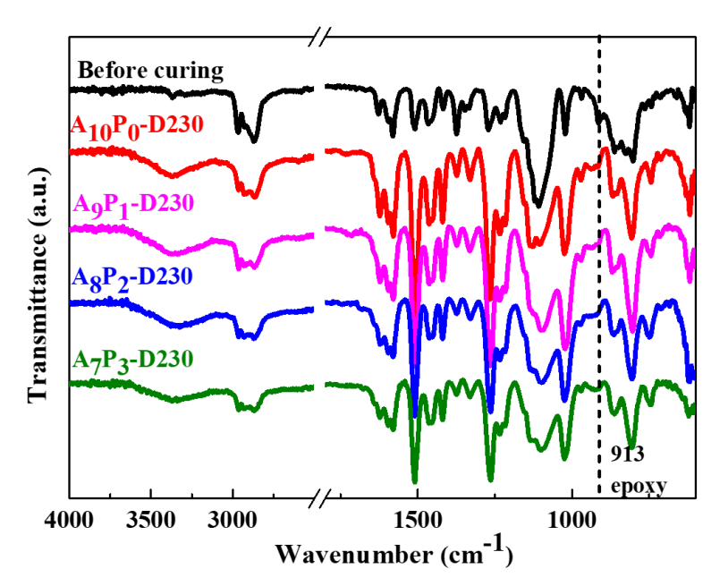
Fig. S2 FTIR spectra of epoxy vitrimer before and after curing.

FTIR spectra of epoxy vitrimer before and after curing are shown in Fig. S2. It can be observed that the epoxy group at 905 cm⁻¹ disappeared and a new peak appeared at 3100-3500 cm⁻¹, which belongs to hydroxyl group, indicating that the epoxy system had been completely cured.
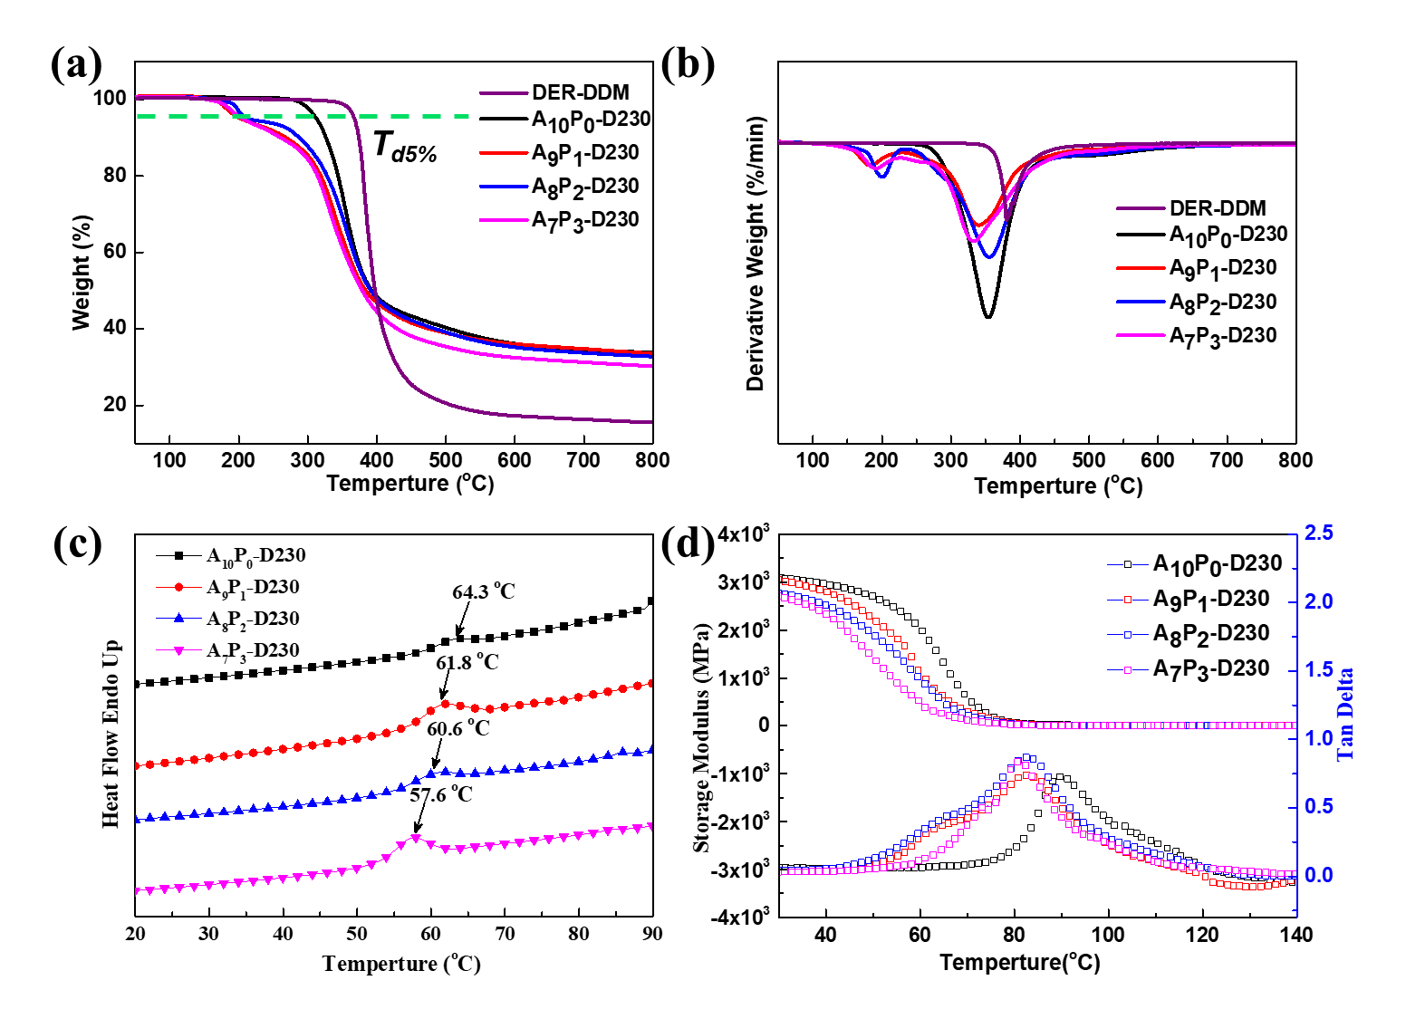
Fig. S3 (a) TGA, (b) DTG curves, (c) Non isothermal DSC curves and (d) DMA curves of cured epoxy resins.

As shown in Fig. S3, the thermal stability of epoxy vitrimer system was studied by TGA, and the relevant data are summarized in Table 2. The carbon residue of epoxy vitrimer system was higher than that of commercial epoxy resin. For epoxy vitrimer A_{x}P_{y}-D230 system, T_{d5%} decreased with the increase content of VDP-EP, because the stability of P-C and O=P-O bonds was worse than that of C-C during heating, which will be decomposed into some phosphorus rich substances [4]. These phosphorus rich substances could form a dense carbon layer on the surface of the matrix to further protect the decomposition inside the matrix. At the same time, the amount of carbon residue at 800 °C also decreased, which was attributed to the increase of carbon residue due to the high content of C=N bond [5]. As shown in Fig. S3b, the decomposition process of epoxy vitrimer A₁₀P₀-D230 and DER-DDM was one step, while the decomposition process of A₉P₁-D230, A₈P₂-D230 and A₇P₃-D230 was two steps. The first step was the decomposition of containing phosphorus groups at low temperature to produce pyrophosphoric acid and metaphosphoric acid; the second step was the further decomposition of the formed carbon layer [6]. We could observe that the degradation rate of the system containing VDP-EP decreased, which was due to the containing phosphorus group that plays an effective role in the system.
Thermal and mechanical properties of epoxy vitrimer A_{x}P_{y}-D230 were studied by DMA, and relevant data were summarized in Table 2. According to the elastic theory of rubber, the influence of adding VDP-EP on the crosslinking density (ν_{e}) of the system was studied. The ν_{e} can be calculated by formula (1):
$v_{e}=E^{'}/3RT$ (1)
Where E' is the storage modulus at T_{g}+60 ºC, R is the gas constant and T is the absolute temperature. The results showed that with the increasing amount of VDP-EP, ν_{e} value gradually decreased, which was mainly due to the steric effect of DOPO, which hinders the movement of segments. After adding VDP-EP, the E' of epoxy vitrimer system was lower than that of pure epoxy vitrimer system. T_{g} is an important property of polymer. The T_{g} is affected by the crosslinking density and the rigidity of the chain segment structure. The greater the crosslinking density, the higher the stiffness of the chain segment, the greater the T_{g}. As shown in Fig. S3 (c) and (d), T_{g} of epoxy vitrimer system was studied by DSC and DMA. We can observe that the T_{g} value obtained from tan δ curve was higher than that of DSC, and the T_{g} of epoxy vitrimer system containing VDP-EP was lower than that of epoxy vitrimer system without VDP-EP. With the addition of VDP-EP, the T_{g} of epoxy vitrimer system gradually decreased. This was mainly because the containing phosphorus group could reduce the average degree of function of the system, partially blocking the cross-linking of the network [7, 8].

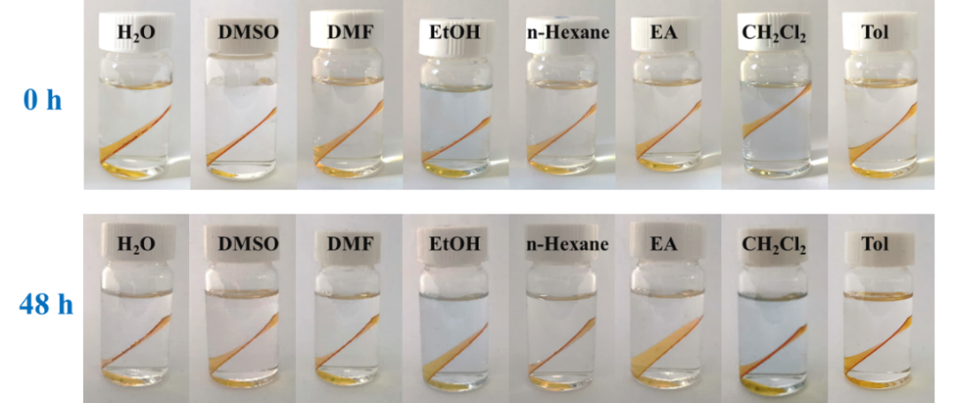
Fig. S4 Comparative photographs of cured epoxy A₇P₃-D230 in different solvents for 0 h and 48 h at room temperature.

The solvent resistance of the epoxy material in different solvents, as shown in Fig. S4, were also investigated. A₇P₃-D230 sample was immersed into various inorganic/organic solvents (water, DMSO, DMF, ethanol, n-hexane, ethyl acetate, dichloromethane and toluene) at room temperature for 48 h: we observed that the sample surface had no variation, indicating that the cured epoxy resin had excellent solvent resistance.

References
1. Wang S, Ma S, Li Q, Xu X, Wang B, Yuan W, Zhou S, You S, Zhu J (2019) Facile in situ preparation of high-performance epoxy vitrimer from renewable resources and its application in nondestructive recyclable carbon fiber composite. Green Chem 21:1484-97. https://doi.org/10.1039/c8gc03477j
2. Chi Z, Guo Z, Xu Z, Zhang M, Li M, Shang L, Ao Y (2020) A DOPO-based phosphorus-nitrogen flame retardant bio-based epoxy resin from diphenolic acid: Synthesis, flame-retardant behavior and mechanism. Polym Degrad Stab 176. https://doi.org/10.1016/j.polymdegradstab.2020.109151
3. Liu C, Chen T, Yuan CH, Song CF, Chang Y, Chen GR, Xu YT, Dai LZ (2016) Modification of epoxy resin through the self-assembly of a surfactant-like multi-element flame retardant. J Mater Chem A 4:3462-70. https://doi.org/10.1039/c5ta07115a
4. Wang S, Ma SQ, Xu CX, Liu Y, Dai JY, Wang ZB, Liu XQ, Chen J, Shen XB, Wei JJ, Zhu J (2017) Vanillin-Derived High-Performance Flame Retardant Epoxy Resins: Facile Synthesis and Properties. Macromolecules 50:1892-901. https://doi.org/10.1021/acs.macromol.7b00097
5. Zhou Z, Su XZ, Liu JC, Liu R (2020) Synthesis of Vanillin-Based Polyimine Vitrimers with Excellent Reprocessability, Fast Chemical Degradability, and Adhesion. ACS Appl Polym Mater 2:5716-25. https://doi.org/10.1021/acsapm.0c01008
6. Dai JY, Peng YY, Teng N, Liu Y, Liu CC, Shen XB, Mahmud S, Zhu J, Liu XQ (2018) High-Performing and Fire-Resistant Biobased Epoxy Resin from Renewable Sources. ACS Sustain Chem Eng 6:7589-99. https://doi.org/10.1021/acssuschemeng.8b00439
7. Menard R, Negrell C, Fache M, Ferry L, Sonnier R, David G (2015) From a bio-based phosphorus-containing epoxy monomer to fully bio-based flame-retardant thermosets. Rsc Adv 5:70856-67. https://doi.org/10.1039/c5ra12859e
8. Gao LP, Zheng GY, Nie XA, Wang YG (2017) Thermal performance, mechanical property and fire behavior of epoxy thermoset based on reactive phosphorus-containing epoxy monomer. J Therm Anal Calorim 127:1419-30. https://doi.org/10.1007/s10973-016-5456-0

