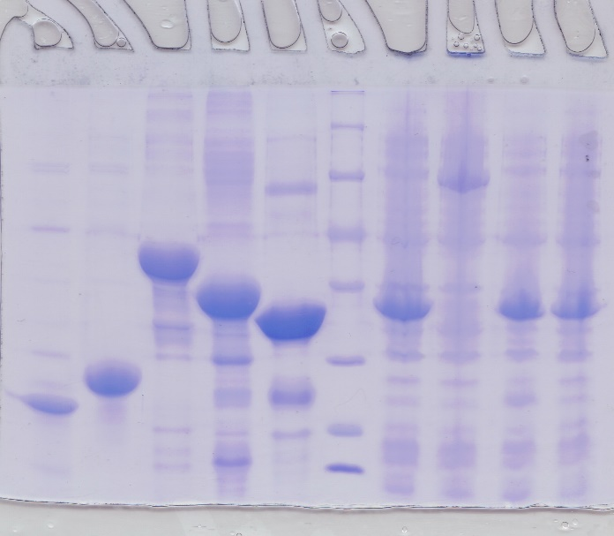

Figure S2-1 Purity and the molecular weight identification of the recombinant protein with 12% SDS-polyacrylamide gel electrophoresis.
Blue box in Figure S2-1 correspondence to Fig.2.A. The sample in Blue box was OsSODCP-his recombinant protein.

Figure S2-2 Recognition of the rabbit polyclonal antibody to OsCu/Zn SOD recombinant protein.
Figure S2-2 correspondence to Fig.2.C.
The sample in Blue box was OsSODCP-his recombinant protein. The sample in Red box was OsSODC1-his recombinant protein. The sample in Orange box was OsSODC2-his recombinant protein. The sample in Green box was OsSODCS-his recombinant protein. The sample in Yellow box was Non-related-his recombinant protein. Each box contained three lanes respectively. The incubated primary antibody in left lanes were pre-immune serum (1:3000) diluted in PBST, the Anti-OsCu/Zn SODs (1:5000) instead of pre-immune serum in middle lane and Anti-his tag antibody (1:2000) in right lane.

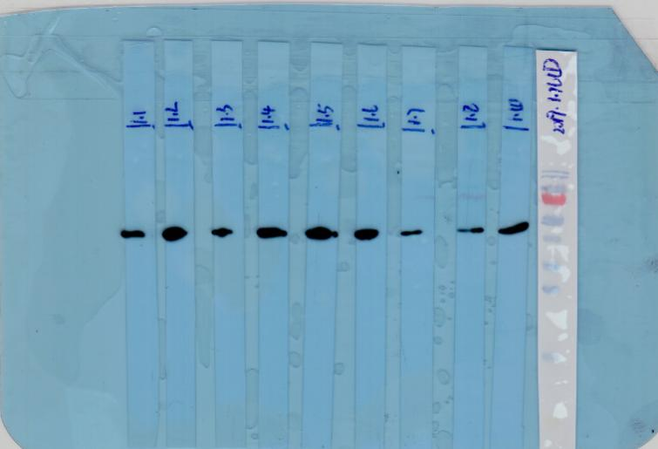
Anti-actin antibody
pre-immune serum
Figure S2-3 Recognition of the rabbit pre-immune serum to leaf tissue lysate.
Blue box in Figure S2-3 correspondence to Fig.3.A. Left lane was the leaf tissue lysate of Nipponbare, right lane was the leaf tissue lysate of 93-11. The incubated primary antibody was a mixture of pre-immune serum (1:3000) and Anti-actin antibody (1:2000) diluted in PBST.
Yellow box in Figure S2-3 correspondence to Fig.3.B. Both lanes were leaf tissue lysate of 93-11before IP with Anti-OsCu/Zn SODs or the pre-immune serum. The incubated primary antibody was Anti-actin antibody (1:2000) diluted in PBST.
Red box in Figure S2-3 correspondence to Fig.4.A. Left lane was the leaf tissue lysate of Nipponbare, middle lane was the leaf tissue lysate of tomato, and right lane was the leaf tissue lysate of Arabidopsis. The incubated primary antibody was a mixture of pre-immune serum (1:3000) and Anti-actin antibody (1:2000) diluted in PBST.
Thermo Scientific PageRuler Prestained Protein Ladder is a mixture of 10 blue-, orange-, and green-stained proteins , The molecular weight from bottom to top is 10 kDa, 17 kDa, 25 kDa, 35 kDa, 40 kDa, 55 kDa, 70 kDa (Red), 100 kDa, 130 kDa, and 180 kDa.
The Anti-actin immuneblot band is between 40 and 55 kDa.
The Anti-OsCu/Zn SODs immuneblot band is between 17 and 25 kDa. There is no band with pre-immune serum.

Anti-OsCu/Zn SODs
Anti-actin antibody
Figure S2-4 Recognition of the rabbit polyclonal antibody to Denatured Cu/Zn SODs both in Nipponbare and 93-11
Blue box in Figure S2-4 correspondence to Fig.3.A. Left lane was the leaf tissue lysate of Nipponbare, right lane was the leaf tissue lysate of 93-11. The incubated primary antibody was a mixture of Anti-OsCu/Zn SODs (1:5000) and Anti-actin antibody (1:2000) diluted in PBST.
Thermo Scientific PageRuler Prestained Protein Ladder is a mixture of 10 blue-, orange-, and green-stained proteins , The molecular weight from bottom to top is 10 kDa, 17 kDa, 25 kDa, 35 kDa, 40 kDa, 55 kDa, 70 kDa (Red), 100 kDa, 130 kDa, and 180 kDa.
The Anti-actin immuneblot band is between 40 and 55 kDa.
The Anti-OsCu/Zn SODs immuneblot band is between 17 and 25 kDa.

Anti-OsCu/Zn SODs
Figure S2-5 Recognition of the rabbit polyclonal antibody with Native Cu/Zn SODs in 93-11.
Blue box in Figure S2-5 correspondence to Fig.3.B. Lane 1 to lane 4 were from left to right. Lane 1 was the immune complexes with pre-immune rabbit serum. Lane 2 was the immune complexes with Anti-OsCu/Zn SODs. Lane3-4 were the leaf tissue lysate of 93-11before IP. The incubated primary antibody was Anti-OsCu/Zn SODs (1:5000) diluted in PBST.
Thermo Scientific PageRuler Prestained Protein Ladder is a mixture of 10 blue-, orange-, and green-stained proteins , The molecular weight from bottom to top is 10 kDa, 17 kDa, 25 kDa, 35 kDa, 40 kDa, 55 kDa, 70 kDa (Red), 100 kDa, 130 kDa, and 180 kDa.
The Anti-OsCu/Zn SODs immuneblot band is between 17 and 25 kDa.

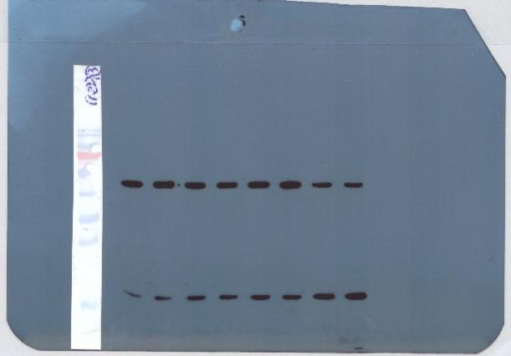
Anti-actin antibody
Anti-OsCu/Zn SODs
Figure S2-6 Expression level recognition of Cu/Zn SODs in Nipponbare and STTM398 under High temperature treatment at different times.
Blue box in Figure S2-6 correspondence to Fig.3.D. Nipponbare seedings were transferred to the light incubator at 40 ℃ with 0, 3, 6 and 12 h. The corresponding samples were in lane 1 to lane 4 from left to right. The incubated primary antibody was a mixture of Anti-OsCu/Zn SODs (1:5000) and Anti-actin antibody (1:2000) diluted in PBST.
Red box in Figure S2-6 correspondence to Fig.3.G. STTM398 seedings were transferred to the light incubator at 40 ℃ with 0, 3, 6 and 12 h. The corresponding samples were in lane 5 to lane 8 from left to right. The incubated primary antibody was a mixture of Anti-OsCu/Zn SODs (1:5000) and Anti-actin antibody (1:2000) diluted in PBST.
Thermo Scientific PageRuler Prestained Protein Ladder is a mixture of 10 blue-, orange-, and green-stained proteins , The molecular weight from bottom to top is 10 kDa, 17 kDa, 25 kDa, 35 kDa, 40 kDa, 55 kDa, 70 kDa (Red), 100 kDa, 130 kDa, and 180 kDa.
The Anti-actin immuneblot band is between 40 and 55 kDa.
The Anti-OsCu/Zn SODs immuneblot band is between 17 and 25 kDa.

Anti- OsCu/Zn SODs
Anti-actin
Figure S2-7 Expression level recognition of Cu/Zn SODs in 93-11 and N22 under High temperature treatment at different times.
Blue box in Figure S2-7 correspondence to Fig.3.G. 93-11 seedings were transferred to the light incubator at 40 ℃ with 0, 3, 6 and 12 h. The corresponding samples were in lane 1 to lane 4 from left to right. The incubated primary antibody was a mixture of Anti-OsCu/Zn SODs (1:5000) and Anti-actin antibody (1:2000) diluted in PBST.
Red box in Figure S2-6 correspondence to Fig.3.G. N22 seedings were transferred to the light incubator at 40 ℃ with 0, 3, 6 and 12 h. The corresponding samples were in lane 5 to lane 8 from left to right. The incubated primary antibody was a mixture of Anti-OsCu/Zn SODs (1:5000) and Anti-actin antibody (1:2000) diluted in PBST.
Thermo Scientific PageRuler Prestained Protein Ladder is a mixture of 10 blue-, orange-, and green-stained proteins , The molecular weight from bottom to top is 10 kDa, 17 kDa, 25 kDa, 35 kDa, 40 kDa, 55 kDa, 70 kDa (Red), 100 kDa, 130 kDa, and 180 kDa.
The Anti-actin immuneblot band is between 40 and 55 kDa.
The Anti-OsCu/Zn SODs immuneblot band is between 17 and 25 kDa.

Anti-actin
Anti-OsCu/Zn SOD

Figure S2-8 The lysate of young Tomato leaves, Arabidopsis thaliana and Nipponbare were immunoblotted with antibodies against OsCu/Zn SODs (anti-OsCu/Zn SOD rabbit Pab)
Blue box in Figure S2-8 correspondence to Fig.4.A. Left lane was the leaf tissue lysate of tomato, middle lane was the leaf tissue lysate of Arabidopsis, and right lane was the leaf tissue lysate of Nipponbare. The incubated primary antibody was a mixture of Anti-OsCu/Zn SODs (1:5000) and Anti-actin antibody (1:2000) diluted in PBST.
The Anti-actin immuneblot band is between 40 and 55 kDa.
The Anti-OsCu/Zn SODs immuneblot band is between 17 and 25 kDa.

