SUPPLEMENTARY INFORMATION

TGFBI mitigated obesity by regulating the Notch-1 signaling pathway

Seul Gi Lee^{a,g}, Jongbeon Chaeª, Seon Min Woo^{g}, Seung Un Seo^{g}, Ha-Jeong Kim^{b}, David D. Schlaepfer^{c}, In-San Kim^{d,e}, Hee-Sae Park^{f}, Taeg Kyu Kwon^{g,h,*}, and Ju-Ock Nam^{a,i;*}

ª Department of Food Science and Biotechnology, Kyungpook National University, Daegu 41566, Republic of Korea
^{b} Department of Physiology, School of Medicine, Kyungpook National University, Daegu 41944, Republic of Korea
^{c} Moores Cancer Center, University of California, San Diego, La Jolla, CA 92093, USA
^{d} KU-KIST Graduate School of Converging Science and Technology, Korea University, Seoul 02841, Republic of Korea
^{e} Center for Theragnosis, Biomedical Research Institute, Korea Institute Science and Technology (KIST), Seoul 02792, Republic of Korea
^{f} School of Biological Sciences and Technology, Chonnam National University, Gwangju 61186, Republic of Korea
^{g} Department of Immunology, School of Medicine, Keimyung University, Daegu 42601, Republic of Korea
^{h} Center for Forensic Pharmaceutical Science, Keimyung University, Daegu 42601, Republic of Korea
^{i} Research Institute of Tailored Food Technology, Kyungpook National University, Daegu 41566, Republic of Korea

*Corresponding authors
Taeg Kyu Kwon
Address: Keimyung University, 1095 Dalgubeoldaero, Dalseo-Gu, Daegu 42601, Korea.
Tel: +82-53-420-4811, Fax: +82-53-424-3349, E-mail: kwontk@dsmc.or.kr
Ju-Ock Nam
Address: Kyungpook National University, 80 Daehak-ro, Buk-gu, Daegu, Korea.
Tel: +82-53-950-7760, Fax: +82-53-950-7762, E-mail: namjo@knu.ac.kr

Supplementary Figure 1. Generation of TGFBI KO mice. (A) Schematic illustration of the TGFBI knockout strategy. Exon 3 in TGFBI with a neomycin cassette was removed through Flp-mediated recombination. (B) Plasma TGFBI secretion from WT and TGFBI KO mice was detected using ELISA.

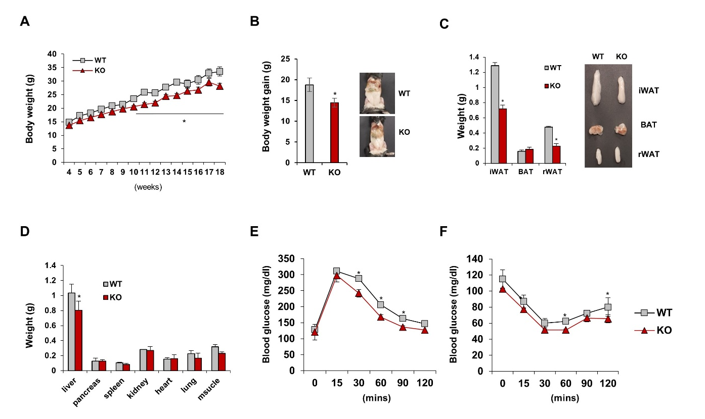
Supplementary Figure 2. HFD-fed female TGFBI KO mice exhibit resistance to diet as male KO mice. (A-B) Body weight and calculated weight gain in HFD-fed female WT and KO mice from 10 to 17 weeks of age (n = 10/group). (C-D) Adipose tissues (C) and organs (D) in 20-week-old HFD-fed female WT and KO mice. The right panels show representative photographs of the fat pads, liver, and abdomen (n = 10/group). (E-F) GTT and ITT results from 17-week-old HFD-fed female WT and KO mice. Error bars represent the ± SEM. *p < 0.05 by two-sided t-test.

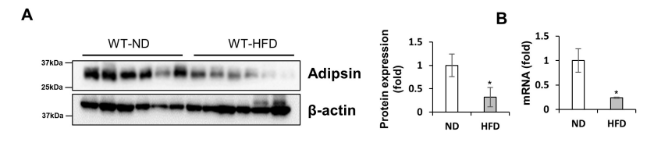
Supplementary Figure 3. Adipsin expression is decreased by HFD feeding relative to shown in Fig. 4. (A-B) Protein and mRNA expression of adipsin in iWAT obtained from ND- and HFD-fed WT mice. Error bars represent the ± SEM. *p < 0.05 by two-sided t-test.

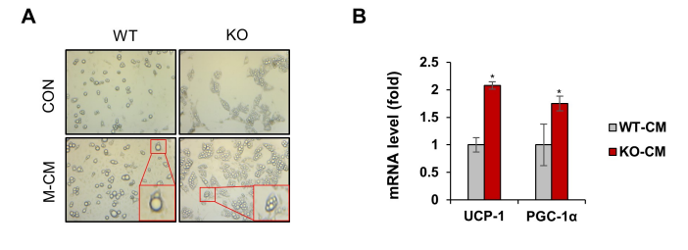
Supplementary Figure 4. BM-MSCs cultured with TGFBI deficient macrophages exhibit a multilocular lipid phenotype and increased expression of browning-related genes. (A) Representative images of BM-MSCs isolated from either WT or KO mice and cultured in presence or absence of M-CM obtained from either WT or KO mice. (B) mRNA expression levels of the indicated genes in these cells. Error bars represent the ± SEM. *p < 0.05 by two-sided t-test.

Gene | Forward | Reverse
Adiponectin | GATGGCACTCCTGGAGAGAA | TCTCCAGGCTCTCCTTTCCT
Adipsin | CTGGGAGCGGCTGTATGT | CACGGAAGCCATGTAGGG
Angiopoietin-3 | GGAAAGACAGCAAGCACTACG | CCACCAGCCACCTGAGTAA
CD86 | TCAATGGGACTGCATATCTGCC | GCCAAAATACTACCAGCTCACT
CD206 | CTCTGTTCAGCTATTGGACGC | CGGAATTTCTGGGATTCAGCTTC
C/EBPα | AAGAAGACGGTGGACAAGCTG | TGCTCCACCTTCTTCTGCAGC
GLUT-2 | ACTTGGAAGGATCAAAGCAATGT | CAGTCCTGAAATTAGCCCACAA
Hes-1 | ACACCGGACAAACCAAAGAC | AATGCCGGGAGCTATCTTTC
Hey | CACCTGAAAATGCTGCACAC | ATGCTCAGATAACGGGCAAC
IL-6 | TTCTTGGGACTGATGCTG | CTGGCTTTGTCTTTCTTGTT
Leptin | GGGCTTCACCCCATTCTGA | TGGCTATCTGCAGCACATTTTG
Notch-1 | TAATGAGTGCAGCCAGAACC | CATAGGGCAGTTCACAGTGG
PGC-1α | CCCTGCCATTGTTAAGACC | TGCTGCTGTTCCTGTTTTC
PPARα | GCCTGTCTGTCGGGATGT | GGCTTCGTGGATTCTCTTG
PPARγ | GGAAGACCACTCGCATTCCTT | GTAATCAGCAACCATTGGGTCA
TNFα | TCCCTTTCACTCACTGGC | ACTTGGTGGTTTGCTACG
UCP-1 | CTGCCAGGACAGTACCCAAG | TCAGCTGTTCAAAGCACACA
VEGF | GCACATAGAGAGAATGAGCTTCC | CTCCGCTCTGAACAAGGCT
Supplemental Table. Primer sequence used in qRT-PCR.

