Supporting Information
Increasing Occupancy Levels in an Operating Room Environment Increases Detectable Ambient CO₂ Concentrations

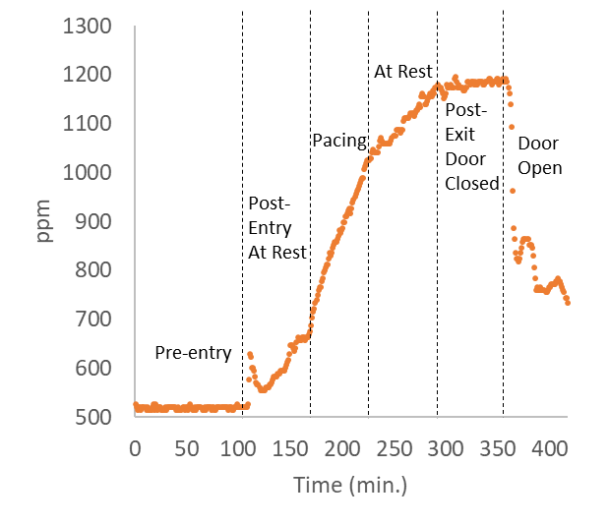
S1: Sensor 1, trial 1 (see Figure 1 for sensor 2 data): CO₂ concentration as a function of occupation time for a single individual in an enclosed OR with no ventilation. When an individual enters an enclosed room, the amount of detectable CO₂ increases with occupation time. The rate of CO₂ increase is dependent on the activity level of the individual. The CO₂ increases more quickly when the individual paces the room compared to when the individual is at rest.

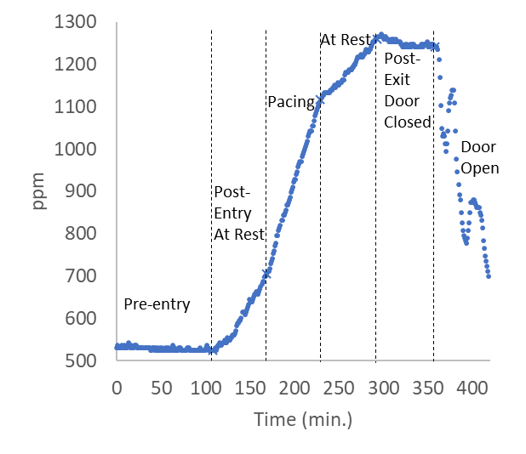
S2: Sensor 2, trial 2: CO₂ concentration as a function of occupation time for a single individual in an enclosed OR with no ventilation. When an individual enters an enclosed room, the amount of detectable CO₂ increases with occupation time. The rate of CO₂ increase is dependent on the activity level of the individual. The CO₂ increases more quickly when the individual paces the room compared to when the individual is at rest.

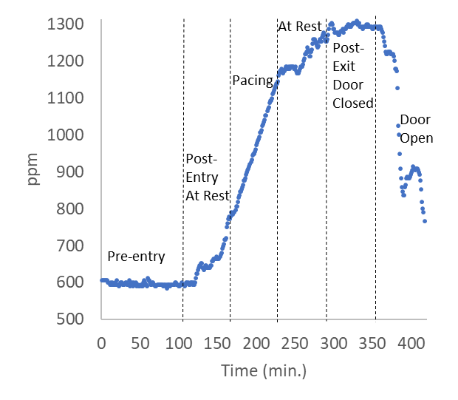
S3: Sensor 1, Trial 2: CO₂ concentration as a function of occupation time for a single individual in an enclosed OR with no ventilation. When an individual enters an enclosed room, the amount of detectable CO₂ increases with occupation time. The rate of CO₂ increase is dependent on the activity level of the individual. The CO₂ increases more quickly when the individual paces the room compared to when the individual is at rest.

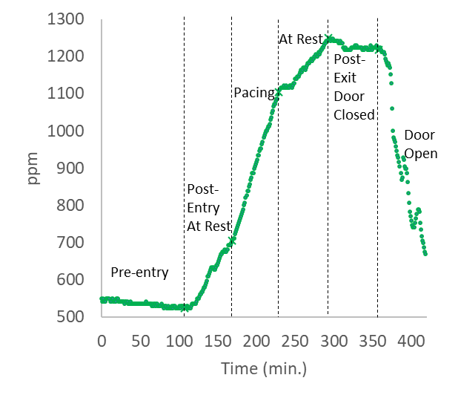
S4: Sensor 2, Trial 3: CO₂ concentration as a function of occupation time for a single individual in an enclosed OR with no ventilation. When an individual enters an enclosed room, the amount of detectable CO₂ increases with occupation time. The rate of CO₂ increase is dependent on the activity level of the individual. The CO₂ increases more quickly when the individual paces the room compared to when the individual is at rest.

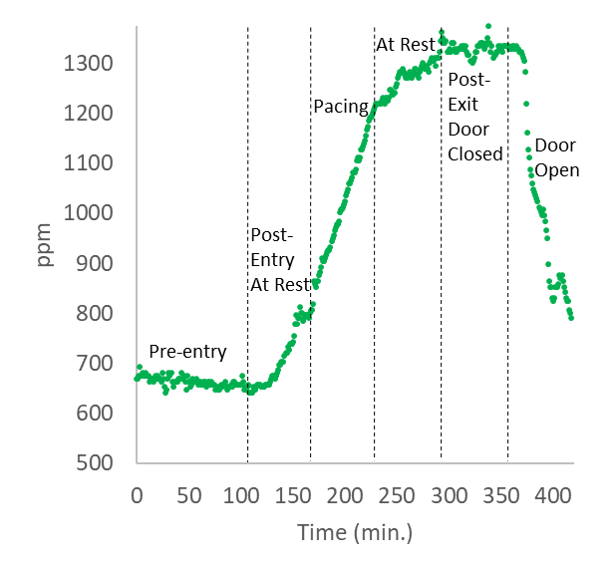
S5: Sensor 1, Trial 3: CO₂ concentration as a function of occupation time for a single individual in an enclosed OR with no ventilation. When an individual enters an enclosed room, the amount of detectable CO₂ increases with occupation time. The rate of CO₂ increase is dependent on the activity level of the individual. The CO₂ increases more quickly when the individual paces the room compared to when the individual is at rest.

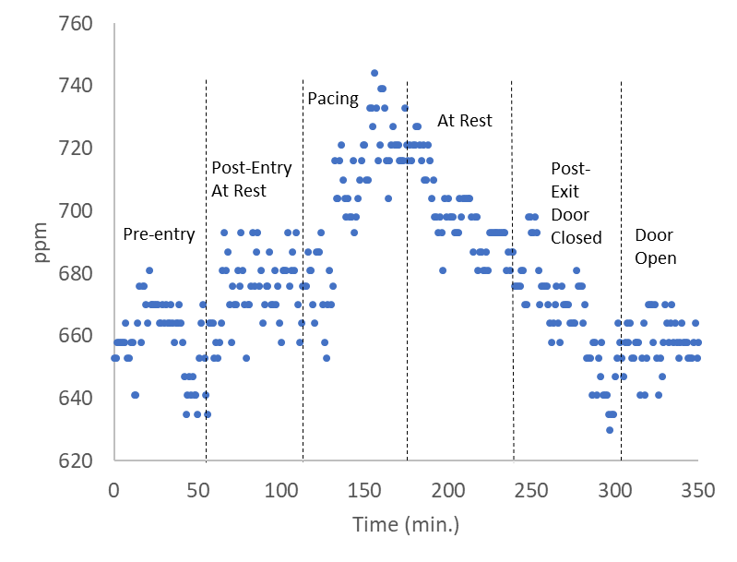

S6: Sensor 1: When an individual enters an enclosed room containing normal OR air flow conditions (positive pressure of 0.03 in. H₂O and a ventilation system operating at 20 ACH), CO₂ exhalation can be detected provided that the individual is moderately active. When a single person paces the OR for 1 hour, the amount of CO₂ in the room increases. When the active individual becomes seated and performs no physical activity the CO₂ level decreases.

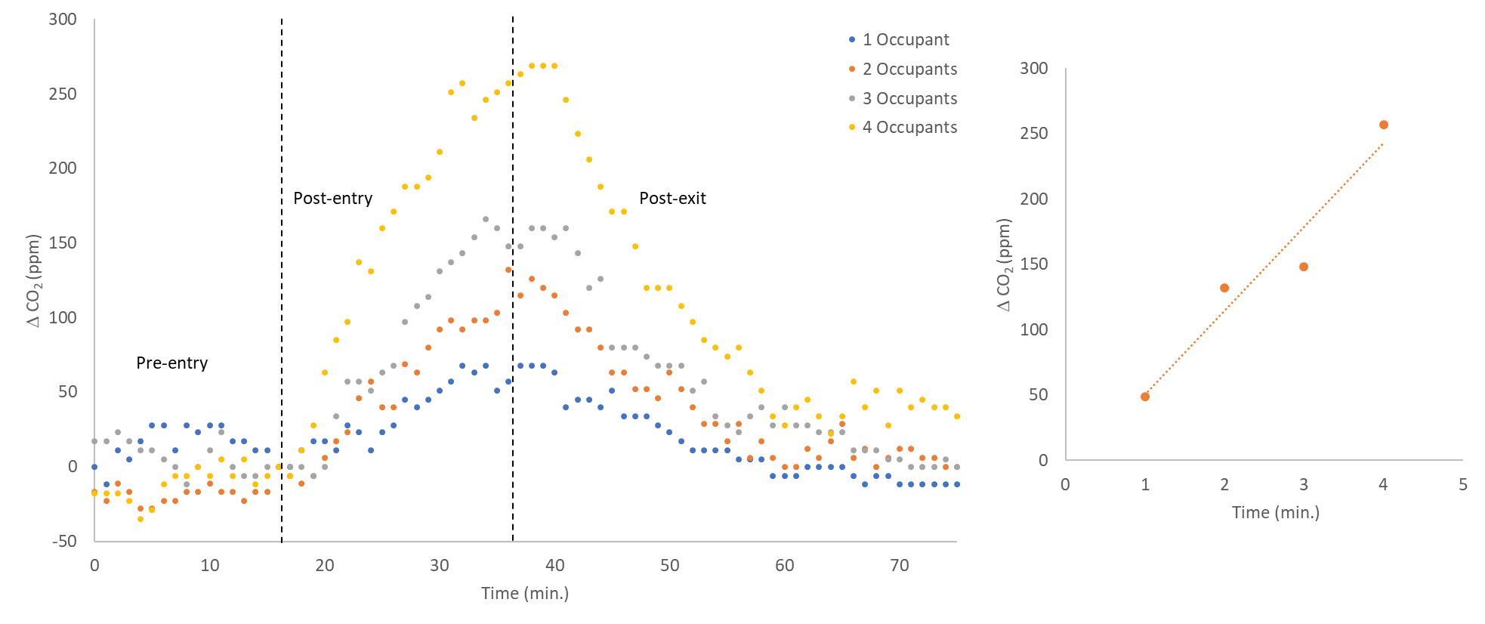

S7: Sensor 1 data: The amount of detected CO₂ increases over a 20-minute period when individuals are present in an OR with an air circulation system operating at a level of approximately 20 ACH and a positive pressure of 0.03 in. H₂O. As the number of individuals in the room increases, the amount of detected CO₂ increases. Upon exit, the CO₂ level decreases.

